

DMN Modeler Report
DT on BKM explicit parameters

Published: 7/30/2018
By: Edson Tirelli
Table of Contents
DT on BKM with explicit parameters 3
Decision Requirement Diagram 3
Elements 3

DT on BKM with explicit parameters

Decision Requirement Diagram
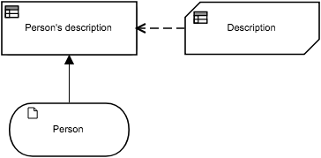

Elements
Person's description (Decision)
Decision Logic (Invocation)
Person's description

 | Description
 | Person  tPerson |  | Person

Description (Business Knowledge Model)
Output Data Type
Type | Text

Decision Logic (Function)
Description
Text
F | ( Person tPerson )
U | Person.Gender | the description | Description
 | Text  "Male", "Female" | Text
1 | "Male" | Person.Name + " is a dad of " + string(Person.Children) + " children."
2 | "Female" | Person.Name + " is a mother of " + string(Person.Children) + " children."

the description

Person (Input Data)
Input Data Type
Type | tPerson

tPerson
Name | Text
Gender | Text  "Male", "Female"
Children | Number

