

DMN Modeler Report
DT list semantics

Published: 7/31/2018
By: Edson Tirelli
Table of Contents
DT - semantics of lists 3
Decision Requirement Diagram 3
Elements 3

DT - semantics of lists

Decision Requirement Diagram
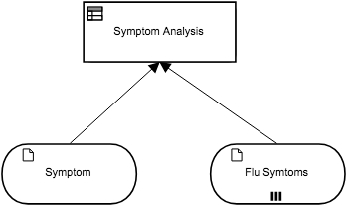

Elements
Symptom Analysis (Decision)
Output Data Type
Type | tListOfStrings

Decision Logic (Decision Table)
Symptom Analysis
tListOfStrings
C | Symptom |  | Symptom Analysis | Description
 | Text |  | tListOfStrings
1 | "cough", "sore throat", "stuffy nose" |  | Symptom + " is in the list of Cold symptoms" | syntax: list of unary tests
2 | Flu Symtoms |  | Symptom + " is in the list of Flu symptoms" | syntax: list variable

Symptom (Input Data)
Input Data Type
Type | Text

Flu Symtoms (Input Data)
Input Data Type
Type | tListOfStrings

tListOfStrings
Text

