**Design Record**

Aidan Johnson

Luke Garland

Top Level RTL Schematic:

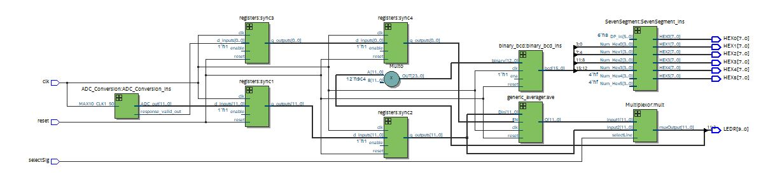

Multiplexor Schematic:

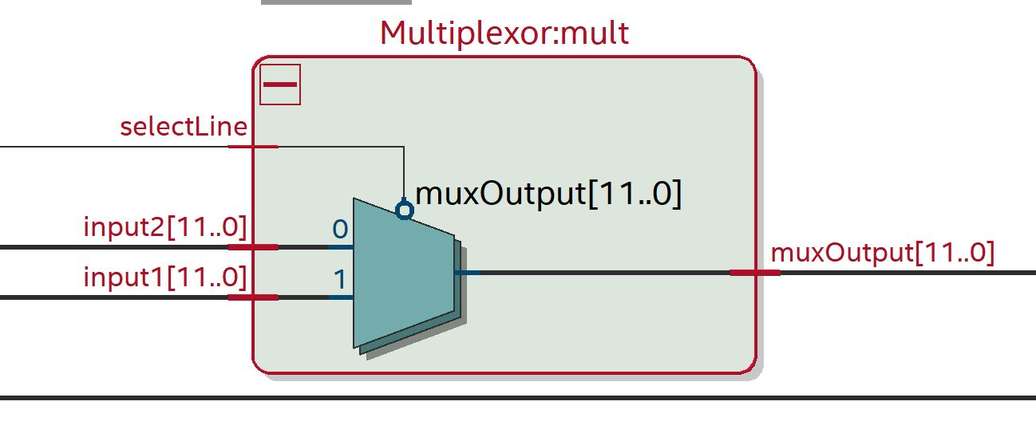

Generic Average Schematic:

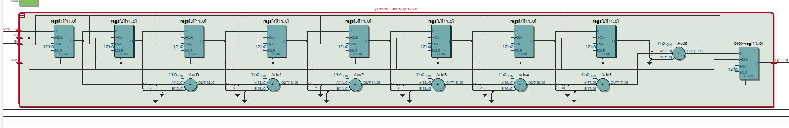

Showing Reset:

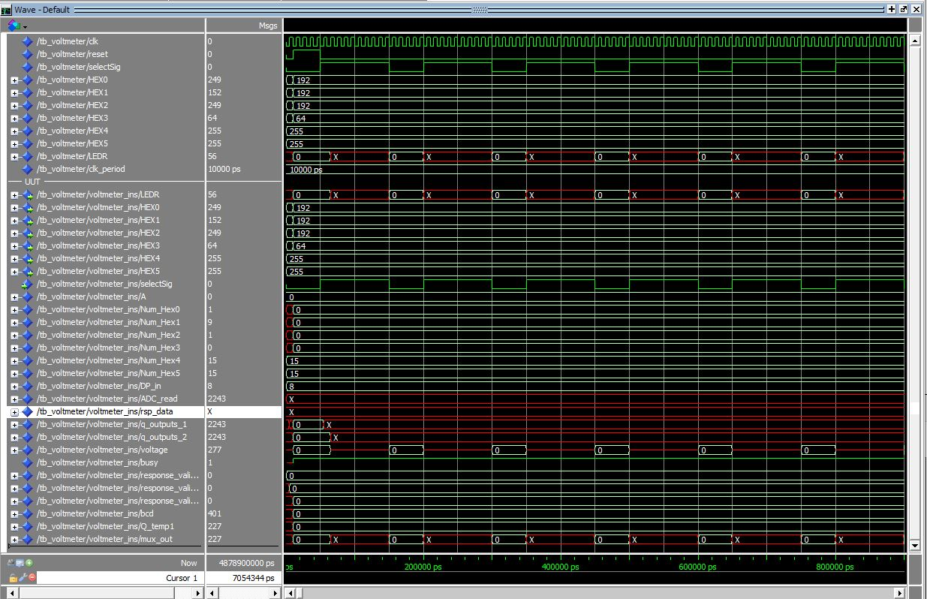

Showing Normal Operation:

