**Prelab 2**

Aidan Johnson

30043501

Showing the Reset:

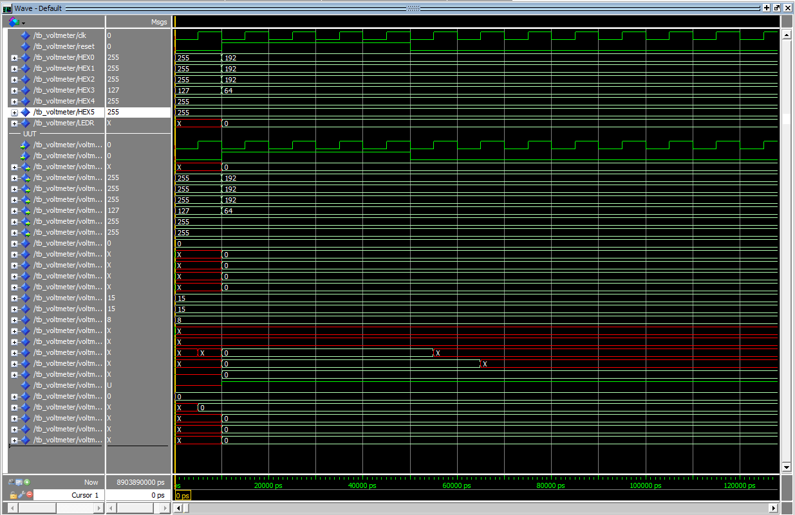

Normal Operation:

