Pre-Lab2: Luke Garland 30046672

Wave showing reset operation

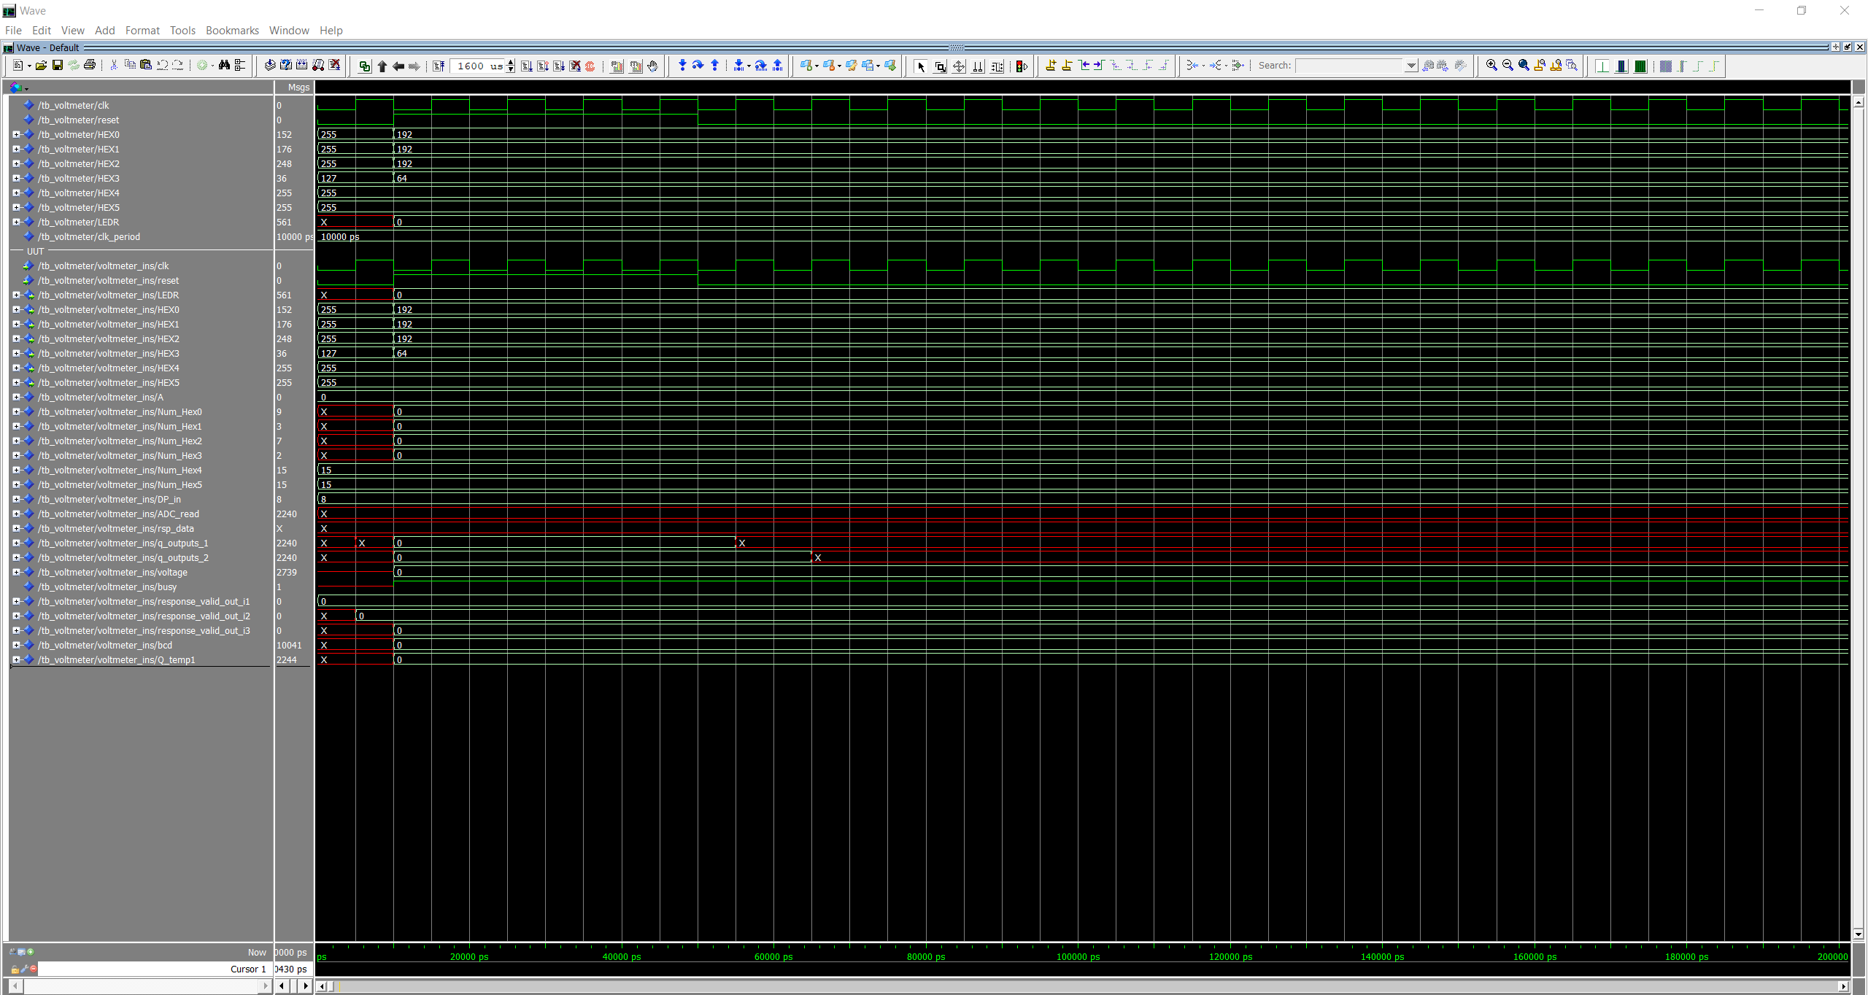

Regular operation

