NFL Onside Kick Analysis

Introduction

The goal of this project is to provide an analysis of onside kicks in the NFL.

In American football, a team kicks off the ball from the 35 yard line to the opposing team, giving them possession. However, the kicking team has the option to perform an onside kick. The onside kick may be recovered by the kicking team so that they retain possession. Performing an onside kick is often seen as an act of desperation since there is a high chance of failure, but recovering the onside kick leads to advantageous field position.

My project is important because if a team were able to recover more onside kicks, their drives would start from at least the 45 yard line and more importantly keep the ball away from the opposing team.

Background Information

**Data**

I collected NFL play by play data using nflscrapR for the 2011-2012 through 2015-2016 seasons. The reason I chose those seasons is because of the frequent rules changes regarding kickoffs in the NFL. The kickoff line waoved up 5 yards in 2011 and the touchback line was moved out 5 yards as well in 2016.

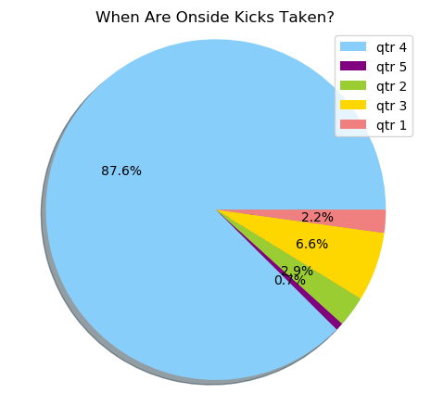

The graph below shows the kicking team’s score margin when they attempt onside kicks. 90.5% of the time the kicking is losing. Clearly, teams almost always attempt onside kicks when they are losing late in the game.

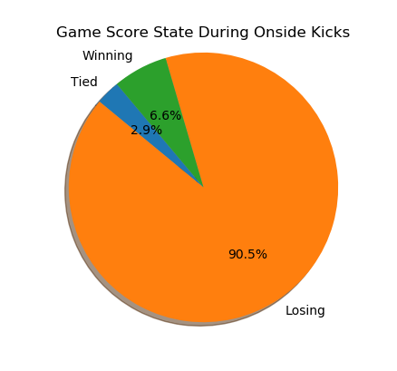

Onside kicks are viewed as a last ditch act of desperation. The graph above shows when in the game teams attempt onside kicks. Teams predominantly attempt onside kicks in the 4th quarter.

Note: qtr 5 means overtime.

Analysis







Conclusion

Other Interesting Information

