Luke Gerhart

Homework 2

(1a) In order to rank the leagues in homefield advantage, I used the cost function for regression based team ratings, but set the rating for both teams to 0. Since the *mi* is known, the function then becomes a function solving for *H*, the home field advantage. The idea is that if two teams are rated equally, then the home team’s margin of victory is due entirely to home field advantage. The function is essentially:

$$min\sum_{i=1}^{N}{(m_{i}-H)}$$

I then estimated *H* using a gradient based approach:



The results are:

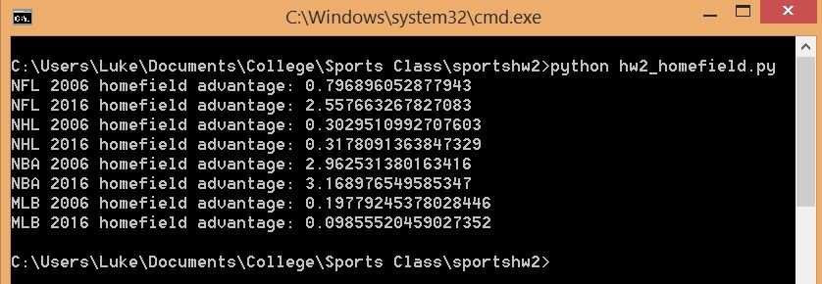

The NBA has the most advantage, then NFL, NHL, MLB.

(1b) The home field advantage for the NHL and NBA haven’t changed much. However, the NFL’s home field advantage more than tripled, going from .797 points in 2006 to 2.558 points in 2016. On the other hand, MLB’s home field advantage was halved, going from nearly 0.2 points to just .098 points.