Astrophysics simulator
Then my subtitle

[School]
[Course title]

Contents
Analysis 2
Problem identification 2
Computational methods 2
Stakeholders 3
Form results 3
Research 9
Kerbal space program 9
PhET 10
SpaceSim 11
Essential features 13
Extra features 13
Limitations 14
Requirements 14
Success criteria 16
Design 17
Decomposition 17
Usability features 17

Analysis

Problem identification
Many people find astrophysics difficult to understand and hard to demonstrate. This project aims to help explain more about how astrophysics works and lets teachers more easily demonstrate the movement of planets and other astronomical phenomena.
My program will allow people to tweak the settings of the simulation in real time and provide an intuitive interface to alter these settings, while allowing more knowledgeable users to have access to all statistics they could need.

Computational methods
Abstraction | I will abstract the problem of complex orbital motion down into the forces acting on each body and the direction of its velocity and acceleration.
Decomposition | I will break down the problem of creating a realistic astrophysics simulation into smaller parts, and work on each of those sequentially, e.g. working on the effect of gravity in the planets, then working on the UI of the inspector panel, then working on the forces overlay.
Object oriented programming | I will use individual objects to create the planets and celestial bodies and have defined methods for the effects of forces such as gravity on each body.
Algorithmic thinking | My program will use a constant game loop to evaluate gravitational forces, acceleration and velocity in the physics simulation, using many variable inputs from the user and output an accurate location of the planet.
Simulation | My program will simulate the movement of planets and where they will end up over time.
Theory and mathematics | My program will use many mathematical formulas to simulate how planets would move relative to each other and will use a lot of mathematical methods to calculate things like distance, force and orbital trajectories.
Data visualisation | Using visualisation to both understand more easily the responses of the form sent to the stakeholders, and to help people visualise all the different attributes and effects in play within the simulation. I apply this by using arrows to visualise the size of the force, using graphs to plot the data and using a colour overlay to help people to visualise the size and magnitude of the gravity.

Stakeholders
The primary end users of my simulation software are physics students at A level and GCSE level who are interested in learning more about astrophysics and space, and the teachers who are teaching them. The physics students can use this program as an interactive learning tool to **************. Some other stakeholders include the IT staff in these schools and colleges who deploy the software, and the examiner.

Form results
I used a Microsoft form to collect the data from my stakeholders – students who do physics. I received 58 responses, and the following images detail their responses.

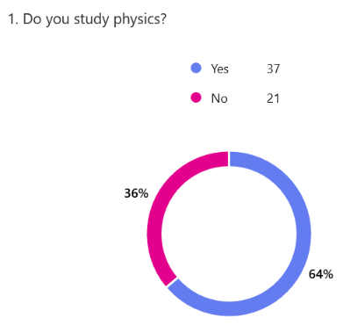
Do you study physics?
Out of the 58 responses, 36% of people said that they do not study physics and 64% said they do. The responses from those who did study physics is useful to closely reflect my stakeholders. However, the responses from those who do not study physics is also useful to highlight the preferences from people with less prior knowledge of physics.

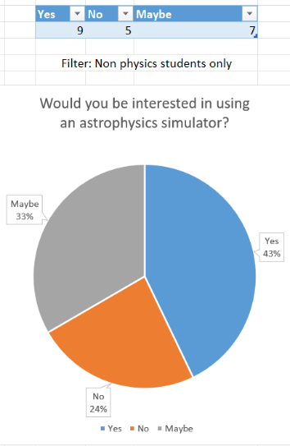
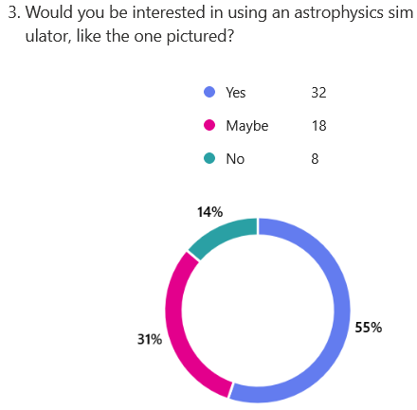
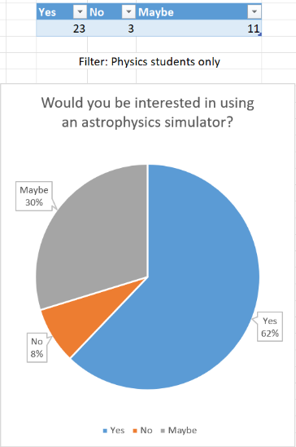
Would you be interested in using an astrophysics simulator, like the one pictured?
This question shows the general level of interest in a potential astrophysics simulator – this indicates that people would want to use my software when it is complete. The proportion of people who are interested in using an astrophysics simulator increases for people who study physics, which shows that my program is more relevant and useful for my stakeholders.

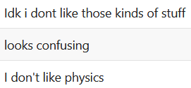
Why not?
For the few people that answered no to the previous question, some of the reasons given are related to a lack of understanding. This could be an indicator that my program should be simplified to be more approachable for a larger audience.

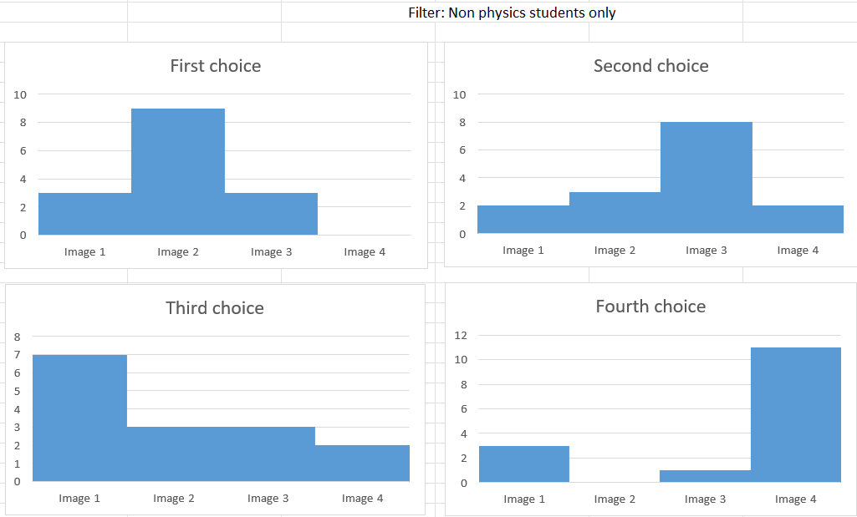
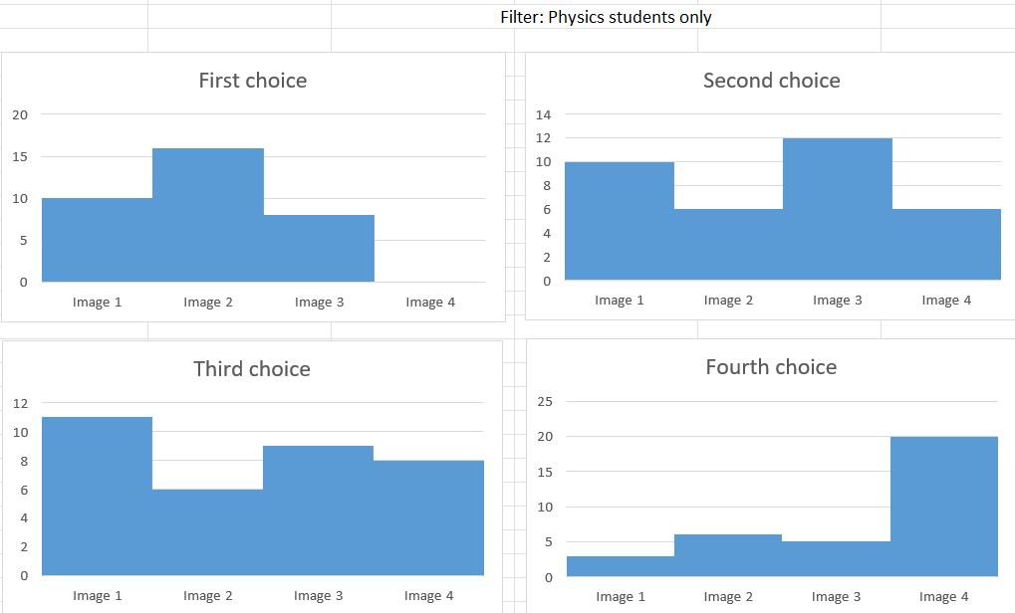
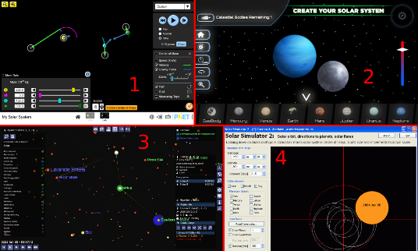
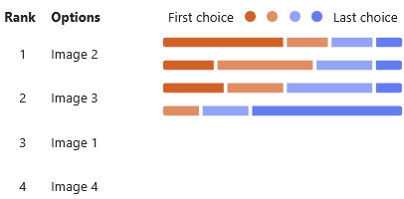
How would you rank each of these UIs (user interfaces)?
This question was included to determine what style of user interface my stakeholders would prefer and how simplistic the UI should be. The results show that most people prefer a simplistic UI, but a large group of people also liked the more complex design. Because the two winning designs were so different, I will try to implement both designs by adding a toggle between “simple” and “advanced” modes. A notable feature of image 2 is it is the only picture with realistic planet textures, however due to the results of a later question, this is most likely not a key part of why this UI performed as well as it did and I will most likely not be implementing this aspect of the project.

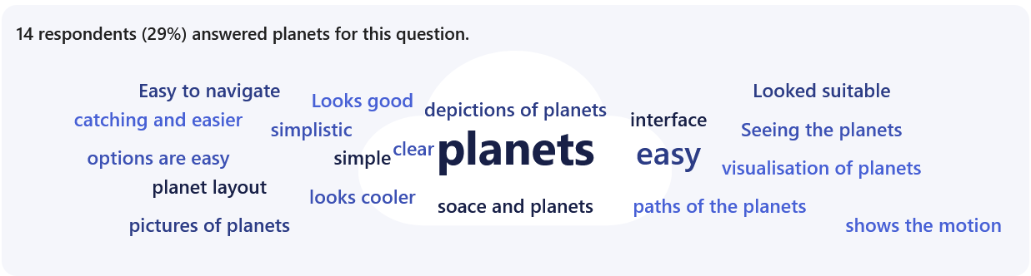
What did you like the most about your top choice?
People had various answers for this question, but the majority of people chose their top option based on simplicity and ease of use. This shows me that my primary audience, students, appreciate simplistic and intuitive designs. Many people also enjoyed having direct access to different prefabricated planets like those in out solar system, so I will make sure that prefab planets are the default with a separate option to create your own.

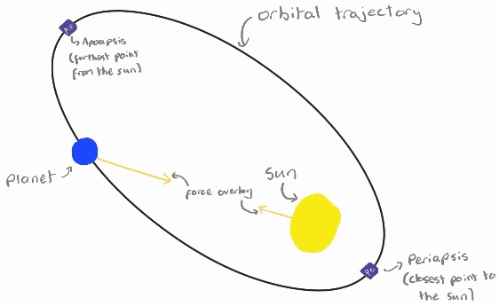
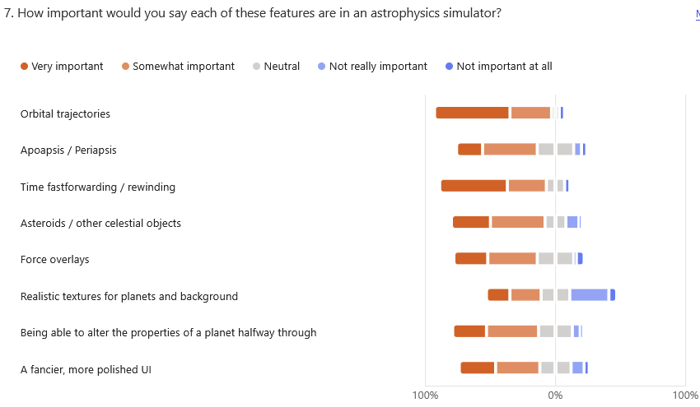
How important would you say each of these features are in an astrophysics simulator?
The results from this question help to point out which features of my simulator are most important for my stakeholders. The two most important features of the project were outlined as orbital trajectories and simulation speed controls, having more “Very important” votes than the rest. This makes sense, as those are fairly core features to a simulator, and orbital lines are a very common feature of space-based programs.

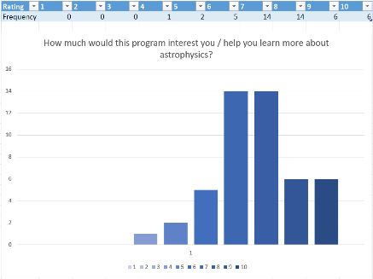
How much would this program interest you / help you learn more about astrophysics?
This question was included to determine whether my program would be beneficial to them. The results show that my stakeholders for this project think that this program would benefit them, showing that this project suits my intended stakeholders.

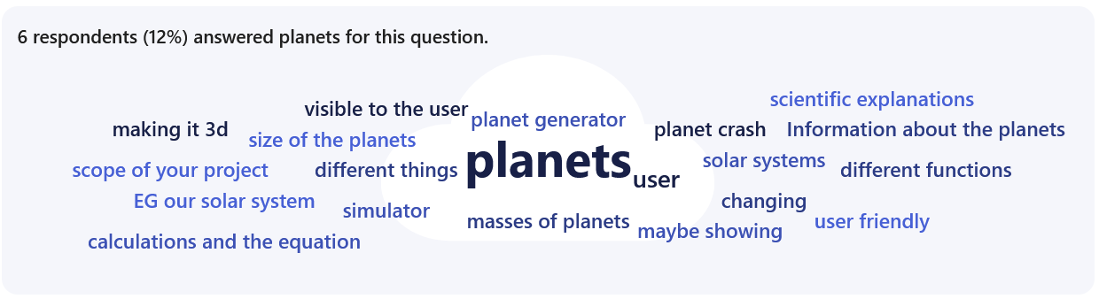
What would you add to this program to make it more interesting / help you learn more?
The answers from this question let each person who answer suggest any features they may want to add to the program. The responses were very varied, but a couple of ideas were the most popular amongst the suggestions.
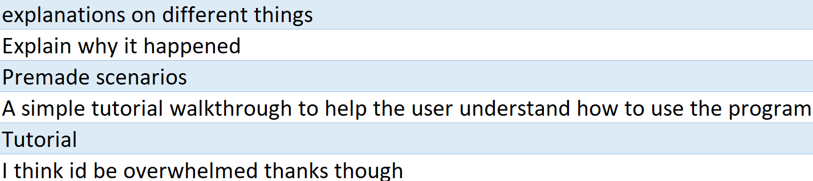
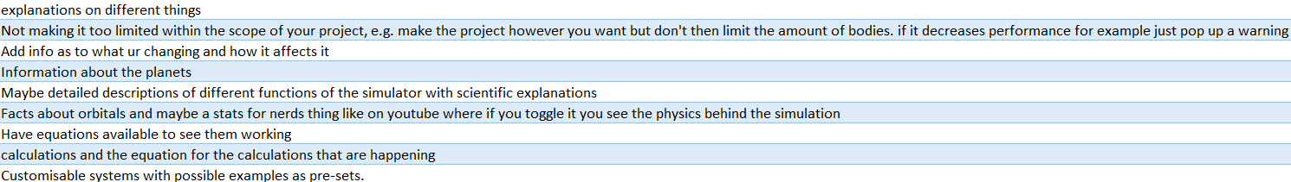
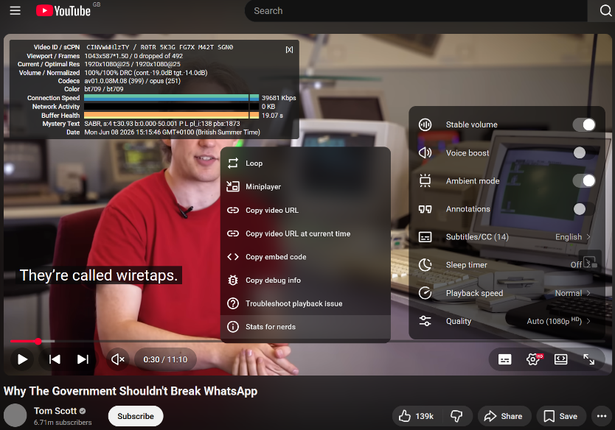
Notice the consistent semi transparent dark grey background colour for each of the separate menus (with extra blur for extra readability for the dropdown menu) for all the separate menus, but the vastly different levels of information density and complexity between the typical settings menu and the optional extra “stats for nerds” menu.
In a dropdown menu, you can access the “stats for nerds” feature
The more standard and minimally designed settings menu which is much more frequently accessed, which serves as the standard settings menu every normal user would see and interact with.
The “stats for nerds” panel shows extra info about streaming and playing the video, which gives all the information you could want in a small extra panel
One of the most requested features was to have a lot of information available to the user, while the second most requested feature was to include a tutorial or to make it simpler and easier to understand, with one person suggesting a feature similar to the YouTube “stats for nerds”. This is an optional extra menu that you can bring up in the YouTube site that shows you all the details and interesting parts of the video playback, stats and streaming on the website. I hope to take this idea of having a simplistic base menu for most people, catering for those who felt overwhelmed by a complex interface, while also providing an option to toggle on more detailed and denser panel of settings and pieces of information. This will allow those who wanted a lot of detail and many settings to have that, while not overwhelming the average non-expert user. I could also have the option to toggle between the modes be highlighted at the start of the program, along with an optional tutorial to guide people through the program.

Research
There are many different physics simulators or 3d sandbox games to take inspiration from, but the following three games / simulations had the most interesting features that I wanted to incorporate into my simulations.

Kerbal space program
Kerbal space program (or KSP) is a very popular space game, with the main gameplay loop involving sending rockets up and manoeuvring them around the solar system and beyond.
KSP has orbital lines and trajectory lines showing where the ship will end up, which is something I hope to integrate into my simulation. These simply display apoapsis and periapsis in an intuitive way. Many of the features are specific to 3D (such as the planet visualisation at the bottom of the UI) which will not be needed in my simulation, but some of them can be cleanly implemented.
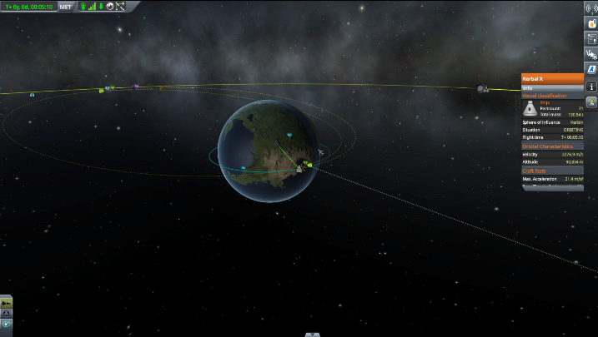

The interface of KSP is an interesting element, which manages to be out of the way of the main display, but pops out an inspector panel when you select an object and displays all relevant information about it. I hope to be able to use this idea to create my own information display when a planet or celestial body is selected, with all of the elements of it able to be adjusted and changed in real time.
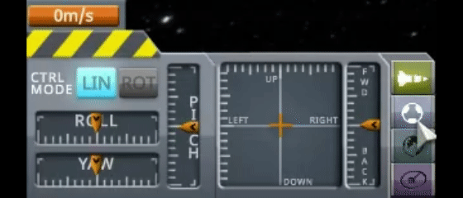
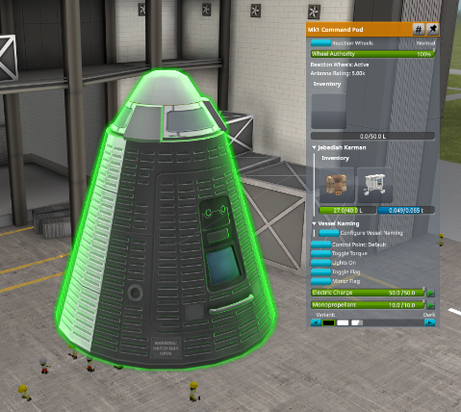

Another notable element is the time warp feature, which I hope to add to my simulation. However, KSP uses slightly differing simulation physics when time warping, which leads to a frustrating situation where if you time warp, there will be a different outcome than simply waiting longer. I will try and implement a time warp feature with near identical physics to normal, while trying to prevent increasing pressure on the hardware significantly.
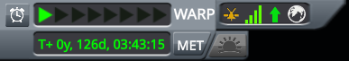

PhET
PhET is a website with many interactive physics simulations for different physical phenomena, primarily used by teachers to demonstrate different effects (like the photoelectric effect). PhET also have a smaller section on astrophysics and have a gravity simulator similar to my project.

PhET has a similar system to the one I am planning to use, with you being able to select planets and select whether to show overlays of forces and velocity. I will look to incorporate this into mine as well, as well as another toggle for acceleration.

The user interface of the PhET simulation is very simple to understand and use – this is something I hope to recreate in my project, while adding in more options to the selection info, and allowing it to be changed in real time. I also hope to replicate the simplistic and modern design each of the buttons have, while creating a consistent colour scheme to establish the navigation hierarchy and make the whole project more cohesive.

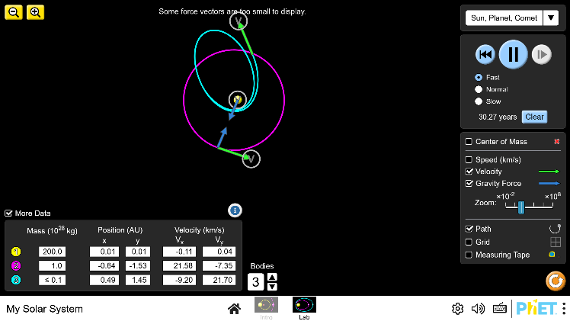
Able to add or remove planets on the fly
Options to speed up / slow down the simulation
Options to toggle velocity, force and path tracing visualisations
States the mass, positions and velocities of all the planets on the screen

SpaceSim
SpaceSim is a 3d astrophysics software that can simulate numerous different situations, can show you all the data you may need to know about all the planet’s features (like velocity or acceleration), and can visually show certain elements.

One feature I like about SpaceSim is the ability to visualise gravity using different colours, which is a feature I may want to add into my simulator. This helps to visualise how the force of gravity changes and how far away its effects can be felt. This also further helps any students using this software to understand the way planets interact with each other in an easy-to-understand way.
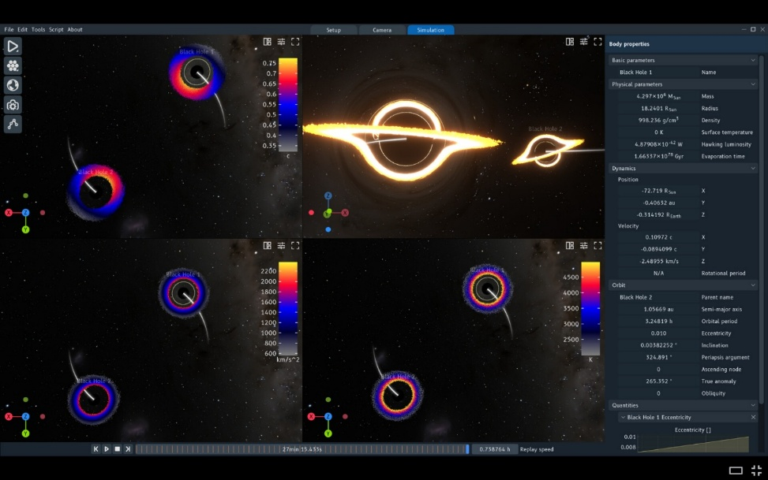
Uses colours to visualise the gravitational fields around celestial objects

SpaceSim also has a feature where it can show you graphs of speed and other attributes. This is similar to a feature I am planning to add to my simulation, which will allow you to graph any 2 attributes of an object as it moves and continues its simulation. SpaceSim can plot multiple graphs, which is more than my program’s one graph, but I will make the axes of the graph fully customisable, which will make this more useful than many preset graphs.
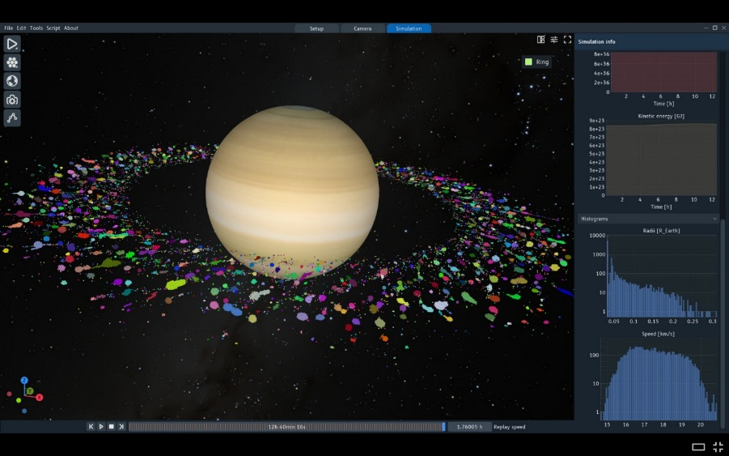
Graphs plotted in real time as the simulation continues, plotting different attributes of each object. The axes of the graph change and grow as the simulation continues, notably the time graph will extend as the time of the simulation moves on.

However, SpaceSim is not exactly what I am aiming for, since this software is 3d, and has much more capability than just astrophysics – for example it can simulate particle physics and collisions and has realistic lighting. This is beyond the scope of my project, so I will not be implementing these features.
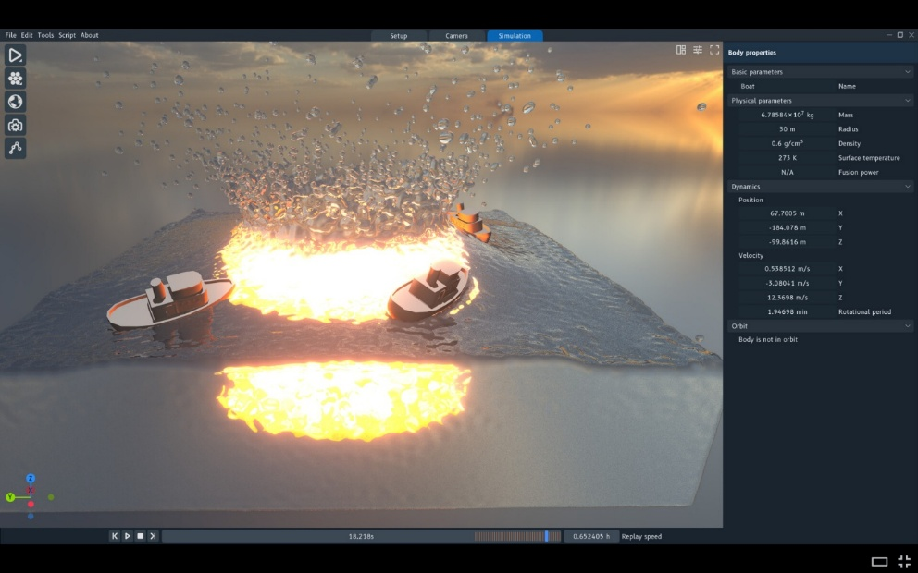

Features

Essential features
One key feature I will include into my program is the ability for the user to pause the simulation at any time and play at any speed they want. This was one of the most requested features in my form and will help teachers and students to observe complex orbits at a comfortable speed. Having a variable speed setting allows people to see both large scale slower simulations and smaller scale fast situations, vastly improving the usefulness of the program. Being able to pause the simulations at any time and adjust variables is important, as it allows for the setup of mid-flight trajectory changes that complex scenarios would require.
Another key feature of my program is having overlays for orbits and trajectories of objects. This was another highly requested feature from my form, and will allow for vastly easier orbital setups, letting even someone with less technical knowledge of physics set up a stable planetary orbit. This is a feature that can be seen in Kerbal Space program and SpaceSim, so it is a mostly universal feature in the genre of astrophysics simulators.
Furthermore, another essential feature is the display of information to the user. While my program will be designed to look user friendly, I also will need to ensure that I include many extra panels to display any extra data the user may want to see, e.g. an extra panel which shows all the statistics of the selected planet like mass, gravitational field strength and size. This will help the software be more useful to more advanced users and make it into more of a professional and capable program which can simulate complex scenarios.
Finally, my fourth essential feature is having preset planets and situations that users can select. This was shown to be an essential feature by the poll results and by the suggestions left. Having prefabricated planets and solar systems will reduce the complexity of the program to uninitiated users and make the entire program easier to use and understand, while being unobtrusive to those who want to fully customise their planets and set up their own scenarios between planets.

Important features
While the list above are the features that I must include in my program, there are several important but not required features that I could add to my program with any extra time I have after finishing the essential features.
One feature to ideally include is an “advanced mode” toggle. Letting the user choose between a more complicated and more minimal design for each UI element is an important inclusion, as evidenced in my feedback form, and will help the program to be more inclusive for users of all levels of technical knowledge.
Another important feature is force, velocity and acceleration overlays. This was highly requested in the form results and is extremely useful for using the program in an educational setting. The ability to toggle these on and off allows for all users of the program to be able to see as much detail as they want to see and no more.
Graphing two elements against each other is another important feature for my program to be able to do. This graphing capability will allow users to view how specific attributes relate to each other, with no restrictions on what attributes can be chosen (of the ones the program tracks), and no restrictions around having to use time on an axis.
Furthermore, allowing the attributes of the celestial bodies to be adjusted mid-way through the simulation without having to stop and restart the simulation would be a good feature to have, as it allows for faster creation of scenarios and more flexibility.
Finally, being able to dynamically add or remove planets during runtime is an important feature to include, as it allows users to simply intuitively edit the number of celestial bodies in the simulation and create their specific scenario easily.
fin.

Extra features
If I achieve all the previously listed features, there are many extra features I could add to my program to make it even better.
One extra feature that could be added is the integration with a pygame GPU library. This would allow for higher performance, since this library would offload the task of rendering the scene to the GPU, reducing the strain on only the CPU and spreading the load across more than just one CPU core.
Another extra feature that could be added is a sprite renderer. This would help with the prefabricated planets’ appearance, letting them be more easily identifiable as Earth, Venus etc. and would allow for custom textures to be applied to any planet the user wants, letting their custom planets feel more personal and controllable.
Colour-coded gravitational field visualisations are another extra feature that could be added, letting users visually see the effects of gravitational fields and how they interact with each other. This could also help physics teachers to show how gravitational fields work, and what shape they take on.
Finally, a pop-out inspector panel would be another useful extra inclusion, as this would allow the user to hide the attributes if needed, allowing for a full screen experience when needed, but with full access to the controls when needed.

Limitations
One limitation my program will have is that I will not be able to create a 100% realistic model of the movements of planets and stars around space – I will not have the time to implement some of the finer parts of astronomical movements like planets having atmospheres or dark matter pulling apart galaxies. This will not affect my stakeholders massively, however, as this program’s aim is to demonstrate more simplistic physical effects like basic orbital scenarios, instead of being the most accurate simulation possible.
Another limitation of my program is that it will only be in 2D. Most astrophysics simulations are three dimensional, which is more realistic and allows you to model real orbits from space. Having a 3D simulation is undeniably useful, however adding this would make the program vastly beyond the scope of my NEA.
Furthermore, I will not be able to recreate shadows and other graphical effects in my program, as these would require a large amount of work to make and the form results show that my stakeholders do not particularly want this as a key feature, instead wanting more focus on other more important things.

Requirements
My program will not be artificially limited in almost any way, so the hardware requirements will vastly change depending on the complexity and size of the simulation. However, to support a base level of performance with normal use, the following table shows the required specifications
 | Software
- Intel i7 or AMD Ryzen 7 CPU  I chose an intel i7 or AMD equivalent because this program, due to being made in python and with pygame, is very reliant on CPU speed. Because of having to simulate the effects each planet has on all of the other nearby planets, this simulation will have quite a high performance requirement, so for an average user an i7 provides enough performance for most things it will be used for.  - Integrated graphics  My simulator will not require a powerful GPU, as all of the computation and rendering is put onto the CPU, with the GPU only used at the very end to display the final image to the screen. If I have enough time to implement the GPU library for pygame, this still will not stress the GPU very much, as it is only rendering and drawing very simple shapes or sprites.  - Mouse and keyboard  - <50MB of storage space needed  - ~1GB of ram | - Any modern operating system, including most Unix and Linux based OS’s, windows and macOS  - A modern version of python and pygame installed on the computer

**Do this**

Success criteria
In order to be considered successful, my program, must satisfy a number of criteria. These are based on the responses from the stakeholders and the purpose of the software and are listed below.
- The system will allow full control the playback of the simulation
  - The simulation will support pausing and resuming at any point without exiting the program or resetting the simulation state
  - The system will allow the user to adjust the simulation speed during runtime, using either predefined values or a continuous scale including non-integer values
- The system will have overlays to visualise the orbital motion of the planets and objects
  - The simulation will show togglable orbital line overlays for each object showing the trajectory up to a configurable distance
  - The orbital lines will be optimised to the point where the simulation can run at 60fps on my laptop
- The system will display information to the user in a manner suitable for both new and advanced users
  - The system information (such as planet scale, mass, velocity, acceleration and simulation controls like playback speed) will be accessible from the main interface
  - Each element on the user interface will have a toggle to switch between a cleaner design and a much more informative panel which is more suited to advanced users
  - The more informative panel will contain additional attributes and information about the selected option
- The system will have various preset options for quick premade additions to the simulation
  - A selection of premade planets which can be added to the simulation will be available to the user
  - A selection of premade simulation scenarios will be available to the user, which will one or more premade planets or objects
  - The user will be able to create a new planet with fully adjustable attribute values

Design

Decomposition
bla bla bla
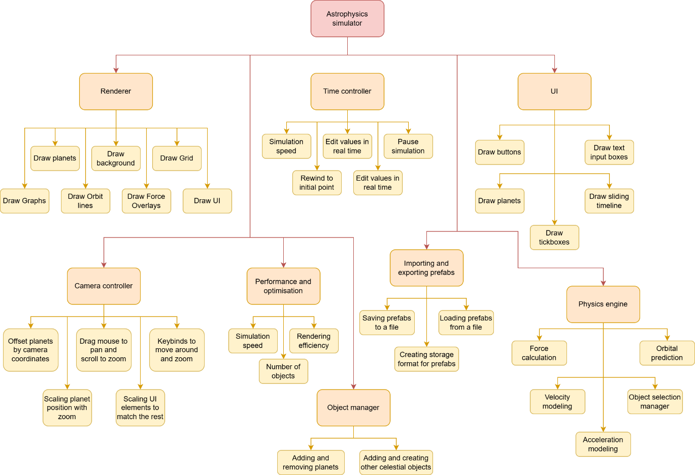
**Do this text ^^**

Structure
Do this also

Algorithms
CFOP

Usability features
Prototype and labels

Variables / Data structures / Validation
woo /s

Iterative test data
iter
ate
small features e.g. colour selector

Post development test data
woo fix it in postttttt
after making a key feature, test if it works
check big parts work & test success criteria

Development

Sprint 1 – Core Simulation
In my first sprint, I want to focus on making the base system of the simulator – getting the background and planets in and getting the movement of the planets around each other working. I will make all of the core objects and the base layout sorted, with full camera controls including panning and zooming, and selective rendering of planets based on what is within the camera’s view.
fin.

References
[1] – luke.hatherly.com

