Astrophysics simulator
Then my subtitle

[School]
[Course title]

Contents
Analysis 2
Problem identification 3
Computational methods 4
Stakeholders 5
Research 6

Analysis

Problem identification
Many people find astrophysics difficult to understand and hard to demonstrate. This project aims to help explain more about how astrophysics works, and lets teachers more easily demonstrate the movement of planets and other astronomical phenomena.
My program will allow people to tweak the settings of the simulation in real time, and provide an intuitive interface to alter these settings.

Computational methods
Abstraction | I will abstract the problem of complex orbital motion down into the forces acting on each body and the direction of its velocity and acceleration.
Decomposition | I will break down the problem of creating a realistic astrophysics simulation into smaller parts, and work on each of those sequentially, e.g. working on the effect of gravity in the planets, then working on the UI of the inspector panel, then working on the forces overlay.
Object oriented programming | I will use individual objects to create the planets and celestial bodies, and have defined methods for the effects of forces such as gravity on each body.
Algorithmic thinking | My program will use a constant game loop to evaluate gravitational forces, acceleration and velocity in the physics simulation, using many variable inputs from the user and output an accurate location of the planet.

Stakeholders
The primary end users of my simulation software are physics students at A level and GCSE level who are interested in learning more about astrophysics and space, and the teachers who are teaching them. Some other stakeholders include the IT staff in these schools and colleges who deploy the software, and the examiner.

Research
There are many different physics simulators or 3d sandbox games to take inspiration from, but the following three games / simulations had the most interesting features that I wanted to incorporate into my simulations.

Kerbal space program
Kerbal space program (or KSP) is a very popular space game, with the main gameplay loop involving sending rockets up and manoeuvring them around the solar system and beyond.
KSP has orbital lines and trajectory lines showing where the ship will end up, which is something I hope to integrate into my simulation. These simply display apoapsis and periapsis in an intuitive way. Many of the features are specific to 3D (such as the planet visualisation at the bottom of the UI – see figure 2) which will not be needed in my simulation, but some of them can be cleanly implemented.
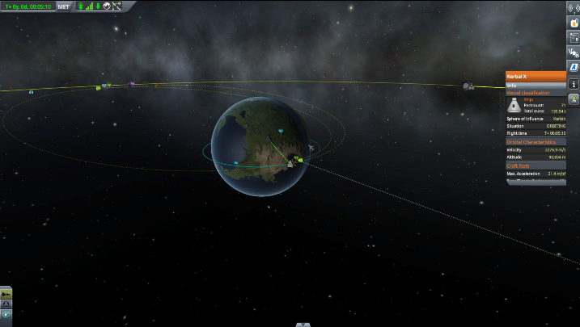
Figure 1 showing orbital trajectories around the planet in KSP

The interface of KSP is an interesting element, which manages to be out of the way of the main display, but pops out an inspector panel when you select an object and displays all relevant information about it. I hope to be able to use this idea to create my own information display when a planet or celestial body is selected, with all of the elements of it able to be adjusted and changed in real time.

<insert pic of KSP interface here>

Another notable element is the time warp feature, which I hope to add to my simulation. However, KSP uses slightly differing simulation physics when time warping, which leads to a frustrating situation where if you time warp, there will be a different outcome than simply waiting longer. I will try and implement a time warp feature with near identical physics to normal, while trying to prevent increasing pressure on the hardware significantly.

<insert picture of time warp in KSP>

PhET
PhET is a website with many interactive physics simulations for different physical phenomena, primarily used by teachers to demonstrate different effects (like the photoelectric effect). PhET also have a smaller section on astrophysics and have a gravity simulator similar to my project.

PhET have a similar system to the one I am planning to use, with you being able to select planets and select whether to show overlays of forces and velocity. I will look to incorporate this into mine as well, as well as another toggle for acceleration.

The user interface of the PhET simulation is very simple to understand and use – this is something I hope to recreate in my project, while adding in more options to the selection info, and allowing it to be changed in real time. I also hope to replicate the simplistic and modern design each of the buttons have, while creating a consistent colour scheme to establish the navigation hierarchy and make the whole project more cohesive.
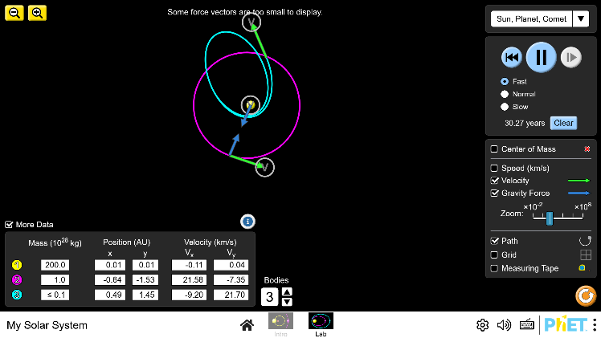
Options to speed up / slow down the simulation
Options to toggle velocity, force and path tracing visualisations
Able to add or remove planets on the fly
States the mass, positions and velocities of all the planets on the screen

