1. Description

Decisions

* There are six crimes categories, fraud, trespass, auto theft, disorderly conduct, robbery and assault.
* Location is represented as a region, where there are 10 regions total.
* Time id is represented in months, as the results are over two years, so 12 months per year
* Overall time table is over two years, so 24 ids’.
* The same applies to the time of calls table, it will be generalized to the months of calls over two years.
* Measurable in crime table is the number of crime per month.
* Measurable in emergency calls table is the number of calls, and number of staff available per month.
* One City can have many streets, so many streets can have the same city.
* One Region can have many cities, so many cities can have the same region.
* There is one station per city.
* Crimes Fact table values are by months over a two-year period, categories and the regions, measuring the number of crimes against these.
* Emergency Calls table values are also by months over a two-year period, categories and station, measuring the number of calls and staff available against these.
* The numbers generated are random, up to certain values.
* The values and names generated are also random.
* ID is the name of the table and ‘id’ at the end of it, for example, Location table id would be ‘Location_id’.
* Foreign key values are represented as the name of the table, then the id, for example ‘Location_id’ from the location table would be ‘Location_Location id’.

Stakeholders:

While the facts tables and queries may benefit the police station in general, the specific stakeholders chosen for this is the police strategists who have the ability use the data to pick when and where the police patrol should be, also the police department management, who have the ability to allocate staff and the last stakeholder being the officers that patrol, as the data can show trends of where is most likely a crime is to occur, allowing them to look for certain things at certain times. The overall aim is to help the police become more effective, and with the queries, they can become more effective in getting arrests and planning/allocating staff.

2. Schema

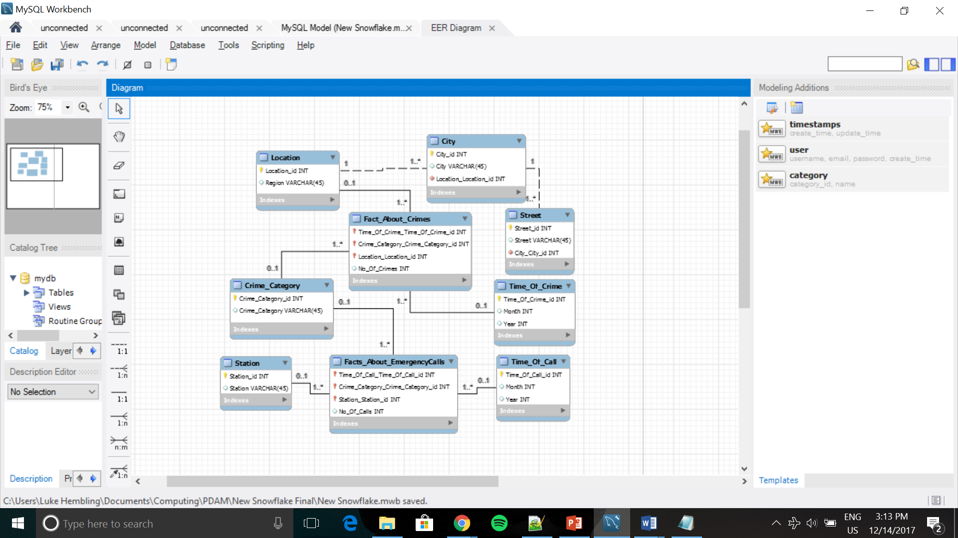

3. Queries

Query 1:

|  |
| --- |
|  |
|  |
| Show the average number of crimes for each region for a specific month and crime category, over two years. Useful because they can use this data to see where they should allocate more staff that might specialize in a type of crime (E.g. Assault). |

Query 2:

|  |
| --- |
|  |
|  |
| The average number of crimes per month for a specific region. Useful as it shows which month is has the highest crime numbers so may plan for the future by having more staff available, and when to have more frequent patrols for a particular region. |

Query 3:

|  |
| --- |
|  |
|  |
| Shows all the months where crimes were 100 and above. Also showing the region and year, they occurred, as well as the crime category. Useful because this singles out the months with the most crimes, and this can show trends for the future. |

Query 4:

|  |
| --- |
|  |
|  |
| Show average number of calls per station, only showing the station where the average number of calls were over 36. Shows which area receives the most calls on average and which station should have the most staff available. This is also useful to allocate staff. |

Query 5:

|  |
| --- |
|  |
|  |
| Shows the average number of calls for a specific station for each crime category. Useful as they can see what crime may occur the most, allowing the station to focus on preventing that crime more than others, by allocating staff to patrol or hiring staff that may specialize in that crime. |

Query 6:

|  |
| --- |
|  |
|  |
| Shows the average number of calls and average number of staff available each month for a specific station. Useful because it shows that maybe they might be under staffed for a month where the average number of calls is high, allowing them to adjust for the future, allowing them to be more effective in the future. |