**FISH 622 Final Exam**

Luke Henslee

4/27/2021

# Problem 1-

Figure 1: Length-at-age for Pacific halibut age under von Bertalanffy model.

Figure 2: Weight-at-age for Pacific halibut under allometric growth model.

Figure 3: Female spawning stock biomass for Pacific halibut.

# Problem 2-

Figure 4: Total instantaneous mortality at age for a cohort.

Figure 5: Numbers-at-age for a cohort.

Figure 6: Catch-at-age for a cohort.

# Problem 3-

Survival matrix (S):

*[,1] [,2] [,3] [,4] [,5] [,6] [,7]*

*[1,] 0.3 0.0 0.0 0.0 0.0 0.0 0.0*

*[2,] 0.0 0.4 0.0 0.0 0.0 0.0 0.0*

*[3,] 0.0 0.0 0.5 0.0 0.0 0.0 0.0*

*[4,] 0.0 0.0 0.0 0.7 0.0 0.0 0.0*

*[5,] 0.0 0.0 0.0 0.0 0.7 0.0 0.0*

*[6,] 0.0 0.0 0.0 0.0 0.0 0.8 0.0*

*[7,] 0.0 0.0 0.0 0.0 0.0 0.0 0.8*

Recruitment matrix (R):

*[,1] [,2] [,3] [,4] [,5] [,6] [,7]*

*[1,] 0 0 0 2 4 6 8*

*[2,] 0 0 0 0 0 0 0*

*[3,] 0 0 0 0 0 0 0*

*[4,] 0 0 0 0 0 0 0*

*[5,] 0 0 0 0 0 0 0*

*[6,] 0 0 0 0 0 0 0*

*[7,] 0 0 0 0 0 0 0*

# Problem 4-

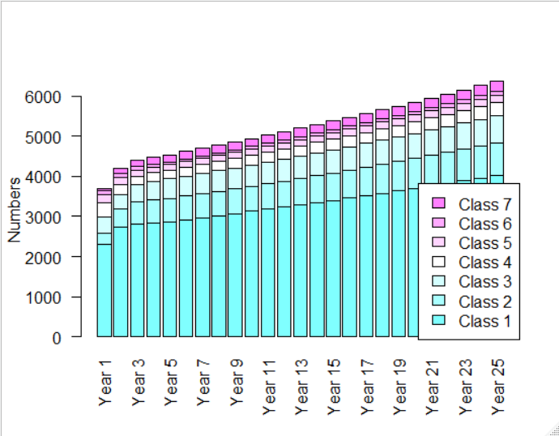

Figure 7: Numbers for each size class in a 25-year projection.

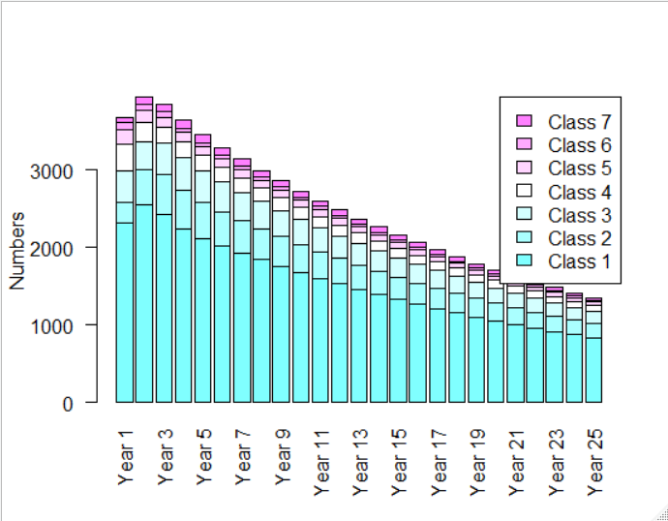

Figure 8: Numbers for each size class in a 25-year projection accounting for size-specific fishing mortality

# Problem 5-

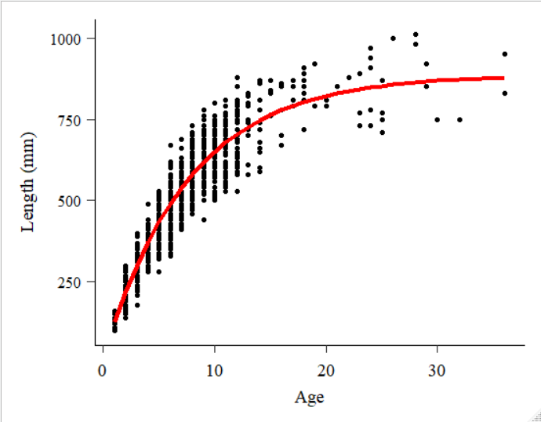

Figure 9: Fitted von Bertalanffy model-predicted length-at-age (red line), plotted over observation data (points).

The fitted estimates for LVB length-at-age model parameters for EBS Greenland turbot are *Linf*= 885.7, *k* = 0.13, and *t0* = -0.19.

Thanks, Curry! Great class.