Appendix

Table S1. Colour solution used to colour worms for the mating assay.
Ingredient | Amount in µl
3.4 mg/ml Grand Bleu [E131, E151] (Les Artistes—Paris) in f/2 | 15 (final concentration: 2.04 mg/ml)
4 ml/50 ml liquid color blue (Dr. Oetker) in f/2 | 5 (final concentration: 1.6%)
algae in f/2 | 3
f/2 with a worm of interest | 2

Table S2. Results of type III ANOVA with Satterthwaite's degrees of freedom and posthoc Tukey test for a linear mixed effects model with selection regime as a fixed effect, replicate population as a random effect nested within selection regime, and generation as a random effect, to test if mating frequency differs between selection regimes.
Selection regime effects | Sum Sq | Mean Sq | NumDF | DenDF | F value | p-value
 | 1438.3 | 719.16 | 2 | 9.049 | 2.958 | 0.103
 | Linear Hypotheses: | Estimate Std. |  | Error | z value | p-value
 | F - C == 0 | -6.495 |  | 3.703 | -1.754 | 0.185
 | M - C == 0 | 2.118 |  | 3.694 | 0.573 | 0.834
 | M - F == 0 | 8.612 |  | 3.686 | 2.337 | 0.051
(Adjusted P values reported -- single-step method)

Table S3. Tukey test for a linear mixed effects model with selection regime as a fixed effect, and replicate population as a random effect nested within selection regime, to test if mating duration differs between selection regimes. Generation was not included in this model since all data was obtained from the same generation.
Selection regime effects | Sum Sq | Mean Sq | NumDF | DenDF | F value | p-value
 | 0.36335 | 0.18168 | 2 | 8.895 | 1.373 | 0.302
 | Linear Hypotheses: | Estimate Std. |  | Error | z value | p-value
 | F - C == 0 | -0.04982 |  | 0.06167 | -0.808 | 0.698
 | M - C == 0 | 0.05202 |  | 0.06120 | 0.850 | 0.672
 | M - F == 0 | 0.10184 |  | 0.06147 | 1.657 | 0.222
(Adjusted P values reported -- single-step method)

Table S4. Analysis of deviance table (type II Wald χ² tests) for LMM with average mating duration, selection regime, and their interaction as fixed effects, and replicate population as a random effect nested within selection regime, to test if they affect mating frequency. Generation was not included in this model since all data were obtained from the same generation.
Response: Mating frequency | χ² | Df | p-value
Average mating duration | 0.471 | 1 | 0.493
Selection regime | 2.310 | 2 | 0.315
Average mating duration: Selection regime | 4.619 | 2 | 0.099

Table S5. Results of Procrustes ANOVA analysis of the effects of the selection regime and generation, while controlling for replicate population, to test if they affect the shape of the stylet, as well as pairwise posthoc comparisons from this model. Permutation procedure: randomization of null model residuals, number of permutations: 1000, estimation method: Ordinary Least Squares, Sums of Squares and Cross-products: type I, effect sizes (Z) based on F distributions. Df – degrees of freedom.
 | Df | SS | MS | Rsq | F | Z | p-value
Selection regime | 2 | 0.079 | 0.040 | 0.030 | 5.474 | 3.744 | 0.001
Generation | 3 | 0.013 | 0.004 | 0.005 | 0.620 | -0.864 | 0.805
Interaction | 9 | 0.206 | 0.023 | 0.079 | 3.174 | 5.208 | 0.001
Residuals | 320 | 2.312 | 0.007 | 0.886
Total | 334 | 2.610
Pairwise comparisons |  | d |  | UCL (95%) |  | Z | p-value
C:F |  | 0.002 |  | 0.002 |  | 1.081 | 0.146
C:M |  | 0.001 |  | 0.002 |  | 0.321 | 0.390
F:M |  | 0.003 |  | 0.002 |  | 1.973 | 0.021

Table S6. Analysis of deviance table (type II Wald χ² tests) for a binomial mixed model with mating order and selection regime as fixed effects, and worm identity and replicate population (nested within selection regime) as random effects, to test if they affect sucking probability in wild-type mating partners after mating with the selection line worms. Df – degrees of freedom.
Response: Wilde-type sucking | χ² | Df | p-value
Mating order | 12.599 | 4 | 0.013
Selection regime | 1.136 | 2 | 0.567

Table S7. Analysis of deviance table (type II Wald χ² tests) for a binomial mixed model with a selection regime as a fixed effect, replicate population as a random effect nested within the selection regime, and generation as a random effect, to test if the selection regime affects sucking probability in the selection line worms.
Response: Selection line worm sucking | χ² | Df | p-value
Selection regime | 0.142 | 2 | 0.932

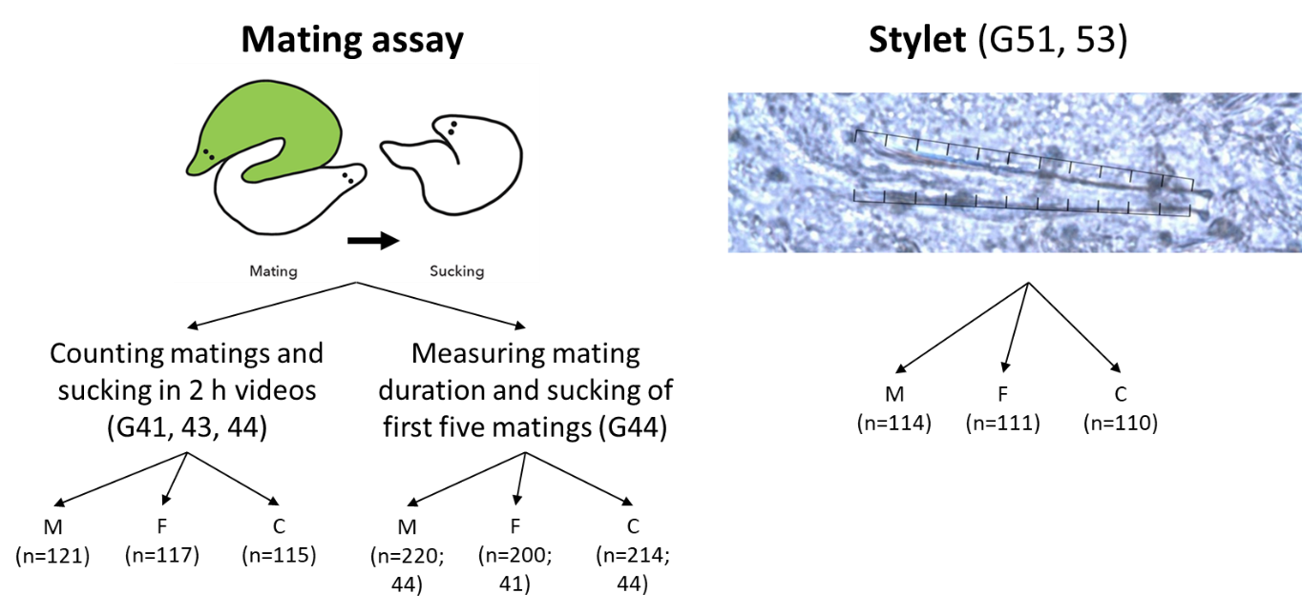
Figure S1. Schema of the experiment. We recorded mating videos of worms after over 40 generations and took pictures of the stylet after more than 50 generations of selection for male- or female-specific fitness. Numbers in the brackets indicate the number of individuals included in the analyses, except for measuring the first five matings of generation 44, where the first number indicates the number of analysed matings per selection regime.
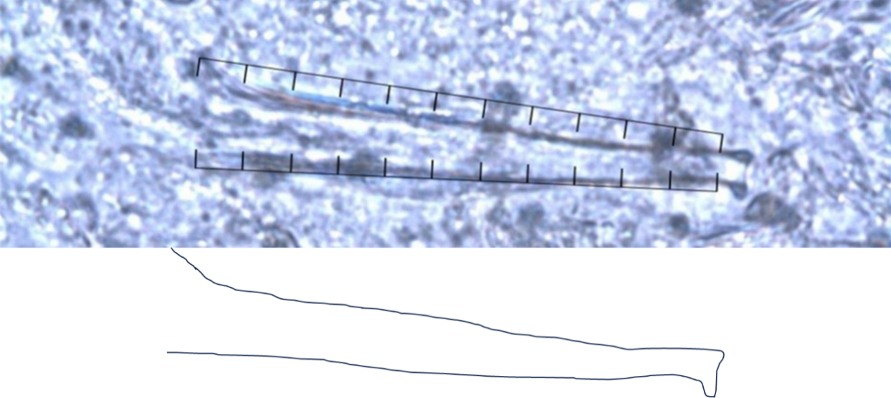
Figure S2. Stylet with “combs” and its schematic representation.

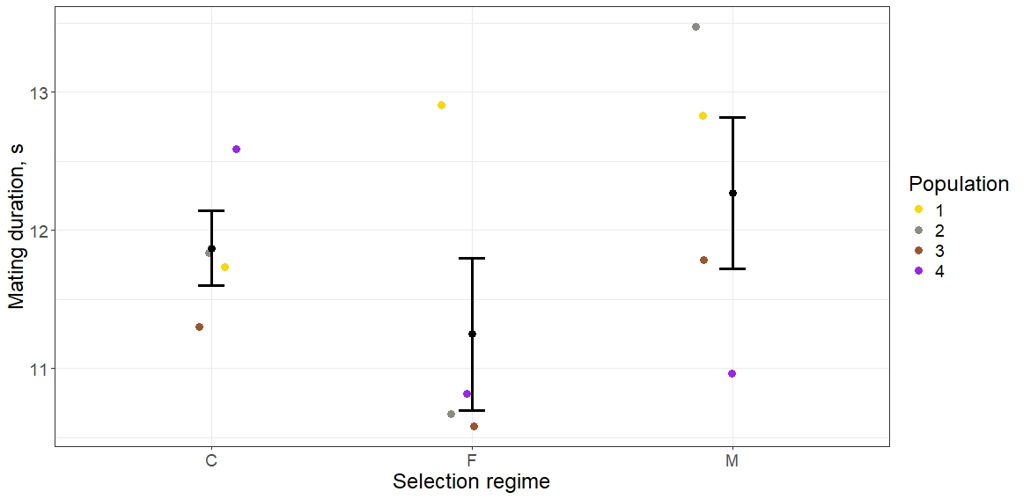
Figure S3. Average mating duration per selection regime calculated from the first five matings in generation 44. Error bars indicate the standard error of the means of all four replicate population data, not the model's output. Male-selected worms tend to mate for longer durations than female-selected worms. However, the difference is not significant (M-F Std.=1.0, P = 0.222).
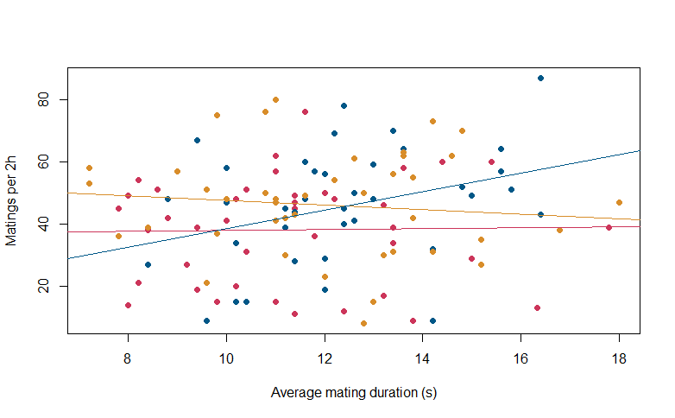
Figure S4. The relationship between mating frequency and average mating duration for the three selection regimes (M - blue, F - red, C - yellow) was calculated from the first five matings in generation 44. The interaction effect between the average mating duration and selection regimes on mating frequency shows a trend towards significance (P = 0.099, Table S4).

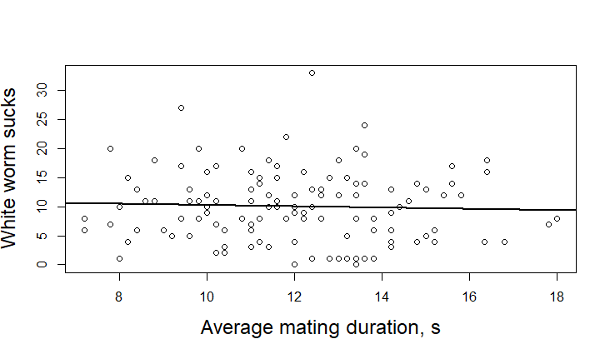
Figure S5. The relationship between the average mating duration and the number of sucks performed by white worms.

