Ecomorphology in Anoles

Background

Anoles are a diverse group of lizards found in the Caribbean and Central and South America. There are about 400 species of anoles, usually all placed in the same genus Anolis, Anoles are Iguanid lizards, placed in the family Polychrotidae.

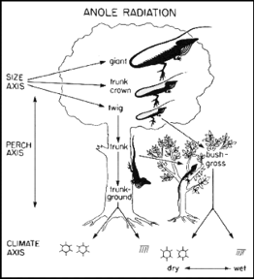
These lizards have become a model system for evolutionary ecology. Numerous studies of their behavior, physiology, neurobiology, community structure, and evolution have resulted in a detailed understanding of the relationship between species and their environments. For example, studies of competition among species of anoles in the 1970s by Tom Schoener and colleagues laid the foundations for the field of community ecology. More recently, scientists have sequenced the complete genome of the green anole, Anolis carolinensis, a breakthrough that will lead to a whole new era of scientific study.
Figure 1. Ecomorphs in anoles. These habitat specialists differ in perch height and perch diameter, as well as numerous morphological characters.

In this lab, you will focus on one of the most famous aspects of the anole radiation: the ecomorphs. There are six ecomorphs, each of which lives in a particular habitat (trunk-ground, trunk, twig, trunk-crown, crown-giant, and grass-bush; Figure 1). Most of these ecomorphs are found on all four islands of the Greater Antilles - Cuba, Hispaniola, Jamaica, and Puerto Rico. They are recognized by the habitats where they live but also by their morphology. For example, twig anoles are small with very short legs and elongate snouts. A non-specialist would have a hard time differentiating Anolis valencienni (found only in Jamaica) from A. insolitus (a species from Hispaniola; Figure 2). However, not only are these two species distinct, they’re not even very closely related!
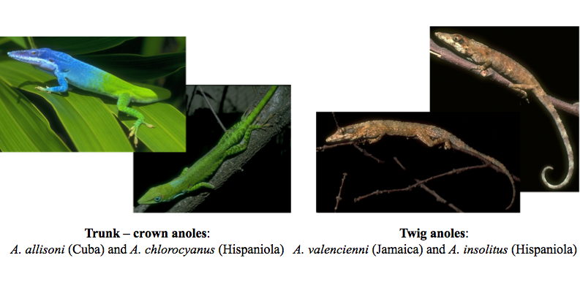
Anole ecomorphs have become famous as an example of convergent evolution, the repeated evolution of similar traits in independent lineages. In this lab, you will investigate patterns of ecomorph evolution in anoles.

i. Basics of Mesquite

You will be using a software package called Mesquite to analyze some data on anoles. Mesquite, written by Wayne and David Maddison, is already installed on the computers in the lab. If you’re interested, this software is completely free and available to download online at http://mesquiteproject.org.

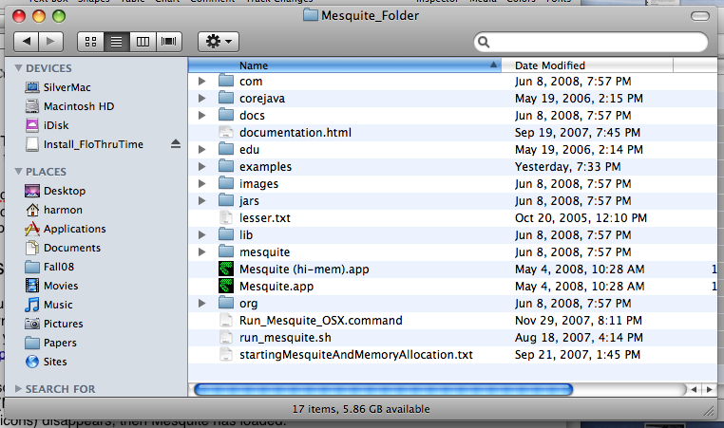
To start Mesquite, find the “Mesquite folder” on your computer, and click on the basic application (Mesquite.app) within that folder. Other versions of the application have higher memory requirements to run very large data sets. When the loading screen (small box in the middle with icons) disappears, then Mesquite has loaded.
Figure 2. Two examples of pairs of species of the same ecomorph from different islands in the Greater Antilles.

Mesquite is menu-driven software, but some menus are only available when the correct window is highlighted. If you get stuck during this lab, and can’t find a certain command, make sure that the window you’re working on is the one you’ve selected in the Mesquite environment.

ii. Getting started: Loading the anole data

- The data you’ll be using for this project is available on my website. Go to this page: http://www.webpages.uidaho.edu/~lukeh/classes/phylogenetics.html and click on anolesLabData.nex. Save this file to your desktop.
- Now, go back to Mesquite and choose File: Open file... Locate the file that you just downloaded and open it in Mesquite.
- You should see three windows open on your desktop, each representing a different part of the anole data set. Look at these windows, and decide what the data sets represent.

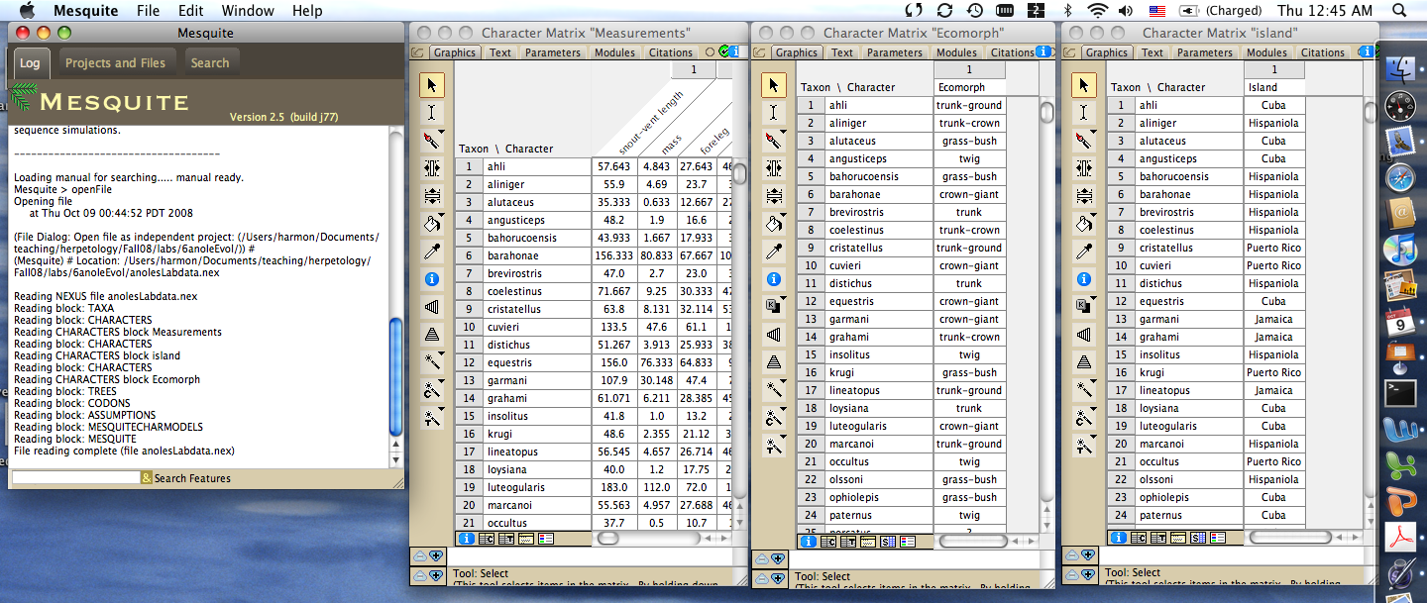
iii. Looking at the anole phylogenetic tree

- To view the anole tree, choose Taxa&Trees:New Tree Window. This will bring up a small dialog window.
- The window will ask for the source of your tree. Choose Stored trees and click OK.
- Look at this tree. It plots the phylogenetic relationships among 30 species of anoles

iv. Plotting islands on the tree

- First, you will plot islands on the tree. Each of these 30 species are endemic to one of the four islands in the Greater Antilles (summarized in the Character Matrix “island” window).
- Choose Analysis:Trace Character History. A dialog window will pop up.
- Choose Parsimony Ancestral States. This will reconstruct the history of island colonization that requires as few island dispersal events as possible.
- Choose island (Standard Categorical Data).
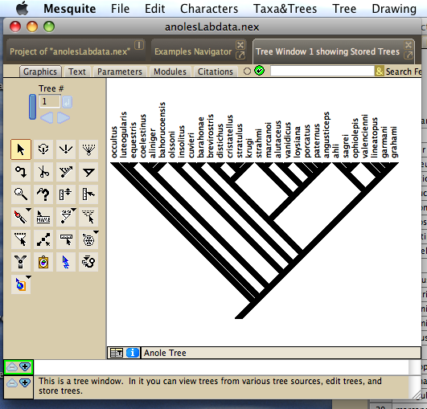
- You will see a reconstruction of the history of island colonization events in the history of these species of anoles. Colored branches represent statistical reconstructions of the location of ancestral lineages in this tree. Branches that have more than one color are ambiguous - that is, we’re not sure where these lineages were found.
- Now reconstruct the history of this character using maximum likelihood. Again, choose Analysis:Trace Character History, but this time select Likelihood Ancestral States. By default, Mesquite fits the Mk model to your data.
- To see the confidence in these reconstructions, choose Drawing...Tree Form...Balls & Sticks. This will show you proportional likelihoods for each character state at every node, as discussed in lecture. Click on any node to see these proportional likelihoods.
- Use this figure to answer the following question:

Discussion question 1:
- How many island dispersal events (changes in color) can you infer from these data?
- Are any of the island groups monophyletic? Were any islands colonized more than once?

v. Plotting ecomorphs on the tree

- Now you will plot ecomorphs on the tree. Each of these 30 species can be classified to one of the six possible ecomorphs (summarized in the Character Matrix “Ecomorph” window).
- As above, reconstruct the evolution of ecomorphs on the tree using both parsimony and ML.
- Use this figure to answer the following question:

Discussion question 2:
- How many changes in ecomorph can you infer from these data?
- Are any of the ecomorphs monophyletic? Which ecomorphs look like they have evolved more than once?

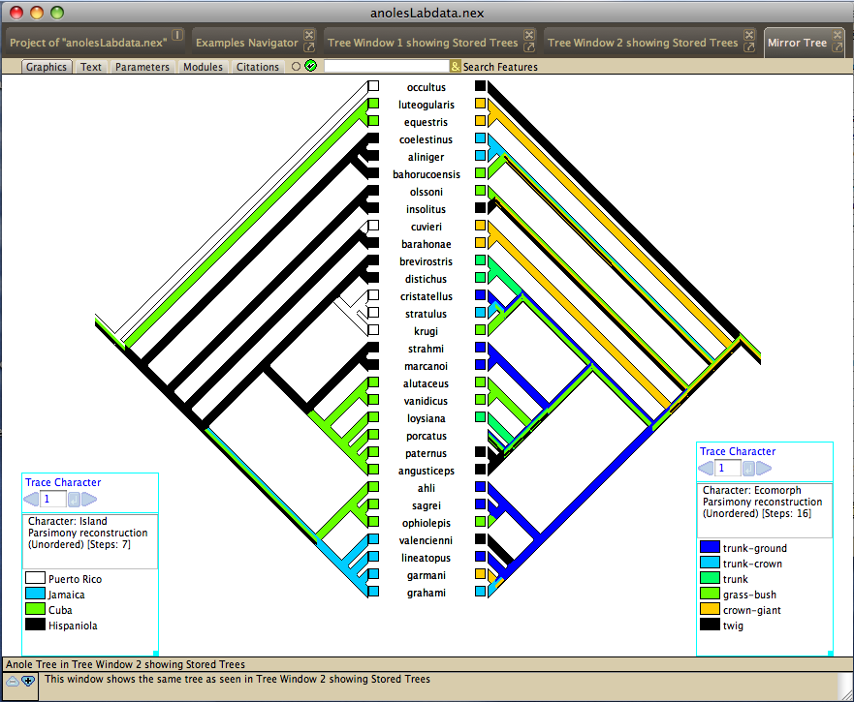vi. Comparing islands and ecomorphs

- To compare the patterns of island dispersal with those of ecomorph evolution, you will want to plot the two reconstructions you’ve just made side-by-side. To do this, follow these steps to make a mirror tree.
- You should make the tree window your active window. Then, choose Tree: Mirror Tree Window.
- You can now plot characters on these side-by-side trees. Choose Mirror: Left Side: Trace Character History. This will open a dialog window. Make the same choices you made above to reconstruct the history of island colonization on the tree on the left.
- Now choose Mirror: Right Side: Trace Character History. This will open a dialog window. Make the choices you made above to reconstruct the history of ecomorph evolution on the tree on the right.
- Compare the patterns of island and ecomorph to answer the questions below.

Discussion question 3
- According to this data set, are all the ecomorphs present on all of the islands? Which are missing?
- Look at the distribution of particular ecomorphs across islands on the tree. For example, focus on the trunk-ground ecomorph. How many times has it evolved? On how many islands? Do you see similar patterns for other ecomorphs?
- Are species that are the same ecomorph category on different islands typically close relatives?

vii. Ecomorphs and morphology

- For the next part of the lab, you will look at measurements for these ecomorphs. First, reconstruct the plot that you made for part v, plotting ecomorphs on the tree, above.
- Choose Drawing: Tree form: Plot tree. This will plot species in the tree against some morphological measurements. The first plot is snout-vent length (axis 1, the x-axis) against weight (axis 2, the y-axis).
- Use the small arrows to change the plot so that you can see axis 1 against axis 3 (Foreleg length). Notice than in all of these plots, the y-axis is reversed (down means the measurement is larger). I have no idea why this is the case.
- Try plotting other combinations of axes. You can look at the character matrix “Measurements” to see what each axis represents. Notice how the different colored dots (different ecomorphs) are arranged on the plot.
- Now reconstruct ancestral states for some of the continuous characters using parsimony (likelihood is not implemented). The procedure is similar to what you did above, but the result is different for continuous characters.
- Answer the last set of discussion questions.

Discussion question 4:
- Which ecomorph type has the largest body size? Which has the smallest?
- Which has the most lamellae overall? What about if you consider the relationship between lamellae and body size? Is there a relationship? Do some ecomorphs tend to have fewer (or more) lamellae than you would expect based on their body size?
- Do anoles represent a good example of convergent evolution? Why or why not?

