EAS 501

Energy and its impacts

Project 2

Title: G2.6. Critical review of atmospheric and ocean oxygen depletion

Team members:

Luke Johnson

[lukejohn@seas.upenn.edu](mailto:lukejohn@seas.upenn.edu)

Shankar Ramanathan

[nshank@seas.upenn.edu](mailto:nshank@seas.upenn.edu)

Submission Date

Monday December 11th, 2017

Critical review of atmospheric oxygen depletion

**Project Description:**

Background

Hydrocarbons (mostly fossil fuels and biomass) are converted to CO2 to generate energy, taking the oxygen from the ambient air, which leads to the reduction of the average concentration level of this vitally important substance even when the established contribution of photosynthetic organisms does not change. It is estimated that photosynthesis generates daily about 1.8×10^8 tons oxygen, yet the oxygen daily depletion just due to fossil fuel combustion, not including microorganism growth, is about 7.5×10^7 tons, similar order of magnitude. The huge use of fuels thus creates a huge depletion of oxygen, which is considered by some to pose a global environmental threat at least equal to that of greenhouse effect.

Procedure

Based on a thorough survey of related available literature, and your own analysis of the information, determine the rate of oxygen depletion and of its replenishment, this the net rate of oxygen depletion, associated environmental risks, and possible remedies. The study must be quantitative.

Extent of deliverables/objectives completed

The extent at which we have went to in order to carry out the procedure and analyze the background seems sufficiently adequate. We have done an extensive review of the literature, and used whatever resources available to come up with simple models for calculating the net rate of oxygen depletion. The approach taken with this report was to strongly focus on analyzing data for the major factors of this process, and to rely more on the literature review for the minor factors resulting in oxygen depletion/replenishment. The environmental risks and remedies have been explored in the background review and are re-emphasized in the conclusions and recommendations section.

Admittedly, not much resources were collected beyond an analysis of fossil fuels due to either a lack of raw data from supplementary information or due to low interest in this research field. It is noted, however, that oceanic oxygen depletion is a high impact and interesting field that has produced a lot more data. As a result, we feel the methods used to formulate the results were crude and based on tidbits of information collected from multiple sources.

Progress Report comments

You have included a lot of relevant information but:

1. Did not follow the suggested format and content of the progress report (it is to your advantage to read them all and follow them carefully), including the fact that you neither included the stated objectives, nor the work plan and division of work

1. Understood. Our goal was to focus on getting the project format correct, and forgot to pay attention to this detail of having a correct progress report format.

2. Among other things, you should have, as suggested, developed the project quantitative performance criteria that you are expected to evaluate,

1. Understood. We have accounted for this after completing the project.

3. The references are not AT ALL cited properly,

1. Corrected and cited properly, as we had planned to submit the final project correctly cited.

4. I didn't find your comments about the paper by Chirkov, that was stated in the project description to have originated my work on this topic.

1. Yes, this has been noticed and we have corrected for this loss of information in the background review.

5. Obviously, a detailed quantitative description of the relation between oxygen and plants would have been very useful

1. You will find that we have done an extensive review on plants and their effect on oxygen depletion.

**Abstract**

In this report, an exploration of the different facets that contribute to oxygen depletion is explored. From a literature review, it is discovered that atmospheric oxygen concentration is decreasing, according to experimental observations, and most recent studies from prehistoric oxygen captured in ice. A more urgent issue discovered is the rate at which the ocean is being deoxygenated. Using sustainability calculations, an attempt at determining what the overall rate of oxygen depletion in the atmosphere is carried out. The most important factors of this potential deoxygenation is explored: oxygen production from plants, oxygen consumption from fossil fuels, and oxygen dissolution from the ocean.

Quantitative analysis of oxygen lost to the atmosphere suggests that oxygen levels have fallen by 0.7 percent over the past 800,000 years. Scripps Global Oxygen Management research say that we lose 19 O2 molecules out of every 1 million O2 molecules in the atmosphere each year. We have also analyzed the other plausible reasons for atmospheric oxygen than fossil fuel burning like an undiscovered oxygen sink or rising erosion rates and also due to change in land use and agricultural plantations. An interesting account of how photosynthesis could have led to maintenance of the 20% present-day level of O2 has been discussed.

Using information based on chemical composition of popular fuels like coal, natural gas, and crude oil, we used theoretical models to determine the rate of oxygen depletion from burning such fossil fuels. Initially performing this calculation, it would seem that fossil fuel burning plays a considerable role in consuming oxygen on the planet, at an average rate of 4.5e10 kg/year in 2015, and is expected to increase annually by 4.7e8 kg/year, which is orders of magnitude greater than any other factors. Using data obtained from the literature, and using known information about the biosphere, an extrapolated calculation of what the total respiration and photosynthesis rate on the planet is performed. It is determined that animal respiration is not a considerable portion of oxygen depletion on the planet. Plant oxygen production in 2015 is calculated to be 2.45e16 kg/year, increasing at a rate of 6e14 kg/year, and animal oxygen consumption in 2015 is estimated to be 3e12 kg/year, and will increase annually at a rate of 9e8 kg/year

When considering overall balances, for ocean oxygen depletion, we only needed to consider the rate of oxygen leaving the ocean. To do this, we again reference work done in the literature that shows how deoxygenation is occurring and the rate at which it occurs. It is concluded that this is definitely due to rising ocean temperatures. With the rising ocean temperature in the past 50 years, we see that although ocean deoxygenation is increasing, this added to the atmosphere. However, this poses a major issue for the oceans of the world, which has gathered a lot of online interest and concern for this. Marine life, including both oxygen consumers and producers, are heavily affected by either the temperature changes or the oxygen concentration drop. Calculations lead us to a constant rate of ocean deoxygenation of 3e13 kg/years.

All these factors are then combined to come up with a form for the overall rate of oxygen depletion. Overall, based on crude and oversimplifying assumptions, a negative depletion rate is obtained of -1.11e16 kg/year, increasing at a rate of 3e14 kg/year, which goes against what the literature is portraying. Only assuming that the main fossil fuels contribute to oxygen depletion, not getting metabolic rates for individual species of plants and other photo-organisms, the rate of deforestation on the planet, the rate of increase of the biosphere, and no spatial differences between concentration in the oceans, lead to the potentially incorrect trend for oxygen depletion. Even without the correct trend, we can make strong conclusions, in that at the rate that the above ground plant biosphere is growing, above ground oxygen concentrations will be safe for next few centuries ahead of the current population. Again, it is stressed that ocean oxygen depletion is the biggest issue pressing the environmental concern with the diatomic molecule. Mankind should aim to maintain, or increase, the amount of oxygen that our oceans maintain, and if not, will pose direct consequences for both the life that lives in and depends on the ocean, and hence, indirectly, all species on the planet.

**Introduction**

In today’s society, the dependency on energy has made it a necessity in modern cultures around the world. Typically, energy, used in mechanical, electrical, and thermal forms, allows for systems to perform some work or useful output for our daily needs. This energy is typically created via combustion of fossil fuels. These fuels stoichiometrically react with Oxygen, an oxidizing agent which allows for the thermal decomposition of these hydrocarbons into simpler molecules: CO2 and H2O. CO2 is a greenhouse gas that is accounting for the rapid increase in atmospheric CO2 concentration, from mankind’s over-excessive use of fossil fuels, and the rising global temperature which has resulting in global warming. Although the implications of CO2 increase has been preached by the world’s leading scientists, and is now a respected fact among the scientific community, there is still another issue that comes out of burning gases. Oxygen is consumed in this combustion reaction, and with the increase in demand for the world’s energy due to modernization and population growth, a question to ask is: is mankind using oxygen faster than it is produced from other natural/manmade processes?

Besides O2 consumption from burning fuels, a consideration of how living organisms (humans in particular), ocean sequestration (or lack thereof), and other chemical processes affect the oxygen cycle. A consideration of how plants and other processes that add O2 to the atmosphere is studied. All of these factors are to be cumulated into a rate of how Oxygen in the atmosphere changes over time. With a yearly trend of this outcome, we can provide conclusions and feasible recommendations based on what is needed to keep Earth at a sustainable and vital amount of ambient Oxygen. An analysis of how oceanic oxygen is tied into the atmospheric oxygen content is provided as well.

**Background review**

It is initially proposed that Oxygen wasn’t one of the abundant molecular species in the air for the first half of the Earth’s history. The oxygen content measured in modern days are a result of both phytoplankton photosynthesis in sedimentary rock (as well as subsequent decomposition) and the escape of the primary abundant gaseous species: hydrogen 3. Due to the abundance of Oxygen in the atmosphere, scientists have not been concerned about the issues that may result from this change due to fossil fuel usage. Carbon Dioxide concentration doubling in the atmosphere since the pre-industrial era have brought about much more pressing issues that need to be dealt with in a timely manner, due to its characterization as a greenhouse gas that largely contributes to greenhouse effect and hence, global warming 1.

Scientists have been able to obtain an idea of how oxygen concentration has changed over the past million years by measuring oxygen content trapped in ice. The figure below shows that there may not be much to worry about in regards to the gentle oxygen concentration changes. These changes, however, most likely result from the processes that mandate the partial pressure of atmospheric oxygen, mainly weathering fluxes and prehistoric erosion 58.

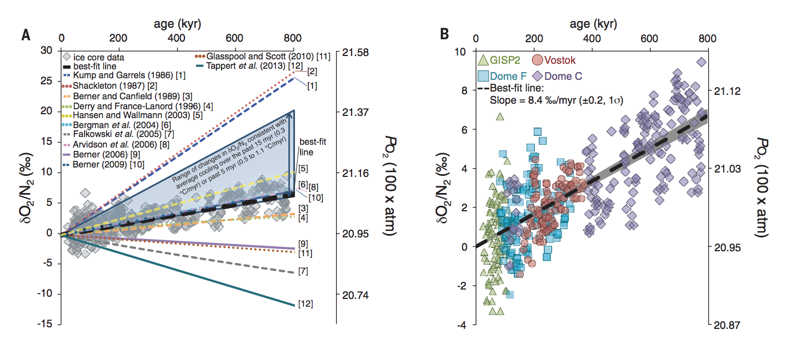

**Figure 1** - Prehistoric O2/N2 levels versus age of the Earth 58

The Scripts O2 program at UCSD has shown that the main contributions of oxygen depletion are from fossil fuel usages and oceanic diffusion, which is then used by CO2 producing organisms. It is important to look at the sources of atmospheric oxygen and if this factor is being affected from other global changes 10, 52. Two-thirds of atmospheric oxygen is produced by phytoplankton. Additionally, due to the increasing global temperature, there is less mixing of atmospheric oxygen into oceans, which result in variation in oceanic oxygen concentrations 5. Scientists at the University of Leicester propose that oceanic microbial photosynthesis may be severely affected by global warming of oceans by just 6 degrees C, which could cause a decrease in oxygen produced and cause mortality on a great scale 19. Although Oxygen can vary by altitude of measurement, a standard for this study will assume well mixed and spatially invariant oxygen concentration in the atmosphere at any level. Figure 2 below shows the trend of O2/N2 ratio in the atmosphere at the La Jolia Station in California. Although in small time scales there are oscillations in the concentration, there is a long term decline in the O2/N2 ratio, showing the increase in rate of oxygen depletion.

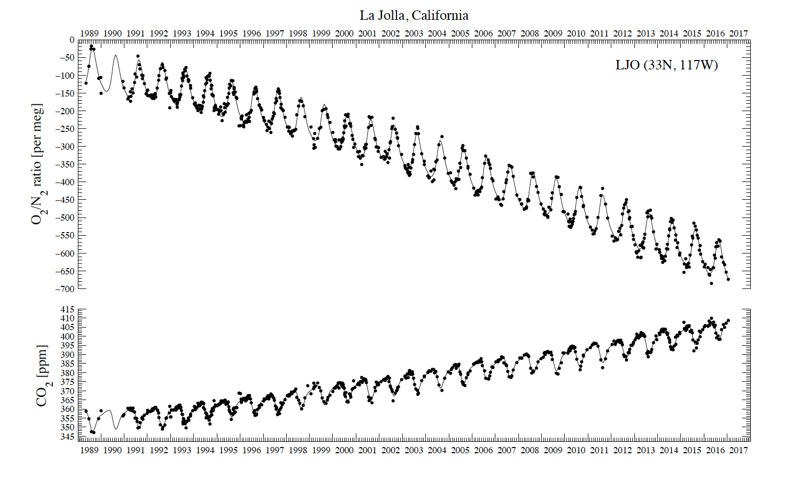

**Figure 2** - Measurement of O2/N2 versus year measured at the La Jolla station in California 17

It has been shown that not only is oxygen levels decreasing, but that this rate is increasing, and thus the depletion is accelerating. It is estimated that under the influence of global warming, the ocean oxygen levels are predicted to drop to 7% over the next 100 years, which poses a danger for marine life 22. It is estimated that this decline will continue for the next 1000 years. With a 1900% increase in oxygen depletion due to the industrial era, it is of interest to see how such drastic changes affect the environment we live in and sustainability for all 21. Not only is life endangered in this natural disturbance, but so is the motion of the elements on the planet. Oxygen reduction leads to a slowing down of aerial circulation around the planet that gives a refresh in nutrients, gases, rainfall, temperature, and the weather in general. Noting that weather is extremely fragile to miniscule changes in its system, accelerated oxygen depletion can result in extreme variation of the order of natural processes relative to other effects. Again, this can be harmful for phytoplankton responsible for water splitting to reproduce atmospheric oxygen 23. Figure 3 below shows how ocean oxygen levels have fluctuated over the past 60 years.

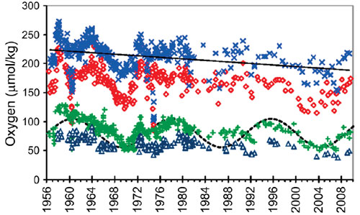

**Figure 3** - Trend of oxygen concentration versus year measured in the Pacific Ocean 61

Another factor in decreased atmospheric oxygen can be absorption of oxygen into water at colder tropic zones, and that rises that can sometimes be measured with ocean oxygen concentration arise from fluctuations due to ocean currents. It is estimated that 3 oxygen molecules are consumed for every Carbon Dioxide molecule produced from the burning of fossil fuels 21. The main factor that is causing both oceanic and atmospheric oxygen reduction is undoubtedly climate change and the warming of the oceans. A typical mechanism of the transport of oxygen can be seen below in Figure 4. O2 can be produced from plants and other photosynthesizing organisms. Fossil fuels and animal respiration mainly account for the consumption of O2. O2 can either be absorbed or released from the ocean. Most atmospheric oxygen was produced from oceanic microorganisms. This is limited by how much Carbon dioxide is then consumed by these same organisms. Carbon dioxide is also converted to the carbonate ion form while dissolved in the world’s oceans 18.

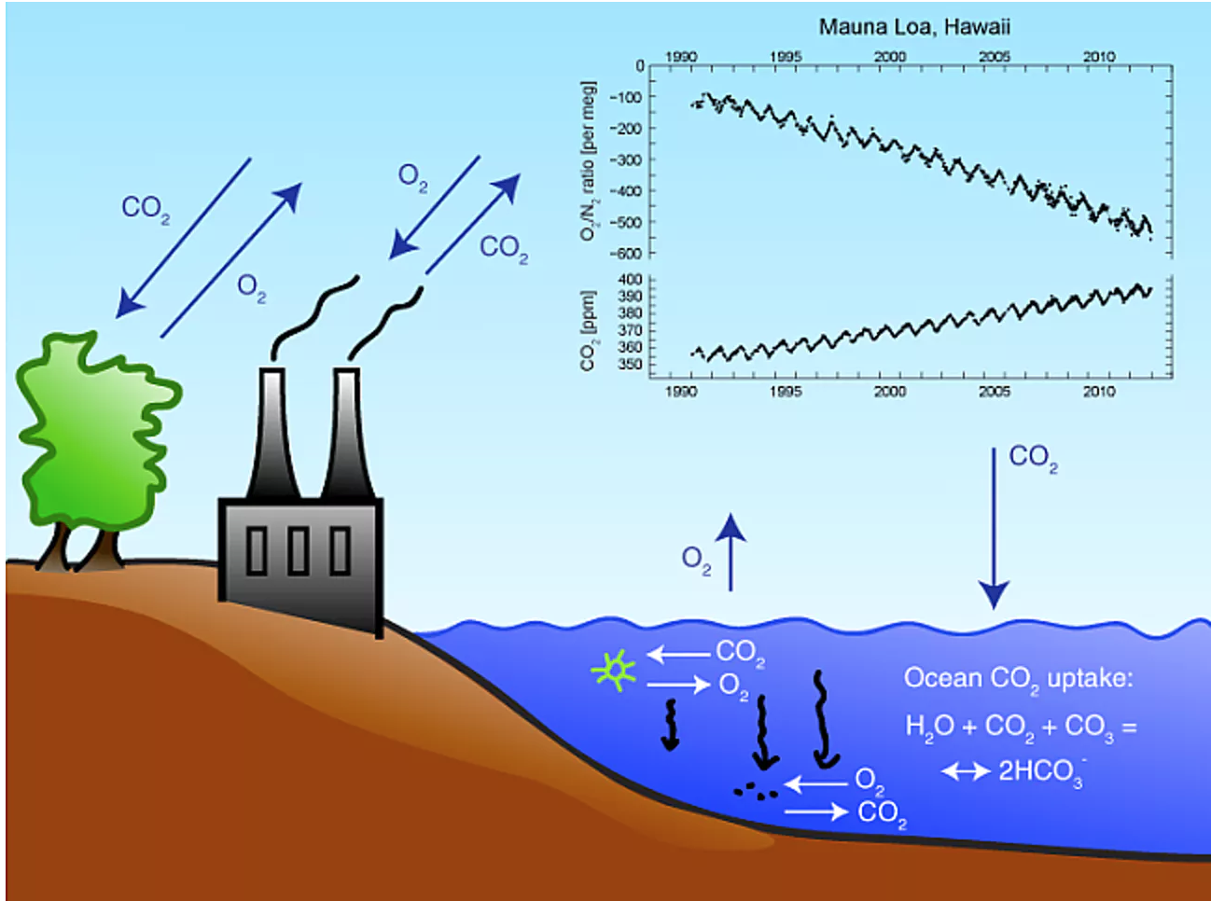

**Figure 4** - Mechanism of major contributions to oxygen depletion/replenishment, with Figure 2 18

While no danger exists that our O2 reserve will be depleted, nevertheless the O2 content of our atmosphere is slowly declining - so slowly that a sufficiently accurate technique to measure this change wasn't developed until the late 1980s. [Ralph Keeling](http://earth.agu.org/revgeophys/keelin01/keelin01.html), its developer, showed that between 1989 and 1994 the O2 content of the atmosphere decreased at an average annual rate of 2 parts per million. Considering that the atmosphere contains 210,000 parts per million, one can see why this measurement proved so difficult 10.

This drop was not unexpected, for the combustion of fossil fuels destroys O2. For each 100 atoms of fossil-fuel carbon burned, about 140 molecules of O2 are consumed. The surprise came when Keeling's measurements showed that the rate of decline of O2 was only about two-thirds of that attributable to fossil-fuel combustion during this period. Only one explanation can be given for this observation: Losses of biomass through deforestation must have been outweighed by a fattening of biomass elsewhere, termed global "greening" by geochemists. Although the details as to just how and where remain obscure, the buildup of extra CO2 in our atmosphere and of extra fixed nitrogen in our soils probably allows plants to grow a bit faster than before, leading to a greater storage of carbon in tree wood and soil humus. For each atom of extra carbon stored in this way, roughly one molecule of extra oxygen accumulates in the atmosphere.

Many reasons might be given for swings in the atmosphere's O2 content. One in particular stands out. As life evolved, the makeup of the food web responsible for the degradation of the organic matter manufactured by plants has changed. A startling example of such a change is found at the geologic boundary separating the [Paleozoic](http://www.ucmp.berkeley.edu/paleozoic/paleozoic.html) and [Mesozoic](http://www.ucmp.berkeley.edu/mesozoic/mesozoic.html) periods. At this point in planetary history, life experienced a terrible catastrophe. Ninety percent of species living in the ocean and 70 percent of those on land suddenly died out, never to reappear. This loss must have totally disrupted the finely tuned food web that had developed over the 300-million-year-long Paleozoic period. Suddenly most of the key players were gone. Replacements surely stepped in on short notice, but their scheme for dividing up the food supply must surely have been different and at least initially less efficient. Indeed, this is what the isotopes of carbon and sulfur tell us. Before the extinction event, the reduced material accumulating in sediments was dominated by carbon; afterward, iron sulfide shared a far greater part of the pie. It would be surprising if a major police action by the atmosphere's O2 was not required in order to re-establish a smooth flow of electrons through the ocean-atmosphere system.

Perhaps the most amazing thing about our planet is that we have any O2 at all. The cloud of gas and dust from which our solar system formed was dominated by hydrogen gas. As hydrogen atoms eagerly donate electrons to any element capable of latching onto them, our Earth was constructed from highly reduced (electron-rich) material. Except at its very surface, it remains so. Were our atmosphere, ocean, and soils stirred back into the Earth's interior, our O2 would be totally annihilated. Just how O2 came into being remains a mystery. The most likely explanation is that water molecules that wandered to the outer edges of the atmosphere were knocked apart by ultraviolet rays from the Sun. The light hydrogen atoms were able to evaporate to space, while the much heavier oxygen atoms were bound to Earth by gravity and mated with the reduced sulfur and carbon exposed at the Earth's surface. Only when this conversion had been completed could O2 begin to accumulate in our atmosphere. Records kept in sediments tell us this task took at least 2.5 billion years (more than half of geologic time). The evolution of multicellular organisms, and hence of our ancestors, awaited this transition from an O2-free to an O2-bearing atmosphere

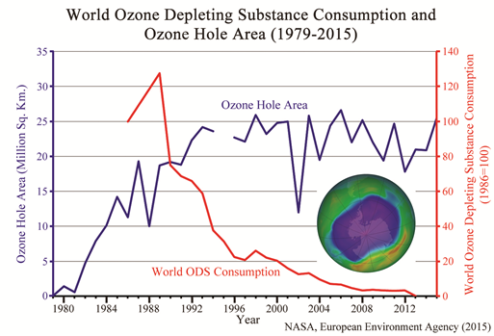

**Figure 5** - Change of ozone hole size over the past 30 years

To provide quantitative results, since 2015, we know there are 2.3e12 tons of CO2 in the atmosphere, which has led to the effects mentioned before. The oil equivalent in fossil fuels is 2e7 tons a day, which comes to an annual global fuel requirement of 7.3*10^9 tons! The chemical equations below can be analyzed and used to perform a mass balance to determine how much oxygen is being depleted from the atmosphere. Work completed by Chirkov et al stresses the importance of curving our dependence on burning this nonrenewable source, if current reliance on fossil fuels continue. His calculations lead to an oxygen consumption rate due to fossil fuels of 7.5e7 tons annually. Additionally, it is estimated that oxygen generation of 1.8e8 tons daily, which, although of the same order of magnitude as fossil fuel oxygen consumption, still is much greater than the rate oxygen is being removed from the atmosphere. However, this is an issue that shouldn’t be ignored; a rapid increase of reliance on nonrenewable fuels could change the way the current oxygen dynamics work 48. The chemical reactions provided below from Chirkov et al show how oxygen is reduced due to a combination of reactions that humans use ambient air for:

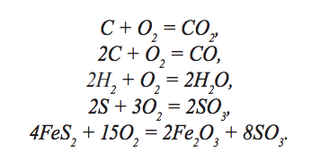

**Equations** (1, 2, 3, 4, and 5) 48

The method used to calculate oxygen depletion involves first determine how much oxygen is consumed per mass of products formed. Once that is done. A relationship between the mass of oxygen consumed and the energy needed is quickly calculated. The oxygen depletion is then computed by using the specific weight, the relationship mentioned before, and the amount of fuel consumed within a specific time interval. The table below shows atomic percentages of O C, H, and S, and their contribution to the atmospheric oxygen consumption. Annual Oxygen consumption due to fuel usage is estimated to be at 7.5e7 tons. With this framework in mind, we develop a strategy to compute a trend of oxygen consumption relative to oxygen production using the models from this study. There have also been solutions provided to oxygen depletion, where algae agriculture/introduction can be used to consume CO2 while synthesizing O2, hence solving two problems in one step 48.

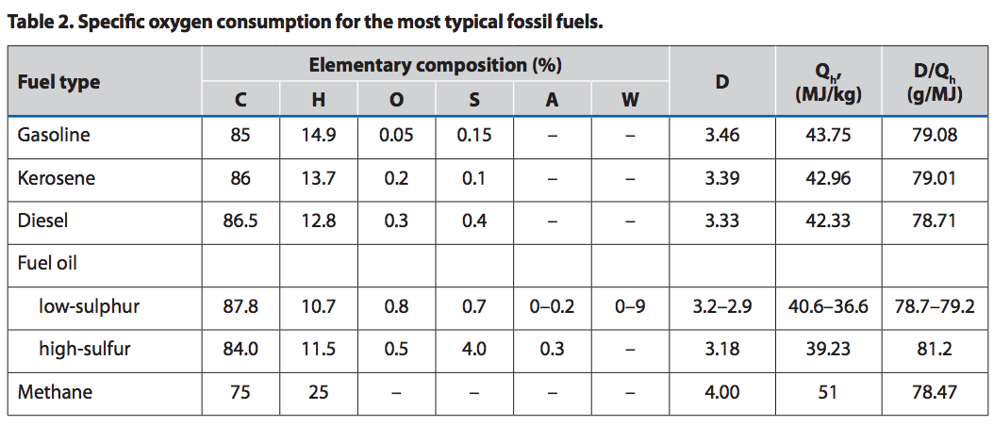

**Figure 6** - Table of compositions of hydrocarbons in relation to mass of oxygen consumption 48

This report from Chirkov does conclude with strong recommendations and suggestions. These suggestions all come from the use of constructing plants that work on photosynthetic microalgae to enhance both the rate at which oxygen is being produced on the planet, and to reduce the population’s dependence on traditional fuels that require an oxygen input. Additionally, these organisms reproduce at a faster rate than trees and other traditional biofuels, and could solve once complication in using biofuels which is deforestation and a balance of what is being used as resource and what remains to sustain the biosphere of a particular area. Such a model could be sustainable by a cyclic process in which CO2 produced from burning is then consumed by these algae farms. What is also interesting is the effect of decaying organisms in warmer climates that require huge amounts of oxygen in order to carry out decomposition, which can essentially call for a considerable amount of oxygen consumption to that of most land animals combined.

**Scope/description of the research**

Our goal in this report is to calculate the rate of oxygen depletion. In order to do this, based on the literature review, 3 main components are considered to come up with an overall rate: natural processes, fossil fuel burning, and ocean deoxygenation. Other minor factors are reviewed and analyzed in the sections below. The eventual goal is to show, as a function of time, how the Earth’s oxygen concentration is changing, and how the rate itself is changing, whether it be accelerating or decelerating. Data was obtained from the Scripps O2 program at UCSD 10 which allowed for a basis set of determining how the Oxygen concentration was changing as a function of time. For fossil fuel production, two main sources were used: Our World in Data 28 was used to extract data for fossil fuel usage as a function of the year, and The World Bank 29, 30 was used to extract data for energy capita, and the world population as a function of the year.

For plant and animal information, we turn to using crude approximations of the functions needed to project trends of oxygen production or consumption of a living organism as a function of its mass. Data for these trends were provided from Protero et al 59 and Nowak et al 38 , respectively. Finally, data from Falkowski et al 61 was used to calculate how ocean oxygen concentration linearly varies by year, this data, coupled with the amount of water in the oceans, was used to calculate both the volume of water in the oceans and the varying amount of oxygen in them, assuming that the volume of oceans are constantly at a fixed density.

**Method of the research**

Establishing how oxygen affects the atmosphere, and a trend of how oceanic oxygen concentrations are changing, the next step is to set up a method for calculating a yearly rate of atmospheric oxygen change, be it on a concentration or count based. To capture this we need to know what causes a positive change in oxygen concentration by reactive production or physical release, and what causes a negative change in oxygen consumption by reactive consumption of physical capture. The leading causes of positive changes are plant and phytoplankton respiration, oceanic release, and other miscellaneous chemical processes. The leading causes of negative changes are organism aerobic respiration, chemical combustion, oceanic absorption, and other miscellaneous chemical processes.

Quantifying and quantizing these variables are crucial to present accurate and predictive trends of oxygen changes over the next few years. To perform this, we acknowledge that there are several major factors in the change of oxygen in the atmosphere: oxygen consumption due to the burning of fossil fuels, oxygen production from photosynthesis, and oxygen diffusion out of warming oceans. For fossil fuels, we use the model provided from Chirkov et al to perform a detailed chemical balance of the amount of fossil fuels being used for burning to calculate how much oxygen is consumed as a result. For plants and animals, an analysis of the biosphere is necessarily. It is desired to calculate the plant and animal biosphere, and use some generalized specific respiration or photosynthesis rate, and with the mass of the biosphere, to determine the oxygen consumption/production rate for living organisms.

The third factor, that being of oxygen diffusion, was computed by using the work of Falkowski et al 61 to estimate what the rate of ocean oxygen depletion was, based on the volume of the ocean, and a set invariable density. All of this information will then be combined to compute the net oxygen depletion on Earth. Even with such a brute force method to determine this rate, we can deliver strong qualitative and quantitative conclusions that give insight on how mankind can proceed with tackling the implications shown from the separate analysis of these equally important factors of oxygen change in the atmosphere.

**Results and Discussion/Validation of Results**

The data obtained for oxygen concentrations around the world have been collected from the Scripps O2 program. Additionally, we can obtain the usage of fuels and from there, compute the rate of oxygen consumption. An estimate of phytoplankton oxygen production can also be included in the calculation for annual oxygen depletion. For clarity, the results will be broken up in separate forms of analysis, serving a purpose to eventually tie in major contributions of oxygen consumption into an overall analysis of the study. Another approach will be taken, where the oxygen content is analyzed based on the amount of air in the atmosphere and the average concentration measured from one of the Scripps stations. Finally, considerations, assumptions, and recommendations are provided.

**Case study: Oxygen depletion due to fossil fuels/nonrenewable sources of energy**

Since most countries provide data on fuel usages starting in 1970, the focus of the study will be placed there. It is of interest to determine how much of each fuel is consumed, and direct relate this to energy consumption. As stated before, different forms of fossil fuels require different amounts of oxygen for either complete or incomplete combustion. It will be assumed that complete combustion happens. Using the formulas provided by Chirkov et al 48, this calculation is performed. To tackle this question, we must consider which countries contribute greatly to the issue of oxygen depletion; this problem is most likely heavily related to countries that contribute to global carbon dioxide emissions. The world has in general learned to depend on other sources of energy in the past 50 years. Figure 7 below is a trend of the percentage of energy due to burning fossil fuels. It can be seen that the percentage has greatly increased, as is expected with the advancement of technology and an overall conscious effort towards handing CO2 emissions. Despite a decrease since 1970, the decline has been steep, and as shown before, oxygen depletion continues to thrive. This graph does not necessarily portray that humans have depended less on burning fossil fuels 30.

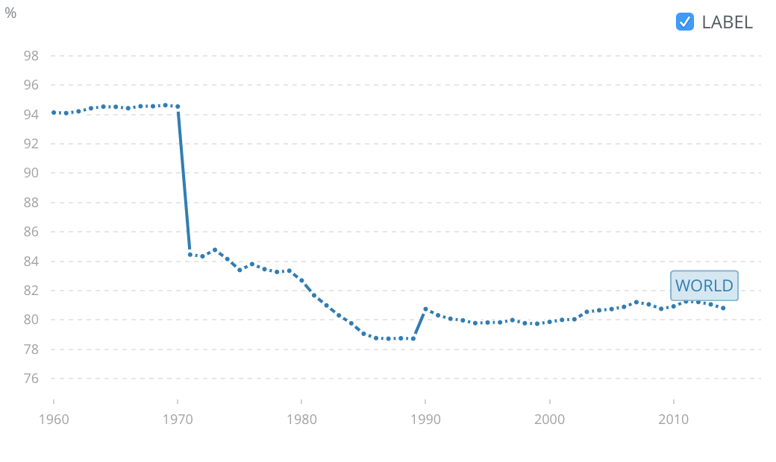

**Figure 7** - World percentage of fossil fuel in energy usage from 1960 to 2015 30

How many countries still heavily rely on fossil fuels? To answer this, we look at the fossil fuel percentage of total fossil fuel production in the countries around the world. Figure 8 below shows how countries have either shifted towards a larger or smaller use of specific sources of fossil fuels for a primary energy source. Coming from the dominantly used coal to using more combined crude oil and natural gas, it can be assume that most of the oxygen depletion due to fossil fuels are due to these newer, relatively more abundant sources of energy 28. The data from Our World in Data will be used to project how oxygen concentration has changed over the past two millennia.

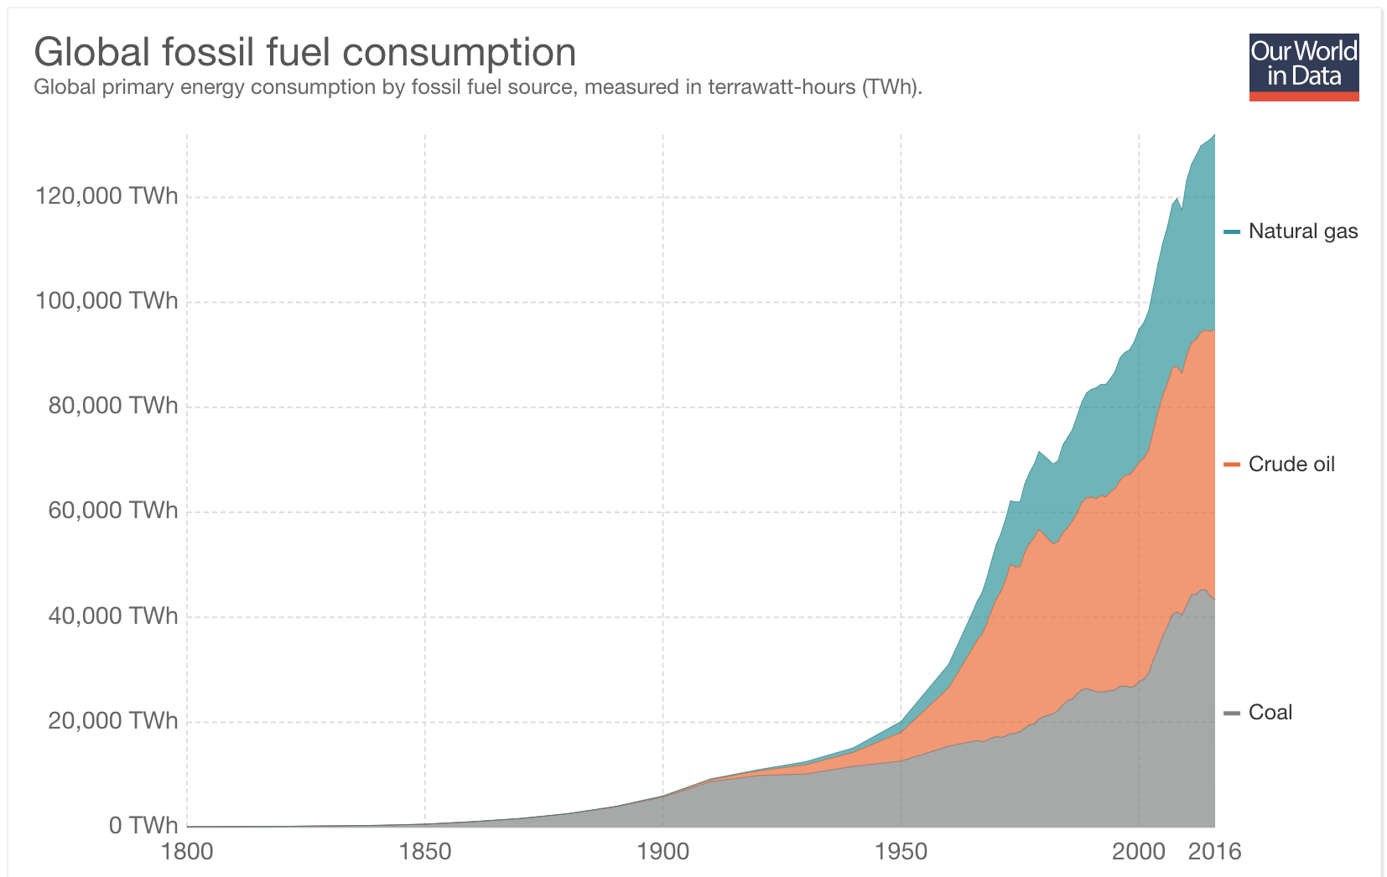

**Figure 8** - Global trend of fossil fuel in energy usage from 1800 to 2016 28

Before an analysis of the fossils are performed, one more question to ask is: which country is the cause of the rapid increase in depletion? This can be done by plotting all major fuel consuming countries against each other, to see how it has preceded versus time, and if countries have become aware of this trend and tried to combat it. Figure 9 below shows this trend for the energy usage, which is total energy per capita, for the following countries that are big players in fossil fuel burning: Qatar, Iceland, Trinidad, Curaco, Bahrain, Kuwait, Canada, UAE, USA, Saudi Arabia, Singapore, South Korea, and a few others to list. The 20 countries with the largest capita energy usage were studied. Except for Curaco, most countries consuming large amounts of per person energy have almost doubled in the last 50 years, meaning that with population increase on a global scale, per person energy consumption and thus energy consumption is increasing, which may provide similar implications for oxygen consumption.

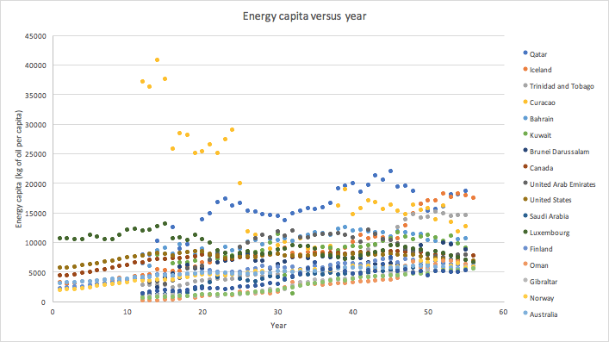

**Figure 9** - Trend of fossil fuel usage per capita for 20 countries from 1960 to 2016. Data obtained from combining 29, 30

Our world in data has provided energy usage based on fuel sources in energy units of TWh. Using a simple unit conversion, we can convert back to the amount of mass of each of these sources, and then apply the algorithm to get to the amount of oxygen consumed from the consumption process. This process is straightforward: if the specific energy of these fuels are known, then we can compute its mass. Doing this, we now use the method proposed by Chirkov et al 48 , but first it would be wise to determine the composition of both natural gas and crude oil. Figure 10A below shows the calculated oxygen consumption per year due to fossil fuels. As stated earlier, coal was one of the first fuels used, and its use has skyrocketed, particularly in developing countries. Most countries still rely heavily on coal, and this is reflected in its major contribution to oxygen depletion due to fossil fuels. It can only be consumed that if other sources of fuels are not seriously considered and implemented, then the current trend will only continue for the next 100 years. Such a trend will be portrayed further in this paper.

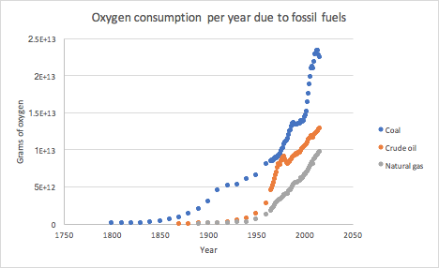

**Figure 10A** - Oxygen consumption as a function of time due to different fossil fuels

We also note that the contribution that fossil fuel burning adds to the oxygen depletion effect is quite significant. To complete this case study, all fossil fuel types are added to show the total effect of oxygen depletion due to fossil fuels. Figure 10B shows this trend, which is an upward oscillating trend. Using polynomial regression analysis in Excel, it was found that this function fits well to higher order polynomials like 5th and 6th order, with an R2 value of 0.993. If anything, one of the most remarkable aspects of this paper is the accuracy (relative to atomic and species balance), and of the pattern of which we can possibly predict how mankind, assuming not drastic changes in energy source used, will continue to contribute to oxygen depletion as a result of burning fossil fuels. Now that we have shown how man made processes have directly affected oxygen depletion, a look at how humans have indirectly caused oxygen depletion is explored.

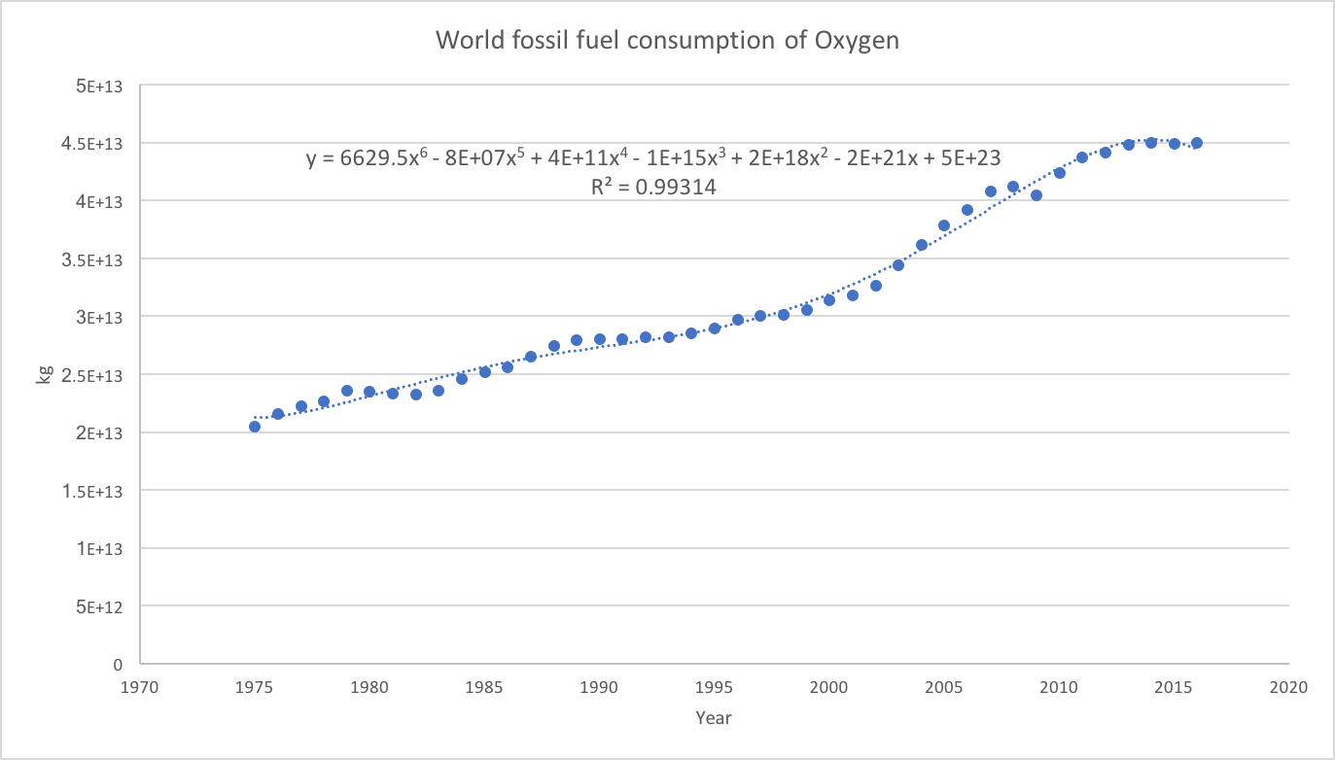

**Figure 10B** - Oxygen consumption as a function of time due to fossil fuel burning

**Case study: Quantitative analysis of land Natural Processes and overall atmospheric oxygen change**

What balances occur between natural respiration and production of oxygen? Humans, vertebrates, and most invertebrates, for example, consume oxygen to produce CO2 and H2O. Plants, algae, and microbes that are above ground consume CO2 to form complex carbohydrates and oxygen. In addition to this, other significant processes that consume/produce oxygen are considered as a contribution to oxygen concentration change due to natural processes.

First, an outline of what the natural oxygen changers are is appropriate. Figure below shows the oxygen cycle, which will be the starting foundation of our analysis. An important point to note is that this analysis is only for how direct oxygen is manipulated on an annual basis. There are two sub cycles that manipulate oxygen: The respiration-photosynthesis cycle, and the assimilated biomass cycle. Since both the burial of organic material and the small transfer due to degradation and fertilization is coupled to the total change of atmospheric oxygen, the overall balance of oxygen only depends on the respiration-photosynthesis cycle. Note that aerobic bacteria that cause this degradation and require oxygen for fuel will be included in the above ocean biosphere 33.

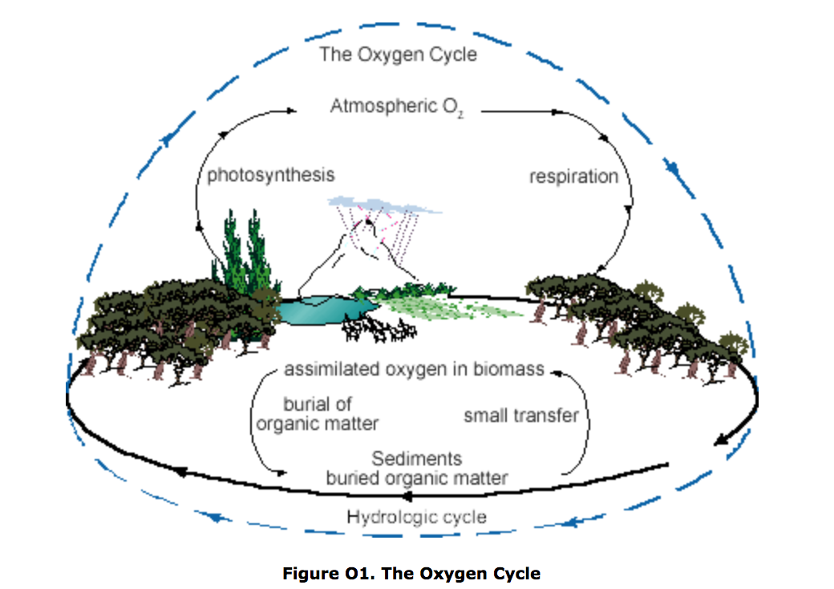

**Figure 11** - The Oxygen Cycle 33

As stated above, oxygen produced from plants is then respired by land vertebrates and invertebrates. From here, we separate the biosphere, which is the main contributor of oxygen change, into factions based on their rate of oxygen consumption and production. If the total weight of animals and plants can be quantified, and a correlation between weight and oxygen consumption is established, then we can determine how plants and over ground animals affect the oxygen concentration. What’s interesting to note is that an analysis of this sort will be slightly more complicated for oceanic oxygen changes, since many more significant chemical processes involve oxygen.

First, data regarding the number and weight of groups, families, or species of particular organisms is explored. The amount of total plant and animal biomass for a specific year can be calculated, and from that we can perform a sample calculation of what the total oxygen consumption is from trends of how the mass of an organism determines how much oxygen it either consumes or produces. It is known that land plant biomass is approximately 1000 times that of animal biomass 47. Using algebra, and knowing that the total land biomass is equal to 1841 Pg (petagrams), we can calculate how much plant and animal biomass there is. Then, we can extrapolate data from the observation of land mammals and how oxygen consumption rate increases on either a standard or log-log plot to calculate what the total oxygen consumption rate of animals are for a given year. The same calculation is performed for land plants of any given year. Predicting trends from a data point can be done by determining how the biomass is changing on average each year, resulting in a change of the oxygen depletion/accumulation.

There is an established power law relationship for the oxygen consumption as a function of land animal size (primarily mammals). This relationship turns useful for approximating based on the total land animal biomass, how much oxygen is consumed by animals on a yearly basis 41, 59. Based on animal biomass data collected in 1975, 2000 million tons of the biosphere consists of oxygen breathing organisms, and 2,000,000 million tons of total land biomass belong to plants. This value was calculated from knowing that the ratio of plant to animal biomass is approximately 1000. The data from the power law was focused on the larger weight side to obtain a linear relationship of the weight to better approximate the amount of oxygen that a collective mass would consume. It is noted that this is a crude approximation, as oxygen consumption and metabolic rates vary drastically between families and groups in the animal kingdom, however, most of this data is inaccessible through literature search and requires brute simplification of the models used. It is calculated that based on the land animal total weight, they collectively consume 1.05e16 mL. However, to compare to plant oxygen production, this value is converted to moles by dividing the volume by the set RTP basis, that is 24 L/mol. Then, oxygen has a MW of 32 g/mol. Finally, the mass is converted to weight by using Newton’s Law, where mass and force are related to each other by Earth’s gravitational constant. Overall, from the year 1975, the land animal’s oxygen consumption rate is 3.19e12 lbs.

Proceeding to analyzing land plant data, since there is no established relationship between plant size and oxygen production rate, we assume that there is a specific oxygen production rate regardless if the plant is a tree or an oxygen producing microbe living above water. Using the data from both Nowak et al 38, we can calculate the weight of the plant based on a quadratic fit relation between the dhb (diameter measured at the base of the tree) and the weight of a tree in tons. The oxygen production rate based on the diameter of trees in Minneapolis, Minnesota is provided and this data coupled with the weight-dhb relationship is used to calculate the relationship between weight and average rate of oxygen production of trees. It is calculated that in 1975, the total plant oxygen production over land was equal to 3.05e13 lbs. What’s interesting to note is that this value only varies by an order of magnitude from the oxygen produced by plants. Looking at it from a specific oxygen consumption/production rate, animals use oxygen for dynamic tasks, which would require more oxygen to produce more energy than plants relative to a standard weight.

Determining what the standard balance is between the two main processes that consume and produce oxygen, we would like to conceptualize a way to develop a trend of how oxygen changes due to natural processes occur. If the metabolic, and hence, oxygen consumption per weight of plants or animals remain the same, then we can contribute the changes in oxygen in the atmosphere to the rate of growth in the above ground biosphere.

For animals, due to a severe lack of data measuring how the biosphere changes, a very crude assumption will be made: animal biosphere has, in general, increased at the same rate as that of humans, since besides humans, the population of largely contributing biosphere species like cattle and other smaller animals would most likely increase as a result of our influence on the planet. This growth would call for humans to introduce new technologies to support a an increasing population. Therefore, this mass will then be superimposed into a function that similarly predicts human population growth. Intuitively, that means that the overall trend of oxygen trend amongst animals would also be increasing linearly, as is shown below in Figure 12.

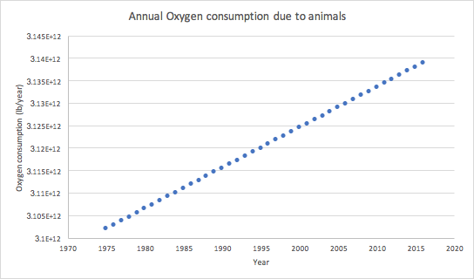

**Figure 12** - Linear increase of oxygen consumption in animals vs year

In an effort to derive a trend for how the plant biosphere is increasing as a function of time, we turn to knowing that plant matter oxygen production increases at a linear rate as well. The biomass of terrestrial bodies is increasing at a rate of 56.4 billion tons of C per year 47. This means that if we keep the specific oxygen production the same, this can be related to how steep or gentle the rate of plant oxygen production is changing. Overall, the oxygen that is being fed into the atmosphere due to plants is several orders of magnitude greater than what animals remove from it. It is predicted that the rate of oxygen production due to plants increases by a factor of 100 lbs. every year due to the vast increase of plant biomass. Figure 13 below validates this analysis, which is shown, as stated before, to be linearly dependent on the year.

To conclude this section, we plot both consumption and production as positive and negative oxygen depletion rates for animals and plants respectively. If we are just comparing natural processes that are above ground, then it is clear that with making assumptions that provide the maximum rate of these oxygen reactions, then plants heavily overcompensate what animals may consume for their respiratory processes. Plants may not on a specific level, need more oxygen than animal cells, but they reproduce at a rate that is increasing exponentially larger than oxygen consuming organisms. This means a focus on another process that may be causing a decrease in concentration may be appropriate. A separate analysis of the oceansphere will be completed in the next section of the results.

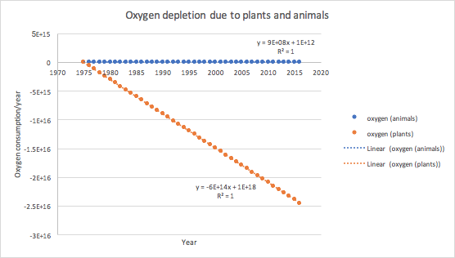

**Figure 13** - Linear increase of oxygen production in plants vs year, along with animal oxygen consumption for relevance

**Case study: Quantitative analysis of under ocean Natural Processes and overall atmospheric oxygen change**

To understand how the ocean affects the oxygen, there is only one descriptor that gives us all the information needed to include in this report: the rate at which oxygen dissolves out of all major ocean bodies. It is mentioned earlier that it is understood that ocean oxygen levels are decreasing due to an increase in water body temperatures and a change in the environment for processes that either consume or produce oxygen. It is already known that marine organisms like fish, marine vertebrates, and invertebrates consume ocean oxygen for respiratory purposes. Additionally, phytoplankton accounts for most of the oxygen production that may escape the oceansphere. Temperature is another factor that determines how much oxygen leaves the oceans. Are these main factors significant enough to change dissolved oxygen concentrations?

A total analysis in this section will give in detail what the significance of oxygen release from the ocean contributes to atmospheric oxygen depletion. Also, as a reminder, we have not considered the effect of burning fossil fuels, which is hypothesized to being the major contributor to oxygen depletion. Oxygen depletion in the ocean has become an environmental concern, and while the objective of this project is to determine what the oxygen depletion rate is in the atmosphere, we proceed noting that such effects on the ocean are detrimental to the environment.

From literature review, an idea of how oxygen dissolution from oceans has changed over the past 50-100 years can be portrayed in our discussion as well. What is indisputably true is the effect that rising sea temperatures have on oxygen diffusion out of the ocean. As a result, we can potentially observe how temperature rise has affected trends of oxygen release. Referring back to Figure 3 in the background review, the paper responsible for this article notes that this linearly decreasing and oscillating trend results from either natural processes or deoxygenation, which shows that the rate that oxygen is being released into the atmosphere is increasing because of such an effect. To effectively use this trend, we must determine what the oxygen release from the oceans were at a specific time point on the graph, and relate this to the oxygen depletion that is occurring in the atmosphere. Luckily, the simplicity of this model stems from the overall balance of oxygen that is leaving; the outer balance of oxygen in the ocean that accounts for what is of interest to this study only comes from oxygen that is diffusing outside the water. We can directly produce a trend from this based on how the ocean’s concentrations decrease over the past 50 years.

We can calculate, based on the concentration of the Pacific ocean, the rate of deoxygenation that is occurring, since temperature change leading to dissolution is the single most detrimental change in ocean oxygen depletion. It is estimated that the planet holds 326 million cubic miles of water. Using a constant density and constant spatial mixture of oxygen in water, the mass of all the water on planet, and hence, the amount of oxygen that the Earth’s waters is losing is calculated. Using the linear model of concentration change in the ocean, a calculated that 3e18 kg of Oxygen is being removed from the oceans every year. This rate is assumed to be constant for demonstrated purposes and based on the assumptions leading to this result.

What’s interesting to note is that the oxygen depletion from oceans has a very small effect on the overall change of oxygen concentration, even with a model that provides a maximum concentration of what the oxygen content can be in the ocean. Table 1below demonstrates how this trend over the past 50 years was used to perform a sample calculation of what this potential rate is, based on a linear decrease of ocean concentration. Moving to a totalistic approach to how oxygen concentration, and amount, in the atmosphere has changed, and has or will affect the biosphere and environment, is an eventual objective in this critical analysis of the rate of oxygen depletion.

|  |  |  |  |  |
| --- | --- | --- | --- | --- |
| **Table 1 -** Calculation to determine ocean deoxygenation | | | | |
| Year | conc (umol/kg) | moles of O2 | mass (kg) | O2 **rate (kg/yr)** |
| 1956 | 225 | 3.05723E+17 | 9.78314E+15 | **2.81821E+13** |
| 2010 | 190 | 2.58166E+17 | 8.26131E+15 |  |

**Case study: Quantitative analysis of Oxygen lost to space**

Atmospheric oxygen levels have changed dramatically over Earth’s history, but [getting hard numbers](http://gizmodo.com/first-oxygen-appeared-on-earth-way-earlier-than-we-real-1729432804) to build out the record has proven extraordinarily difficult. We know that for the first few billion years, our atmosphere didn’t have oxygen at all. Then, tiny green algae called cyanobacteria evolved and flooded the skies with the stuff, [triggering an apocalypse](http://www.slate.com/blogs/bad_astronomy/2014/07/28/the_great_oxygenation_event_the_earth_s_first_mass_extinction.html) for oxygen-intolerant life forms.

To do that, they turned to one of the best oxygen records we have—ice cores from Greenland and Antarctica, which contain trapped air bubbles representing snapshots of our atmosphere over the past million-odd years. By examining the ratio of oxygen to nitrogen isotopes within these cores, the researchers were able to pull out a trend: oxygen levels have fallen by 0.7 percent over the past 800,000 years, meaning sinks are roughly 2 percent larger than sources57.

The Scripps O2 Program measures changes in atmospheric oxygen levels from air samples collected at stations around the world. This sampling network provides a global and hemispheric perspective on oxygen variability. The Scripps O2 Program is based at the Scripps Institution of Oceanography at La Jolla, California and is under the direction of Professor Ralph Keeling52.

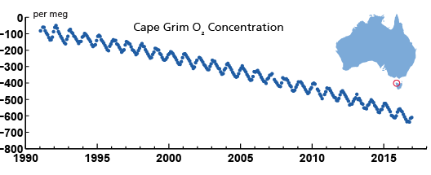

**Figure 14** - Decreasing oxygen concentration levels from 1990 to 2015 in ‘meg’(molecule of oxygen out of a million molecules of oxygen) observed from Cape Grim Station

Source: *Scripps* O2 *Program | Atmospheric Oxygen Research*. (2017). *Scripps*O2*.ucsd.edu*. Retrieved 10 December 2017, from [http://scrippsO2.ucsd.edu/](http://scrippso2.ucsd.edu/)

Oxygen levels are decreasing globally due to fossil-fuel burning. The changes are too small to have an impact on human health, but are of interest to the study of climate change and carbon dioxide. These plots show the atmospheric O2 concentration relative to the level around 1985. The observed downward trend amounts to 19 'per meg' per year. This corresponds to losing 19 O2 molecules out of every 1 million O2 molecules in the atmosphere each year52.

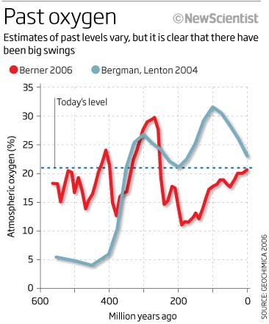

**Figure 15:** Evolution of atmospheric oxygen over millions of years

Source: Stunned Scientists Warn World Could Run Out of Breathable Air -- Sott.net. (2017). Sott.net. Retrieved 10 December 2017, from https://www.sott.net/article/215699-Stunned-Scientists-Warn-World-Could-Run-Out-of-Breathable-Air

[Robert Berner](http://earth.geology.yale.edu/people/moreinfo.cgi?netid=berner) of Yale University thinks oxygen levels plummeted after the Carboniferous before slowly rising to present day levels. His model tracks the oxygen level as 30 percent 300 million years ago. That plummeted to levels that we have today - about 19 to 21 percent depending on elevation. But then, after the Yucatan was struck by an asteroid roughly 65 million years ago, the dinosaurs began to die out. Many ascribe the saurian extinction to the global cooling and darkness following the asteroid strike, but Berner believes what finally did the dinosaurs in wasn't the large space rock, but lack of oxygen. He argues that oxygen levels plummeted to as low as 5 percent.

Other evidence suggests that oxygen levels fell sharply during other eras caused by volcanic eruption, the natural plant growing cycles, mass extinction of flora in the sea or other unknown causes. One unknown cause could be the collapse of Earth's magnetic field and the sun's hard radiation bombarding the unprotected planet for thousands of years. As the plants died off and massive amounts of carbon were released into the atmosphere, the oxygen levels took a nosedive54.

It is difficult to measure changes in O2 because there is so much of it in the atmosphere compared with CO2. So a proxy is used instead. Changes are measured as differences in O2/N2 ratios expressed in “per meg” units against the ratio in a standard mixture kept at the Scripps Institute of Oceanography, La Jolla California in the USA, which pioneered the measurement.

D(O2/N2) per meg = 106[(O2/N2)sam - (O2/N2)]ref/ (O2/N2)]ref (1)

This difference is used to define O2 concentration: 4.8 per meg are equivalent to 1 ppm (i.e., 1 mmole O2 per mole of dry air). By making the assumption that atmospheric N2 concentrations are constant, this definition of O2 concentration can be applied to derive O2 fluxes as follows [9, 10].

An Atmospheric Potential Oxygen (APO) is defined, also in per meg units, as the sum of oxygen as determined n eq. (1) and the oxygen that went into producing the CO2 in the atmosphere.

APO per meg = D(O2/N2) + aB 4.8[CO2] (2)

where aB represents the O2:CO2 exchange ratio for land photosynthesis and respiration; and [CO2] is the concentration of CO2 in the atmosphere. This assumes that variations in APO can only be caused by air-sea exchanges of O2, N2 and CO2, and by combustion of fossil fuels.

Oceanic uptake of atmospheric CO2, however, reduces the observed upward trend in atmospheric CO2 concentrations, but has no effect on the observed downward trend in O2/N2 ratios. Thus the global budgets for atmospheric CO2and O2can be respectively represented by eqs (3) and (4).

DCO2 = F – O – B (3)

DO2 = aFF + aBB + Z (4)

Where DCO2 is the globally averaged observed change in atmospheric CO2 concentration, DO2 is the globally averaged observed change in atmospheric concentration, F is the source of CO2 emitted from fossil fuel combustion (and cement manufacture), O is the oceanic CO2 sink, B is the net land biotic CO2 sink (including biomass burning, land use change and land biotic uptake); aF and aB are the global average O2:CO2 exchange ratios for fossil fuels and land biota respectively, and Z is the net exchange of atmospheric O2 with the ocean. All except exchange ratios are in units of moles per year.

Combining eqs 2, 3 and 4 gives:

DAPO = (-aF + aB)F – aBO + Z (5)

where DAPO is the globally averaged observed change in APO. Eq. 5 is used to obtain the oceanic sink, and then eq 3 is used to obtain the land biotic sink. This gives less uncertainty, as APO is less variable than the O2/N2 ratios.

The largest fall in O2 was observed in the study of Swiss research team led by Francesco Valentino at University of Bern, for data collected at high altitude research stations in Switzerland and France. The researchers speculated that the large decrease in atmospheric oxygen since 2003 could have been the result of oxygen being taken up by the ocean, either due to a cooling of water in the North Atlantic, or water moving northwards from the tropic cooling, both of which would increase the water’s ability to take up more oxygen. However, it would require unrealistic cooling to account for the change in O2concentration. And all the indications are that the ocean waters have warmed since records began.

In a second study, atmospheric O2 and CO2 data collected from two European coastal stations between 2000 and 2005 were analyzed. Mace Head Ireland (53O20’N 9o54’W, 35 m above sea level), which serves as the marine background, relatively free from local fossil fuel consumption, and Station Lutjewad (53O24’N, 6O21’E) on the northern coast of The Netherlands 30 km to the northwest of the city of Groningen, which serves as a continental station receiving continental air with northerly winds. Similar trends were detected.

Over the entire period at Lutjewad, CO2 increased by 1.7+0.2 ppm/y while oxygen decreased at -4.2+0.3 ppm/y; the corresponding figures for Mace Head were 1.7+0.1 ppm/y and -4.0+0.3 ppm/y. O2 is decreasing faster than can be accounted for by the rise in CO2. Furthermore, the decrease is not uniform throughout the entire period; instead it is much steeper between 2002 and 2005 at both stations, and is not accompanied by any change in the trend of CO2 increase. This sharp acceleration in the downward trend of atmospheric O2 from 2002-2003 onwards in Ireland and The Netherlands is in accord with the findings in Switzerland and France21.

**Case study: Oxygen depletion due to other unnatural processes besides fossil fuel burning**

The second study mentioned in above analysis cannot be explained by a realistic increase in fossil fuel use, or oxygen uptake by cooler ocean waters; if anything, oxygen level in the oceans has also been falling. So where and what is this oxygen sink that is soaking up oxygen? One distinct possibility that has been considered is that an extra oxygen sink has opened up on land as the result of human activities.

James Randerson at University of California Irvine was lead author on a report published in 2006 pointing out that a decrease in atmospheric O2 could result if carbon within the land biosphere becomes more oxidized (sequestering more oxygen) through disturbance of natural ecosystems. This has changed the natural land cover, replacing it with plants that effectively remove more oxygen from the atmosphere21.

Atmospheric exchange of O2 with land ecosystems is commonly expressed in terms of a net carbon flux from the atmosphere to the ecosystem (Fnet) and the net O2:CO2exchange ratio (Rnet):

dO2/dt = - Rnet Fnet (6)

By convention, positive sign indicates release into the atmosphere and negative sign sequestered in the land biosphere. The net rate is really a difference between two processes, one moving from atmosphere to biosphere, and the other in reverse, from biosphere to atmosphere, so eq. (6) can be written as follows.

dO2/dt = - (Rab Fab + RbaFba) (7)

where Fab is the atmosphere to biosphere carbon flux (the same as net primary productivity, NPP), Rab is the oxidative ratio related to NPP (moles O2 released per mole CO2 fixed), Fba is the biosphere to atmosphere return flux (a combination of respiration, fires and other losses), and Rba is the oxidative ratio related to the return flux (moles O2 consumed per mole CO2 released).

In an ecosystem at steady state (in dynamic balance), Fab and Fba will have the same magnitude. But the carbon in Fba is always offset in time from newly assimilated carbon in Fab because of carbon storage in the plant, dependent on plant tissue lifetimes, rates of litter and soil organic matter decomposition, and so on. Changes in Rab and Rba have the potential to cause relatively large changes in atmospheric O2, basically because of the time delays between fixation and the return flux due to carbon storage. The longer the carbon storage (turnover) time, the larger the effective offset between Fab and Fba; so O2 is consumed at a slower rate, and more of it remains in the atmosphere

Randerson and colleagues hypothesize that increasing levels of disturbance across natural ecosystems in recent decades has decreased Rab. This includes wide-spread deforestation and replacement of woody vegetation with pastures and crops in the tropics, an increase in fire activity and tree mortality and increasing the abundance of deciduous tree species and herbaceous plants in the boreal (northern) regions. Globally, this includes an increase in invasive species and increased disturbance of agricultural soils by plowing and grazing during the 20th century.

All these activities increase the oxidation state of carbon in plant and soil organic matter. The increases in oxygen content of the resultant biomass causes a small sink for atmospheric O2 that has not been accounted for in atmospheric budgets.

Within a plant, lipids and lignin compounds have carbon that is more reduced, i.e., with more hydrogen and less oxygen; they have and large R values of 1.37 and 1.14 respectively, and are energetically more costly to build than compounds such as cellulose and starch, which have less hydrogen, more oxygen, and R value of 1.0. Thus, the expansion of agriculture and grazing during the 20th century has probably caused a decrease in the oxidative ratio of the plant biomass within these disturbed ecosystems. Using several simple models, the researchers showed that, indeed, small changes in Rab could lead to substantial decreases in atmospheric oxygen.

Another research team has raised the possibility that reactive nitrogen produced in making artificial fertilizers for agriculture could also be tying up more oxygen in plant tissue, soil organic matter and oceans in the form of nitrates21.

**Case study: The importance of oxygen accounting in climate policies**

Change in land use, and increased oxidation of nitrogen could explain the long term steady decline in atmospheric O2, and may well also account for the sharp acceleration of the downward trend since 2002 and 2003. These years happen to coincide with record rates of deforestation. In Brazil, 10 000 square miles were lost mainly to pasture land, soybean plantations and illegal logging, a 40 percent rise over the previous year. Massive deforestation has continued in the Amazon and elsewhere, spurred by the biofuels boom; it is estimated that nearly 40 000 ha of the world’s forests are vanishing every day. The crucial role of forests and phytoplankton in oxygenating the earth shows how urgent it is to take oxygen accounting seriously in climate policies. Reductionist accounting for CO2 alone is insufficient, and even grossly misleading and dangerous.

A case in point is the proposal of the International Biochar Initiative (IBI). ‘Biochar’ is charcoal produced to be buried in the soil that IBI has been promoting worldwide over the past several years as a means of sequestering carbon from the atmosphere to save the climate and enhance soil fertility. It involves planting fast growing tree and various other crops on hundreds of millions of hectares of ‘spare land’ mostly in developing countries, to be harvested and turned into charcoal in a process that could produce crude oil and gases as low grade fuels. There are many excellent arguments against this initiative , but the most decisive is that it will certainly further accelerate deforestation and destruction of other natural ecosystems (identified as ‘spare land’). In the process, it could precipitate an oxygen crisis from which we would never recover21.

Rising erosion rates would have exposed more pyrite and organic carbon to the atmosphere. Pyrite is better known as fool's gold, and organic carbon consists of the remains of organisms, mostly land plants and aquatic photosynthetic microorganisms such as algae. Previous research found that both pyrite and organic carbon can react with oxygen and remove it from the atmosphere.

Alternatively, when the ocean cools, as it has done over the past 15 million years, before fossil fuel burning, the solubility of oxygen in the ocean increases. That is, the oceans can store more oxygen at colder temperatures for a given concentration of oxygen in the atmosphere. Oxygen-dependent microbes in the ocean and in sediments can then become more active and consume this oxygen, leaving less of the element in the atmosphere, he added.

Future research can identify what geological processes are consistent with these findings and thus help to identify the major processes that control atmospheric oxygen levels49.

**Case study: An analysis of how much oxygen is produced from water vapor in sunlight**

The biological era was marked by the simultaneous decrease in atmospheric carbon dioxide (CO2) and the increase in oxygen (O2) due to life processes. We need to understand how photosynthesis could have led to maintenance of the ~20% present-day level of O2. The buildup of oxygen had three major consequences that we should note here.

Firstly, Eukaryotic metabolism could only have begun once the level of oxygen had built up to about 0.2%, or ~1% of its present abundance. This must have occurred by ~2 billion years ago, according to the fossil record. Thus, the eukaryotes came about as a consequence of the long, steady, but less efficient earlier photosynthesis carried out by [prokaryotes](http://www.biology.arizona.edu/cell_bio/tutorials/pev/page2.html).

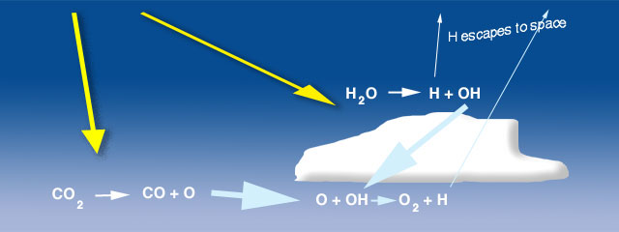

**Figure 16** - Photolysis of water vapor and carbon dioxide produce hydroxyl and atomic oxygen, respectively, that, in turn, produce oxygen in small concentrations. This process produced oxygen for the early atmosphere before photosynthesis became dominant.

Source: *Evolution of the Atmosphere*. (2017). *Globalchange.umich.edu*. Retrieved 10 December 2017, from <https://globalchange.umich.edu/globalchange1/current/lectures/Perry_Samson_lectures/evolution_atm/>

Oxygen increased in stages, first through photolysis (Figure 17) of water vapor and carbon dioxide by ultraviolet energy and, possibly, lightning:

H2O -> H + OH

produces a hydroxyl radical (OH) and

CO2 -> CO+ O

produces an atomic oxygen (O). The OH is very reactive and combines with the O

O + OH -> O2 + H

The hydrogen atoms formed in these reactions are light and some small fraction escape to space allowing the O2 to build to a very low concentration, probably yielded only about 1% of the oxygen available today. Secondly, once sufficient oxygen had accumulated in the stratosphere, it was acted on by sunlight to form ozone, which allowed colonization of the land. The first evidence for vascular plant colonization of the land dates back to ~400 million years ago. Thirdly, the availability of oxygen enabled a diversification of metabolic pathways, leading to a great increase in efficiency. The bulk of the oxygen formed once life began on the planet, principally through the process of photosynthesis:

6CO2 + 6H2O <--> C6H12O6 + 6O2

where carbon dioxide and water vapor, in the presence of light, produce organics and oxygen. The reaction can go either way as in the case of respiration or decay the organic matter takes up oxygen to form carbon dioxide and water vapor. Life started to have a major impact on the environment once photosynthetic organisms evolved. These organisms fed off atmospheric carbon dioxide and converted much of it into marine sediments consisting of the innumerable shells and decomposed remnants of sea creatures.

|  |
| --- |
| **Figure 17** - Oxygen production vs Time  Source: *Evolution of the Atmosphere*. (2017). *Globalchange.umich.edu*. Retrieved 10 December 2017 |

While photosynthetic life reduced the carbon dioxide content of the atmosphere, it also started to produce oxygen. The oxygen did not build up in the atmosphere for a long time, since it was absorbed by rocks that could be easily oxidized (rusted). To this day, most of the oxygen produced over time is locked up in the ancient "banded rock" and "red bed" rock formations found in ancient sedimentary rock. It was not until ~1 billion years ago that the reservoirs of oxidizable rock became saturated and the free oxygen stayed in the air. The figure illustrates a possible scenario.

We have briefly mentioned the difference between reducing (electron-rich) and oxidizing (electron hungry) substances. Oxygen is the most important example of the latter type of substance that led to the term oxidation for the process of transferring electrons from reducing to oxidizing materials. This consideration is important for our discussion of atmospheric evolution, since the oxygen produced by early photosynthesis must have readily combined with any available reducing substance. We have been able to outline the steps in the long drawn out process of producing present-day levels of oxygen in the atmosphere. We refer here to the geological evidence55.

**Study: Total measure of oxygen amounts and concentrations, and predicted trend for the future**

The present level of Oxygen in the atmosphere is balanced at a such a level that less would impede survival of a number of organisms while more would lead to a greater probability of fires. At 25 % oxygen damp twigs and grass of a rain forest would ignite56.

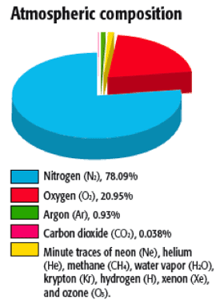

**Figure 18** - Atmospheric composition of gases.

Source: Earth?, I. (2017). *Is oxygen the most abundant element on Earth?*. *Earthscience.stackexchange.com*. Retrieved 10 December 2017, from https://earthscience.stackexchange.com/questions/7644/is-oxygen-the-most-abundant-element-on-earth/7649(image)

**Case study: total analysis of all major factors involved in atmospheric oxygen replenishment/depletion**

To complete the analysis of net atmospheric deoxygenation, a consideration of ocean deoxygenation, fossil fuel consumption, and animal and plant effects on oxygen in the atmosphere. All weights measured will be converted to kg, the SI unit for oxygen. Our trend will then be compared to what the Scripps Institute at University of California San Diego has measured in regards to Oxygen concentration trends. First, we take a measure of what the oxygen concentration on the plant was measured as at a specific time point, preferable starting from 1975, where the basis for animal and plant biomass data was compiled. As before, a fixed component calculation will be imposed, where only oxygen in variable in the atmosphere (naturally, there is no immediate risk in the other component: nitrogen, being depleted in the atmosphere). The equations below are used to determine what the net oxygen rate of oxygen is when congregating these separate effects, and the consequent concentration of oxygen in the atmosphere.

Table 2 below shows how each individual factor that leads to oxygen depletion contributes to the net oxygen change in the atmosphere. An important observation is how fossil fuel consumption of oxygen measures several orders of magnitude away from the fuel production provided from plants. Figure 19 shows a linear result of how oxygen is varying in the atmosphere. In fact, we display a trend that goes against the initial hypothesis in that oxygen depletion in decreasing, and the rate amount of oxygen entering the atmosphere is accelerating by 3e14 kg every year. Despite what may be established for an expected decrease in oxygen concentration, in concluding we provide an explanation for why our model failed to produce an otherwise expected result in how oxygen concentration should vary over time. It is stressed again that these model make extraneous assumptions to provide the best case scenario guaranteed only by how much was found through a review of the current literature.

|  |  |  |  |  |
| --- | --- | --- | --- | --- |
| **Table 2**: Oxygen depletion in the atmosphere | | | | |
| rates (kilograms/year) | | | | |
| Year | natural | fossil fuel | ocean | **total** |
| 1975 | -1.25E+13 | 2.05E+10 | -2.82E+13 | -4.06E+13 |
| 1985 | -2.72E+15 | 2.52E+10 | -2.82E+13 | -2.75E+15 |
| 1995 | -5.43E+15 | 2.89E+10 | -2.82E+13 | -5.46E+15 |
| 2005 | -8.13E+15 | 3.78E+10 | -2.82E+13 | -8.16E+15 |
| 2015 | -1.08E+16 | 4.49E+10 | -2.82E+13 | -1.09E+16 |

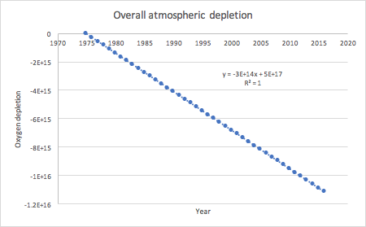

**Figure 19** - Overall linear atmospheric oxygen production which is expected to increase by 3e14 kg every year

**Conclusion and Recommendations**

Overall, this paper did not succeed in showing an overall steady or increasing oxygen depletion rate, based on what has been portrayed in the literature. The most worrying statistic measured was how plants contribute to oxygen depletion. Most prehistoric oxygen comes from phytoplankton in the ocean, which may explain why such high amounts of oxygen can even be dispelled into the atmosphere in the first place. However, emphasis on this model shows that the faults in theoretically calculating the net oxygen depletion comes from mainly how plants contribute to O2 loss.

Some of these factors not incorporated into the model include how deforestation accounts for the decrease in oxygen. Not enough data was found to know how respiration rates differ between the major groups of photosynthetic organisms, nor of these abundance with respect to those that exist on land. Basing these calculations off of knowing that the plant biosphere is at least 1000 times larger than the animal biosphere, and that there is a specific rate at which the plant biosphere is growing, seem to lead to more than likely, incorrect trends. However, this gives an excellent framework for the advancing and complication of the model to be more accurate to what is being observed at national laboratories. Using the model presented by Chirkov et al 48 we successfully came up with a decent model to calculate how different forms of fuels may affect the atmospheric oxygen concentration, albeit more accurate than the contribution of oxygen from plants, animals, and the oceans.

Other forms of oxygen decrease and increase were shortly explored, and as expected, did not lead to as adverse results as what was examined in greater detail. While based on what was presented, there seems to be no immediate danger in the world for potential oxygen shortages, it is important to realize that oxygen usage from fossil fuels is increasing, which relates to the fact that CO2 production is also increasing, which has led to the explosive growth of the atmosphere CO2 concentration, which poses an even bigger problem. Truthfully, in writing this report, it gave the authors a greater appreciation for the issue of oceanic oxygen depletion, which will affect marine life, and eventually, life that produces O2 due to the dissolution of CO2 from the oceans as well. This issue is of grave concern and should be heavily studied in the next 20 years to ensure that low level oxygen hotspots are re-oxygenated, and that the ocean can be shielded from the cause of this, which is oxygen depletion due to fossil fuel burning.

In conclusion, we extract the following main points and recommendations:

* Fossil fuels do indeed consume a considerable amount of atmospheric oxygen, and is something that, if not considered, could pose an issue for the planet. However, at the acceleration of deoxygenation due to fossil fuels is currently, this will not pose an issue for the planet any time soon. In fact, fossil fuels are the cause of temperature increase which can also increase atmospheric oxygenation due to ocean deoxygenation.
* A lot of other unnatural processes besides fossil fuel burning such as deforestation, illegal, logging, use of large quantity of oxygen from plant tissue to the contamination of nitrogen fertilizers into oceans can contribute to the depletion of atmospheric oxygen.
* Although our sustainability model did not match our hypothesis based on crude assumptions, important information can be extracted from the individual trends. Plant oxygenation of the planet most likely added more oxygen to the planet at a rate greater than anything else can extract it from the planet. We must pay close attention to deforestation and in allowing for the growth of the planet biosphere faster than humans are extracting from it.
* Ocean deoxygenation is the single greatest issue resulting from another form of atmospheric oxygen depletion: fossil fuel burning. Since it is already known what needs to be done to reduce CO2 emissions and prevent average annual global temperature increases, it is also known how to deal with ocean deoxygenation, which is just a consequence of global warming.
* Emphasized again, a concentration of oxygen in the atmosphere is to be moderated, and as solutions to global warming in general, shifting focus of fuel usage to renewable sources of energy, and promoting government incentives and subsidizations to promote building oxygen/carbon dioxide cyclic greenspaces and oxygen implementation back into the ocean. The sustainable engineer however, understands that these changes are not so simple, and require deeper analysis beyond the scope of this project, to validate the economic, environmental, and social implications of wanted to moderate Oxygen levels.
* As predicted by Robert Brener of Yale University, that oxygen levels have plummeted down to 21% from 30% across a span of 30 million years, oxygen levels beyond 25% poses a risk of fires to damp twigs and grasslands as discussed above.
* Therefore, oxygen depletion is an observed trend that needs to be in check, while the rate of its depletion is not alarming as we have abundant reserves.

**References**

#### Zielinski, S. (2015). *Earth's Oxygen Levels Can Affect Its Climate*. *Smithsonian*. Retrieved 10 December 2017, from https://www.smithsonianmag.com/science-nature/earths-oxygen-levels-can-affect-its-climate-180955572/

#### Karam PA, e. (2017). *The effects of changing atmospheric oxygen concentrations and background radiation levels on radiogenic DNA damage rates. - PubMed - NCBI* . *Ncbi.nlm.nih.gov*. Retrieved 10 December 2017, from https://www.ncbi.nlm.nih.gov/pubmed/11669208

#### *Variations in atmospheric oxygen levels shaped Earth's climate through the ages*. (2017). *Phys.org*. Retrieved 10 December 2017, from https://phys.org/news/2015-06-variations-atmospheric-oxygen-earth-climate.html

#### *Variations in atmospheric oxygen levels shaped Earth’s climate through the ages | University of Michigan News*. (2015). *Ns.umich.edu*. Retrieved 10 December 2017, from http://ns.umich.edu/new/releases/22942-variations-in-atmospheric-oxygen-levels-shaped-earth-s-climate-through-the-ages

#### O2 *Dropping Faster than* CO2 *Rising*. (2017). *I-sis.org.uk*. Retrieved 10 December 2017, from <http://www.i-sis.org.uk/O2DroppingFasterThanCO2Rising.php>

#### *Features: Atmospheric oxygen--an endangered resource?*. (2017). *Columbia.edu*. Retrieved 10 December 2017, from http://www.columbia.edu/cu/21stC/issue-2.1/broecker.htm

#### *Earth's Atmosphere Is Losing Oxygen at an Accelerated Rate, Study Says | The Weather Channel*. (2017). *The Weather Channel*. Retrieved 10 December 2017, from https://weather.com/science/nature/news/earth-atmosphere-losing-oxygen

#### Shaffer, G., Olsen, S., & Pedersen, J. (2009). Long-term ocean oxygen depletion in response to carbon dioxide emissions from fossil fuels. *Nature Geoscience*, *2*(2), 105-109. doi:10.1038/ngeo420

1. Laboratory, O. (2017). Modern Records of Atmospheric Oxygen (O2) from Scripps Institution of Oceanography. Cdiac.ess-dive.lbl.gov. Retrieved 10 December 2017, from http://cdiac.ess-dive.lbl.gov/trends/oxygen/modern_records.html

#### *Scripps* O2 *Program | Atmospheric Oxygen Research*. (2017). *Scripps*O2*.ucsd.edu*. Retrieved 10 December 2017, from http://scrippsO2.ucsd.edu/

#### *Forbes Welcome*. (2017). *Forbes.com*. Retrieved 10 December 2017, from https://www.forbes.com/sites/trevornace/2016/09/27/earths-oxygen-levels-declining-scientists/#2296c6e67e4d

#### (2017). *Cdc.gov*. Retrieved 10 December 2017, from https://www.cdc.gov/niosh/docket/archive/pdfs/niosh-125/125-atmospheremanagementf-m.pdf

#### Shaffer, G., Olsen, S., & Pedersen, J. (2009). Long-term ocean oxygen depletion in response to carbon dioxide emissions from fossil fuels. *Nature Geoscience*, *2*(2), 105-109. doi:10.1038/ngeo420

#### Lyons, T., Reinhard, C., & Planavsky, N. (2014). The rise of oxygen in Earth’s early ocean and atmosphere. *Nature*, *506*(7488), 307-315. doi:10.1038/nature13068

1. Kump, L. (2008). The rise of atmospheric oxygen. Nature, 451(7176), 277-278. doi:10.1038/nature06587

#### Berkner, L., & Marshall, L. (1964). The history of oxygenic concentration in the Earth's atmosphere. *Discussions Of The Faraday Society*, *37*, 122. doi:10.1039/df9643700122

#### *Research Overview | Scripps* O2 *Program*. (2017). *Scripps*O2*.ucsd.edu*. Retrieved 10 December 2017, from http://scrippsO2.ucsd.edu/research-overview

#### *The Atmosphere Is Losing Oxygen as Fast as It's Gaining Carbon Dioxide*. (2016). *Inverse*. Retrieved 10 December 2017, from <https://www.inverse.com/article/21419-atmospheric-oxygen-levels-falling>

#### *Global warming disaster could suffocate life on planet Earth, research shows — University of Leicester*. (2017). *Www2.le.ac.uk*. Retrieved 10 December 2017, from https://www2.le.ac.uk/offices/press/press-releases/2015/december/global-warming-disaster-could-suffocate-life-on-planet-earth-research-shows

#### Smillie, S. (2017). *Fish under threat from ocean oxygen depletion, finds study*. *the Guardian*. Retrieved 10 December 2017, from <https://www.theguardian.com/environment/2017/feb/20/fish-under-threat-oxygen-depletion-oceans-study>

#### O2 *Dropping Faster than* CO2 *Rising*. (2017). *I-sis.org.uk*. Retrieved 10 December 2017, from http://www.i-sis.org.uk/O2DroppingFasterThanCO2Rising.php

#### *Ocean Oxygen Decline*. (2017). *Climateemergencyinstitute.com*. Retrieved 10 December 2017, from https://www.climateemergencyinstitute.com/ocean_oxy_karen_vt.html

#### Conners, D. (2017). *Declining oxygen concentrations might threaten ocean health | EarthSky.org*. *Earthsky.org*. Retrieved 10 December 2017, from http://earthsky.org/earth/declining-oxygen-concentrations-might-threaten-ocean-health

#### *The Rise of Oxygen - Astrobiology Magazine*. (2003). *Astrobiology Magazine*. Retrieved 10 December 2017, from https://www.astrobio.net/news-exclusive/the-rise-of-oxygen/

#### Shaffer, G., Olsen, S., & Pedersen, J. (2009). Long-term ocean oxygen depletion in response to carbon dioxide emissions from fossil fuels. *Nature Geoscience*, *2*(2), 105-109. doi:10.1038/ngeo420

#### Ito, T., Nenes, A., Johnson, M., Meskhidze, N., & Deutsch, C. (2016). Acceleration of oxygen decline in the tropical Pacific over the past decades by aerosol pollutants. *Nature Geoscience*, *9*(6), 443-447. doi:10.1038/ngeO2717

1. JOURNAL OF GEOPHYSICAL RESEARCH, VOL. 102, NO. A10, PAGES 22,273-22,277, OCTOBER 1, 1997

#### *Fossil Fuels*. (2017). *Our World in Data*. Retrieved 10 December 2017, from https://ourworldindata.org/fossil-fuels/

#### *Fossil fuel energy consumption (% of total) | Data*. (2017). *Data.worldbank.org*. Retrieved 10 December 2017, from https://data.worldbank.org/indicator/EG.USE.COMM.FO.ZS

#### *Energy use (kg of oil equivalent per capita) | Data*. (2017). *Data.worldbank.org*. Retrieved 10 December 2017, from <https://data.worldbank.org/indicator/EG.USE.PCAP.KG.OE>

#### *Energy density*. (2017). *En.wikipedia.org*. Retrieved 11 December 2017, from https://en.wikipedia.org/wiki/Energy_density

#### *Petroleum*. (2017). *En.wikipedia.org*. Retrieved 11 December 2017, from https://en.wikipedia.org/wiki/Petroleum

#### *Environmental Decision Making, Science, and Technology*. (2017). *Environ.andrew.cmu.edu*. Retrieved 11 December 2017, from http://environ.andrew.cmu.edu/m3/s4/cycleOxygen.shtml

#### *All of Earth's land mammals by total weight in one graph (notice wild vs. livestock)*. (2017). *TreeHugger*. Retrieved 11 December 2017, from https://www.treehugger.com/sustainable-agriculture/all-earths-land-mammals-total-weight-one-graph-wild-livestock.html

#### Science, L. (2012). *The Weight of the World: Researchers Weigh Human Population*. *Live Science*. Retrieved 11 December 2017, from https://www.livescience.com/36470-human-population-weight.html

#### *How much do oceans add to world’s oxygen? | EarthSky.org*. (2017). *Earthsky.org*. Retrieved 11 December 2017, from http://earthsky.org/earth/how-much-do-oceans-add-to-worlds-oxygen

#### *metabworksheet.htm*. (2017). *Csmbio.csm.jmu.edu*. Retrieved 11 December 2017, from http://csmbio.csm.jmu.edu/biology/danie2jc/metabworksheet.htm.htm

#### (2017). *Nrs.fs.fed.us*. Retrieved 11 December 2017, from https://www.nrs.fs.fed.us/pubs/jrnl/2007/nrs_2007_nowak_001.pdf

#### Jirak, T. (2015). *Need to breathe? Trees please! | Canadian Lung Association Blog*. *Blog.lung.ca*. Retrieved 11 December 2017, from http://blog.lung.ca/2015/07/need-to-breathe-trees-please/

#### *Population, total | Data*. (2017). *Data.worldbank.org*. Retrieved 11 December 2017, from <https://data.worldbank.org/indicator/SP.POP.TOTL>

1. Review of Concepts. (2017). Mathbench.umd.edu. Retrieved 11 December 2017, from <http://mathbench.umd.edu/modules/misc_scaling/page25.htm>

#### *Mass of the Biosphere - The Physics Factbook*. (2017). *Hypertextbook.com*. Retrieved 11 December 2017, from https://hypertextbook.com/facts/2001/AmandaMeyer.shtml

#### (2017). *Uaex.edu*. Retrieved 11 December 2017, from https://www.uaex.edu/publications/pdf/FSA-5021.pdf

#### (2017). *Journals.plos.org*. Retrieved 11 December 2017, from http://journals.plos.org/plosone/article/file?id=10.1371/journal.pone.0126228&type=printable

1. Ecology Letters, (2010) 13: 1182–1197
2. Field, C.B.; Behrenfeld, M.J.; Randerson, J.T.; Falkowski, P. (1998). "Primary production of the Biosphere: Integrating Terrestrial and Oceanic Components". [*Science*](https://en.wikipedia.org/wiki/Science_(journal)). 281 (5374): 237–240. [Bibcode](https://en.wikipedia.org/wiki/Bibcode):[1998Sci...281..237F](http://adsabs.harvard.edu/abs/1998Sci...281..237F). [doi](https://en.wikipedia.org/wiki/Digital_object_identifier):[10.1126/science.281.5374.237](https://doi.org/10.1126%2Fscience.281.5374.237). [PMID](https://en.wikipedia.org/wiki/PubMed_Identifier) [9657713](https://www.ncbi.nlm.nih.gov/pubmed/9657713).

#### *Biomass (ecology)*. (2017). *En.wikipedia.org*. Retrieved 11 December 2017, from https://en.wikipedia.org/wiki/Biomass_(ecology)#cite_note-Behrenfeld-5

1. Vladimir Chirkov, OXYGEN DEPLETION OF ATMOSPHERE AND REMEDY CONCEPT, Energy Bulletin No. 19, 2015, 54-61

#### 33. Science, L., & Earth, P. (2016). *Earth's Atmospheric Oxygen Levels Continue Long Slide*. *Live Science*. Retrieved 10 December 2017, from <https://www.livescience.com/56219-earth-atmospheric-oxygen-levels-declining.html>

#### O2 *Dropping Faster than* CO2 *Rising*. (2017). *I-sis.org.uk*. Retrieved 10 December 2017, from http://www.i-sis.org.uk/O2DroppingFasterThanCO2Rising.php

#### Watts, A. (2013). *Dr. Vincent Gray on historical carbon dioxide levels*. *Watts Up With That?*. Retrieved 10 December 2017, from https://wattsupwiththat.com/2013/06/04/dr-vincent-gray-on-historical-carbon-dioxide-levels/

#### *Scripps* O2 *Program | Atmospheric Oxygen Research*. (2017). *Scripps*O2*.ucsd.edu*. Retrieved 10 December 2017, from [http://scrippsO2.ucsd.edu/](http://scrippso2.ucsd.edu/)

#### (2017). *Newscientist.com*. Retrieved 10 December 2017, from <https://www.newscientist.com/data/images/archive/2769/27692001.jpg>

1. Stunned Scientists Warn World Could Run Out of Breathable Air -- Sott.net. (2017). Sott.net. Retrieved 10 December 2017, from https://www.sott.net/article/215699-Stunned-Scientists-Warn-World-Could-Run-Out-of-Breathable-Air

#### *Evolution of the Atmosphere*. (2017). *Globalchange.umich.edu*. Retrieved 10 December 2017, from <https://globalchange.umich.edu/globalchange1/current/lectures/Perry_Samson_lectures/evolution_atm/>

#### *Water ( Solid,Liquid, Gas) - SliderBase*. (2017). *Sliderbase.com*. Retrieved 10 December 2017, from <http://www.sliderbase.com/spitem-79-5.html>

1. (2017). *Gizmodo.com*. Retrieved 11 December 2017, from <https://gizmodo.com/our-atmosphere-is-leaking-oxygen-and-scientists-dont-kn-1786948116>
2. A Pleistocene ice core record of atmospheric O2 concentrations D. A. Stolper, M. L. Bender, G. B. Dreyfus, Y. Yan and J. A. Higgins. Science 353 (6306), 1427-1430. DOI: 10.1126/science.aaf5445
3. Prothero, J. W. (1979). Maximal oxygen consumption in various animals and plants. *Comp. Biochem. Physiol.*, *64A*(9), 463–466.
4. Christensen, A. B., Hecht, J. H., Walterscheid, R. L., Larsen, M. F., & Sharp, W. E. (1997). Depletion of oxygen in aurora: Evidence for a local mechanism. *J. Geophys. Res.*, *102*(A10), 22273. <https://doi.org/10.1029/97JA01800>
5. FALKOWSKI, P. G. (2011). Ocean Deoxygenation : Past , Present , and Future, *EOS Transactions American Geophysical Union 92*(46).

|  |  |  |
| --- | --- | --- |
| **Criteria** | **Points Possible** | **Points Earned** |
| **How comprehensive and up to date is the background review** | **35** | **35** |
| **Quality of the analytical method** | **20** | **17** |
| **Scope and validity of the results** | **15** | 15 |
| **Discussion of the results, and conclusions** | **25** | **24** |
| **Creativity of the analysis, method, conclusions, etc.** | **5** | **5** |
| **Total** | **100** | **96** |
|  |  |  |

Very well performed analysis. Many factors of oxygen depletion have been mentioned and numerically quantified. Oxygen replenishment and possible remedies that would change quantitatively could be emphasized a tad bit more. Overall, Nice effort!

Excellent report. NL