EAS 501

Energy and its impacts

Project 1

Title: G1.9. The relationship between the per-person national energy consumption, GDP and GDP PPP, energy use, income inequalities, and HDI

Team members:

Luke Johnson

lukejohn@seas.upenn.edu

Shankar Ramanathan

nshank@seas.upenn.edu

Submission Date

Tuesday November 7th, 2017

The relationship between GDP PPP, energy consumption, income, inequalities, and HDI

**Project Description:**

Background

Economists often claim that GDP increases with energy consumption, hence extrapolating that increased energy consumption is justified if a nation wishes to increase its GDP. It is becoming increasingly obvious that energy consumption may create disastrous effects, and there is evidence that the GDP can increase without an increase in energy consumption. It is also not convincing that the GDP should be used as the best indicator of quality of life, there are other indices such as the HDI, equality, and ones that describe “happiness” that go beyond money. Furthermore, it is of interest to determine how national energy consumption and GDP affect inequality on energy consumption and income.

Procedure

Write a thorough critical review of the relationship between GDP and GDP PP, and energy consumption, and inequality (can use the Atkinson Index for example) and HDI, give examples of the relationship between these parameters for at least 10 representative countries, from the poor to the rich, and discuss ways by which this relationship can be changed to decrease energy consumption yet maintain, or even increase the GDP and equality. Discuss briefly the significance of the GDP as an indicator of national “happiness”.

Extent of deliverables/objectives completed

We have gathered enough data on GDP HDI Energy relationships and performed analysis by combining data from various articles. The assigned objectives of evaluating the relationship between GDP PPP, energy consumption, income, inequalities, and HDI were met . A brief discussion of Happiness vs GDP HDI Social Progress Index were also discussed and included in the report.

The data was extensively collected and plotted appropriately in order to examine trends between variables of interest. Showing how overall indicators of wealth and wellbeing like GDP, HDI, and happiness are affected by energy consumption was the main goal of this report. Trends of each country are discussed and explained based on its specific social, economic, and industrial circumstances.

Progress Report comments

1. As requested, please submit all reports in WORD, it is then easier to mark up and revise as needed.

1. Understood, done as a docx file.

2. Also don't continue ignoring the general guidelines, for example "A progress report, defining exactly the scope of the project, the chose/adapted study method and the quantitative criteria that would be used to satisfy attainment of the project objective, the results obtained, plans for completion, as well as the planned division of work among the team members, is due as shown in the project descriptions attachment."

1. This has been included in the final report.

3. Start reports by copying the given assignment background, objectives and method, so we always have the same understanding.

You may modifications in these but then explain what and why.

1. Done.

4. You are on the right track but if this indicates your progress so far, then you may have a difficulty completing a proper report by the deadline. If it helps, you may reduce the number of considered countries to maybe 8.

1. Addressed and did the analysis for 13 countries

5. Also don't continue ignoring the general guidelines, for example "A progress report, defining exactly the scope of the project, the chose/adapted study method and the quantitative criteria that would be used to satisfy attainment of the project objective, the results obtained, plans for completion, as well as the planned division of work among the team members, is due as shown in the project descriptions attachment."

1. We have incorporated these guidelines into the final report.

6. Such a comparison of each of the criteria between the selected nations is good, but even more important is the comparison between the indicators (such as GDP, HDI) for each country independently all indicators plotted on the same graph for the same country, with brief attempt to explain slopes (trends) of each with time, e.g., why does HDI drop while GDP rises, etc. This explanation would be based on the component values that make up each indicator, which is typically available from the indicator's source.

1. This has been done.

7. As mentioned it would be good, but not mandatory, to also include some indicator of happiness of nations.

1. Done.

8. You realize that such a graph without country legends is not useful. Also, all information you copy ad obtain from sources must be accompanied by specific full reference citations.

1. Just an earlier form of the graph. These figures have been plotted in Excel to accurately show labels.

**Abstract**

In this report, the relationships between GDP, HDI, World Happiness Index, energy consumption, energy production, and Social Progress Index, which is related to HDI, are established and explained based on trends that are both intra-national and international, in an attempt to better understand how these variables affect each other. Particularly for the United States, GDP has a linear relationship to HDI. In the report, we also find other countries with relationships similar to the US, and other countries with varying GDP HDI relations. In strengthening understanding of energy-economy variation, 2 examples of the relationship between energy and GDP are shown: the United States and China, based on the coupling and decoupling of these variables. Specifically, we gauge the specific relationship between GDP and HDI.

The relationships between energy consumption and production and the GDP and HDI of nations are investigated for 13 countries: United States, Canada, China, Australia, Brazil, Mexico, UK, Russia, Germany, Norway, India, Bahamas, and Trinidad and Tobago. It is determined that countries can be grouped based on their HDI ranking to label its level of development, and based on how energy consumption affects changes in GDP and HDI. GDP can either be very elastic, inelastic, or completely unaffected by energy consumption. HDI is known to be a better indicator of the social and economic progress of a country, and has a better and more robust relationship with energy consumption and production. HDI isn’t affected by consumption changes, which show that overall social and economic factors of developed countries are unaffected by consuming more or less energy.

We conclude the report by examining how happiness changes with energy consumption, HDI, Social Progress and GDP. It is noted that beyond a particular happiness for developing nations, greater energy consumption doesn’t lead to greater happiness. Social Progress is a better indicator for the overall quality of life in a nation than Happiness. Countries are happier, using less energy to accommodate economic growth is feasible and possible for developing countries that wish to obtain similar national standards.

**Introduction**

Due to a close relationship between a country’s energy reserves/resources, and its economic and financial stability, it is often conceived that a country’s GDP is representative of the amount of energy that it owned/exported. The gross domestic product is typically used as an indicator of a state’s well-being. One of the issues with this is the inequality that an averaged value can provide. Measuring the effectiveness of a value like GDP depends on how wealth is distributed across the population of a country. However, it is believable that GDP is a multidimensional function based on many other factors representative only of a country’s financial success.

The Human Development Index, GDP purchasing power parity (GDP PPP), energy consumption, and inequality are other factors that can be used to model quality of life by both social and economic means. The focus of this project is critically analyzing the methods, data, results, limitations, assumptions, and statistical significance of established relationships between these variables that describe the wealth of a nation. Ideally, it is desired to describe how energy consumption and use affects the HDI of a nation, and if an increase in consumption is necessary for GDP growth. Another variable, happiness, is one that is used to measure a country’s overall well-being and content with a particular state. Within this document, a description of our own derived conclusions will be made that captures a review of the social, economic, and financial implications of the GDP and its relation to indices that are crucial in understanding a nation’s developmental progress.

**Background review**

The Gross Domestic Product, or GDP, is one of the first metrics used to measure the economic status of a country. It represents the total dollar value of all goods and services produced over a specific time period; you can think of it as the size of the economy. Usually, GDP is expressed as a comparison to the previous quarter or year. For example, the Q3 2017 GDP is up 3%, this is thought to mean that the economy has grown by 3% over the third quarter. While quarterly growth rates are a periodic measure of how the economy is faring, annual GDP figures are often considered the benchmark for the size of the economy. The United States has a GDP of $18,869.4 billion as of the fourth quarter of 2016, according to the Bureau of Economic Analysis26.

However, the need for a metric that not only includes economic growth, but a measure of the livelihood of those living in a country continued to be of interest for influential studies of the quality of a nation. The Human Development Index was introduced by the United Nations as a representation of national human development specific to a country. . The use of the Human Development Index has shown that economic growth is not indicative of growth in other sectors of a society, like in health and education. For example, it was shown by Samuel Preston that changes in GDP and life expectancy were not statistically significant. 23

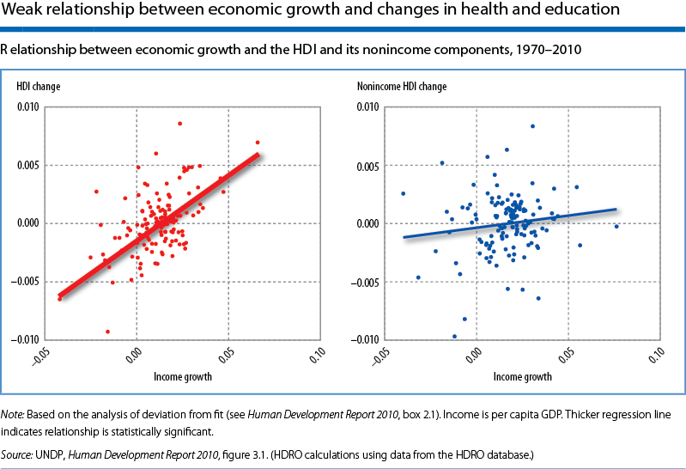

The left panel above shows a positive association—though with substantial variation—suggesting that growth and improvements in human development are positively associated. Remember, however, that income is part of the HDI; thus, by construction, a third of the changes in the HDI come from economic growth, guaranteeing a positive association. A more useful exercise is to compare income growth with changes in the non-income dimensions of human development. The 2010 HDR did this using an index similar to the HDI but calculated with only the health and education components indicators of the HDI to compare its changes with economic growth. The non-income HDI is presented in the right panel of figure . The correlation is remarkably weak and statistically insignificant. This ties into what was mentioned previously about how GDP at most only contributing a third to human development23.

Additionally, it has been shown that indices like the Social Progress Index is a better indicator of social development and progress. Some fundamental questions to ask about the progress of a country socially are: does a nation provides essential amenities to its citizens; is there an available foundation from which citizens can build on developing social growth; and if countries are allowing those that live in it to reach their maximum potential? 25

To put this in perspective, it is useful to compare Russia and Mexico. Russia has a significantly higher GDP per capita than Mexico ($23,564 vs $16,291) and both countries score similarly on Basic Human Needs and Foundations of Wellbeing. Yet they diverge on Opportunity (Russia 49.19; Mexico 60.88). On self-reported life satisfaction, Mexico scores 7.03 on a ten-point scale, compared to 5.59 in Russia24.

In part, this result is reflecting the interplay between the Social Progress Index and GDP per capita: GDP per capita is correlated with Basic Human Needs and Foundations of Wellbeing, but has only a noisy relationship with Opportunity. This finding raises a more fundamental point: exclusive attention to economic indicators as a means for raising subjective well-being has the consequence of distracting attention from aspects of social performance such as Tolerance and Inclusion or Personal Rights which are more loosely linked to traditional measures of economic development24

Although it has been established that HDI is a better indicator of a holistic quality of a country, has the relationship between GDP and HDI been extensively reviewed? Is it possible to analytically predict what a country’s GDP is based on HDI? Figure B1 below shows how HDI varies based on the GDP for all countries in the year 2013.1

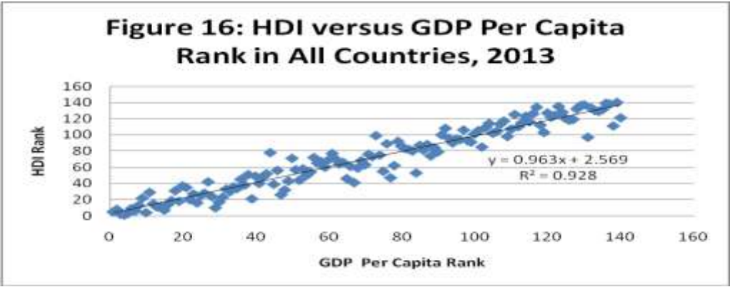

Figure B1 - HDI GDP relationship in 2013

In general there is a high positive correlation between these two variables. Examining the data across several different years, can we observe similar linear relationships between these two variables? Also, are different trends observed from grouping countries based on their human development ranking?

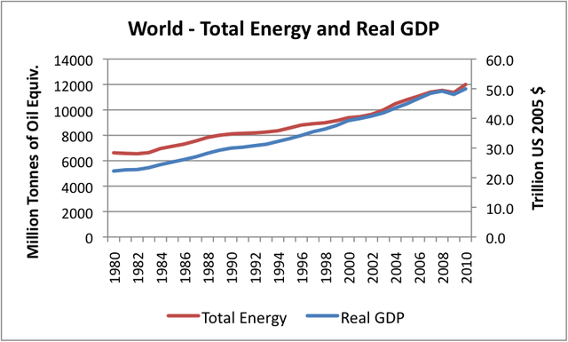

Figure B227: Total Energy vs GDP

Prior to 2000, world real GDP (based on [USDA Economic Research Institute data](http://www.ers.usda.gov/Data/Macroeconomics/)) was indeed growing faster than energy use, as measured by BP Statistical Data. Between 1980 and 2000, world real GDP growth averaged a little under 3% per year, and world energy growth averaged a little under 2% per year, so GDP growth increased about 1% more per year than energy use. Since 2000, energy use has grown approximately as fast as world real GDP–increases for both have averaged about 2.5% per year growth. This is not what we have been told to expect. Why should this “efficiency gain” go away after 2000? Many economists are concerned about [energy intensity of GDP](http://en.wikipedia.org/wiki/List_of_countries_by_energy_intensity) and like to publicize the fact that for their country, GDP is rising faster than energy consumption. These indications can be deceiving, however. It is easy to reduce the energy intensity of GDP for an individual country by moving the more energy-intensive manufacturing to a country with higher energy intensity of GDP. What happens when this shell game is over? In total, is the growth in world GDP any less energy intense? The answer since 2000 seems to be “No”. It seems that at least part of the issue is declining [energy return on energy invested](http://en.wikipedia.org/wiki/Energy_returned_on_energy_invested)(EROI)–we are using an increasing share of energy consumption just to extract and process the energy we use–for example, in “fracking” and in deep water drilling. This higher energy cost is acting to offset efficiency gains. But there are other issues as well, which will be discussed further.

If GDP growth and energy use are closely tied, it will be even more difficult to meet CO2 emission goals than most have expected. Without huge efficiency savings, a reduction in emissions (say, 80% by 2050) is likely to require a similar percentage reduction in world GDP. Because of the huge disparity in real GDP between the developed nations and the developing nations, the majority of this GDP reduction would likely need to come from developed nations. It is difficult to see this happening without economic collapse27. Despite a strong relationship between GDP and energy consumption, only very few fortunate developed countries express similar trends to the World GDP. The United States for example shows a decoupling of its GDP and energy indices normalized and compared on an annual basis.

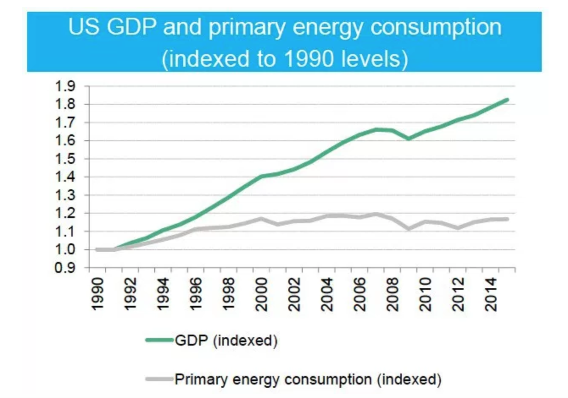

GDP and energy consumption indices over a 14 year period

The US is potentially following a desirable trend in showing that it is possible for a country to decouple its GDP and cause for its positive change without drastically increase the consumption. Other countries however, show a trend in which energy consumption is strongly related to an increases in a similar fashion to GDP. The table below shows how the rapid increase in China’s national development resulted in equal rates of changes both in economic growth and energy consumption.8

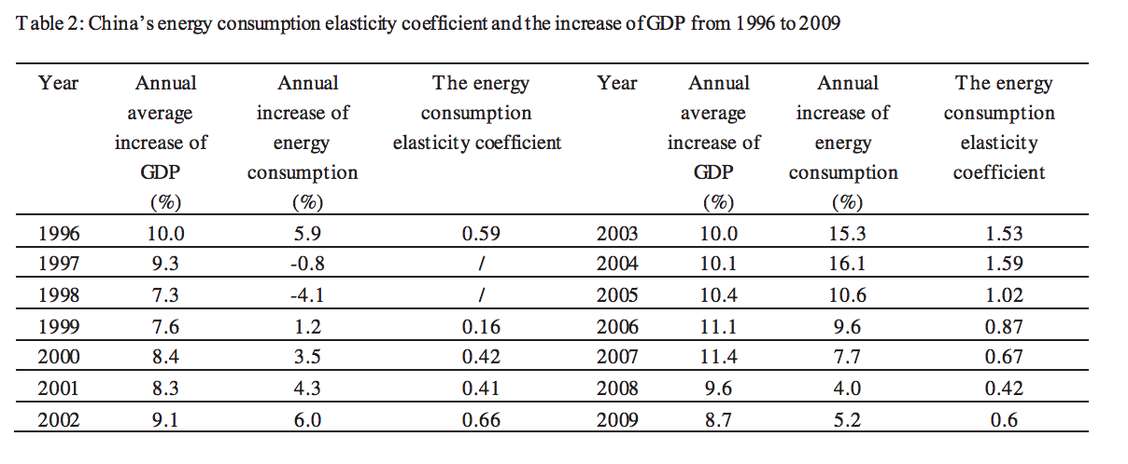

China’s economy is heavily dependent on its energy consumption, which is shown in how the two changes are related to each other based on an increase or decrease in economic growth. The elasticity between the energy growth and economic growth, particularly between the years 2003 and 2004, are strong indicators of this relationship. In this report, we further elaborate on trends to explain the economic - energy relationship between select countries of the study. The figure below shows how the world GDP and world energy consumption has changed over the past 50 years and its prediction towards the year 2035.

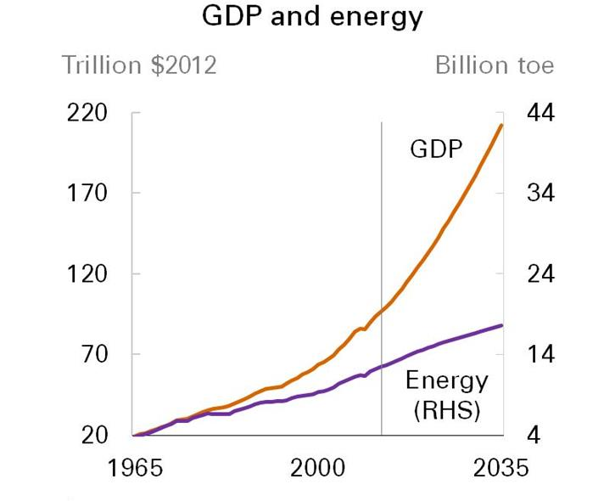

Figure B4: GDP and Energy Prediction 2035 by BP

Steve Kopits (energy analyst and frequent contributor to the discussion at Econbrowser) raised an interesting observation. He noted that forecasts of the potential for future energy production by the companies that many may be counting on to meet future energy demand appear to be inconsistent with the relation between energy use and GDP growth that held for the last 40 years. For example, for the next 30 years [ExxonMobil is](http://cdn.exxonmobil.com/~/media/Reports/Outlook%20For%20Energy/2014/2014-Outlook-for-Energy-print-resolution.pdf) anticipating an annual world GDP growth rate of 2.8% per year with only 1% annual growth of energy production, consistent with an income elasticity of 0.35, half the historically observed 0.7 elasticity. [BP](http://www.bp.com/content/dam/bp/pdf/Energy-economics/Energy-Outlook/Energy_Outlook_2035_presentation.pdf) has a similar forecast28. Every joule of energy saved is a joule of energy gained. This forecast, if it turns out to be as expected, is a huge gain for the whole world as to amount of energy saved and also establishes the fact that GDP of a country can grow without a growth in energy consumption.

**Scope/description of the research**

HDI, GDP PPP, Income inequality, Human Inequality and Income indices, energy consumption are the data required for performing the analysis of the relationship between the various parameters considered. These were downloaded from the United Nations Development Programme. Energy consumption and production data were downloaded from the US Energy Information Administration (EIA).11 Population, Gross Domestic Product in US $ were obtained from the World Bank,29 where this information can be downloaded and manipulated for public use. The data for GDP and HDI relationships span from 1990 to 2010 in 5 year intervals (limited due to GDP PPP provided), and then from 2010 to 2015 annually. For energy consumption and production, data was recorded annually from the EIA database, and significant data of interest was used from 1990 to 2013 (due to limitations of available statistics).

The countries of interest were selected based on interest of the team members, high and low ranking social progress and human development rankings, region, and size. It was desired to make the data set as broad and as inclusive as possible to give a larger view of the variation of these factors and indices.

**Method of the research**

The GDP (Gross Domestic Product) can be equivalently calculated in three different ways: either by the sum of all income earned by a country within a year, sum of added values to a country within a year, or as the sum of the income consumed during the year.11 The GDP PPP (Gross Domestic Product purchasing power parity) is a standardized GDP to internationally compare wealth between other countries using purchasing power parity as a reference. The Human Development Index, or HDI, is a measure of the average achievement of a nation’s development, using the mean of three core indices: life expectancy, education, and gross national index. The parameters for the HDI rank are life expectancy, expected and mean years of schooling, and gross national income per capita. Our approach for connecting the following parameters involves finding the most recent data collected for the countries of interest for this study. After deliberation, the following countries were selected: United States, Canada, China, Australia, Brazil, Mexico, UK, Russia, Germany, Norway, India, Bahamas, and Trinidad and Tobago.

This paper will begin with a thorough analysis of relationships between GDP and GDP PPP, inequality indices, income indices, and HDI for these countries, and the trend of GDP over the past 10 years, and give explanation for these variations in the GDP. Additionally, a study of our own constructed trends to compliment this paper, as well as a critique of the methods and assumptions used to measure inequality and HDI, will discussed in detail. The data for the HDI over the past 15 years is obtained from the United Nations Development Programme Human Development Reports. If explicit GDP values cannot be found, then we can use OECD as well as the World Bank and the US Energy Information Administration to collect data for the GDP, population, and energy consumption of a nation. Although analysis of each country’s trends is key, multiple countries with the same trend will be plotted on the same axes to save space in graphing and in making it easier to reference to a common figure.

**Results and Discussion/Validation of Results**

**Case study: Relationship between GDP and HDI**

Figure A below shows the HDI trend as a function of the year over the past 15 years (excluding 2016 and 2017, will be redone in Excel for legend labeling). In the course, a discussion arose from the Index value and how they vary amongst countries, and from the reasoning behind the variation over the years. The dependent variable is HDI, and the independent variable is the year

**Figure A** - HDI vs year for selected countries

An important point to note is that countries have respective HDI ranks from highest (1) to lowest. It appears that for most countries, there is a steady increase in the index, which means that for the countries in this set, the standard of life is increasing by providing social and economic amenities. One could argue that this is due to a more equal distribution of wealth among the citizens. Speaking from my own observation, even though there is data missing for the Bahamas’ HDI from 1995 to 2000, this trend is not surprising, as the standard of living has not changed much, and the economy growth is very minimal due to a strong focus in social industries such as tourism, banking, and sustainable/local fishing. Comparing the Bahamas to Trinidad and Tobago, that has excelled educationally and economically due to its energy export, it could be said that there is a correlation to economic growth and the HDI of a country, a potential measure of a country’s wealth. The Bahamas having a higher HDI than Trinidad and Tobago could be due to the social indices and life expectancy indices used in the calculation. Table A below shows the ranking of the HDI and GDP of these countries from 2015 indices and 2011 PPP $ of these countries, respectively.

**Table A: HDI rank of countries in study and respective GDP PPP**

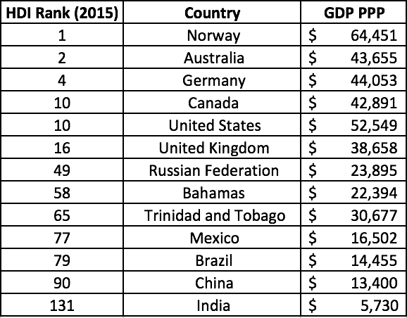 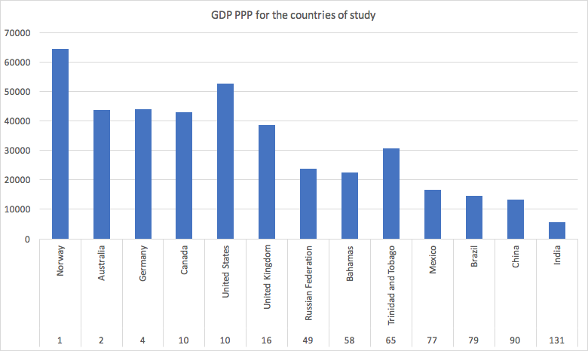

Using the UNDP Human Development Data, the GDP PPP of each country of interest is measured as well in Figure B. Most countries on this list have had a steady increase in GDP except for the Bahamas, for reasons discussed previously. At one point, the GDP PPP of the Bahamas was higher than that of Trinidad and Tobago until their country discovered off shore oil reserves. However, what is quite interesting is that the Bahamas still has a greater HDI than Trinidad and Tobago. Perhaps it is within good reason to account for other indices when measuring wealth and human development.

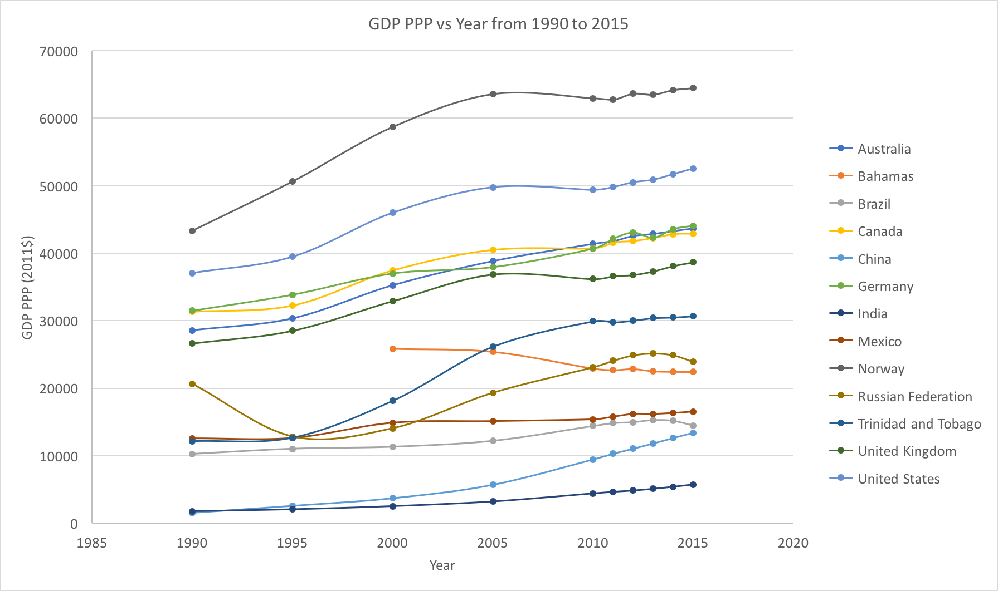

**Figure B** - GDP PPP vs year for selected countries

Finding the GDP PPP for the countries of interest, we can study the effects of changing parameters that may factor into how a country’s income varies. Moving forward, we can modify the data to simply plot and observe what happens to the Gross National Product when the Human Development Index changes yearly. This can also be done for energy expenditure, income, and inequality indices. A point of interest is seeing if regardless of the country, we can derive a function that describes the HDI based on the GDP, and if a clear trend isn’t present, then include how the other indices can improve the model analytically.

The figure below shows the relationship between GDP PPP and HDI for the 13 countries of study. What’s interesting to note is how it changes for specific subsets of countries, showing how the change in HDI leads to a weak effects on GDP for developing countries, and a stronger

effect on GDP for developed countries. This became evident by grouping the countries based on the ranges by which their HDI varied. It also shows that the HDI could be a possible factor that can predict the GDP of countries, which isn’t surprising as GDP is accounted for in the calculation of HDI.

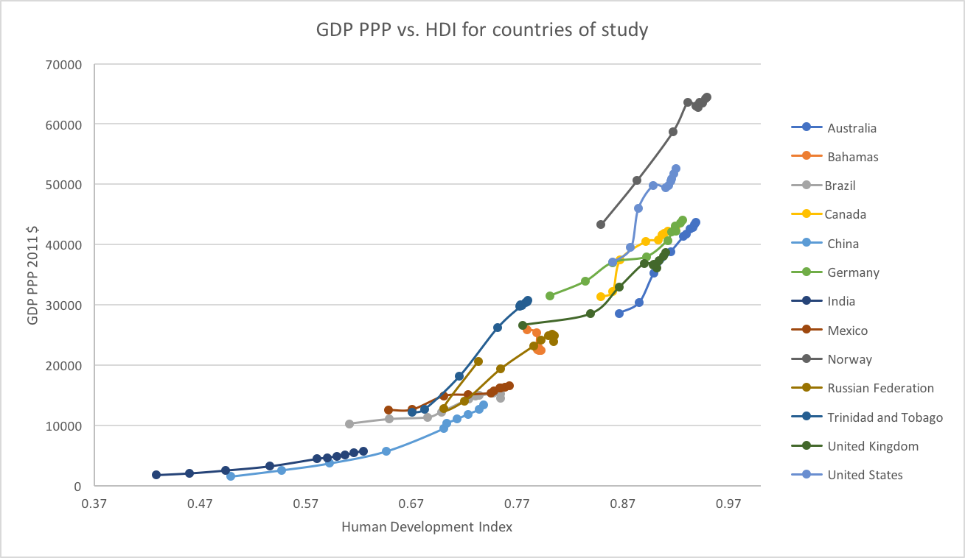

**Figure C** - GDP HDI relationship between countries of study

An immediate intuition leaded to plotting all of the GDP PPP data values together with all of the correlating HDI values to see how well a polynomial, exponential, or power law fit can accurately predict what a country’s GDP is based on its HDI, and how GDP can change depending on an increase or decrease of HDI. Figure C1 below shows the resulting regression analysis to theoretically fit GDP as a function of HDI.

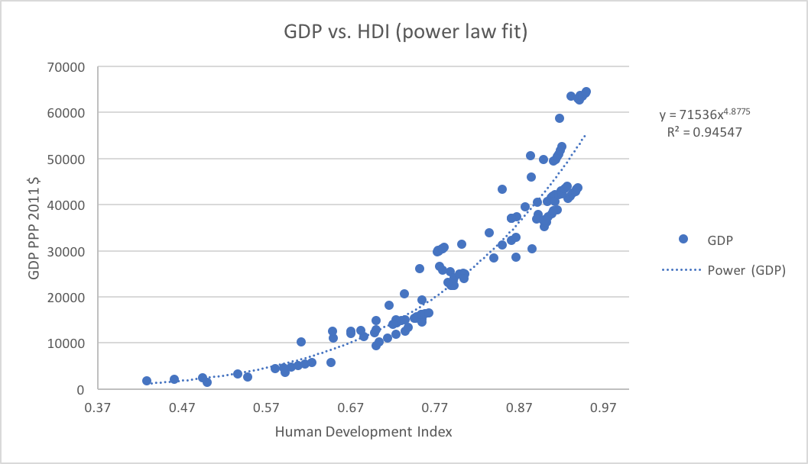

**Figure C1** - International relationship between GDP and HDI for countries of study

After performing analysis using different types of function, the best fits were obtained from using both power law and exponential fits. It’s always interesting to see an exponential function fit data due to its constant application in mathematically describing natural phenomena, and so one could ponder if the international relationship between GDP and HDI is an expected relationship. The power law expression was chosen due to its slightly higher R2 value, where the GDP PPP as a function of HDI gives the following fit expression for power law and exponential functions, respectively:

Figure C2 below is of the same plot, but showing that we can forcibly express the power law as a log-log plot, to portray this relationship as a linear trend.

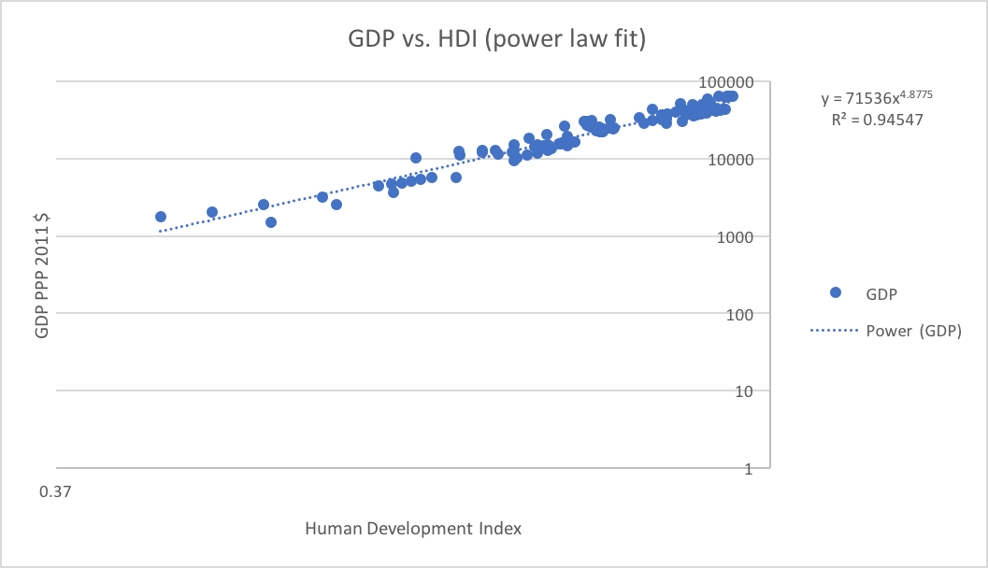

**Figure C2** - Log-log plot of International relationship between GDP and HDI

Understanding now that there is a clear relationship between GDP and HDI that strongly depends on how great the change in HDI is as well as where a country’s HDI is initially placed at, it is desired to further examine how specific factors of the HDI can affect the GDP PPP, and if they do so in a similar fashion as the GDP.

**Case study: GDP and relationship between energy consumption, inequality and income index**

First, it is important to show how the coefficient of inequality and income inequality changes throughout a time interval. Figures D1 and D2 below show this trend from data taken from the United Nations Development Programme. The trends between the coefficient and income inequality are very similar, so reasonable to assume the income inequality heavily affects the value of this coefficient when it is calculated.

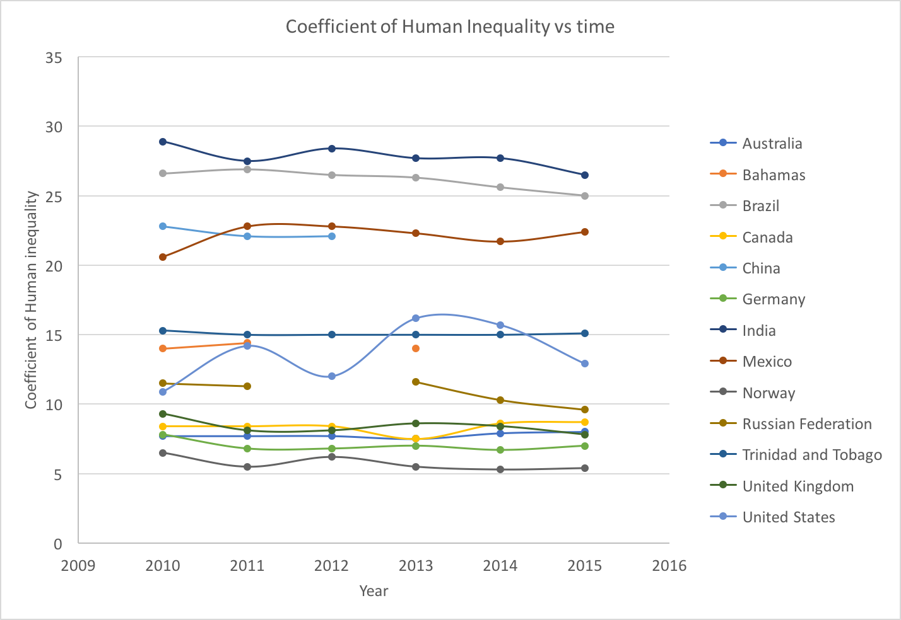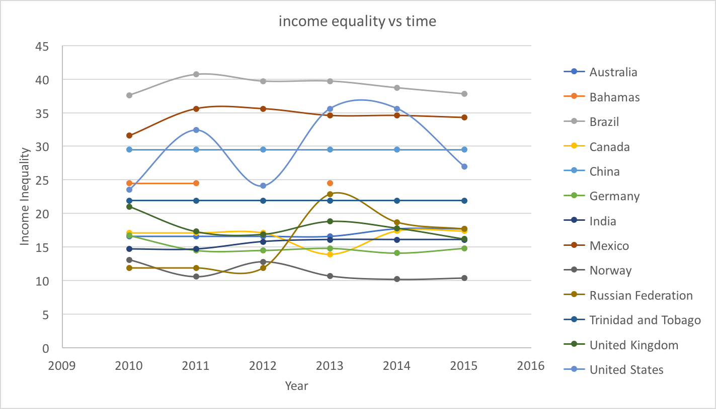

**Figures D1 and D2**: Inequality and income inequality from 1990 to 2015

Obtaining the coefficient of human equality and measuring it against the GDP for the countries of interest, it is evident that the inequality index changes very little as a function of time, which leads to the conclusion that in general there is no clear relationship between a country’s GDP and its inequality measure, which shows that GDP isn’t necessarily a good indicator of the distribution of wealth across a population. Figure E1 below shows this plotted trend from data points from the 13 countries, which further validates this claim of wanting to use GDP PPP to measure a country’s specific wealth.

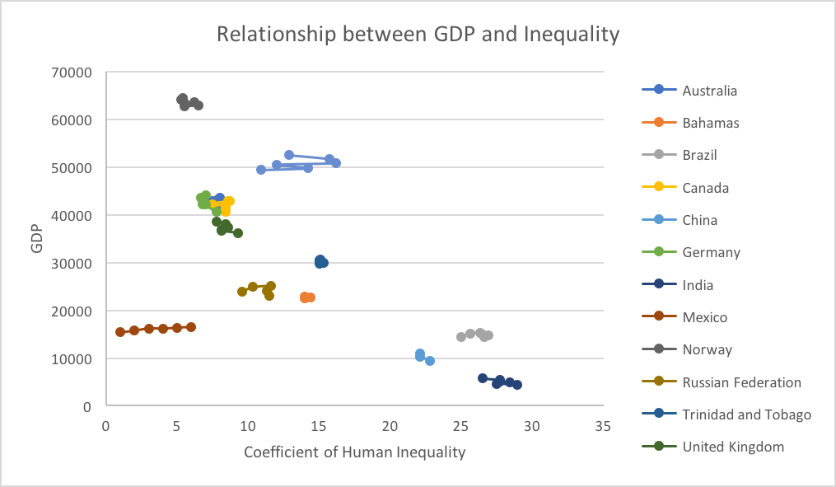

**Figure E1** - GDP PPP vs Coefficient of inequality

From this, there are a few points to make regarding how and where trends lie on this curve. Data for countries are tightly clustered together along the x axis, which shows that GDP isn’t a good measure of inequality or how it might change for a country. Even with small changes in inequality, it barely changes the GDP of a nation, so this means that perhaps another index forms a better relationship with GDP. Additionally, if data from Mexico and China were removed from this plot, it could be stipulated that in general, high GDP correlations to low inequality amongst citizens, and high inequality is measured in poor countries in the bottom right.

To further enforce this viewpoint, Figure E2 shows how the income inequality (a more economical measure of the distribution of wealth) relates to the GDP PPP. The graph bears a similar nature that could in principle be of a negative exponential fit, but outliers in the data from China and India, make this sort of trend analysis impossible unless the data points are removed from the study. Perhaps due to these countries being the two most populous in the world, it is difficult to classify a trend on inequality.

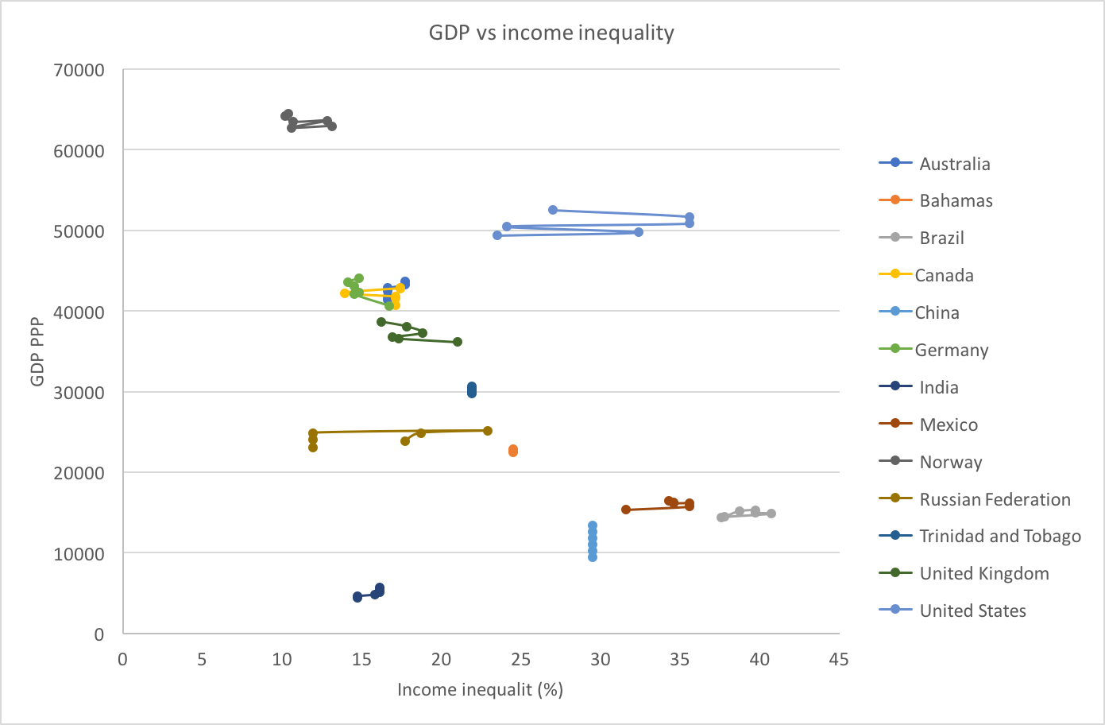

**Figure E2** - GDP PPP as a function of income inequality

**Case study: GDP and energy consumption and production**

It is claimed that the more energy consumed and generated by a country, the higher its standard of living and economic progress. Using information from the US Department of Energy: Energy Information Administration, we can obtain both the energy consumption and production of a country, and see how these variables correlate to the wealth of a country, which is typically measured in either GDP or GNI, where the GNI is the gross national income of a country. Additionally, with the trend noticed between HDI and GDP, it would be beneficial to see how energy imports and exports alter a country’s development. If so, another worthy investigation would be of happiness index affected by a country’s energy usage. A proposed hypothesis is that energy production correlates with GDP, and energy consumption doesn’t for particular countries. Additionally, there may be regions of HDI and happiness that do not scale well with using energy consumption as a parameter.

First, we use collected energy consumption data and apply it to the countries of interest. Figures F1 and F2 below shows how the energy consumption and energy generation has changed over time from 1990 to 2015. The variance in these energy trends are relatively high, which isn’t surprised due to the nature of variance in most of the data processed so far in the report.

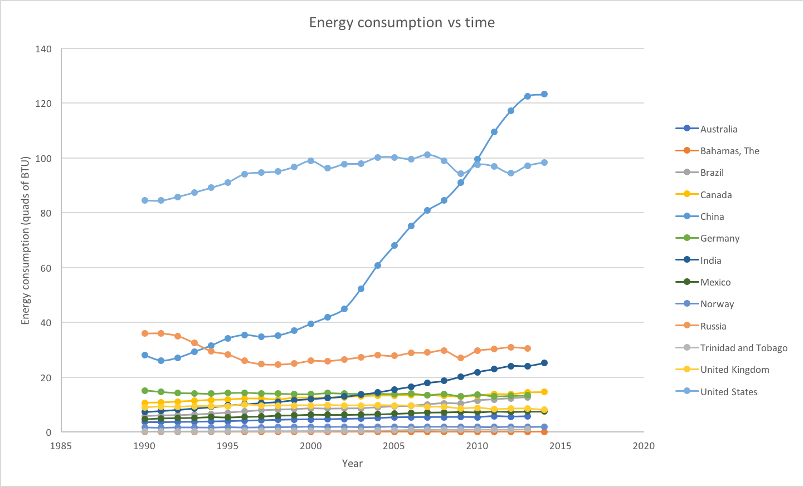 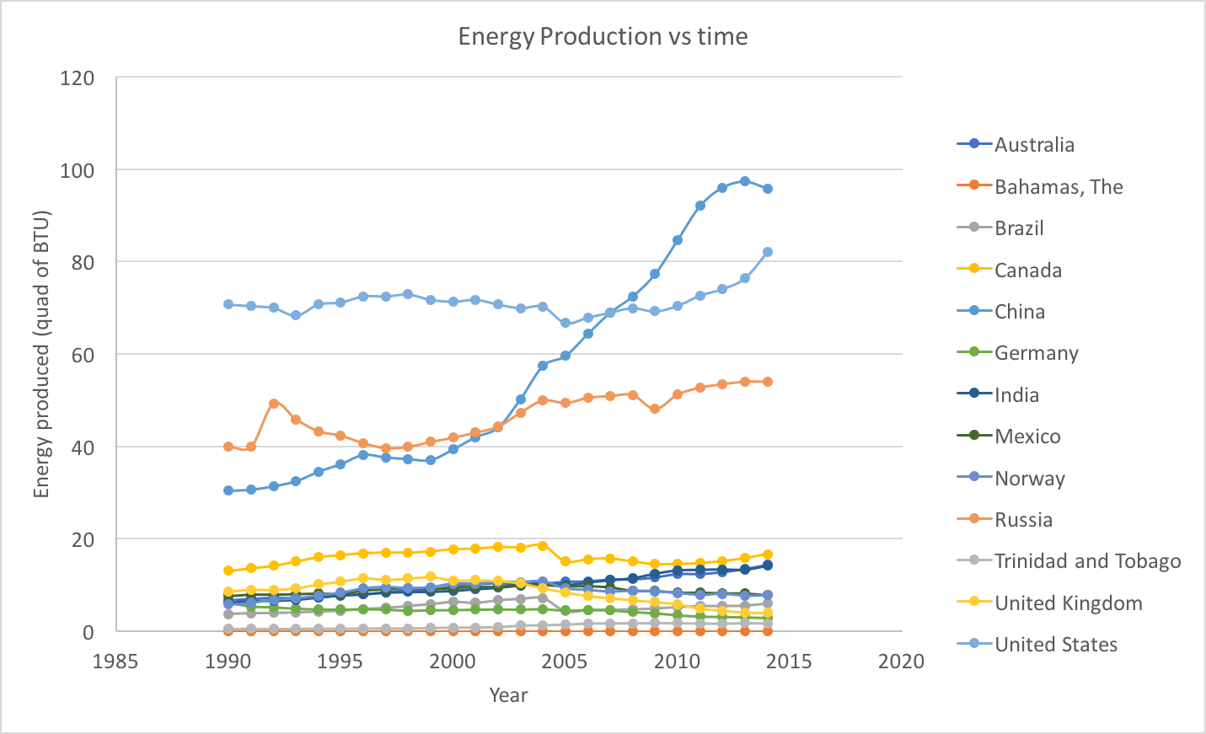

**Figures F1 and F2**: Annual energy consumption and generation from 1990 to 2014

The figures above demonstrate that countries that produce large amounts of energy also consume large amounts of energy. Most countries are at a point where they produce just as much or less than what they consume. Particularly for the US and Russia, both countries experience similar fluctuations in consumption and generation; their energy production is directly related to their internal consumption. A general comment is that countries generally encounter similar changes in both consumption and production. An explanation for the consumption can arise from the advances of technology, the growth of both population and economy, and the modernization of cultures. One might claim that GDP changes can be affected by such an increase. Energy generation is not so easy to predict, nor is it as malleable, as this depends on what fuel sources a country already has or discovers. Also, a country may implement renewable energy sources, which will be shown to usually have a small effect on energy generation except in developing countries.

Energy consumption and generation can be compared to GDP and from this, we can determine if energy in general, plays a role in what the GDP is. To perform this analysis, and based on what was found above, the countries will be placed in 3 groups for visualization purposes based on their GDP, in order to clearly observe yearly trends in this data. First, the countries with the highest HDI ranks of this study will be considered: United States, United Kingdom, Norway, Germany, and Australia. Then, the countries with middle ranking HDI ranks will be studied: Trinidad, Bahamas, Canada, and the Russian Federation. Finally, the lower ranking HDI countries are compared: China, India, Mexico, and Brazil. Additionally, GDP data will be expressed in US dollars from the World Bank database.

First, a detailed analysis is performed on the highest HDI ranking countries of interest. Knowing that they are developed, modernized countries, we can expect a similar trend that can help with describing a relationship between their GDP and energy consumption. The population data of each country and its GDP PPP has been collected from the United Nations Development Programme. We can easily compute the per person energy consumption by finding the ratio between total energy consumption and the population for a specific year. For energy consumption/production and GDP, it will be strictly on a yearly basis, as opposed to the analysis of HDI and GDP, where data was initially from 1990 to 2010 in a 5 year interval, and then yearly from 2010 to 2015. Figure G1 below shows how both energy consumption and generation affects the GDP of a country.

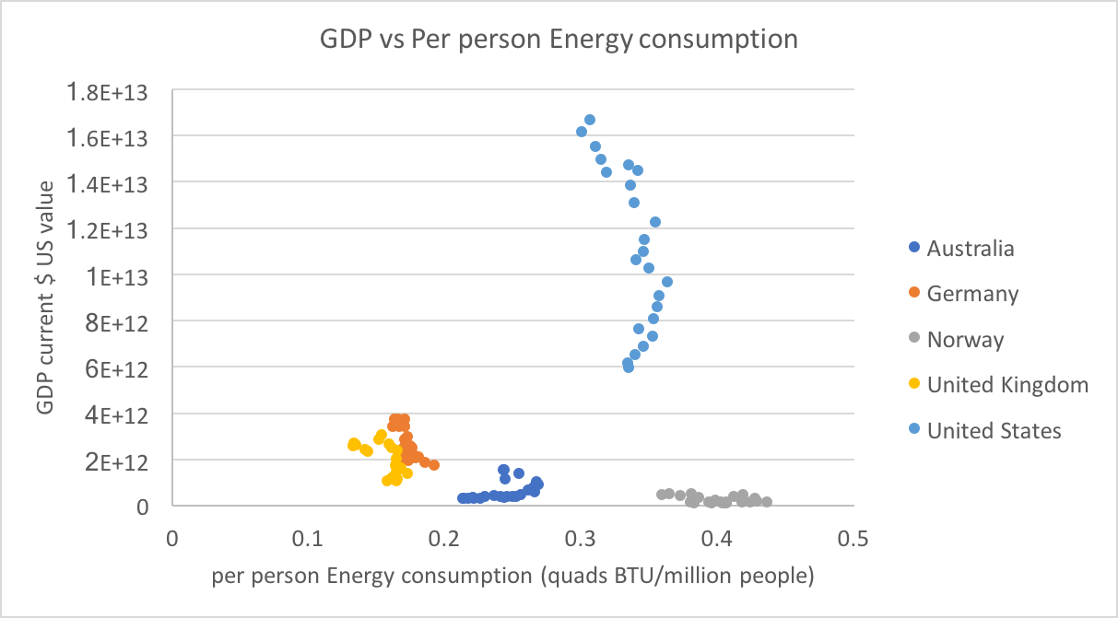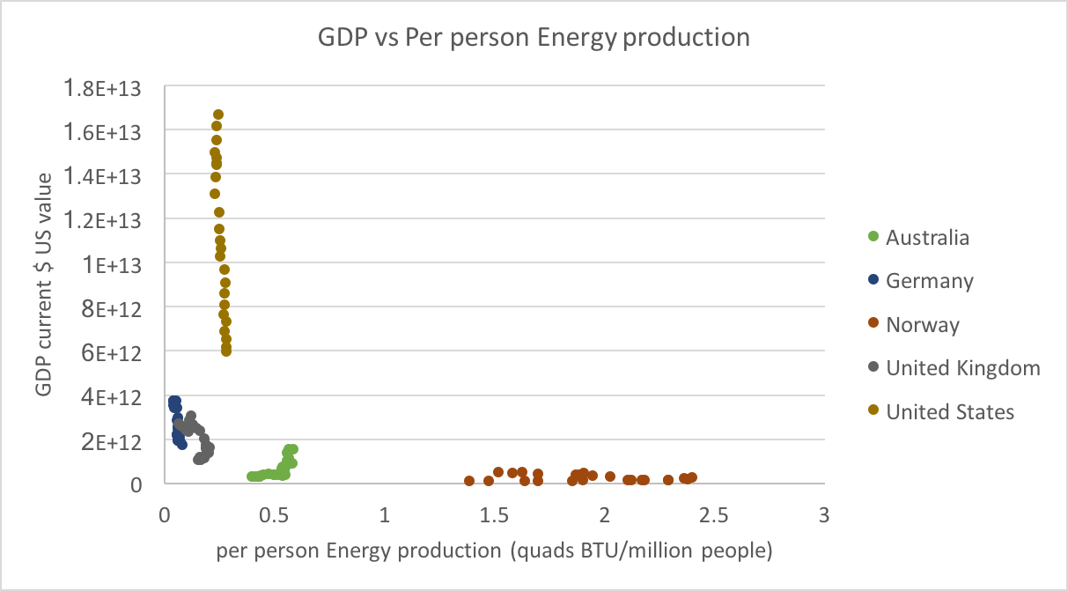

**Figure G1 and G2** - GDP PPP vs energy consumption and generation for developed countries

A common feature between both these figures is that Norway produces and consumes more energy per person than any other developed country on the graph. The production seems reasonable as Norway has also invested in many other renewable sources of energy. The large rate of consumption is most likely due to having an excess of energy at a reasonable price that its citizens over consume as a result. However, a change in how much energy Norway consumes or produces leads to very small changes in its GDP. Looking at the opposite trend in the United States, having small changes in energy consumption or production correlate with drastic changes in the GDP. This goes against an expectation of Norway consuming a much smaller amount of energy than the United States. It is known that the US uses much more energy than the average country on a per person basis, and this graph validates that. Now, we look at the countries with middle ranking of our study. Again we expect a similar trend between these countries, as measured before.

Germany and Britain show stable GDPs over the past few years that seems to be slightly dependent on a change in the energy consumption and production of its citizens. Australia shows almost no changes in GDP due to energy consumption, similar to Norway. If energy consumption and production both don’t lead to a consistent correlation of GDP in developed countries, then what is possibly a better indicator of GDP? Perhaps using the HDI is a more encompassing measure of GDP, and other parameters and variables can be back calculated from such a result. We now turn our interests to middle developed countries based on HDI values, and see if they generally relate to accurate changes in the GDP. Figure H1 below shows the per person energy consumption and generation computed from these smaller and relatively poorer countries; nations with median development success.

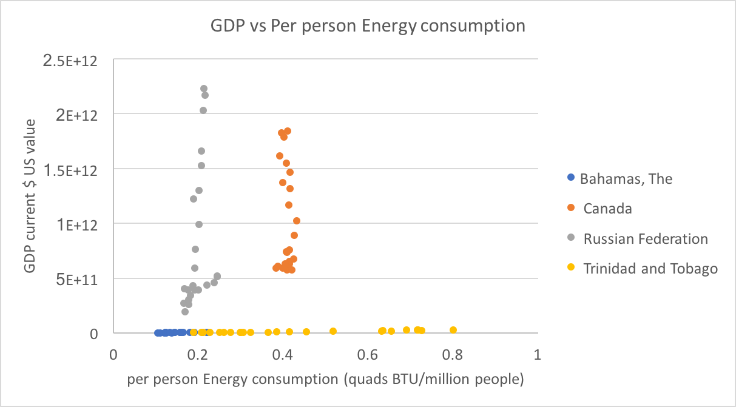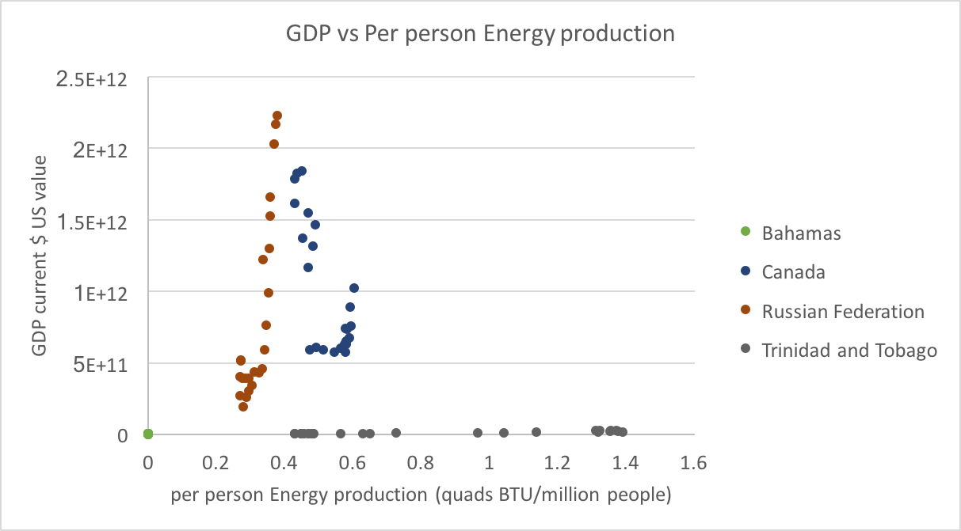

**Figure H1 and H2** - GDP PPP, energy consumption and generation for less developed countries

What’s interesting is how the production of a country’s fuel sources can be correlated to its consumption. For larger more developed countries with the capability to produce energy for export, there is a strong correlation to its GDP, which means a generous percentage of a developed country with huge fuel reserves make up its national income. Countries like the Bahamas and Trinidad and Tobago produce very little fuel exports, and thus have less variance in GDP as a result; their national incomes depend on other factors excluding energy exports. Another interesting thing to note is the complexity of the comparisons made. Even if energy production increases, there can still be positive or negative changes in the GDP, which shows that there are many other factors (primarily decision based) that play in role in deciding a country’s wealth.

To elaborate further on both these Caribbean countries, the Bahamas produces little to no energy for exports or any other purposes. Although it is predicted that oil reserves may exist in territorial waters, environmental concerns arise due to the fear of dealing with the establishment of a new unexplored opportunity like offshore oil rigging. Additionally, particularly on Grand Bahama, where most citizens are limited by a Port Authority that regulates and prohibits renewable energy technologies, this has greatly limited the ability for a country like the Bahamas, even in proximity to just a developed country like the US, in being able to promote sustainable development in the energy industry.

Trinidad and Tobago have a different situation with similar results. Even though the country extracts its oil reserves and uses it as a fuel export, these reserves are limited and do not allow it to compete with nearby export tycoons like the US and Venezuela. As a result, it has to result to other means to contribute to stabilizing and increasing its GDP. Canada and the Russian Federation share similar relations to the US, but not to that of Australia and Germany. This may be due to how much of the consumption is internally contribution to its energy production, and how much can be distributed as export. Canada with oil shoals and Russia with huge fuel reserves have the ability for its energy production and consumption to greatly affect its gross domestic product.

The GDP and energy consumption/production of developing countries will now be considered. As shown before, there seems to be a relationship between how much oil exports a country can send out and how its GDP can change as a result These are countries with the lowest HDI rankings of our study. Figures I1 and I2 below encompass these relationships.

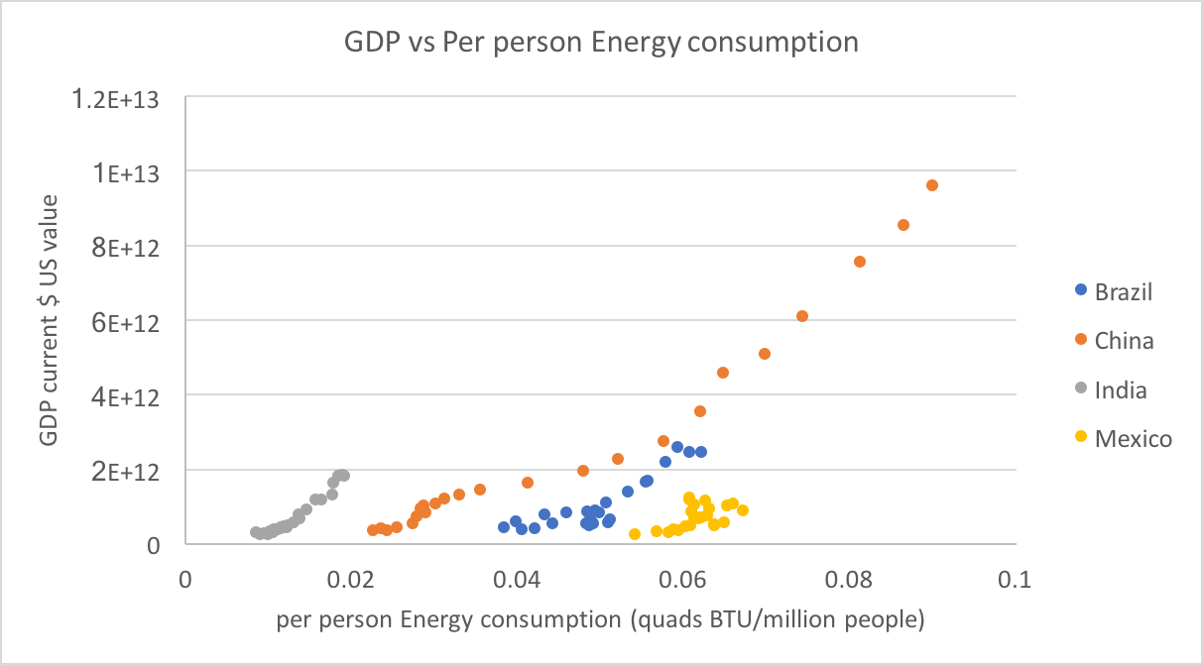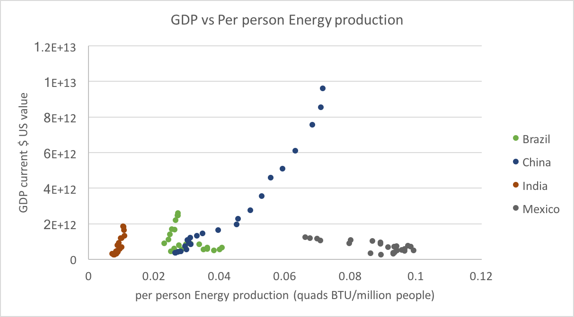

**Figure I1 and I2** - GDP PPP vs energy consumption/generation for developing countries

Developing countries show positive relationships between their per person energy consumption and GDP. Developing countries may see an increase in energy consumption as a strong indicator of economic growth of wealth. Low per person energy consumptions are strong indicators of the developmental standing of a country, and hence, its HDI. China has shown outstanding growth in the energy usage and shows its push towards modernization, which shows it could eventually reach a developed country status in the near future following the trend shown. For China, increasing both consumption and production show great progress in reaching its goal of increasing GDP. India and Brazil show slow changes in GDP due to energy consumption. India’s consumption and production per person is very small and is reflected in its low GDP. Additionally, these rates lead to the conclusion that energy is a negligent contribution to GDP as the country has placed focus elsewhere in increasing wealth. The consumption and production seems to be all internal, where India consumes most of its produced energy, which most likely are in the form of biomass and other renewable sources. Based on the production GDP relationships, India could greatly benefit from producing more energy to increase GDP.

Based on the consumption alone, there seems to be a general rate of change in the range of lower GDP values for all the developing countries in this study. China’s consumption just shows how the function can change if extended into an increasing GDP. Brazil’s variance in GDP shows that the consumption either has no effect on GDP, or can have a slight effect on it, displaying the fluidity of these parameters in relation to complicated quantities. In general it seems Mexico’s energy usage and generation has no effect on its GDP. The per person energy consumption and production in this case indeed shows an increase in GDP, and energy seems to be a good way to observe economic growth. After trying to separate countries based on their development, tying it all together to see if nations have a smooth function between their grouping based on energy consumption and generation.

Another topic of interest is seeing if energy consumption and product relate to changes in the HDI, which may be important in indicating how a country is modernizing itself. Plotting such values against each other can give insight into how energy can impact the development of a nation. For formatting purposes, the figures for the first two subgroups will be left in the Appendix of this report, and the data for the developing countries will be illustrated in Figures J1 and J2 below.

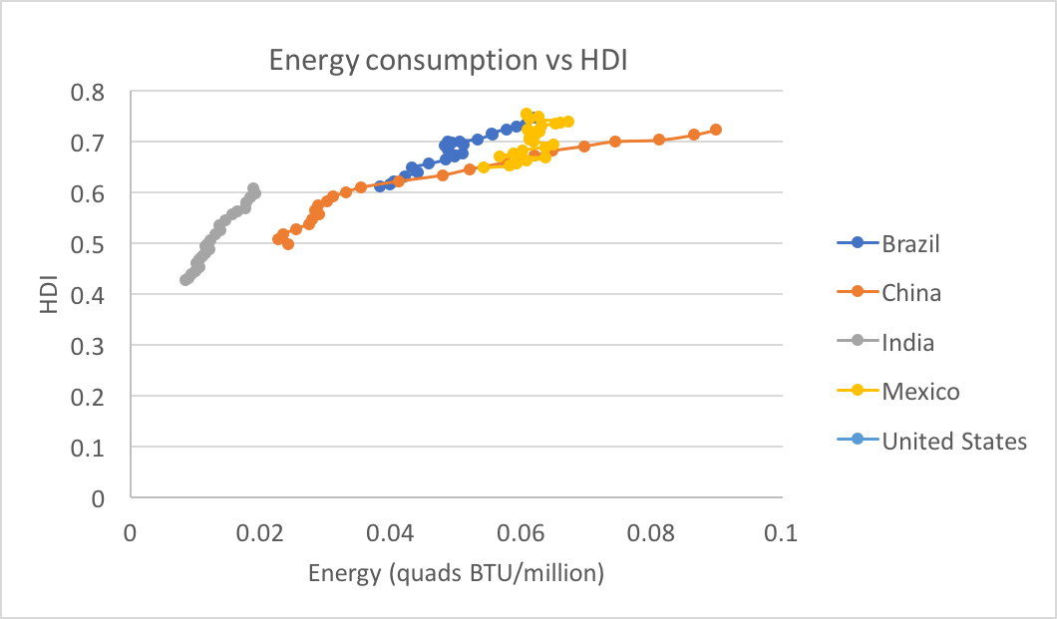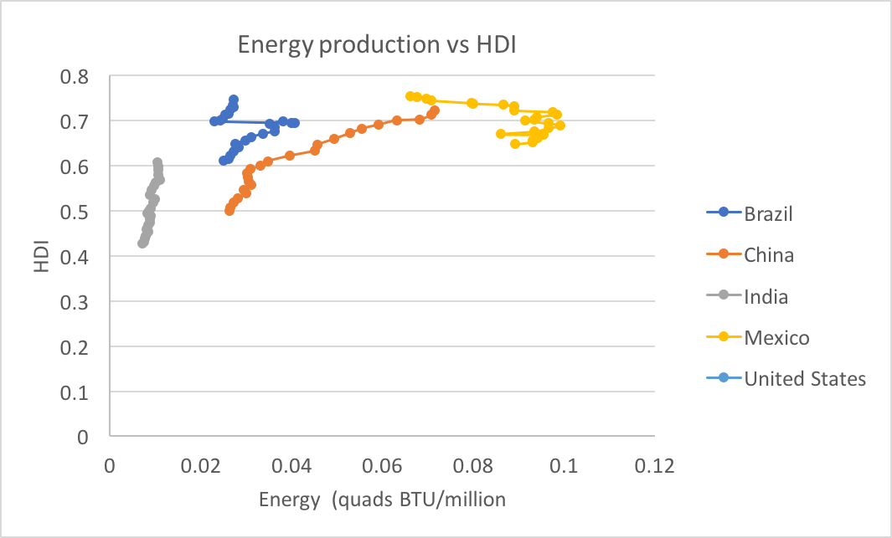

**Figure J1 and J2** - HDI vs energy consumption/production

As stated before with respect to GDP, India could benefit in development by increasing its energy inputs and outputs. Particularly with developing countries, there seems to be a common trend in which energy usage is a good indicator of development and how it can change if the usage is changed. Countries like China, Mexico, and Brazil can steadily become more developed based on an indicator like energy. For lower ranking HDI countries, it generally appears that energy production and consumption is a strong tag for human development. In appendix figures A1/2 and B1/2, the trends for the higher and middle ranking HDI countries based on consumption is shown.

From the developed countries, similar conclusions are made based on the relationship between energy and wealth of a country. Germany and the United Kingdom stand to see steep changes in HDI if they can increase energy production and consumption. Australia, Norway, and the United States have reached a threshold where they have to explore other ventures to increase GDP outside of the energy sector.

Less developed countries experience a steady growth in HDI due to consumption and production. The Bahamas could benefit from its subtropical climate in order to produce energy via renewable means, despite such a high capital in a particular investment. Canada, like the other developed countries is at a point in development where it no longer needs to change how energy is dealt with to increase HDI. Trinidad and Tobago shows a gentle growth of HDI due to its energy dealings; the country could put focus on other social and economic factors that can lead to better human development. What is puzzling is that for such a small country, it produces more energy per citizen than most nations. Even with this advantage of having fuel reserves, it has failed to cause a jump in the country’s standards of living and change in standards for its citizens.

To generalize, if a country can produce a large amount of energy from initially little to no energy reserves, a large change in HDI can be experienced, however, this effect is limited and converges to a steady and then negligible change in development. Logically this makes sense as energy dealings are not the only factor that plays a role in a well-functioning society, although it is a major portion of it. Overall, for countries with lower HDI values, energy consumption and production are indicators of positive human development.

A conclusion to make from this data involves how energy consumption can be lowered in order to maintain or increase the GDP. The answer to this question depends on the country and its preexisting development. Certain countries can have varying per person energy consumption while unchanging the GDP, so it’s simple to conclude that this reduction won’t affect their economic standings. Certain countries have strong GDP energy consumption relationships, and the answer to how energy consumption can be modified while changing the GDP is again difficult to answer. Countries like the USA and China, that seem to experience growth in GDP with growth in consumption, must question what other resources the country is willing to use to give larger contributions to GDP growth. In the US, a significant contribution of GDP growth does in fact from consumption.

Socially, changing the HDI and focusing on aspects that factor into the value and how it’s rated against other countries, one could say that development of a country helps with increasing the rate of educating citizens and decreasing unemployment. From what has been studied, consumption and production seems to strongly depend on each other, and from there, it can be noted that a change in a country’s own energy production can indirectly decrease its consumption. Due to this strong relationship, increasing production increases consumption if the price of energy as a result decreases. Decreasing both energy consumption and production to keep the GDP the same or increase it (especially as a country with a large economic dependence on the export of fuels) is highly unlikely. The best approach would be to note how increasing production can help the economy, and looking to cleaner sources of fuels, can lead to the greatest sustainability for both developing and developed countries.

Finally, an analysis on how happy citizens are with respect to how much energy is available to them is appropriate. Four questions are to be answered in regards to happiness. Does a change in happiness correlate with changes in energy consumption? Can happiness indicate development of a country; is development even needed to make citizens happy? Can we examine the countries from a modern perspective of interest and see how they scale against each other? Is happiness measured accurately amongst countries; do countries have different meanings of the word ‘happy’? What is the social progress index?

The World Happiness Index provides a happiness score to each country. The World Happiness Index report for 2017 has been released and openly provides this data. There are several differing contributes that lead to the summation of the Happiness score: GDP per capita, Social support, Healthy life expectancy, freedom to make life choices, generosity, perceptions of corruption, and dystopia with a residual added to each score. The WHI can be compared to energy usage to see how happiness is changed by it. Figure H1 and H2 below show how HDI and energy consumption vary based on a country’s happiness score.

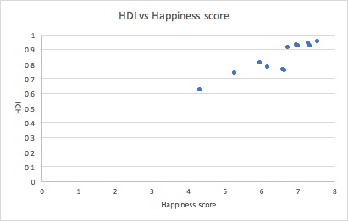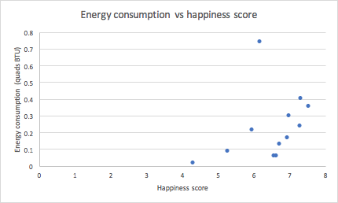

**Figure H1 and H2** - How happiness affects development and energy consumption

The first thing to notice is the linear scaling between HDI and happiness, which shows that HDI can be an effective measure of how happy a country is. If modern amenities are provided and citizens have access to basic human rights and freedom of opinion and choice, then this provides a foundation for the positive growth of a country. In general, energy consumption can be reflected in the happiness as well, seeing the a comparison of the per person energy consumption shows that the more energy a person can consume, the happier they become.

Of course, there is a limitation to this, and determining the maximum amount of energy a citizen of a specific country needs can be crucial for a government to make important social and economic decisions. This does however show the complexities of the comparison; even though Australians and Russians may consume the same amount of energy, their happiness scores varies by almost 2 points, which shows how other political factors can affect the happiness, and how energy may not accurately portray happiness.

**Case study: India**

The below trends and descriptive statistics about India reveal the fact that GDP has a negative correlation with increase in energy (Skewness is negative).It has a positive correlation with electricity, Lignite, Petroleum and no correlation with natural gas while other parameters have a negative correlation with Natural Gas. This shows that GDP alone cannot determine the progress of a nation20.

Furthermore, the IHDI takes into account not only the average achievements of a country on health, education and income, but also how those achievements are distributed among its population by “discounting” each dimension’s average value according to its level of inequality. India has 0.624 and stands 131 among the lower developed countries of the UN’s list of IHDI21.

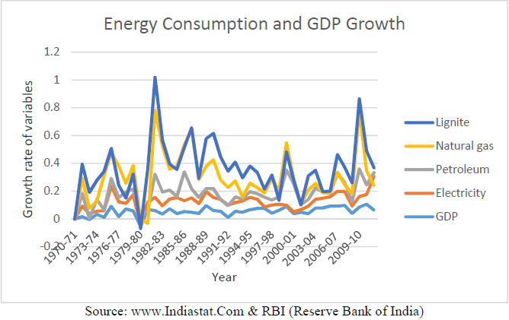

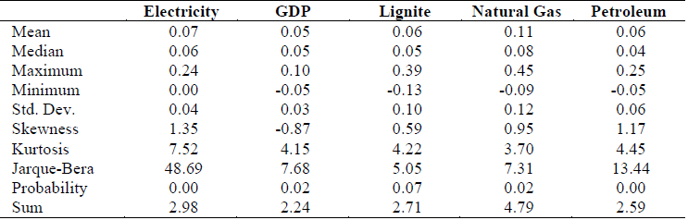Table21: Descriptive Statistics of GDP vs Energy Consumption

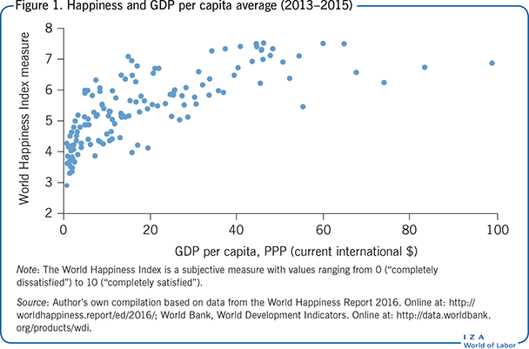

Figure I118:Happiness vs GDP PPP

**Case study: Happiness**

GDP does not increase with increase in with happiness. On the contrary, happiness index is high in countries in where GDP is low. An advantage of GDP is the extent to which it is based on tangible measures, such as the quantity of goods produced. Other measures, such as happiness, depend to a greater extent on components that are more difficult to conceptualize and assess. However, this dichotomy is becoming less clear, as GDP itself depends more and more on the quantity of services produced and intangible elements that are estimated using more subjective methodologies than the quantity of goods produced.

Additionally, even the “quantity” part of the quantity of goods produced is a less certain measure, as it is quality-adjusted to a significant degree, particularly for technology-intensive products, such as semiconductors. Continuing and intensive research by both government and private researchers is therefore needed to maintain GDP’s accuracy as a measure of economic activity in a rapidly changing world. This is one of the reasons why GDP cannot be used an indicator for the quality of life and other factors such as HDI should be considered.18

GDP is an indicator of a society’s standard of living, but it is only a rough indicator because it does not directly account for leisure, environmental quality, levels of health and education, activities conducted outside the market, changes in inequality of income, increases in variety, increases in technology, or the—positive or negative—value that society may place on certain types of output22.

Simon Kuznets wrote that the welfare of a nation can”, he wrote, “scarcely be inferred from a measurement of national income”. And this is because, as hopefully every economist also knows, it is easy to construct examples of undesirable social or environmental phenomena (crime sprees, oil slicks or hurricanes for instance) that can generate both an increase in GDP and a decrease in wellbeing23.

How does happiness affect Social Progress index? We begin by looking at the overall relationship between social progress and life satisfaction. We know that both are correlated with GDP per capita so it is not surprising that social progress is highly correlated with life satisfaction. But, the relationship is more robust than this: after controlling for GDP, there is a statistically and quantitatively significant impact of the Social Progress Index on life satisfaction.

In part, this result is reflecting the interplay between the Social Progress Index and GDP per capita: GDP per capita is correlated with Basic Human Needs and Foundations of Wellbeing, but has only a noisy relationship with Opportunity. This finding raises a more fundamental point: exclusive attention to economic indicators as a means for raising subjective well-being has the consequence of distracting attention from aspects of social performance such as Tolerance and Inclusion or Personal Rights which are more loosely linked to traditional measures of economic development24.

What is truly the best measure of a country’s overall well-being between HDI, Social Progress, GDP, based on happiness? From the above discussions on the relationships between Happiness and HDI, Social Progress and GDP, we can conclude that happiness is related to all of these variables and cannot be treated independently. Additionally, it is clearer that GDP or the economic progress of the nation cannot be the only factor deciding happiness index of a country as it does not account for the intangible values in life that count for Happiness. Finally, when comparing HDI and Social Progress Indicator, the latter would be a more closer fit to measuring Happiness of a country as an appropriate indicator of measuring a nation’s well-being.

Happiness in general, is not distributed evenly amongst countries. In developed countries like the US and the EU, people get access to basic needs of Health, Food and Shelter. These are the basic amenities for people to be happy. However people in third world countries like Congo and Namibia have severe malnutrition and no access to even toilets , food and water. Denial of these essentials creates a difference in happiness. Intellectual and emotional development tend to be low in people who are denied these resources and this leads to loss in physical and mental health, unemployment and ultimately loss in happiness.25

**Conclusion**

Observing the GDP, HDI, and World Happiness Index as a function of energy consumption and production of a country leads to trends that are as widely varying as the sample of countries we have studied. Our analysis allowed for an accurate connection between how the GDP and economic growth of a country can be modeled based on what its HDI is. In understanding the accurate representation between GDP and HDI, we showed how both these indices relate to energy consumption and production. We can generalize these relationships into 3 different groups.

First, there are countries that experience little to no changes in GDP as a result of changes in energy production and consumption. This is preferable as a decrease in energy usage implies progression in environmentally and socially productive directions, and can be experienced by countries with per person consumptions as low as 0.02 and as high as 0.6 qBTU/million people.

Second, there are countries that have strong dependences on consumption and GDP. The United States, for example, shows such a trend, however, it also shows that the United States, GDP can drastically increase or decrease even without a change in the consumption or production, even though it contributes heavily to the economic growth. This is particularly common in countries that produce/export large quantities of fossil fuels, usually ranging from per person consumptions of 0.2 to 0.6 qBTU/million people

Thirdly, there are countries that experience similar changes in both consumption and GDP. China, for example, is validated to experience economic growth as a result of increases in energy consumption. Despite such a large change in GDP, China’s per person consumption is indicative of its developing country status, with a per person consumption of less than 0.1 qBTU/million people, but at the rate it’s proceeding, the Chinese government may realize that they lose the positive relationship between these two variables, and result to looking for other methods to increase the GDP. This is a dangerous observation used by China to indicate economic growth, and in the long term is neither sustainable nor feasible.

Happiness is one of the key measures of a nation’s well-being. Happiness is not measured by the GDP of the country, rather it is measured by the Social Progress Index and partly by the HDI as well. Social Progress is a better way of estimating happiness of a country as it addresses the basic needs of people being satisfied rather than HDI which simply measures the current resource availability.

In conclusion:

* Energy consumption need not increase in order to increase the GDP of a nation. GDP is not the only means of measuring the well-being of a country.
* For developing nations, energy consumption has a strong correlation with HDI. For developed nations, the HDI is weakly correlated to the energy consumption. There appears to be a maximum per person energy consumption where national development is no longer affected.
* Happiness of a nation is best addressed using Social Progress Index , while HDI is also useful in measuring certain parameters that tend to the happiness of a nation.

**References**

1. Arora, V., & Shi, S. (2016). Energy consumption and economic growth in the United States, 1–15. <https://doi.org/10.1080/00036846.2016.1145347>
2. Helliwell, J., Layard, R., & Sachs, J. (2015). World Happiness, 1–171. <https://doi.org/10.1093/acprof:oso/978099732739.001.0001>
3. HELLIWELL, J. F. ., HUANG, H., & WANG, S. (2016). The distribution of world happiness. The World Happiness Report 2016 Update, 42. Retrieved from <http://worldhappiness.report/wp-content/uploads/sites/2/2016/03/HR-V1Ch2_web.pdf>
4. Deb, S. (2015). Gap between GDP and HDI : Are the Rich Country Experiences Different from the Poor ? *IARIW-OECD Special Conference*, (I). Retrieved from http://www.undp.org/content/dam/undp/library/Poverty Reduction/Towards_SustainingMDG_Web1005.pdf
5. Naguib, C. (2015). The Relationship between Inequality and GDP Growth: an Empirical Approach The Relationship between Inequality and GDP Growth: an Empirical Approach. *LIS Working Paper Series*, (631). Retrieved from http://www.lisdatacenter.org/wps/liswps/631.pdf
6. Carmo, D. F., Amoreira, M. G., Bone, R. B., & Federal, U. (2012). SPE 153232 Economic and Social Development of Angola Because of Petroleum Exploration ( Revisited ), *5*, 1–13.
7. Khodabakhshi, A. (2011). Relationship between GDP and Human Development Indices in India. *International Journal of Trade, Economics and Finance*, *2*(3), 251–253. https://doi.org/10.7763/IJTEF.2011.V2.111
8. cong, W., aidong, W., & chongqi, W. (2011). Analyze the relationship between energy consumption and economic growth in China. *Energy Procedia*, *5*(0), 974–979. https://doi.org/10.1016/j.egypro.2011.03.172
9. Hassan, S. A., Zaman, K., & Gul, S. (2015). The Relationship between Growth-Inequality-Poverty Triangle and Environmental Degradation: Unveiling the Reality. *Arab Economic and Business Journal*, *10*(1), 57–71. https://doi.org/10.1016/j.aebj.2014.05.007

#### *Human Development Data (1990-2015) | Human Development Reports*. (2017). *Hdr.undp.org*. Retrieved 7 November 2017, from http://hdr.undp.org/en/data

#### *EIA - Eia.gov BETA*. (2017). *Eia.gov*. Retrieved 7 November 2017, from https://www.eia.gov/beta/

#### (2013). *Eia.gov*. Retrieved 7 November 2017, from https://www.eia.gov/todayinenergy/detail.php?id=10491

#### *U.S. Economic Growth Decouples From Both Energy And Electricity Use*. (2016). *Thinkprogress.org*. Retrieved 7 November 2017, from https://thinkprogress.org/u-s-economic-growth-decouples-from-both-energy-and-electricity-use-16ae78732e59/

#### *Advances in Statistical Models for Data Analysis*. (2017). *Google Books*. Retrieved 7 November 2017, from https://books.google.com/books?id=jnqBCgAAQBAJ&pg=PA171&lpg=PA171&dq=Comparing+Fuzzy+and+multidimensional+methods+to+evaluate+well-being+in+European+regions&source=bl&ots=P56OrjKI1A&sig=JuAvnS4NVU4M1aTm8x8WX_etAu8&hl=en&sa=X&ved=0ahUKEwi3wOvO9__WAhXL6oMKHbSxDbMQ6AEILTAB#v=onepage&q=Comparing%20Fuzzy%20and%20multidimensional%20methods%20to%20evaluate%20well-being%20in%20European%20regions&f=false

#### *OECD Statistics* . (2017). *Stats.oecd.org*. Retrieved 7 November 2017, from http://stats.oecd.org/

#### *Search Results*. (2017). *Data.oecd.org*. Retrieved 7 November 2017, from https://data.oecd.org/searchresults/?q=human+development+index

#### 

#### *How are economic inequality and growth connected? | Equitable Growth*. (2014). *Equitable Growth*. Retrieved 7 November 2017, from http://equitablegrowth.org/human-capital/economic-inequality-growth-connected/

#### Fraumeni, B. (2017). Gross domestic product: Are other measures needed?. *IZA World Of Labor*. Retrieved from https://wol.iza.org/articles/gross-domestic-product-are-other-measures-needed/long

1. Journal of Energy Technologies and Policy www.iiste.org ISSN 2224-3232 (Paper) ISSN 2225-0573 (Online) Vol.5, No.6, 2015

#### *Reserve Bank of India* . (2017). *Rbi.org.in*. Retrieved 7 November 2017, from https://www.rbi.org.in/

1. Latest Socio-Economic Statistical Information & Facts About India. . (2017). Indiastat.com. Retrieved 7 November 2017, from https://www.indiastat.com/

#### *Khan Academy*. (2017). *Khan Academy*. Retrieved 7 November 2017, from https://www.khanacademy.org/economics-finance-domain/macroeconomics/gdp-topic/circular-econ-gdp-tutorial/a/how-well-gdp-measures-the-well-being-of-society-cnx

#### *Measuring Human Progress in the 21st Century | Human Development Reports*. (2017). *Hdr.undp.org*. Retrieved 7 November 2017, from http://hdr.undp.org/en/content/measuring-human-progress-21st-century

1. Social Progress and Life Satisfaction | Social Progress Imperative. (2015). Social Progress Imperative. Retrieved 7 November 2017, from http://www.socialprogressimperative.org/social-progress-and-life-satisfaction/
2. Move over, GDP. (2017). BBC News. Retrieved 7 November 2017, from http://www.bbc.com/news/business-26682206
3. Staff, I. (2005). What is GDP and Why Is It So Important To Investors?. Investopedia. Retrieved 7 November 2017, from http://www.investopedia.com/ask/answers/199.asp
4. Tverberg, G., & &rarr;, V. (2011). Is it really possible to decouple GDP Growth from Energy Growth?. Our Finite World. Retrieved 7 November 2017, from https://ourfiniteworld.com/2011/11/15/is-it-really-possible-to-decouple-gdp-growth-from-energy-growth/
5. "Energy Demand And GDP | Econbrowser." Econbrowser.com. N. p., 2014. Web. 7 Nov. 2017. http://econbrowser.com/archives/2014/06/energy-demand-and-gdp
6. *Population, total | Data*. (2017). *Data.worldbank.org*. Retrieved 7 November 2017, from https://data.worldbank.org/indicator/SP.POP.TOTL

**Appendix**

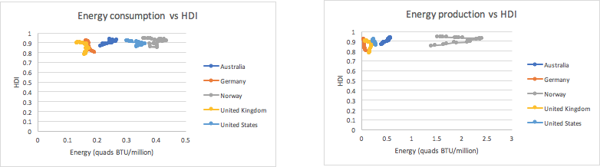

**Appendix Figure A1 and A2** - HDI for developed countries as a function of Energy consumption and production

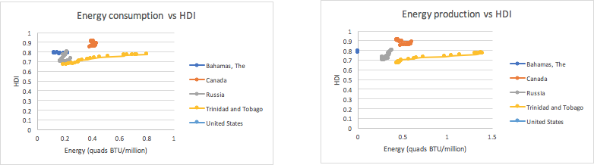

**Appendix Figure A3 and A4** - HDI for less developed countries as a function of Energy consumption and production

|  |  |  |
| --- | --- | --- |
| **Criteria** | **Points Possible** | **Points Earned** |
| **How comprehensive and up to date is the background review** | **35** | **34** |
| **Quality of the analytical method** | **20** | **20** |
| **Scope and validity of the results** | **15** | **13** |
| **Discussion of the results, and conclusions** | **25** | **18** |
| **Creativity of the analysis, method, conclusions, etc** | **5** | **2** |
| **Total** | **100** | **87** |

**A good report overall, but see the comments in the text and below.**

**Your analysis seems good but not all the graphs are adequately readable.**

**The structure of the entire report is slightly haphazard. It should’ve been more organized. Maybe done an extensive analysis for each country in separate sections.**

**The body of the report is very extensive but the conclusions must be drawn well too. A more detailed conclusion summarizing all your findings could’ve earned you more points.**