CUSTOMER CHURN ANALYSIS
EXECUTIVE SUMMARY

PROBLEM SEVERITY
We are experiencing a 20.37% customer churn rate, which is 63% above the industry standard of 10-15%.
Estimated annual revenue impact: $3.7M in recurring revenue lost
Based on 2,037 churned customers with $185.6M in combined account balances.
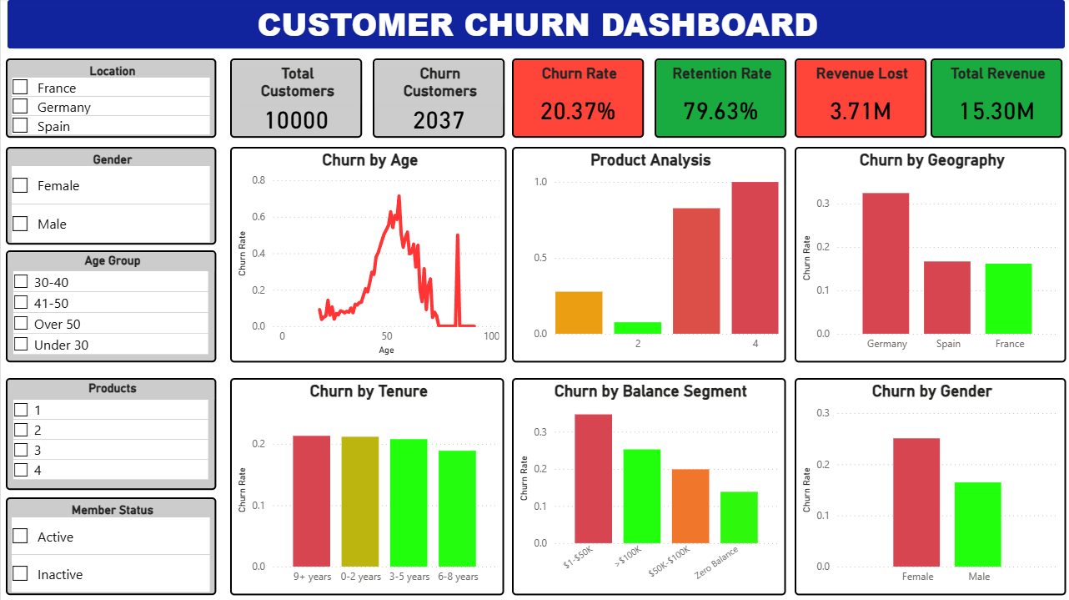
Figure 1: Customer Churn Dashboard Overview

AT A GLANCE
Financial Impact:
- Total Customers: 10,000
- Churned: 2,037 (~20.4%)
- Balance Lost: $185.6M
- Annual Revenue Impact: $3.7M
- Customer Lifetime Value Lost: $18.5M
TOP 3 PRIORITIES:
- 40+ Age Crisis - $2.44M annual revenue at risk (66% of total losses)
- German Market - $98M in balance losses + $1.96M annual revenue (53% of total)
- Product 4 - 100% churn rate, immediate discontinuation

KEY FINDING
Churn is NOT a single problem - it's multiple failures across age demographics (40+ crisis representing 66% of revenue loss), product lines (Product 4 total disaster), and geography (German market accounting for 53% of balance and revenue losses). This requires a multi-pronged retention strategy with URGENT action on high-value customer segments.

CRITICAL FINDINGS - IMMEDIATE ACTION REQUIRED

1. AGE CLIFF AT 40
Status: CRITICAL
The Problem:
- Customers under 40: 7-12% churn rate
- Customers over 40: 33-45% churn rate
- Churn rate TRIPLES after age 40
Financial Impact:
- $2.44M in annual revenue lost (66% of total churn revenue impact)
- Losing high-value customers in their prime earning years
- These customers have significantly higher account balances
Action Required:
- Launch "40+ Retention Program" immediately
- Premium services for customers age 40+
- Dedicated relationship managers
- Enhanced rates/benefits for this segment
Projected Impact: Reducing 40+ churn to under-40 levels could save $1.8M annually
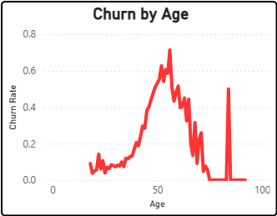
Figure 2: Churn Rate by Age Group

2. PRODUCT 4 CRISIS
Status: EMERGENCY
The Problem:
- 100% churn rate among Product 4 customers
- Small customer base (~3%) but total product failure
- This is not a retention issue - this is a product failure
Action Required:
- DISCONTINUE Product 4 immediately or conduct emergency audit
- Stop all Product 4 cross-selling until root cause is identified
- Contact existing Product 4 customers proactively
- Migrate Product 4 customers to Product 2 configuration
Estimated Savings: $50K-$100K annually
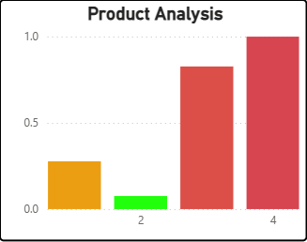
Figure 3: Churn Rate by Number of Products

3. GERMAN MARKET COLLAPSE
Status: URGENT
The Problem:
- Germany has highest churn rate across all geographies
- Represents 25% of customer base
- Requires immediate market investigation
Financial Impact:
- $98M in balance losses (53% of total churn impact)
- $1.96M in annual revenue lost (53% of total revenue losses)
- This single market accounts for over HALF of our churn losses
Possible Causes:
- Local competition offering better rates
- Service quality issues specific to German branches
- Product-market fit problems
Action Required:
- Deploy German Market Task Force
- Investigate German-specific churn drivers
- Conduct competitive analysis in German banking market
- Exit interviews with churned German customers
Projected Impact: Reducing German churn to average could save $1.5M+ annually
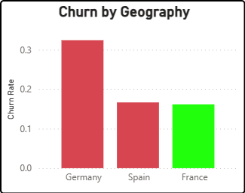
Figure 4: Churn Rate by Geography

4. HIGH BALANCE CUSTOMER EXODUS
Status: CRITICAL
The Problem:
- Customers with HIGH balances are leaving at elevated rates
- These are our most profitable customers
- Likely moving to competitors with better rates/service
Action Required:
- Implement premium services tier for high balance accounts (>$100K)
- Competitive rate matching for top-tier accounts
- Assign relationship managers to high-balance customers
- Concierge banking services
Estimated Impact: Retaining top 20% of high-balance churned customers = $500K+ annual revenue
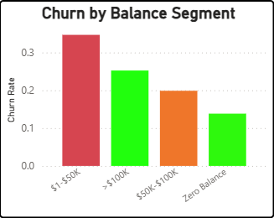
Figure 5: Churn Rate by Account Balance

MODERATE RISK FINDINGS

1. PRODUCT 3 WARNING SIGN
- Elevated churn rates (~80%)
- Not as catastrophic as Product 4, but trending poorly
- Action: Audit Product 3 before it becomes the next Product 4

2. FEMALE CUSTOMER GAP
- Female customers churn at higher rates than males
- Action: Research gender-specific needs, launch women's banking initiative
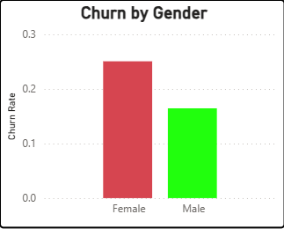
Figure 6: Churn Rate by Gender

3. LOW BALANCE DISENGAGEMENT
- Customers with low/zero balances churn more (expected but addressable)
- Action: Engagement campaigns for dormant accounts, minimum balance incentives

4. INACTIVE MEMBERS
- Inactive members churn more, but not dramatically
- Action: Re-engagement email campaigns, app notifications, exclusive offers

POSITIVE FINDINGS

1. PRODUCT 2 SWEET SPOT
- Product 2 has the LOWEST churn rate across all product counts
- This is the optimal customer configuration
- Action: Promote cross-sell to 2-product configuration
PRODUCT STRATEGY:
- Product 1: Acceptable baseline
- Product 2: Optimal - Target configuration
- Product 3: Monitor closely
- Product 4: Discontinue immediately

2. YOUNG CUSTOMER LOYALTY
- Customers under 40 show excellent retention (7-12% churn)
- Current approach is WORKING for this demographic
- Action: Maintain current service model, do NOT change what's working

CONCERNING FINDINGS

1. TENURE DOESN'T MATTER
The Problem:
- Churn rate is ~20% regardless of customer tenure
- New customers (0-2 years): ~20% churn
- Long-time customers (9+ years): ~20% churn
- Being a customer for 10 years provides ZERO protection
Implication:
- No loyalty effect
- This suggests SYSTEMIC issues, not onboarding problems
- Current loyalty programs are ineffective
Action Required:
- Rebuild customer relationships across entire lifecycle
- Make tenure matter through progressive benefits
- Long-term strategic initiative to create emotional brand connection
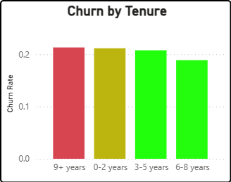
Figure 7: Churn Rate by Customer Tenure

2. SALARY & CREDIT SCORE NEUTRAL
- No significant churn pattern by income or creditworthiness
- Financial demographics don't predict loyalty
- Key Insight: Service quality and product fit matter more than wealth

STRATEGIC RECOMMENDATIONS

PHASE 1: IMMEDIATE ACTIONS (Month 1)
1. EMERGENCY PRODUCT 4 REVIEW
- Halt all Product 4 cross-sells immediately
- Conduct root cause analysis
- Contact existing Product 4 customers proactively
- Migrate to Product 2 configuration
2. LAUNCH "40+ RETENTION PROGRAM"
- Premium service for customers age 40+
- Dedicated relationship managers for high-balance 40+ customers
- Enhanced rates/benefits for this segment
- Competitive rate matching
3. GERMAN MARKET TASK FORCE
- Investigate German-specific churn drivers
- Competitive analysis in German banking market
- Customer feedback and exit interviews
- Germany-specific retention offers
Phase 1 Total Impact: $3.5M+ in potential annual revenue preservation

PHASE 2: SHORT-TERM INITIATIVES (Months 2-3)
1. PRODUCT 2 PROMOTION CAMPAIGN
- Identify customers with only 1 product
- Target cross-sell to reach 2-product sweet spot
- Important: Avoid pushing to 3+ products (higher churn)
2. HIGH BALANCE CUSTOMER CARE PROGRAM
- VIP service tier for accounts > $100K
- Competitive rate matching
- Concierge banking services
- Priority customer service
3. WOMEN'S BANKING INITIATIVE
- Research female customer needs and pain points
- Gender-specific product development
- Targeted retention campaigns
4. PRODUCT 3 AUDIT
- Review Product 3 performance metrics
- Identify improvement opportunities
- Fix or discontinue if necessary
Phase 2 Total Impact: $1.5M+ in potential annual revenue

PHASE 3: LONG-TERM STRATEGY (Months 4-6)
1. CUSTOMER LOYALTY OVERHAUL
- Rebuild emotional connection to brand
- Make tenure matter with progressive benefits
- Community building initiatives
- Rewards program redesign
2. LIFE STAGE BANKING
- Age-specific product suites
- Pre-40 retention preparation programs
- Enhanced retirement planning for 40+ segment
- Tailored services for each life stage
3. GEOGRAPHIC CUSTOMIZATION
- Market-specific retention strategies
- Local competitor monitoring
- Regional product adaptation
- Country-specific value propositions
Phase 3 Total Impact: $500K+ in potential annual revenue

SUCCESS METRICS - 6 MONTH TARGETS
Primary KPIs:
- Overall churn rate: Reduce from 20.4% to 15%
- 40+ age group churn: Reduce from 40% to 25%
- German market churn: Reduce from 32% to 22%
- Product 4: Complete discontinuation or <10% churn
- High balance customer retention: Increase to 90%+
Secondary KPIs:
- Monthly churn rate by segment (age, geography, product)
- Product 2 adoption rate (target: 45% of customer base)
- 40+ customer satisfaction scores (target: 85%+)
- German market Net Promoter Score (target: >50)
- Customer tenure distribution trends
Revenue Metrics:
- Monthly revenue run rate
- Customer Lifetime Value trend
- Revenue per customer (target: $1,600+)
- Retention program ROI

CONCLUSION

KEY TAKEAWAYS
We face a $3.7M annual churn crisis driven by three critical failures:
- 66% revenue concentration in the 40+ age crisis - losing $2.44M annually from our highest-value customers in their prime earning years
- Product 4 complete collapse - 100% churn rate representing total product failure
- German market underperformance - accounting for 53% of total balance losses ($98M) and revenue losses ($1.96M)
The data reveals this is not a marginal problem requiring minor adjustments - it's a systemic breakdown affecting multiple customer segments and requiring immediate executive intervention. Our 20.37% churn rate is 63% above industry standards.
Most concerning: Customer tenure provides ZERO protection against churn. 10-year customers leave at the same rate as new customers, indicating deep systemic issues rather than onboarding problems.

IMMEDIATE ACTION REQUIRED
- Week 1: Present findings to executive leadership and secure buy-in
- Week 2: Secure emergency budget approval for Phase 1 initiatives
- Week 3: Launch 40+ Retention Program and Product 4 discontinuation
- Week 4: Deploy German Market Task Force and begin investigations

FINANCIAL OPPORTUNITY
If we reduce churn by just 5 percentage points (from 20.37% to 15.37%), we will:
- Save 500 customers annually
- Preserve $45.6M in account balances
- Generate $911K in additional annual revenue
- Save $200K in re-acquisition costs
- Build foundation for sustainable long-term growth
Total addressable opportunity: $1.1M+ in annual revenue recovery

THE COST OF INACTION
Continued losses:
- $3.7M annual revenue losses
- Declining competitive market position
- Accelerating erosion of our most valuable customer segments (40+ and high-balance)
- Further market share loss in key geographies (Germany)
The opportunity: A focused, data-driven retention strategy targeting our three critical failure points can recover $1M+ in annual revenue within 6 months and establish sustainable retention improvements.

FINAL RECOMMENDATION
This analysis provides the roadmap. Executive commitment and rapid execution will determine our success.
The window for action is closing - our best customers (40+, high-balance, German market) are leaving at unsustainable rates. Every month of delay costs $308K in lost revenue.
END OF EXECUTIVE SUMMARY
Prepared by: Phuc, Data Analyst
Date: February 2026
Project: Customer Churn Analysis
Data Source: 10,000 customer records, Churn_Modelling dataset, https://www.kaggle.com/datasets/shantanudhakadd/bank-customer-churn-prediction

