Task 2: Deleting a user with an inappropriate role
Goal
Log in with an Admin account and delete a user’s account with an inappropriate user role

Method
- Log into the FUSS website using the following details: username: tester, password: admin.
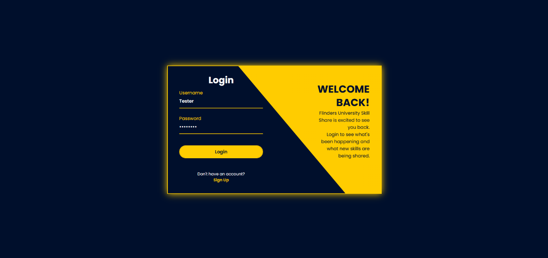

- In the Navbar, navigate to the “Dashboard” and click on the “User Management” Page

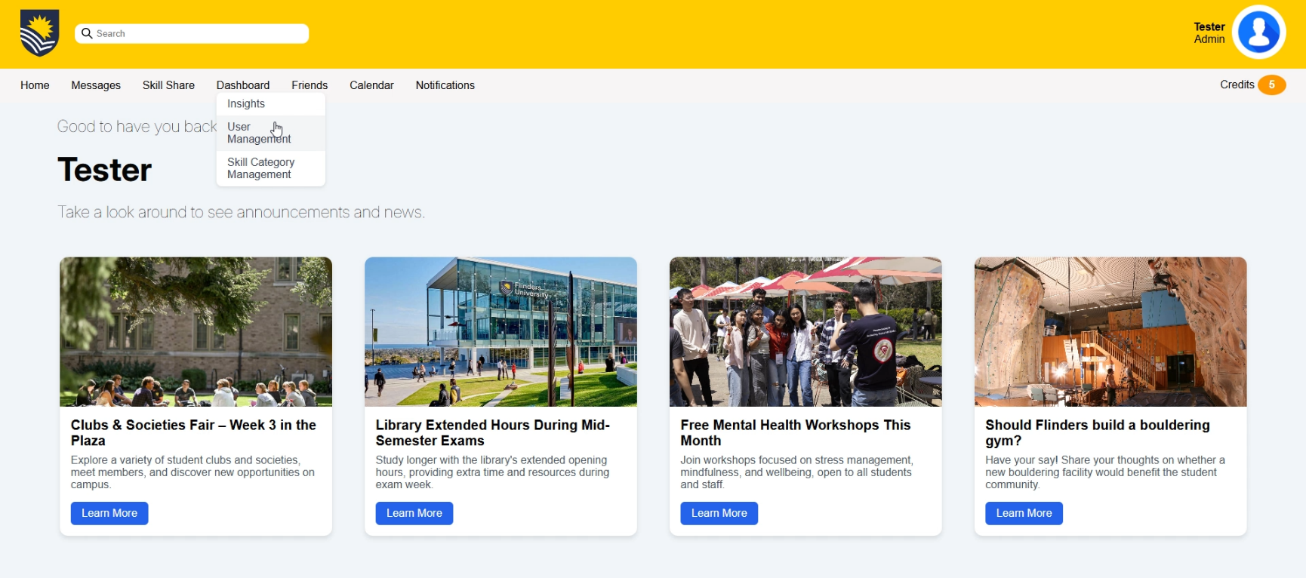

- View the management table and locate the user with the student ID of 3
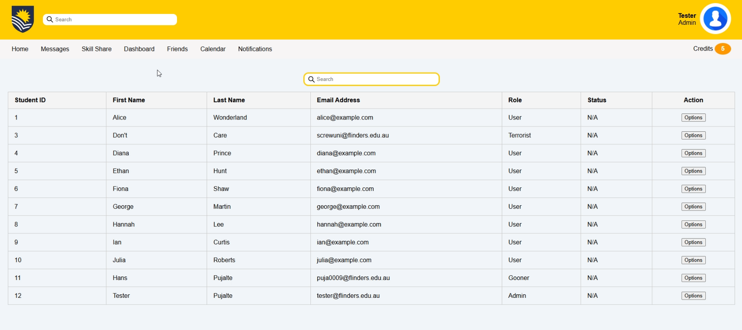

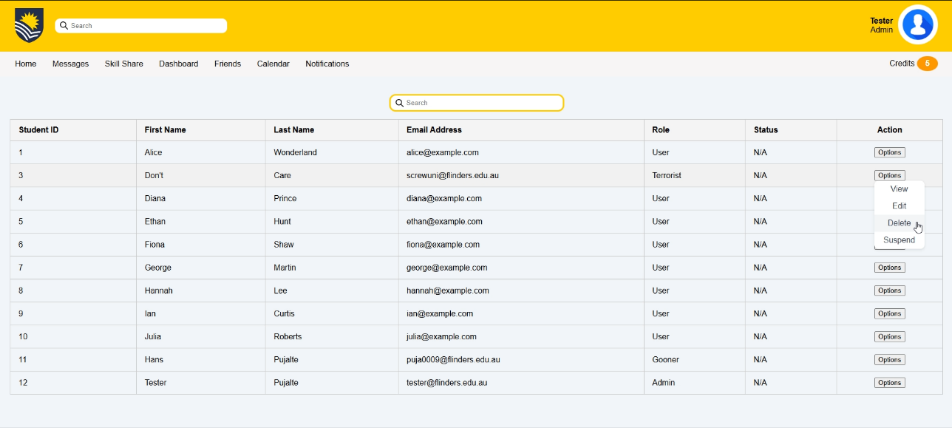
- Hover over the “Options” button. In the dropdown menu, click the “Delete” button

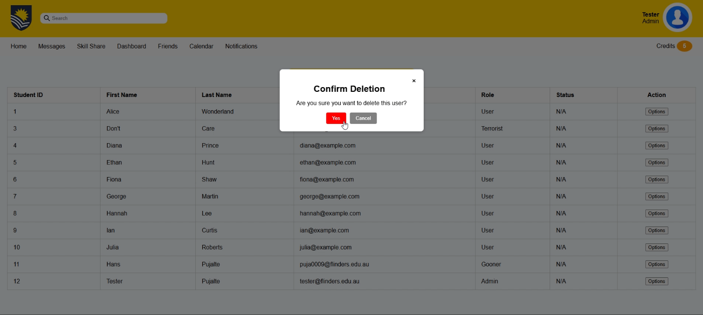
- Confirm deletion by selecting the “Yes” option

Evaluation
- Overall, I found this task…

Very difficult |  |  |  |  |  | Very easy
1 | 2 | 3 | 4 | 5 | 6 | 7

- How visually clear and organised was the “User Management” table interface?
Very cluttered |  |  |  |  |  | Very clear
1 | 2 | 3 | 4 | 5 | 6 | 7

