Task 1: How to book a Service on FUSS
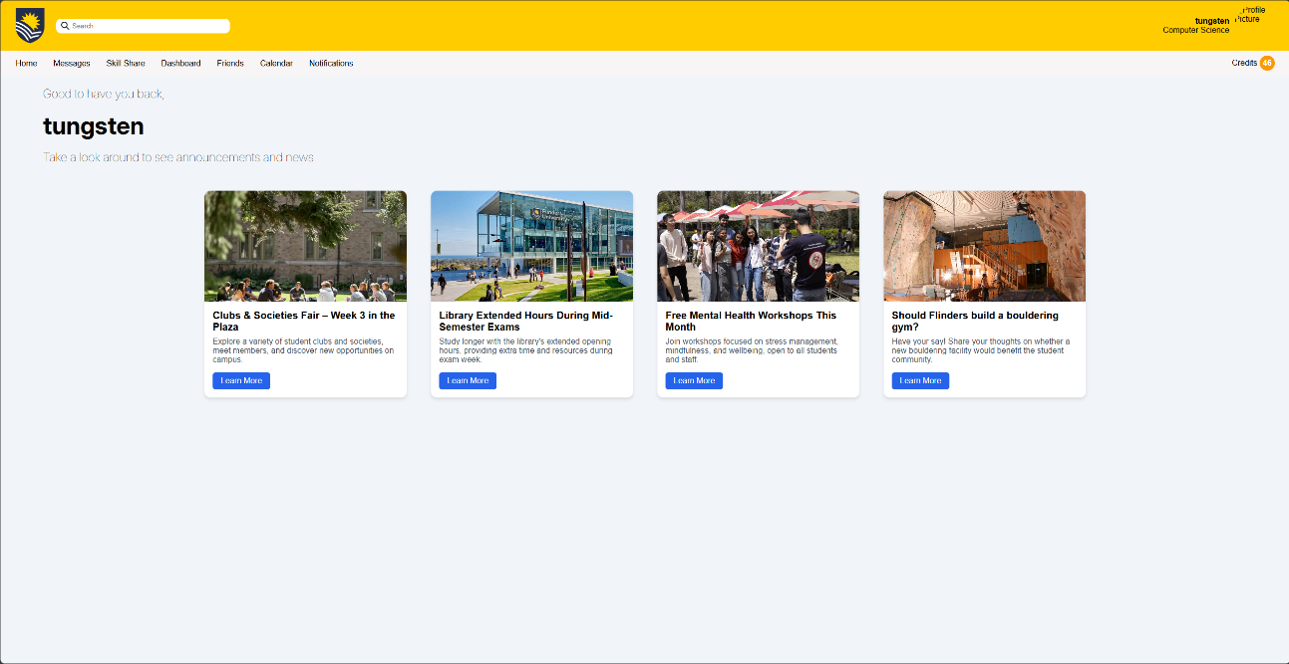
Once you first login you will be presented with the Home Page
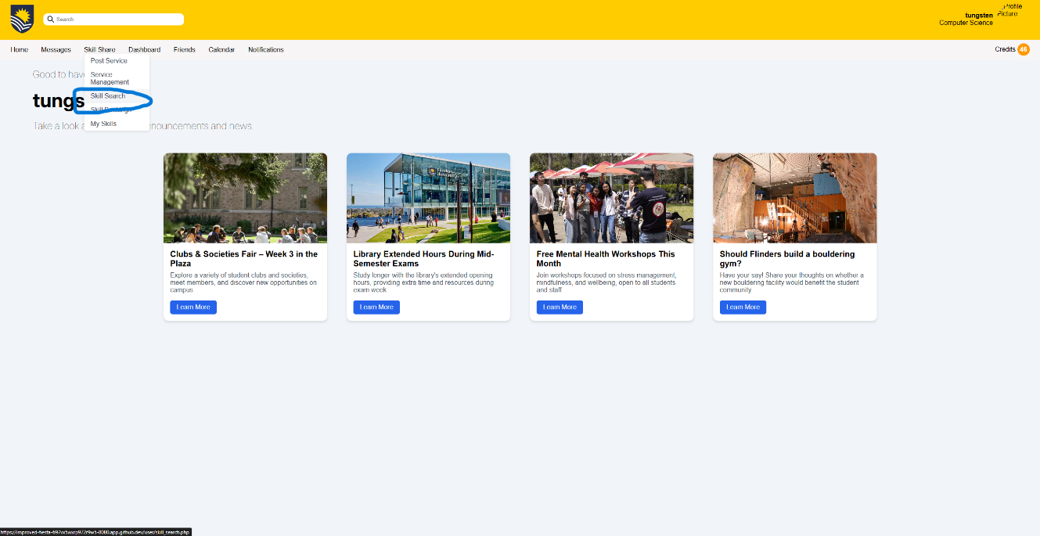
- From here navigate to the skill share tab and select skill search

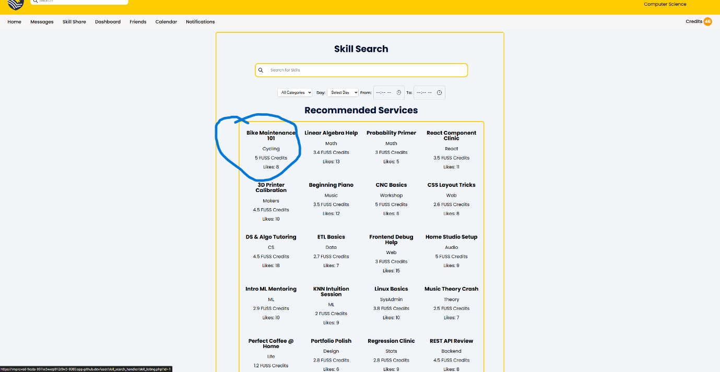
- From here you have multiple skills to click on
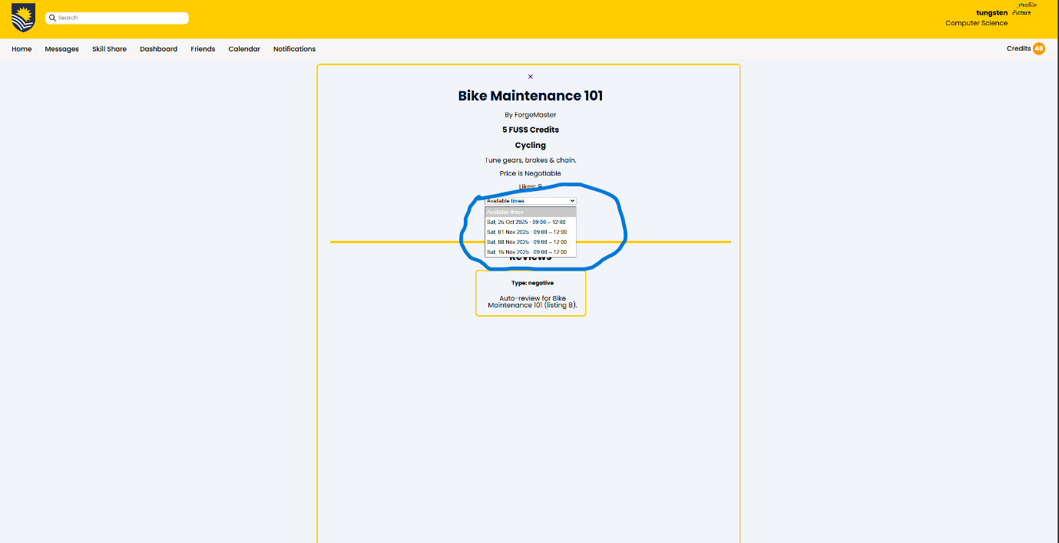
- By clicking on Bike Maintenance 101 it takes you to the following page, from this page you can click the drop down menu to select a time for someone to help you with the skill

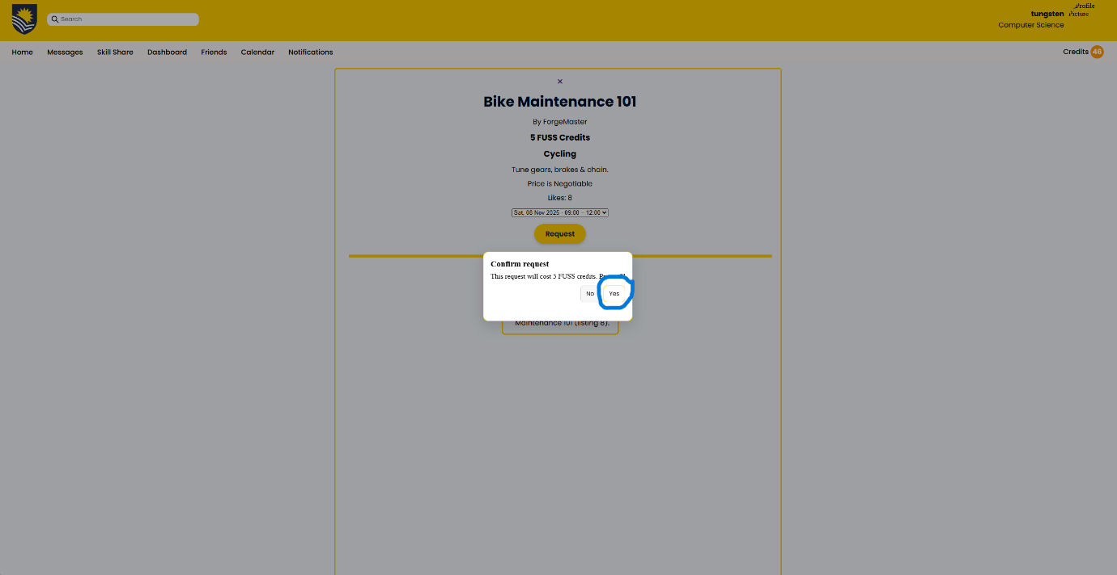
- From here a pop up comes up telling you the amount of FUSS credits the skill will cost and asks if you want to confirm the skill. From here you click yes to confirm the booking

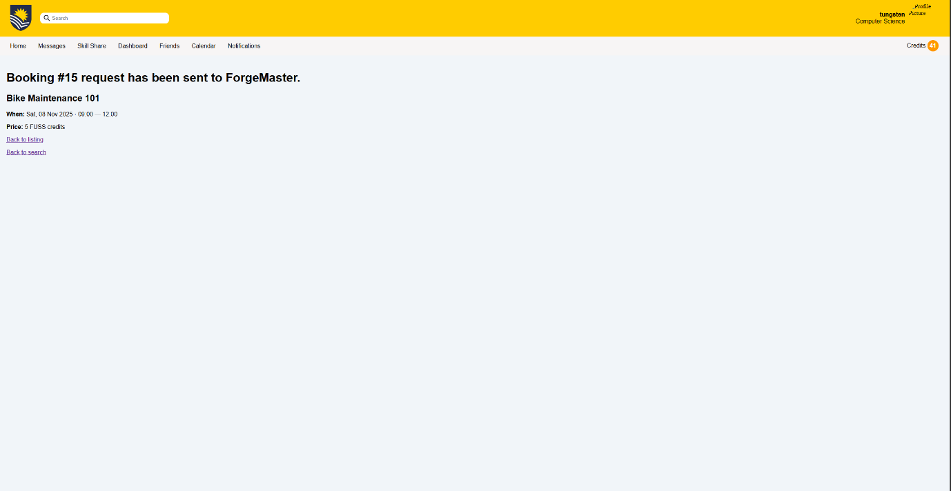
- From here you see the confirmation page once your skill has been booked

Task 2: How to confirm your booking and leave a review
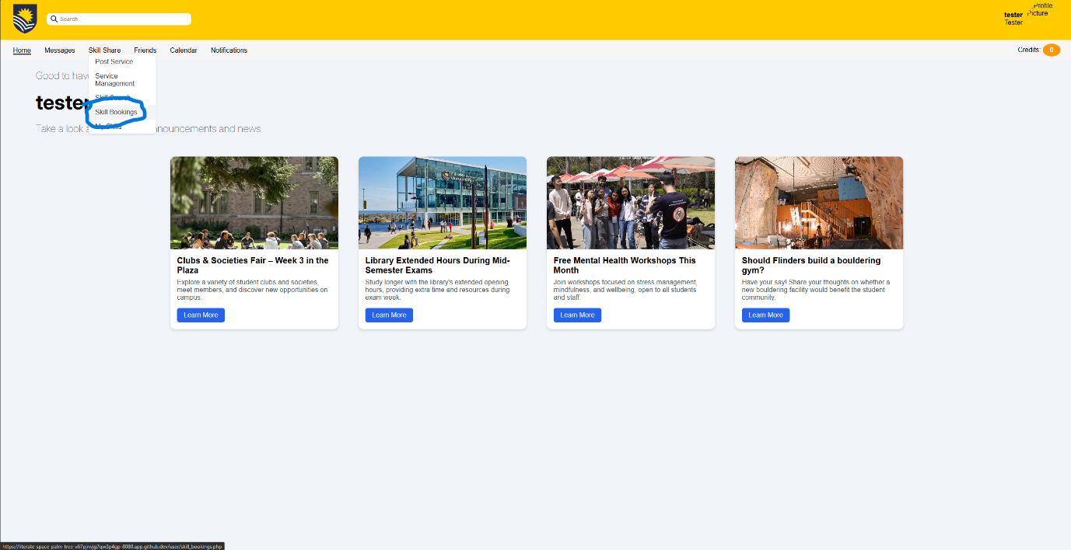
- From the Skill Share tab go to the Skills Booking Tab

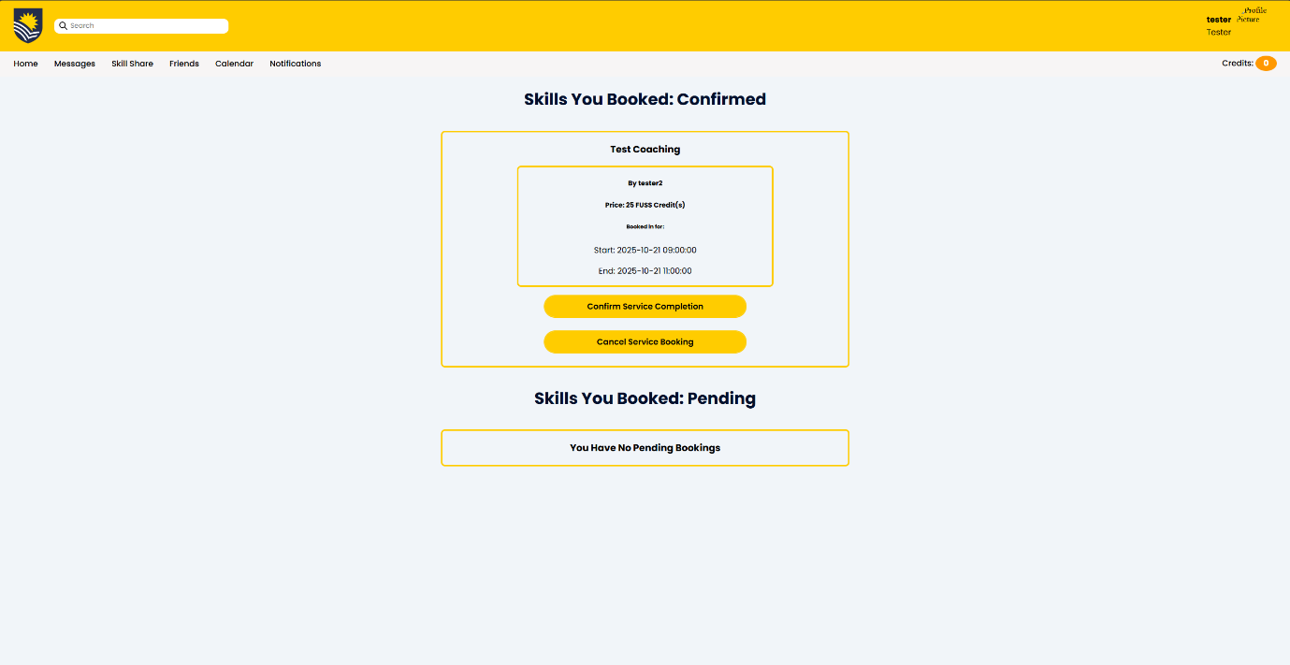
- From this click the Confirm Service Complete button to begin the review process

- Once the button is clicked it will take you to this page where you can fill in a review to the service that has been completed
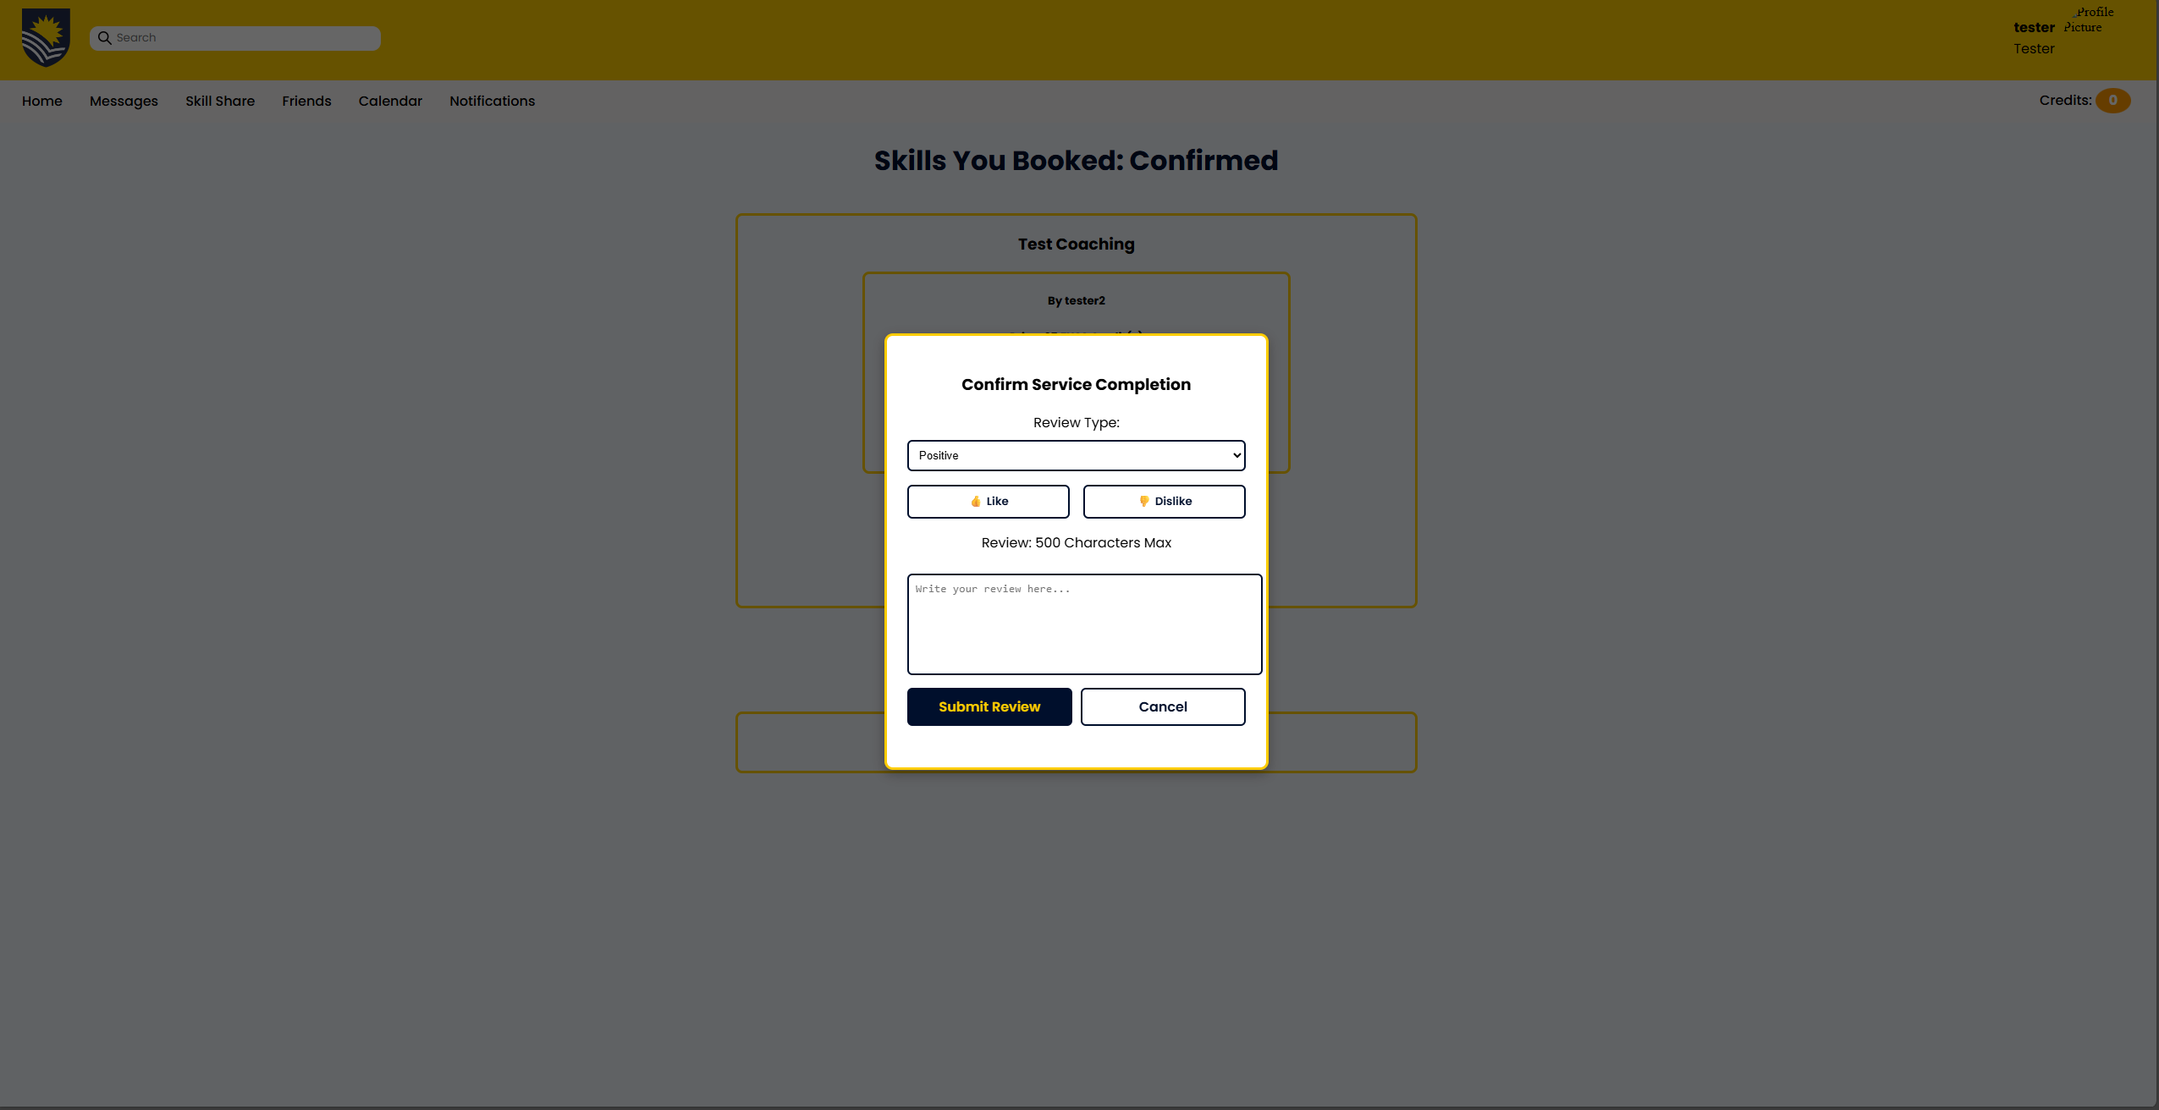

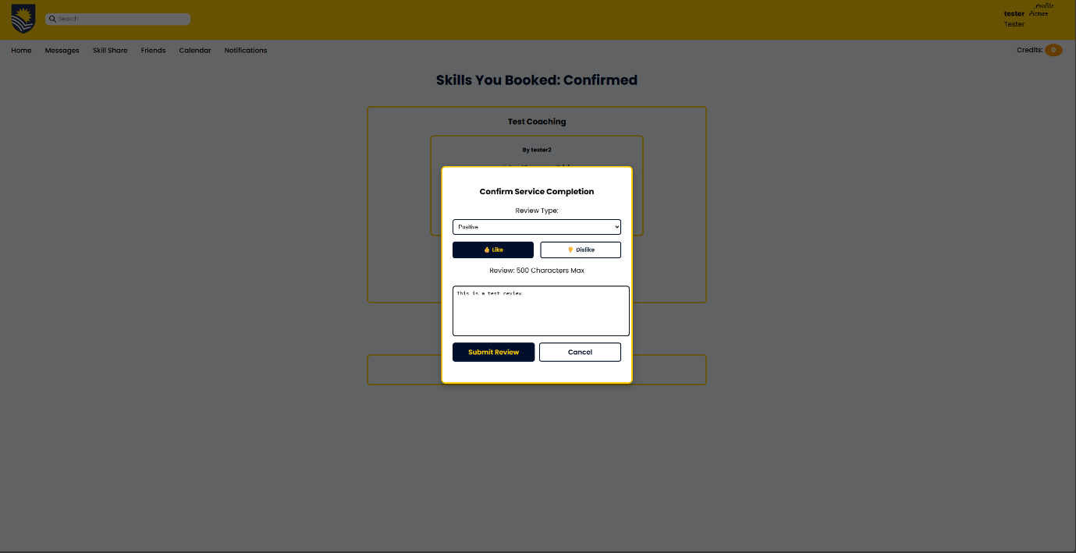
- From this we see how a user is able to fill out a review. From this then click Submit review

- Once you have completed the review you will be presented with the following page which confirmed how your review was submitted
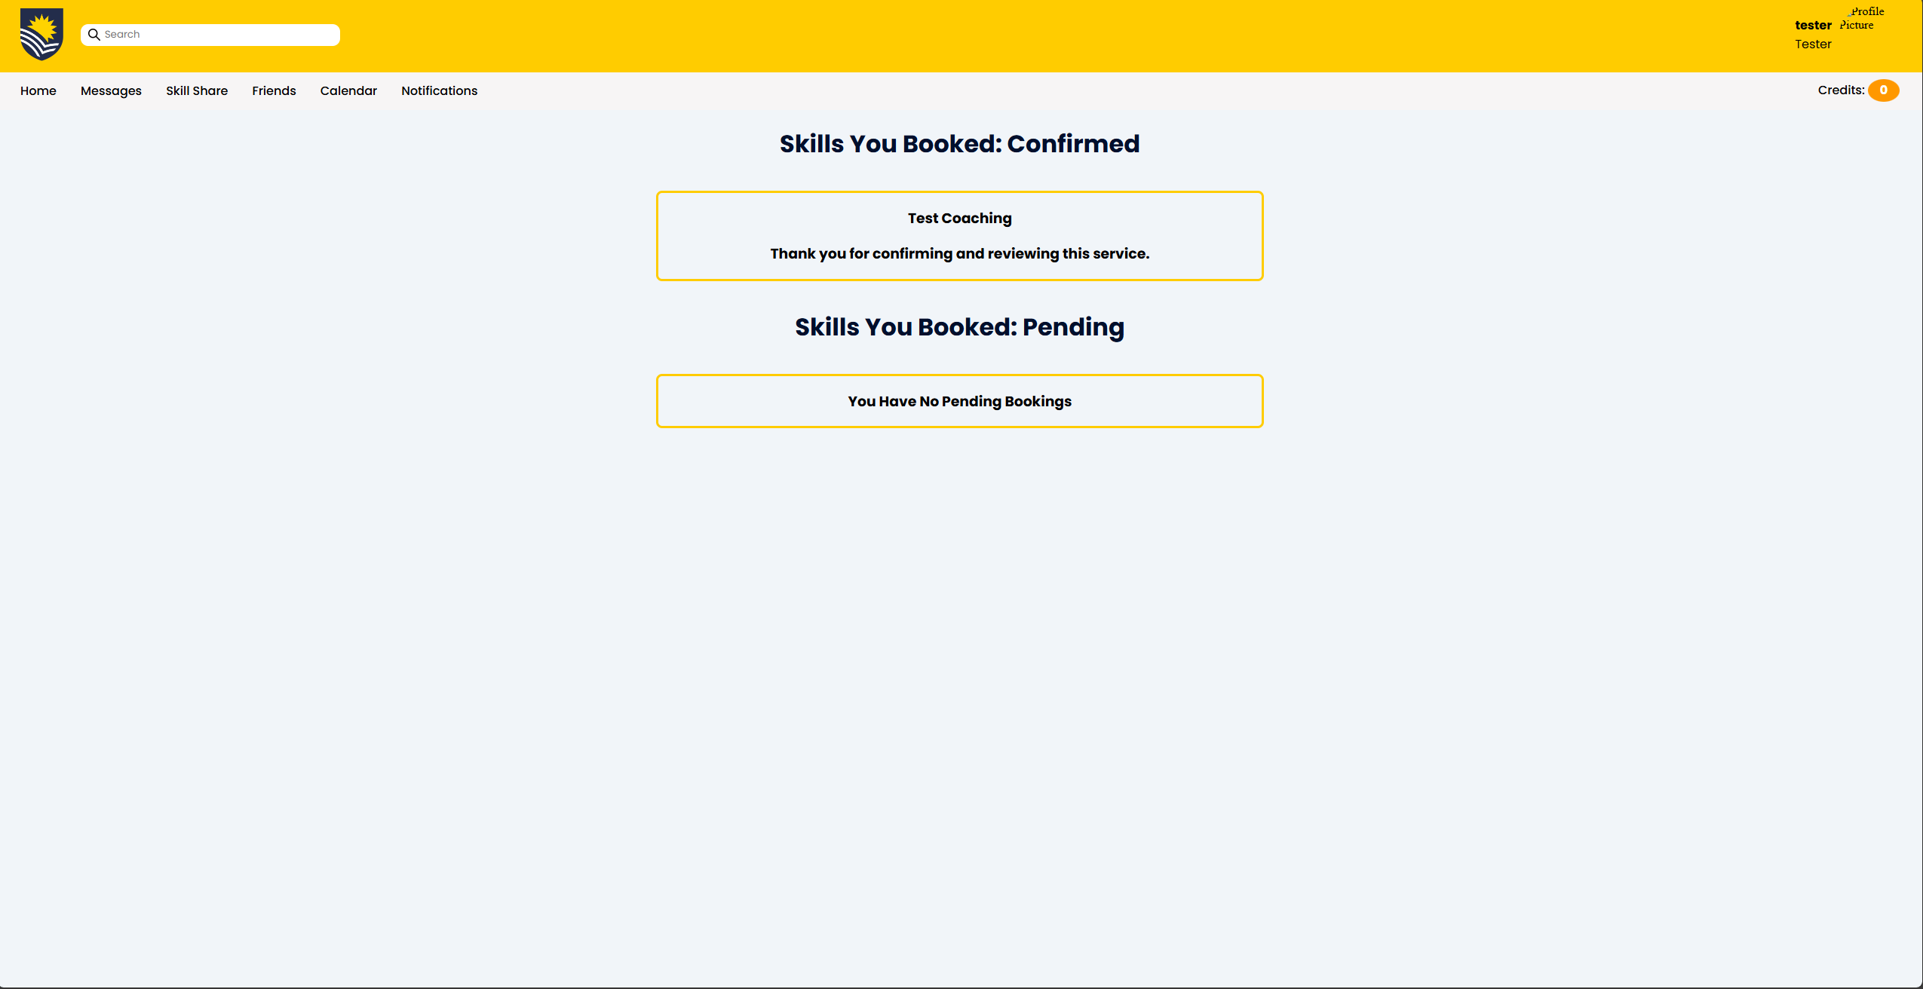

- Overall, I found this task…

Very difficult |  |  |  |  |  | Very easy
1 | 2 | 3 | 4 | 5 | 6 | 7

- How confident are you that you completed the task successfully?

Not at all confident |  |  |  |  |  | Very confident
1 | 2 | 3 | 4 | 5 | 6 | 7

