Task 1: Posting a Skill to FUSS
As a user login into FUSS and post a service of your choice to the skill share area.

- Login into FUSS with username: tester, password: admin


- Navigate to the post service section
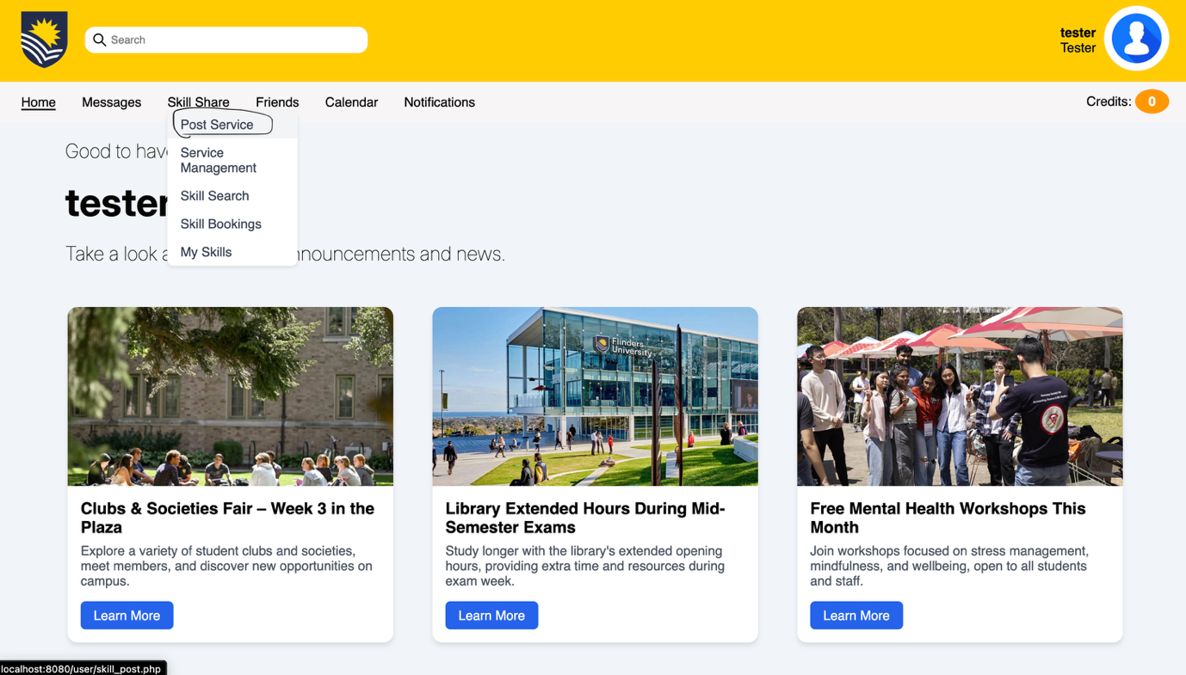

- Fill in the form correctly and ensure you have created at least one available time slot, then click the post button
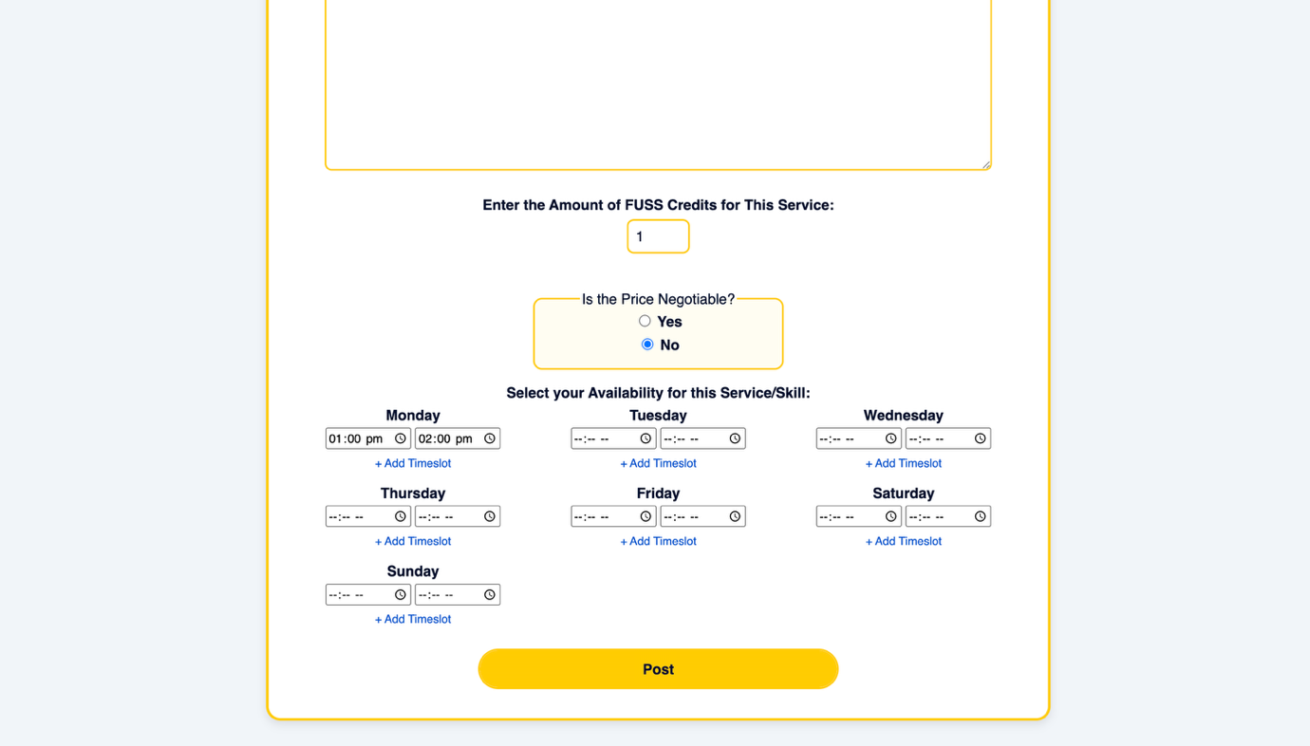

- Then navigate to the skill search area to confirm your skill has been posted.
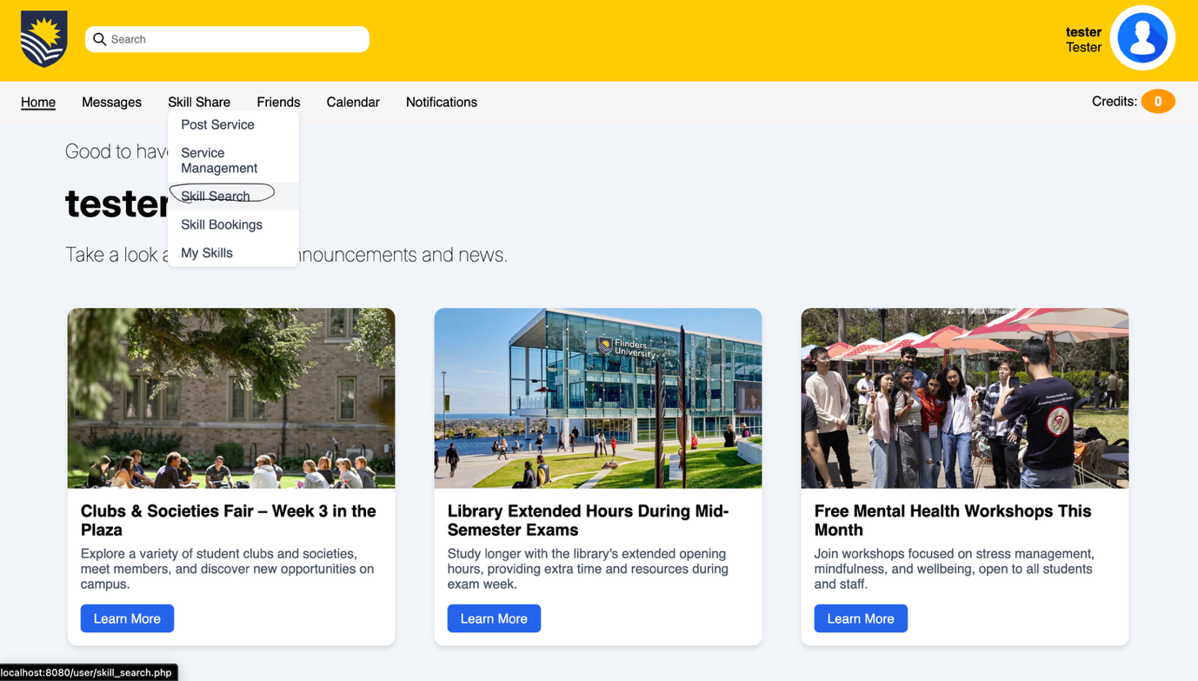
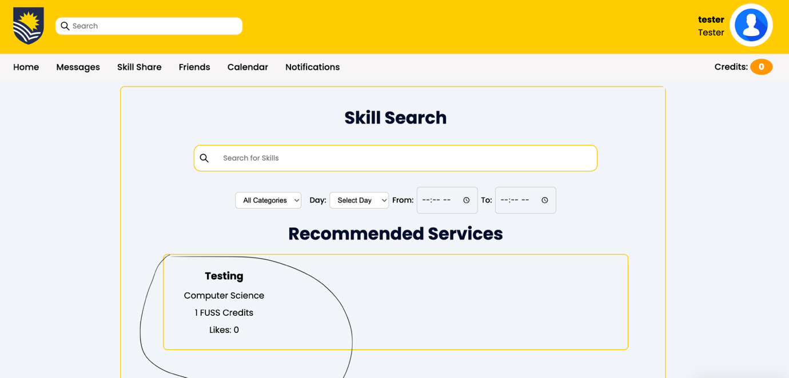

- Overall, I found this task…

Very difficult |  |  |  |  |  | Very easy
1 | 2 | 3 | 4 | 5 | 6 | 7

- How confident are you that you completed the task successfully?

Not at all confident |  |  |  |  |  | Very confident
1 | 2 | 3 | 4 | 5 | 6 | 7

