Task 4: Create a new user and login
Goal
Create a new user account from the sign-up page and login.

Method
- From the start up page select Sign Up.
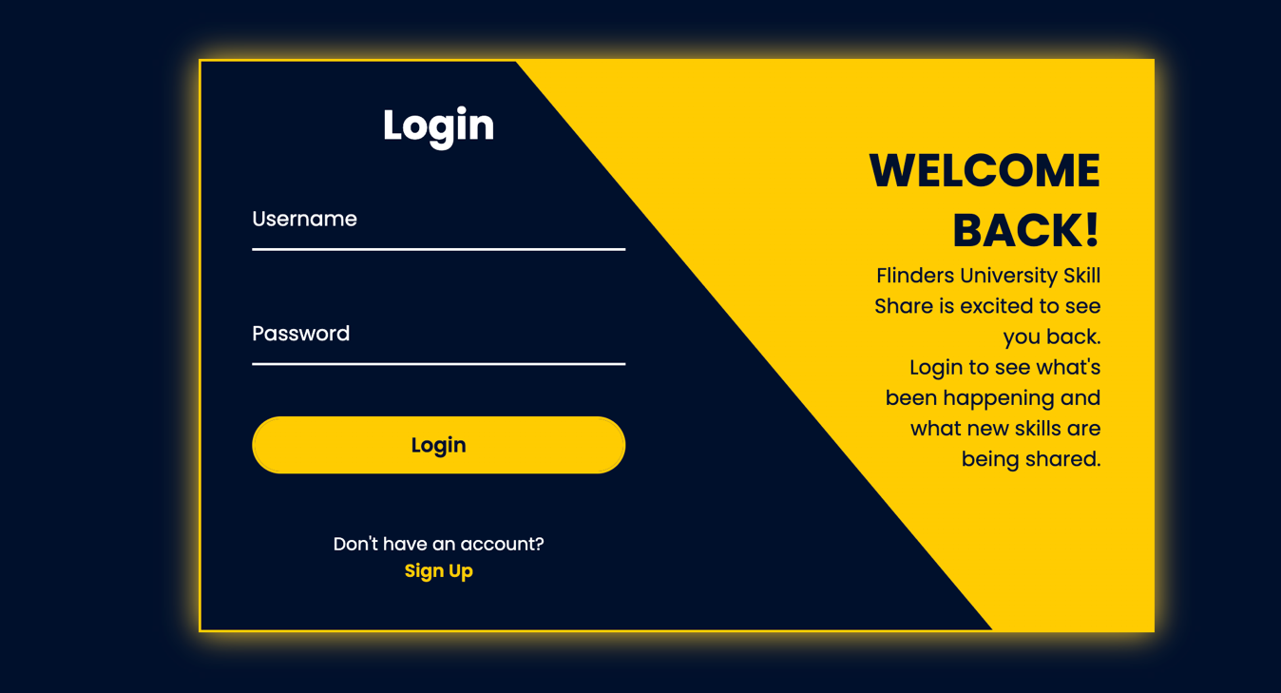

- Next, enter a username and valid Flinders email then select Register.
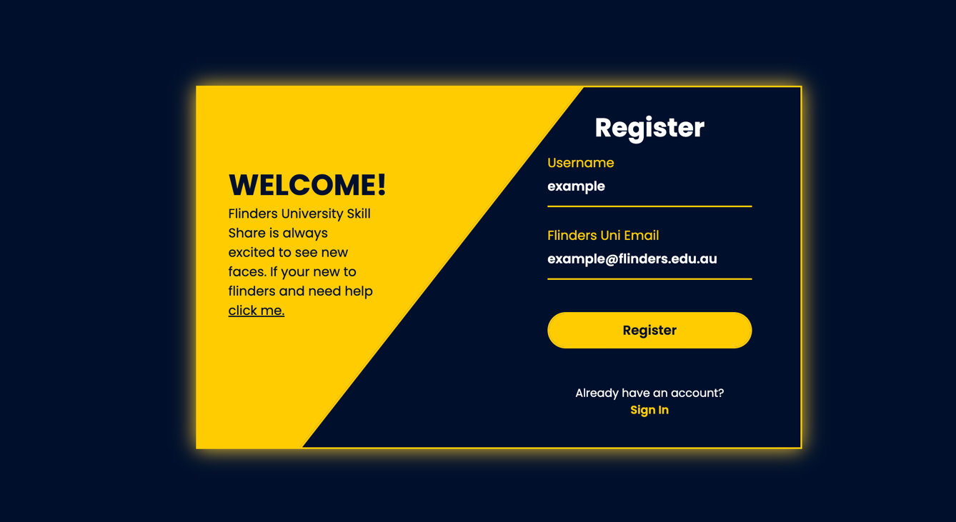

- Fill in the form with the correct details, agree to the Terms and Conditions, then click Register.
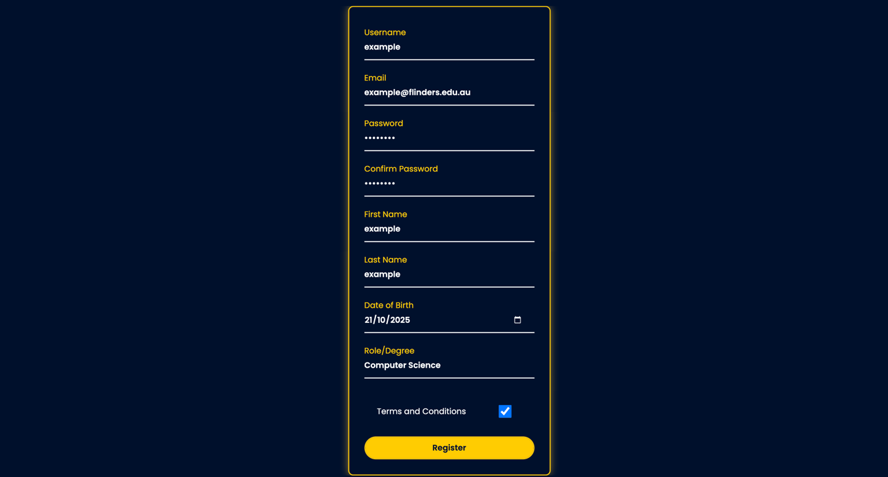

- After clicking Register, enter your new username and password.
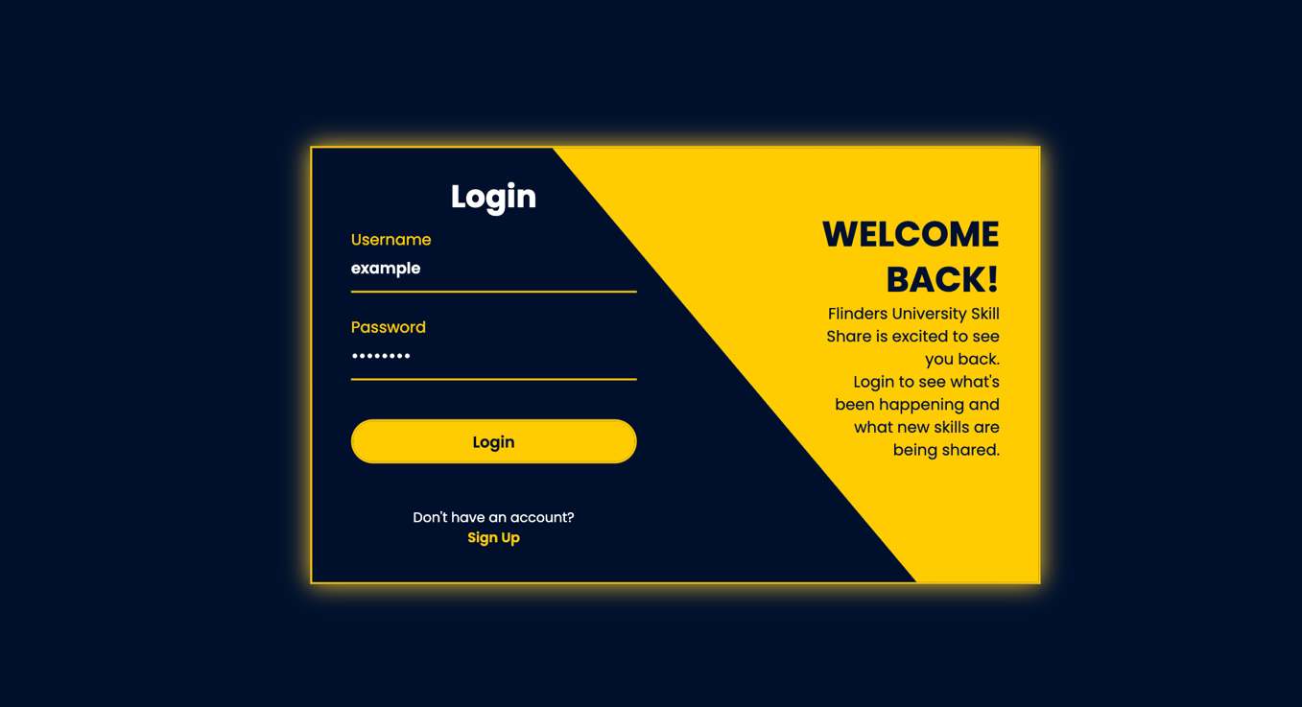

- Select Login. You will now be displayed with the user homepage.
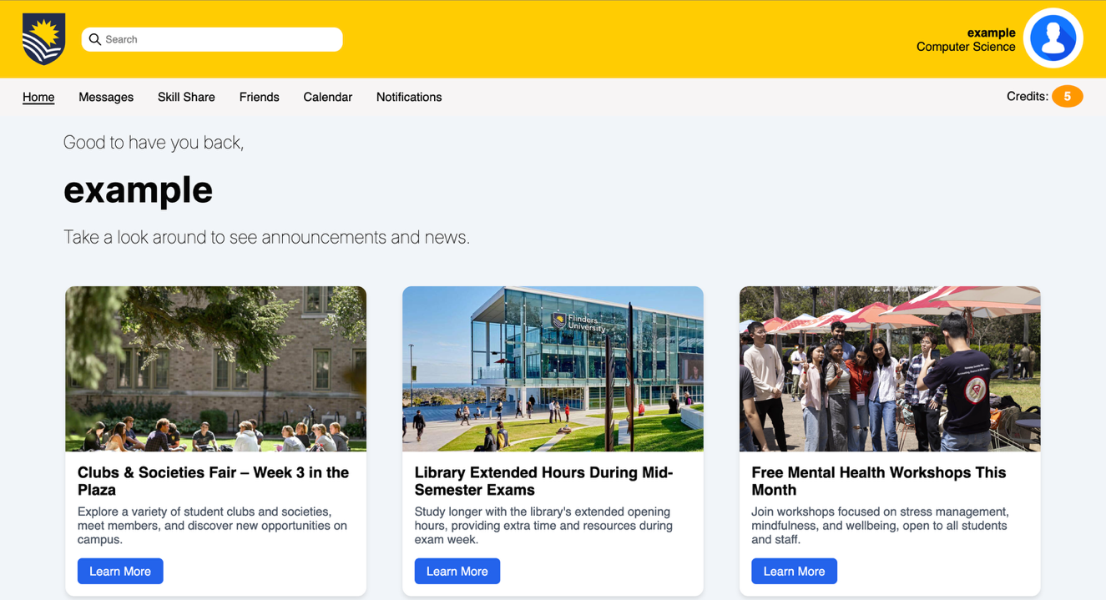

Evaluation
- Overall, I found this task…
Very difficult |  |  |  |  |  | Very easy
1 | 2 | 3 | 4 | 5 | 6 | 7

- How confident are you that you completed the task successfully?

Not at all confident |  |  |  |  |  | Very confident
1 | 2 | 3 | 4 | 5 | 6 | 7

