GEC1044 Chinese Medicine Theory and Practice

Supporting Student Health
through Chinese Food Therapy
Final Project
Student Name Lou Yu
Student ID [Add student ID]

1 Introduction
My interest in caring for health became personal in March 2025, when I experienced difficulty starting everyday activities and serious problems with physical movement. At one point, I needed a wheelchair. I have since recovered the ability to walk. That experience made ordinary things, such as getting out of the house and taking part in daily life, feel much more important to me.
This project uses that experience as a starting point for thinking about student health. It focuses on fatigue, poor appetite and unsettled sleep, concerns identified in the GEC1044 project brief, and develops a Chinese yam, lotus seed and red date congee for home preparation. My argument is that a useful recipe should have a clear purpose, a sensible combination of ingredients and a place within everyday care. Psychological ideas help explain how feelings, habits and participation in daily life fit into that care. Chinese food therapy provides a framework for selecting the ingredients.

2 My experience and the importance of everyday care
The most striking part of my experience was the effect on daily functioning. Moving around and starting an activity had become difficult. Looking back, recovery means more to me than a change in how I felt. Being able to walk again restored a practical part of my independence.
My doctor advised me to exercise while avoiding strenuous activity and gym training. The activities discussed included brisk walking or gentle jogging in a park, and swimming at a suitable low or moderate intensity. This advice gave me a useful starting point for the project: care should be manageable enough to fit the person who is doing it.
The same question applies to food. A student may understand that regular meals matter but still struggle with preparation, appetite or an irregular schedule. I therefore chose a meal that can be cooked in one pot, uses familiar ingredients and does not depend on expensive equipment. My previous illness motivates this choice; the congee is designed for everyday nourishment and the student concerns addressed in this project.
My photograph of a pulse diagnosis slide at Thong Chai also connects this personal concern with what I learnt in class (Figure 1). Lecture 7 describes diagnosis as a process of bringing observations and history together. The photograph reminds me to pay attention to the whole situation rather than build an explanation around a single symptom.
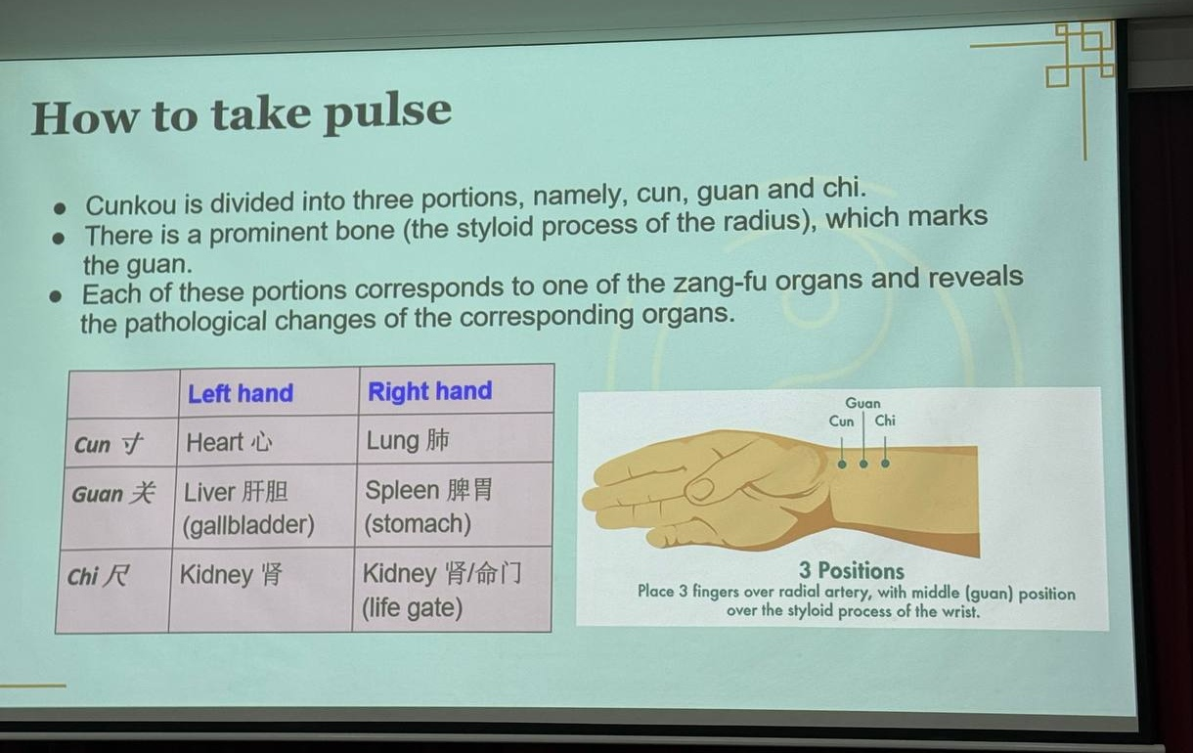
Figure 1 Pulse positions explained during the Thong Chai teaching session. Photograph by the author.

3 Understanding the health concerns

3.1 A Chinese medicine perspective
Chinese medicine gives meaning to a symptom through its relationship with other signs. Poor appetite alongside tiredness, for example, leads to different questions from poor appetite alongside marked thirst, heat and agitation. Lecture 7 introduces the four diagnostic methods and the need to combine their findings. This approach makes the choice of food depend on the person's presentation.
For this recipe, the main design direction is to support the Spleen and Stomach while including ingredients traditionally associated with calming the spirit, or shen. These terms describe functions within Chinese medicine. The Spleen and Stomach are relevant to receiving and transforming food, while the Heart has a connection with mental and emotional activity. This relationship gives the recipe a way to address nourishment and mental rest together.
The choice also needs to be specific. The University of Hong Kong's explanation of insomnia distinguishes several patterns, including Heart and Spleen deficiency accompanied by tiredness, and Liver fire accompanied by irritability. I use this distinction to keep the congee focused on nourishment and gentle daily care. Strong heat, agitation or another dominant presentation would call for a different food selection.

3.2 A psychological perspective
Hooley, Nock and Butcher organise abnormal psychology through a biological, psychological and social approach. This offers a useful way to examine physical condition, emotional experience and the circumstances of daily life together. In my account, the practical consequences of limited movement deserve as much attention as feelings: difficulty going out also changes access to activities, people and independence.
The psychology textbook used in PL1101E explains how the meaning attached to a stressful situation affects the response to it. It also discusses rumination, in which repeated attention to distress can interfere with problem solving. These ideas suggest useful questions about student life: does worrying about unfinished work make it harder to rest, and does poor rest make the next day's work feel more difficult?
Behavioural approaches add a practical step. Completing an achievable activity can create opportunities for enjoyment, feedback and a sense of progress. Cooking one meal or following a suitable walking routine gives this idea a concrete form. I use these examples as ways of organising daily care, with the level of activity matched to physical ability.
These psychological and Chinese medical perspectives meet at the level of lived experience. Both encourage attention to eating, rest and the person's surroundings. In the recipe analysis, Chinese medical concepts explain the intended combination of ingredients. Psychological concepts help me examine the experience of preparing food and returning to daily routines.

4 The recipe and its ingredients

4.1 Chinese yam lotus seed and red date congee
I designed the congee around a simple aim: make a nourishing meal that is easy to prepare, with a traditional rationale linking digestion and mental rest. The starting point is the Hong Kong Department of Health's yam and red date congee. Its published example uses 200 g yam and 30 g red dates with rice. My version adds lotus seeds, uses 15 g red dates for a lighter sweetness, and specifies the rice and water so that the cooking process can be repeated.
The proposed batch makes two portions. All quantities below are planned kitchen weights. Fresh yam and dried ingredients are listed separately because their weights and preparation differ.
Ingredient | Planned weight | Specification
Chinese yam | 200 g | Fresh peeled edible portion
Lotus seeds | 20 g | Dried shelled seeds with green embryos removed
Red dates | 15 g | Dried pitted edible portion
Rice | 80 g | Dry uncooked white rice
Water | 1,000 ml | Starting amount; add if needed during cooking

4.2 Why these ingredients belong together
Chinese yam, or shan yao, provides the main link with the digestive focus. The Hong Kong Polytechnic University materia medica describes dried yam rhizome as sweet and neutral, associated with the Spleen, Lung and Kidney. Its traditional functions include supporting the Spleen and Stomach. I use fresh Chinese yam in the meal, following the fresh yam preparation described by the Department of Health.
In cooking, yam also gives the congee a soft texture and makes it more substantial than a herbal drink. That matters to this project because the intended product is a meal. A pleasant texture and a manageable portion are part of making food acceptable when appetite is low.
Lotus seed, or lian zi, connects the two aims of the recipe. Its traditional description includes supporting the Spleen and calming shen. The Polytechnic University lists it as sweet, astringent and neutral, with associations to the Spleen, Kidney and Heart. This gives a clear reason for including it in a recipe concerned with nourishment and unsettled sleep. I specify dried, shelled seeds with the green embryo removed, so that the ingredient is lotus seed rather than lotus plumule.
Red dates, or da zao, add a smaller nourishing component and sweetness. Their traditional functions include supplementing middle qi and nourishing blood and calming shen. The Polytechnic University describes them as sweet and warm, associated with the Spleen and Stomach. Using a modest quantity lets the dates flavour the congee without turning it into a heavily sweetened dessert. No extra sugar is included in the first version.
Rice holds the combination together as ordinary food. It supplies the starch that thickens the congee and provides a familiar meal base. Lecture 9 includes rice among sweet foods associated with nourishment. The rice therefore has both a practical cooking role and a place in the food therapy discussion.
Ingredient | Nature and flavour | Traditional affinity | Role in this congee
Chinese yam | Neutral and sweet | Spleen Lung Kidney | Main digestive and nourishing focus
Lotus seed | Neutral sweet and astringent | Spleen Kidney Heart | Links digestive support with calming shen
Red date | Warm and sweet | Spleen Stomach | Supporting nourishment and natural sweetness
Rice | Sweet in the lecture classification | Food base | Provides a familiar meal and soft texture

Figure 2 shows the herb properties discussed during the Thong Chai session. Nature, flavour, meridian affinity and function provide separate questions to ask about an ingredient. Applying these questions to my recipe is more useful than choosing foods simply because they are described as healthy.
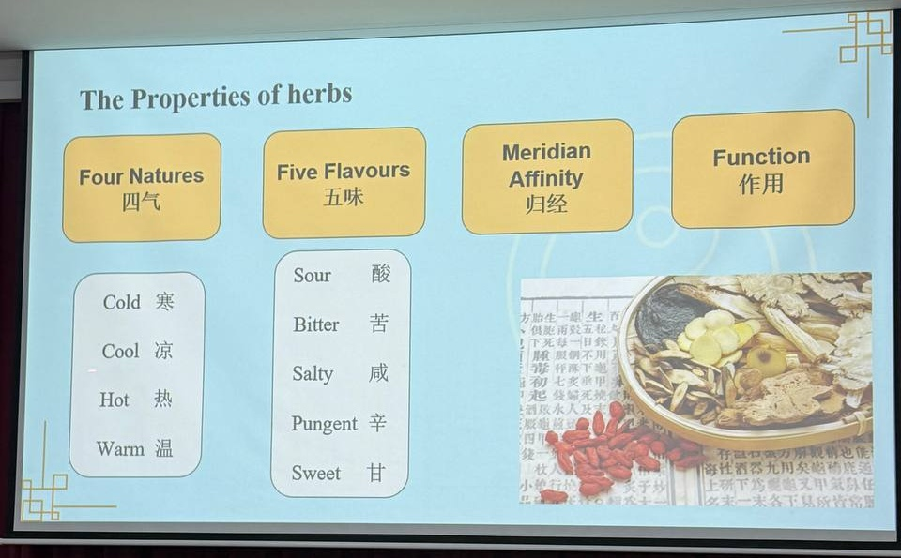
Figure 2 A teaching slide on the properties of herbs at Thong Chai. Photograph by the author.

4.3 The choices behind the combination
I kept the recipe to four ingredients so that each one has a clear role. Yam anchors the digestive aim, lotus seeds connect nourishment with calming shen, dates contribute flavour and a small supporting component, and rice makes the combination a meal. Lecture 9's discussion of formula roles helped me think about these priorities. A household congee does not need a separate ingredient for every role in the chief, minister, assistant and envoy scheme.
This also explains the ingredients I left out. Ginseng and additional tonic herbs would make the recipe more complicated without answering a specific need identified here. Lily bulb would give a clearer direction towards nourishing yin and addressing dryness; it belongs in a version designed around those signs. My first recipe stays with the digestive and nourishing focus.
Zhang Zhongjing's medical tradition provides a useful historical connection between presentation and formula selection. In the transmitted Shanghan lun tradition, congee also appears within instructions accompanying treatment. I take from this the importance of considering food and the person's condition together. The present congee is my adaptation of food therapy materials rather than a classical prescription.

5 Preparing and documenting the congee
The preparation is designed for a saucepan with a lid. First, weigh the ingredients. Rinse the lotus seeds and prepare them according to the packet instructions, checking that the green embryos have been removed. Wash the rice. Peel the yam using gloves if its sap irritates the skin, then cut it into small pieces. Wash and pit the dates.
Place the rice, lotus seeds and 1,000 ml water in the saucepan. Bring to the boil, then reduce the heat and simmer gently. Add the yam and dates and continue cooking until the rice breaks down and the lotus seeds are tender. Stir occasionally and add a little water if necessary. Allow about 45 to 60 minutes in total, using tenderness rather than the clock as the final check. Divide the cooked congee into two portions and serve warm.
The preparation photographs will record the actual weights, ingredient handling, cooking and finished portion. Their captions will identify the date and what each photograph shows.
Add four original cooking photographs here
Weighing | Preparing | Simmering | Finished portion
Figure 3 Preparation record to be added after cooking. Four photographs will show weighing, preparing the ingredients, simmering and the finished portion.

6 Acupuncture and the care experience
Acupuncture deserves a separate place in the report because it connects a physical treatment with the experience of seeking care. Lecture 8 explains it through the regulation of qi, blood and yin and yang, with point selection and technique guided by the person's presentation. This is the Chinese medical account of the treatment.
The Thong Chai slide I photographed focuses on what a patient may experience during acupuncture (Figure 4). It distinguishes expected needling sensations from issues that require attention. For me, its relevance is the value of an explanation before and during treatment. A patient who understands what is being done has a clearer basis for asking questions and describing discomfort.
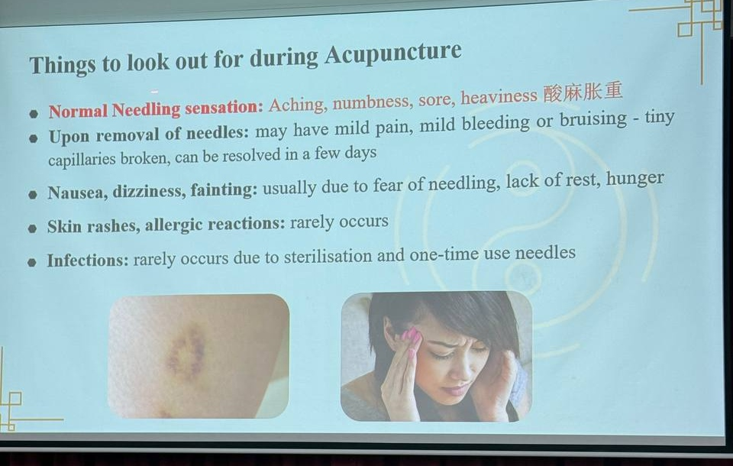
Figure 4 Patient sensations and precautions discussed in the Thong Chai acupuncture session. Photograph by the author.
Research provides another way to examine acupuncture and psychological health. MacPherson and colleagues randomly assigned 755 adults with depression to acupuncture plus usual care, counselling plus usual care, or usual care alone. At three months, both added interventions were associated with greater improvement in depression scores. The study evaluates a course of care over time and offers evidence about that particular population and outcome.
A psychological reading asks what happens throughout a treatment encounter. Attention from a practitioner, a clear plan and expectations about recovery are relevant parts of the patient's experience. The trial measured expectations and perceived practitioner empathy, while its design assessed the overall intervention. This makes it useful for discussing care as a process involving treatment, communication and continued participation.
For my own recovery account, the useful next step is a dated treatment history: what was treated, the acupuncture sessions and medication involved, and which everyday functions improved. That chronology will give the personal section concrete detail. It will also keep the clinical episode separate from the later congee project.

7 Exercise and everyday health preservation
My doctor's advice gives exercise a clear place in daily care. I would apply it through suitable park activity and low or moderate intensity swimming, while following the advice to avoid strenuous exercise and gym training. The choice of intensity matters as much as the name of the activity. The CDC distinguishes recreational swimming from swimming laps, and lists jogging among vigorous activities. The pace and duration therefore need to follow the individual advice I receive.
Lecture 10 places movement alongside diet, rest and emotional cultivation within yangsheng, or nourishing life. Its discussion of daoyin connects attention, breathing and movement. What I find useful is the idea of caring for health through repeated everyday actions. An activity that fits my ability and can be repeated has a clearer place in that routine than an exhausting session.
Psychologically, such a routine provides opportunities to take part in life again. A manageable walk has an identifiable beginning and end; preparing congee results in a meal. These activities give concrete examples for reflecting on effort, enjoyment and progress. Their meaning comes from what I can actually do and how the routine fits my life.
Warm water belongs in the same everyday routine. I would use it as a comfortable way to maintain regular fluid intake, alongside fluids from meals. NHS guidance supports drinking regularly and adjusting intake to circumstances such as hot weather or activity. Warm water is a practical habit in this report; the recipe, movement and treatment each retain their own purpose.

8 Reflection and conclusion
The strongest part of this design is the connection between its aim and its ingredients. Yam addresses the digestive focus within food therapy, lotus seeds bring together nourishment and calming shen, dates contribute flavour and traditional nourishment, and rice turns the combination into a meal. This gives me a reason for each choice and a way to explain the recipe as a whole.
The cooking trial will test whether that design works in everyday use. I will record the time, ingredient cost, texture, sweetness, portion size and any discomfort. I will also describe the experience in plain terms: whether it was enjoyable to prepare, easy to eat and realistic to make again. These observations answer the practical question of whether a student could use the recipe in a regular routine.
Add the cooking and tasting record here, including the actual time, cost, texture, taste, portion size and personal response.
Regaining mobility made daily functioning central to how I think about health. This project connects that concern with a practical meal: its ingredients have a clear food therapy rationale, while preparation and suitable activity create manageable steps in daily care.

9 Bibliography
Cacioppo, John T., Laura A. Freberg, and Stephanie J. Cacioppo. Discovering Psychology: The Science of Mind. 4th ed. Cengage Learning, 2022.
Centers for Disease Control and Prevention. “How to Measure Physical Activity Intensity.” December 4, 2025. https://www.cdc.gov/physical-activity-basics/measuring/.
Chinese University of Hong Kong, School of Chinese Medicine. “傷寒論註.” Attributed to Zhang Ji, with commentary by Ke Qin. Accessed November 6, 2026. https://www.scm.cuhk.edu.hk/en-gb/elearning-platform/chinese-medicine-texts-collection-2/chinese-medicine-texts-collection-5/chinese-medicine-texts-collection-5/.
Hong Kong Department of Health, Chinese Medicine Regulatory Office. “药补或食补?” Accessed November 6, 2026. https://www.cmro.gov.hk/html/gb/useful_information/public_health/exhibit_boards/Herbal_Tonics_or_Food_Tonics.html.
Hong Kong Polytechnic University. “大枣.” Accessed November 6, 2026. https://herbaltcm.sn.polyu.edu.hk/sc/herbal/chinese-date.
Hong Kong Polytechnic University. “山药.” Accessed November 6, 2026. https://herbaltcm.sn.polyu.edu.hk/sc/herbal/common-yam-rhizome.
Hong Kong Polytechnic University. “莲子.” Accessed November 6, 2026. https://herbaltcm.sn.polyu.edu.hk/sc/herbal/lotus-seed.
Hooley, Jill M., Matthew K. Nock, and James N. Butcher. Abnormal Psychology. 18th global ed. Harlow, England: Pearson, 2021.
Lou Yu. Photographs of teaching slides in the Thong Chai visit collection. October 15, 2026. Personal photographs.
MacPherson, Hugh, Stewart Richmond, Martin Bland, Stephen Brealey, Rhian Gabe, Ann Hopton, Ada Keding, et al. “Acupuncture and Counselling for Depression in Primary Care: A Randomised Controlled Trial.” PLoS Medicine 10, no. 9 (2013): e1001518. https://doi.org/10.1371/journal.pmed.1001518.
National University of Singapore. GEC1044 Chinese Medicine: Theory and Practice. Lectures 2, 3, 7, 8, 9, and 10. Course teaching materials, AY2026/27 Semester 1.
National University of Singapore. GEC1044. “Assessment.” Course page text saved November 5, 2026.
NHS. “Water, Drinks and Hydration.” Accessed November 6, 2026. https://www.nhs.uk/Live-well/eat-well/food-guidelines-and-food-labels/water-drinks-nutrition/.
Pearson. “Abnormal Psychology, Global Edition.” Title overview. Accessed November 6, 2026. https://www.pearson.com/en-nz/subject-catalog/p/abnormal-psychology-global-edition/P200000003860?view=educator.
梁頌然. “中醫藥如何治療失眠.” University of Hong Kong Faculty of Medicine. February 5, 2022. https://www.med.hku.hk/zh-hk/media/knowledge-exchange/newspaper-columns/2022/feb/chinese-medicine-treatment-for-insomnia.

National University of Singapore, GEC1044, “Assessment,” course page text saved November 5, 2026; GEC1044, Lecture 9, “Food Therapy Living in Harmony with Nature,” 2:12–3:24 and 38:51.
GEC1044, Lecture 7, “The Art and Science of TCM Diagnostics,” Part One, 10:00–12:22.
Lou Yu, photograph of the pulse diagnosis teaching slide, Thong Chai visit collection, October 15, 2026, photo_2026-10-15_23-47-39.jpg.
GEC1044, Lecture 7, Part One, 3:23–4:32 and 10:00–12:22; Part Two, 13:22–19:17.
GEC1044, Lecture 2, “Natural Philosophy Organs and Meridians,” section on zang-fu; Lecture 9, 38:51.
梁頌然, “中醫藥如何治療失眠,” University of Hong Kong Faculty of Medicine, February 5, 2022, https://www.med.hku.hk/zh-hk/media/knowledge-exchange/newspaper-columns/2022/feb/chinese-medicine-treatment-for-insomnia.
Jill M. Hooley, Matthew K. Nock, and James N. Butcher, Abnormal Psychology, 18th global ed. (Harlow, England: Pearson, 2021), general approach; Pearson, “Abnormal Psychology Global Edition,” title overview, accessed November 6, 2026, https://www.pearson.com/en-nz/subject-catalog/p/abnormal-psychology-global-edition/P200000003860?view=educator.
John T. Cacioppo, Laura A. Freberg, and Stephanie J. Cacioppo, Discovering Psychology: The Science of Mind, 4th ed. (Cengage Learning, 2022), 570, 643.
Cacioppo, Freberg, and Cacioppo, Discovering Psychology, 614, 660–61.
Hong Kong Department of Health, Chinese Medicine Regulatory Office, “药补或食补?” accessed November 6, 2026, https://www.cmro.gov.hk/html/gb/useful_information/public_health/exhibit_boards/Herbal_Tonics_or_Food_Tonics.html. Rice, lotus seeds, water, portions and the reduced date quantity are this project's adaptation.
Hong Kong Polytechnic University, “山药,” accessed November 6, 2026, https://herbaltcm.sn.polyu.edu.hk/sc/herbal/common-yam-rhizome; Hong Kong Department of Health, “药补或食补?”
Hong Kong Polytechnic University, “莲子,” accessed November 6, 2026, https://herbaltcm.sn.polyu.edu.hk/sc/herbal/lotus-seed.
Hong Kong Polytechnic University, “大枣,” accessed November 6, 2026, https://herbaltcm.sn.polyu.edu.hk/sc/herbal/chinese-date.
GEC1044, Lecture 9, 22:51.
GEC1044, Lecture 9, 7:03 and 38:51.
Lou Yu, photograph of “The Properties of Herbs” slide, Thong Chai visit collection, October 15, 2026, photo_2026-10-15_23-47-48.jpg.
GEC1044, Lecture 9, 54:45.
GEC1044, Lecture 3, section on formula medicine; Chinese University of Hong Kong School of Chinese Medicine, “傷寒論註,” attributed to Zhang Ji, with commentary by Ke Qin, accessed November 6, 2026, https://www.scm.cuhk.edu.hk/en-gb/elearning-platform/chinese-medicine-texts-collection-2/chinese-medicine-texts-collection-5/chinese-medicine-texts-collection-5/.
GEC1044, Lecture 8, “Acupuncture Theory and Practice,” 1:02–9:04.
Lou Yu, photograph of “Things to Look Out for during Acupuncture” slide, Thong Chai visit collection, October 15, 2026, photo_2026-10-15_23-47-53.jpg.
Hugh MacPherson et al., “Acupuncture and Counselling for Depression in Primary Care: A Randomised Controlled Trial,” PLoS Medicine 10, no. 9 (2013): e1001518, https://doi.org/10.1371/journal.pmed.1001518.
MacPherson et al., “Acupuncture and Counselling,” methods and discussion. The trial evaluated the overall interventions rather than separating specific and nonspecific effects.
Centers for Disease Control and Prevention, “How to Measure Physical Activity Intensity,” December 4, 2025, https://www.cdc.gov/physical-activity-basics/measuring/.
GEC1044, Lecture 10, “Chinese Ideas of Health Preservation and Ageing,” 0:15–3:06, 22:06 and 29:54.
NHS, “Water Drinks and Hydration,” accessed November 6, 2026, https://www.nhs.uk/Live-well/eat-well/food-guidelines-and-food-labels/water-drinks-nutrition/.

