Home Manual Template
Luke Mewburn
Table of Contents

Introduction

Overview
This is a template for a home manual.
An external plan of the home is shown in External connections figure.

Land title
Tip
Template: Add description of land title.

Change history
Date | Description
2026-02-12 | Initial mdbook template version.

1 Emergency information
In an emergency, the following contacts are available:
Item / Service | Phone | Provider
Battery
Builder
Electricity |  | Template.  See Electricity distributor.
Electrician
Fire | 000 | Template. ACT Emergency Services.
Internet |  | Template.  See Internet retailer.
Locksmith
Plumber
Solar clean |  | Template.  See Solar PV.
Storm and flood | 132 500 | ACT SES.
Water and sewer |  | Template.  See Water and sewer supplier.
Note
The relevant connection locations and shut-oﬀs are shown in External connections figure.

2 Maintenance intervals
Various components of the home need regular maintenance.
Item | Interval | Section
Air purifier filters | Device notification | Air purifiers
Battery damage inspection | 3 months | Battery energy storage system
Battery long term inspection | 2 years | Battery energy storage system
Battery system test | 5 years | Battery energy storage system
Clocks | DST changeover | Appliances, including: Dishwasher, Dryer, Microwave, Oven, Steam Oven, and Washing Machine.
Garage roller door | Device notification | Roller door
Garden watering settings | Monthly | Garden controller
Reverse cycle intake | DST changeover | Reverse cycle air conditioner
Sewer pipes | As required, usually annual | Sewer pipes
Smoke alarm test | DST changeover | Smoke alarms
Smoke alarm replace | 10 years | Smoke alarms
Solar PV system test | 5 years | Solar PV
Water filters | Annual | Water filters

3 Figures

Overview
This chapter contains all the figures for the home manual.

External

External connections figure
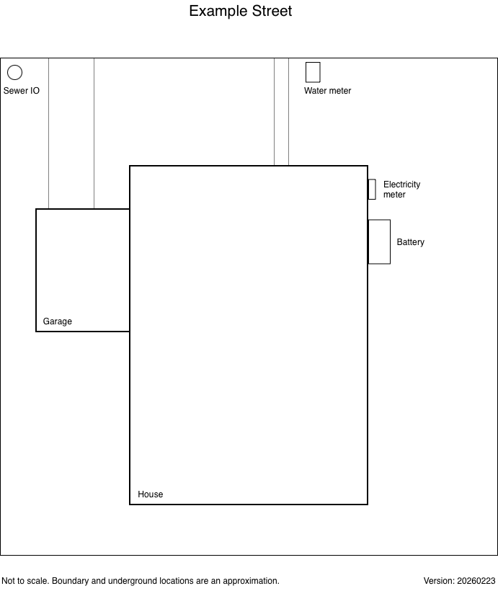
Note
Template: This is an example house, with a 3 layer draw.io figure.

Electricity outside figure
Tip
Template: Add inline figure of external electricity / energy connections.

Cameras figure
Tip
Template: Add inline figure of external cameras (if any).

Garden figure
Tip
Template: Add inline figure of garden watering.

Water and sewer figure
Tip
Template: Add inline figure of external water and sewer connections.

Internal

Electricity inside figure
Tip
Template: Add inline figure of internal electrical connections.

Lights inside figure
Tip
Template: Add inline figure of internal light fittings.

Internet of Things figure
Tip
Template: Add inline figure of internal IoT devices and locations.

Network ports figure
Tip
Template: Add inline figure of internal network ports.

Other

Electricity circuit figure
Tip
Template: Add inline figure of electrical circuits (e.g., solar and battery).

Local Area Network figure
Tip
Template: Add inline figure of LAN diagram.

4 Appliances
Tip
Template: Add or remove appliances as necessary. Add extra notes in a section describing appliance-specific notes.

Air purifiers
Item | Description
Description
Model
Serial numbers
Purchase date
Warranty expiry
Supplier
Filter part number
Filter replacement interval

Barbeque
Item | Description
Description
Model
Serial number
Purchase date
Warranty expiry
Supplier

Blender
Item | Description
Description
Model
Serial number
Purchase date
Warranty expiry
Supplier

Coffee machine
Item | Description
Description
Model
Location
Serial number
Purchase date
Warranty expiry
Product care expiry
Product care number
Supplier
Manufacturer
Service

Dishwasher
Item | Description
Model
Location
Serial number
Purchase date
Warranty expiry
Supplier
Manufacturer
Service

Dryer
Item | Description
Description
Model
Location
Serial number
Purchase date
Warranty expiry
Supplier
Manufacturer
Service

Induction cooktop
Item | Description
Description
Model
Location
Serial number
Delivery date
Warranty expiry
Supplier
Manufacturer
Service

Microwave
Item | Description
Description
Model
Location
Serial number
Purchase date
Warranty expiry
Supplier
Manufacturer

Oven
Item | Description
Description
Model
Location
Serial number
Delivery date
Warranty expiry
Supplier
Manufacturer
Service

Rangehood
Item | Description
Description
Model
Location
Serial number
Delivery date
Warranty expiry
Supplier
Manufacturer
Service

Refrigerator
Item | Description
Description
Model
Location
Serial number
Delivery date
Warranty expiry
Supplier
Manufacturer
Service

Sound bar
Item | Description
Description
Model
Location
Serial number
Purchase date
Warranty expiry
Supplier
Manufacturer

Steam oven
Item | Description
Description
Model
Location
Serial number
Delivery date
Warranty expiry
Supplier
Manufacturer
Service

Television
Item | Description
Description
Model
Location
Serial number
Bezel description
Bezel model
Purchase date
Warranty expiry
Supplier
Manufacturer

Vacuum cleaner
Item | Description
Description
Model
Location
Serial number
Purchase date
Warranty expiry
Supplier
Manufacturer

Washing machine
Item | Description
Description
Model
Location
Serial number
Purchase date
Warranty expiry
Supplier
Manufacturer
Service

5 Doors and windows

Blinds - interior
Item | Description
Model
Installation date
Warranty
Supplier and installer

Blinds - exterior
Item | Description
Model
Installation date
Warranty
Supplier and installer

Doorbell
Item | Description
Model
Location
Batteries
Installation date
Warranty
Supplier and installer

Door seals
Item | Description
Model
Supplier
Location

Double glazed windows
Item | Description
Installation date
Warranty
Supplier and installer

Locks
Tip
Template: Describe locks and different keys in use. For example, doors, windows, screen doors, garage, etc.

6 Energy

Overview
Tip
Template: Add description of energy sources and connection points. Include Battery, Solar PV, computer UPSes, etc.
The external electrical connections and appliances are shown in Electricity outside figure.
The internal electrical connections are shown in Electricity inside figure and Lights inside figure.
A circuit diagram of the battery and solar systems is shown in Electricity circuit figure.

Electricity distributor
Item | Description
Provider
Emergency phone
General enquiries phone
Connection location
Service type
Meter location
Internal sub-board location
National Metering Identifier
Meter 1 - Template
Meter 2 - Template
Meter 3 - Template

Electricity retailer
Item | Description
Provider
Account number
Account Owner
Plan
Tariff information
Password entry
Device 1 | Template: Describe devices managed See Battery energy storage system
Tip
Template: If this provides a virtual power plant (VPP), add links to the managed devices

Electricity circuits

Electricity meter circuit breakers
Tip
Template: Describe where the main circuit breakers are, and link to the figures.
See Electricity outside figure.

External appliance circuit breakers
Tip
Template: Describe where the various external device circuit breakers are, and link to the external figure.

Electricity sub board circuit breakers
Tip
Template: Describe where the various internal circuit breakers are, and link to the relevant figures.
See Electricity inside figure and Lights inside figure.
The electrical and light circuits are (with lights and fans shown in italic):
Circuit | Neutral | Purpose
1 | N1 | Template: Describe appliances and/or rooms.
2 | N2
3 | N3
4 | N4
5 | N5
6 | N6
7 | N7
8 | N10
9 | N11
AC | N14
HW | N15

Battery energy storage system
Item | Description
BESS model
Battery location
Battery capacity
Battery serial number
Gateway location
Gateway serial number
Installation date
Warranty expiry
Supplier and installer
Installation reference
Monitoring support
Password entry
Service: check for damage
Service: electrician inspection
Service: system test

EVSE (EV charging)
Item | Description
Model
Location
Serial number
Installation date
Warranty expiry
Supplier
Installer
Password entry

Lights
Item | Description
Model
Locations
Purchase date
Supplier
Order #
Installation date
Installer

Mirrors - backlit
Item | Description
Model
Locations
Purchase date
Supplier
Invoice
Installation date
Installer

Smoke alarms
Item | Description
Model
Locations
Battery type
Installation date
Replacement date
Supplier
Test interval | DST changeover

Solar PV
Item | Description
Inverter model
Inverter location
Inverter capacity
Inverter serial number
Inverter warranty expiry
Panel count and model
Panel location
Panel capacity
Panel warranty
Installation date
Supplier and installer
Service: system test

UPS
Item | Description
Model
Location
Capacity
Serial number
Battery replacement date
Battery supplier
Monitoring protocol

7 Furnishings

Art rail
Item | Description
Model - rail
Model - droppers
Model - light clips
Model - heavy clips
Supplier

Built-in robes
Item | Description
Installation date
Warranty
Supplier and installer

Carpet
Item | Description
Model
Purchase date
Warranty
Supplier and installer

Insulation

In-wall insulation
Item | Description
Type
Installation date
Warranty
Supplier and installer

Roof insulation
Item | Description
Type
Installation date
Warranty
Supplier and installer
Notes

Letter box
Item | Description
Description
Model
Location
Purchase date
Warranty expiry
Supplier

Parquetry
Item | Description
Type
Locations
Installation date
Installer

Sun lounge
Item | Description
Model
Purchase date
Warranty
Supplier and installer

Sun lounge cover
Item | Description
Model
Purchase date
Warranty
Supplier and installer

8 Garage

Overview
Tip
Template: Describe garage setup (if any). List access points (road location), etc.

Roller door
Item | Description
Model
Location
Serial number
Installation date
Supplier and installer
Service interval

Tools
Tip
Template: Describe tools.

9 Garden

Overview
Tip
Template: Describe garden setup (if any). Include water shutoffs, watering system setup, etc.
An external plan of the garden watering system is shown in Garden figure.

Garden controller
Item | Description
Model
Location
Installation date
Supplier and installer

Garden zones
Tip
Template: Describe garden zones (if any).
Zone | Wire color | Valve box | Type | Location
1
2
3
4
5
6
7
8

10 Heating and cooling

Overview
Tip
Template: Describe heating and cooling setup

Reverse cycle air conditioner
Item | Description
Air intake
Outdoor model
Outdoor location
Outdoor serial number
Indoor model
Indoor location
Indoor serial number
Controller model
Controller location
Installation date
Warranty expiry
Supplier and installer

11 Internet of Things

Overview
Tip
Template: Describe IoT setup (if any). List vendors (e.g., Apple Home, HomeAssistant, IKEA), and link to subsections here. List IoT types.
The location of the IoT devices is shown in Internet of Things figure.

IoT vendor 1
The IoT vendor 1 is:
Item | Description
Model
Location
Serial
Purchased
iCloud account
Network port
Network connection
iOS and macOS application
HomeKit location / name

IoT vendor 1 devices
Name | Type | Location | Notes
Template device

Cameras

Overview
Tip
Template: Describe cameras (if any), NVR setup. Cross-link to relevant Local Area Network. For locations, see Cameras figure and Network ports figure.

Camera 1
Item | Description
Model
Location
MAC
Purchase date
Supplier

12 Local Area Network

Overview
Tip
Template: Describe the LAN setup, including physical ports and IP design.
See Local Area Network figure for a figure of the LAN.
See Network ports figure for a figure of the network ports.

Network configuration

Internal servers
Tip
Template: Describe the internal servers (if any). Cross-link to the Network devices section below.

Firewall
Tip
Template: Describe the firewall (if any).

Network devices

Access point 1
Item | Description
Model
Location
MAC
Purchase date
Supplier

13 Network and internet

Overview
Tip
Template: Describe network and internet setup, including connection points, retailer, wholesaler (e.g., NBN).
The internet is connected via ... The internal connection ports are in the ... See Electricity outside figure.
The internal network cable connections are shown in Network ports figure.
See section Local Area Network (LAN) for the network design.

Internet retailer
Item | Description
Provider
Emergency phone
Account
Service type
Modem
Modem location
Password entry

Internet wholesaler
Item | Description
Provider
Connection location
Connection type
Internal location

14 Roof and gutters

Overview
Tip
Template: Describe roof and gutters.
The Colorbond roof was installed in 2025, replacing the original concrete tile roof and the garage metal roof.

Gutters and flashing
Item | Description
Style and color
Installation date
Warranty
Supplier and installer

Roof
Item | Description
Style and color
Installation date
Warranty
Supplier and installer

15 Water and sewer

Overview
Tip
Template: Add description of water and sewer items. For example: The potable water supply is located at ... The Garden shutoff is located at ... The Sewer IO (inspection outlet) is located at ... The hot water heat pump is located at ...
The water and sewer connections are shown in Water and sewer figure.

Water and sewer supplier
Item | Description
Provider
Emergency phone
Account
Meter location and shutoff
Sewer inspection outlet

Hot water heat pump
Item | Description
Heat pump model
Heat pump location
Heat pump serial number
Heat pump warranty expiry
Tank model
Tank location
Tank capacity
Tank build date
Tank serial number
Tank warranty expiry
Installation date
Supplier
Installer - plumber
Installer - electrician

Sewer pipes
Tip
Template: Describe the sewer pipes type, location of inspection outlet, etc. If maintenance is required (e.g., old pipes and tree roots), describe the fix.

Toilets
Tip
Template: Add description of toilets, and any useful maintenance tips.

Water filters
Tip
Template: Add description of any water filters, and any useful maintenance tips.

Glossary
Term | Description
AC | Air Conditioning
ACT | Australian Capital Territory
BESS | Battery Energy Storage System
DST | Daylight Saving Time
EV | Electric Vehicle
EVSE | Electric Vehicle Supply Equipment (AKA "EV wall charger")
FIT | Feed-in Tariff
GPO | General Power Outlet
HVAC | Heating, Ventilation, and Air Conditioning
HW | Hot Water
IO | Inspection Outlet
IoT | Internet of Things
LAN | Local Area Network
OEM | Original Equipment Manufacturer
PV | Photovoltaic (solar system)
PVC | Polyvinyl Chloride
VPP | Virtual Power Plant

