Algorithm Testing Part 2
Summary 2
1. Variables 2
2. Algorithms 3
2-1. Algorithm 1 3
2-2. Algorithm 2 3
2-3. Algorithm 3 3
2-4. Algorithm 4 3
2-5. Calculating R_{i} (Binning) 3
3. Data Collection 5
4. Comparing Scanning Periods 6
4-1. Algorithm 1 7
4-1-1. Statistics 7
4-1-2. Showing Normality 7
4-1-3. Significance Testing 7
4-2. Algorithm 2 8
4-2-2. Statistics 8
4-2-2. Showing Normality 8
4-2-3. Significance Testing 8
4-3. Algorithm 3 9
4-3-1. Statistics 9
4-3-2. Showing Normality 9
4-3-3. Significance Testing 9
4-4. Algorithm 4 10
4-4-1. Statistics 10
4-4-2. Showing Normality 10
4-4-3. Significance Testing 10
5. Comparing Algorithms 11
5-1. Showing Normality 11
5-2. Significance Tests 11
6. Conclusions 13

Summary
In this paper, we compare the effectiveness of multiple algorithms on their ability to estimate location based on signal strengths to nearby beacons at multiple different scanning periods. We also investigate the performance of each algorithm for different scanning periods.

1. Variables
Let's define the following variables:
- n is the number of beacons used in the location computation
- (x_{true}, y_{true}, floor_{true}) is the true position of the testing device (phone)
- (x_{i}, y_{i}, floor_{i}) is the position of a nearby beacon
  - 1 ≤ i ≤ n
- (x₀, y₀, floor₀) is the estimated position of the testing device (phone) using one of the algorithms
- R_{i} is the estimated distance from a beacon based on rssi

2. Algorithms
In this section, we will define the different algorithms used to compute position.

2-1. Algorithm 1
This is the algorithm that was first used on the BOSSA platform to compute position. It minimizes the following expression:

2-2. Algorithm 2
This is the algorithm currently being used on the BOSSA platform. It minimizes the following expression:

2-3. Algorithm 3
Minimize the following expression:

2-4. Algorithm 4
Minimize the following expression:

2-5. Calculating R_{i} (Binning)

Recall that R_{i} is the estimated distance the testing device is from a beacon. This is calculated using the RSSIs a phone gets from a beacon. More specifically, we use a set of four bins to map RSSI to distance. We will call the process of mapping RSSI to distance using this table binning throughout the paper.

In the previous paper, we discussed changing the binning strategy since the beacons being used to collect data had changed. Our data did not prove that the new binning strategy was any better or worse than the original binning strategy; however, we will continue to use this new binning strategy here.

-76.67 dBm | -70 dBm | 0 dBm
15 meters | 5 meters | 1 meter
Table 1 – The new RSSI to distance mappings for algorithms 1, 3, and 4

-90 dBm | -70 dBm | 0 dBm
8.3 meters | 5 meters | 1 meter

Table 2 – The RSSI to distance mappings for algorithm 2

3. Data Collection
In order to test the effectiveness of the algorithms, we gathered test data from buildings where beacons were deployed. Originally, we marked testing positions on a map of the building, used an app to automatically gather signals strengths of nearby beacons for a period of time on a phone, and then run the algorithms over the data collected by the phone. This is how we collected data from Alumni Hall in Fall of 2018 and how it was done on the data set collected from a few years ago. However, data was collected differently from Stewart Building from this year. I collected data just by going to as many places as I could and running the tests.
In this paper, we are only using the data set collected from Stewart building as no new data has been collected from Alumni.
It’s also worth noting that data points whose error was above 20 meters were removed from this data. This is because we found a few test cases had extremely high error due to the ineffective placement of the beacons. Each of these caused errors larger than 20. It did not appear that other test cases exhibited such high error with beacons being reasonably placed.

4. Comparing Scanning Periods
In this section, we will be comparing the effectiveness of each algorithm using different beacon scanning periods. We will show whether or not there is a significant difference in accuracy when changing the scan periods.

4-0. Showing Symmetry

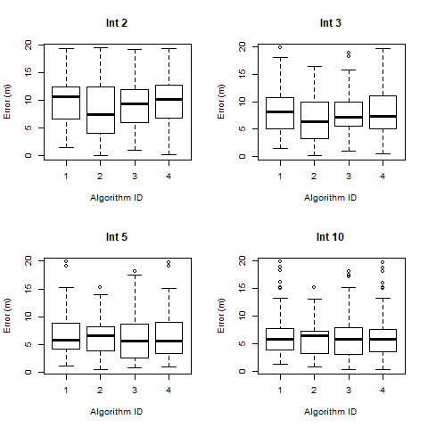
In this first section, we are going to show whether or not the data is symmetric. A symmetric distribution means the left side of the distribution mirrors the right side of the distribution. We expect the sensor data to follow a roughly normal distribution, which is a specific type of symmetric distribution. This is because RSSI is a seemingly random and chaotic variable that will cause the distance estimates to change randomly as well. To do this, we will use the following box plots:

s
Figure 0 – Box plots of the location estimates from Stewart Building floor 1 at differing beacon scanning periods.

From Figure 0, we see that the location estimates produced by each algorithm at each interval seem to follow roughly symmetric distributions. The median is close to the mean (typically) and the upper and lower quartiles (dotted lines) are roughly the same length. However, there are a few exceptions to this.

At an interval of 10 seconds, algorithm 2 has a median much higher than the mean.

4-1. Algorithm 1

4-1-1. Statistics
In this section, we will show some basic statistics of the location estimates created by algorithm 1 at different scanning periods.
 | 2 seconds | 3 seconds | 5 seconds | 10 seconds
Mean | 9.459 | 8.561 | 7.299 | 7.291
Standard Deviation | 4.376 | 4.831 | 4.400 | 4.978
Table 3 – The mean and standard deviations of error for algorithm 1 at different scanning periods (intervals).

In this table, we see the mean error of the location approximation is decreasing as scan duration increases. We also notice that the mean error between 2 and 3 seconds and 10 seconds is nearly halved, but the mean error between 5 seconds and 10 seconds is somewhat close.

4-1-2. Showing Normality
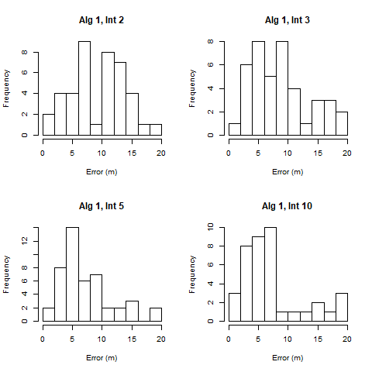
From Figure 1, we see the data follows roughly symmetric distributions. However,

Figure 1 – Histograms of error for algorithm 1 at different scanning periods (intervals)

4-1-3. Significance Testing
We should collect more data before going on to significance testing for this algorithm. The data does not appear to be normally distributed, but that could change if the sample size is increased.

4-2. Algorithm 2

4-2-2. Statistics
In this section, we will show some basic statistics of the location estimates created by algorithm 2 at different scanning periods.
 | 2 seconds | 3 seconds | 5 seconds | 10 seconds
Mean | 8.473 | 6.859 | 6.362 | 6.059
Standard Deviation | 5.134 | 4.392 | 3.443 | 3.373
Table 4 – The mean and standard deviations of error for algorithm 2 at different scanning periods (intervals).

In this table, we see the mean error of the location approximation is decreasing as scan duration increases. We also notice that the mean error between 2 and 3 seconds and 10 seconds is nearly halved, but the mean error between 5 seconds and 10 seconds is somewhat close.

4-2-2. Showing Normality
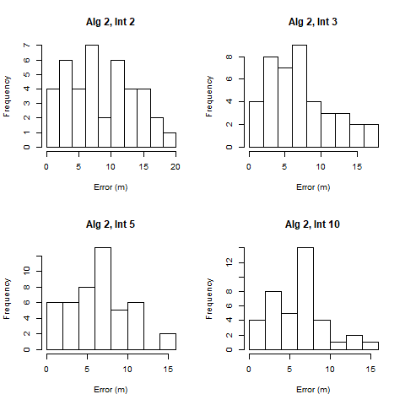
From figure 2, we see that the data does not follow a normal distribution for scanning periods of 3 seconds, 5 seconds, and 10 seconds. The scanning period of 2 seconds can be justified as roughly normal.

Overall, the usage of a t-test is inappropriate for the data we have. The shape of these distributions could be explained by the small sample size. It may also be the case that the error follows a gamnma or beta distribution.

4-2-3. Significance Testing
We should collect more data before going on to significance testing for this algorithm. The data does not appear to be normal or symmetrical, which rules out two of the more common testing methods.

4-3. Algorithm 3

4-3-1. Statistics
In this section, we will show some basic statistics of the location estimates created by algorithm 3 at different scanning periods.
 | 2 seconds | 3 seconds | 5 seconds | 10 seconds
Mean | 9.227 | 8.561 | 6.090 | 6.778
Standard Deviation | 4.308 | 4.831 | 4.139 | 4.750
Table 5 – The mean and standard deviations of error for algorithm 3 at different scanning periods (intervals).

In this table, we see the mean error of the location approximation is decreasing as scan duration increases. We also notice that the mean error between 2 and 3 seconds and 10 seconds is nearly halved, but the mean error between 5 seconds and 10 seconds is somewhat close.

4-3-2. Showing Normality

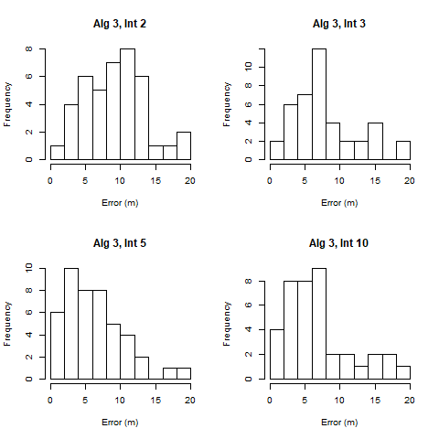
From figure 3, we see that the data does not follow a normal distribution for scanning periods of 3 seconds, 5 seconds, and 10 seconds. The scanning period of 2 seconds seems to be roughly normal, though.

Overall, the usage of a t-test is inappropriate for the data we have. The shape of these distributions could be explained by the small sample size. It may also be the case that the error follows a gamnma or beta distribution.

Figure 3 – Histograms of error for algorithm 1 at different scanning periods (intervals)

4-3-3. Significance Testing
We should collect more data before going on to significance testing for this algorithm. The data does not appear to be normally distributed, but that could change if the sample size is increased.

4-4. Algorithm 4

4-4-1. Statistics
In this section, we will show some basic statistics of the location estimates created by algorithm 4 at different scanning periods.
 | 2 seconds | 3 seconds | 5 seconds | 10 seconds
Mean | 9.611 | 8.365 | 6.783 | 7.036
Standard Deviation | 4.572 | 4.639 | 4.594 | 5.159
Table 6 – The mean and standard deviations of error for algorithm 4 at different scanning periods (intervals).

In this table, we see the mean error of the location approximation is decreasing as scan duration increases.

4-4-2. Showing Normality

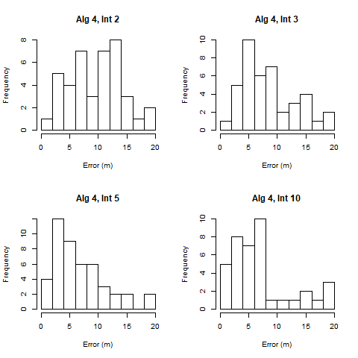
From figure 4, we see that the data does not follow a normal distribution for scanning periods of 3 seconds, 5 seconds, and 10 seconds. The scanning period of 2 seconds seems to be roughly normal, though.

Overall, the usage of a t-test is inappropriate for the data we have. The shape of these distributions could be explained by the small sample size. It may also be the case that the error follows a gamnma or beta distribution.

Figure 4 – Histograms of error for algorithm 4 at different scanning periods (intervals)

4-4-3. Significance Testing
We should collect more data before going on to significance testing for this algorithm. The data does not appear to be normally distributed, but that could change if the sample size is increased.

5. Comparing Algorithms
In this section, we will compare the effectiveness of each algorithm on calculating location using the new bins on the data set collected from Stewart Building this year. In order to do this, we must show that the differences between the errors for each pair of algorithms follows a normal distribution. After that, we can use a paired t-test to compare the algorithms.

5-1. Showing Normality
Below is a table of histograms showing the difference between the approximation errors for each algorithm on the data set collected from Stewart building.
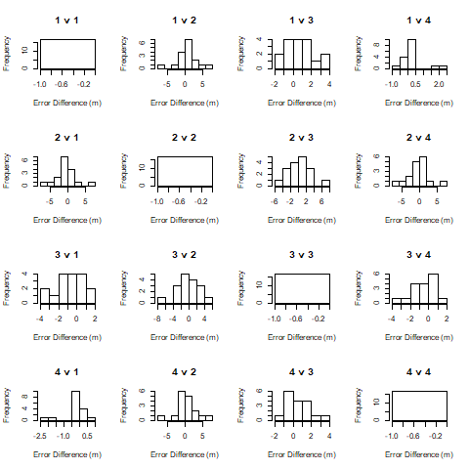
Figure 5 – This figure shows the histograms of error between the algorithms on data collected on floor 1 of Stewart Building

From figure 5, we see that the differences between each algorithm follow a roughly normal distribution for the most part. However, the graphs of 1 v 4 and 3 v 4 don’t appear to be very normal. We will run their t-tests anyway.

5-2. Significance Tests
Since the differences between the approximation errors of the algorithms are adequately normal, we can perform paired t-tests for each combination of algorithm. In the table below, we show the probabilities that the difference between using one algorithm and another occur just by chance.
 | Algorithm 1 | Algorithm 2 | Algorithm 3 | Algorithm 4
Algorithm 1 | 1 | 0.192 | 0.077 | 0.255
Algorithm 2 | 0.192 | 1 | 0.445 | 0.336
Algorithm 3 | 0.077 | 0.445 | 1 | 0.130
Algorithm 4 | 0.255 | 0.336 | 0.130 | 1

Table 7 – the probabilities that the difference in location approximation on floor 1 of Stewart Building between two algorithms occurs by chance

From table 3, we see the probability that the difference in location error between algorithms 1 and 3 occurs by chance is 7.7%. From table 3, we know the mean error of algorithm 1 when the scanning period is 10 seconds is 6.623 meters. From table 4, we know the mean error of algorithm 3 when the scanning period is 10 seconds is 5.970. Therefore, we can conclude that algorithm 3 performs significantly better than algorithm one in Stewart building and the scanning period is 10 seconds.

6. Conclusions
We should collect more data before making conclusions about the cost of lowering the scanning period. As for the efficiency of the algorithms, it seems like algorithm 3 performs better than algorithm 1. Other than that, there isn’t any evidence to suggest that one is better than another.

