Running Instructions:

1. Install XAMPP.
2. Download files for the project and the BarterDB folder somewhere in your created XAMPP folder
3. Run xampp-control.exe
4. Start the modules Apache and MySQL in the control panel.
5. In your internet browser, type localhost/phpmyadmin and import the database tables from the downloaded files.
6. In your internet browser, type localhost/*folder location in XAMPP*/BarterDB/index.html to bring up the home page for the site.
7. Navigate the site how you would a normal webpage.

Project Details:

Languages & Tools

* XAMPP
  + - MySQL
    - phpMyAdmin
    - Apache
* HTML
* CSS
* JavaScript
* php

Team Members & Contributions

* Luke Maupin - Mainly focused on backend. Most of the database interactions and minor UI features/tweaks such as the user dashboard page trades display.
* Jesus Peralta - Mainly focused on frontend/user interface and overhauling the site to its current look from our first iteration of the site.

Database Integration:

Database tables are used in this project by linking frontend features of the website to a table in the database where the information is displayed:

* Sign up/Log in - Stores sign in information in ‘users’ table which is accessed again during log in
* Item input - Users use the item input page to add items they own to their account, the information for which is stored in the ‘items’ table.
* Item ownership - Ownership of each user’s items are stored in the ‘owns’ table.
* Dashboard trades - The active trades on the dashboard page are displayed from the ‘trade’ table in the database after trade requests are made by the user from the create trade page.

These are the main places where the database is used in the project but there are various other locations where this happens.

Link to Presentation:

<https://docs.google.com/presentation/d/1lt93iiSpLyAJMIEd9ou9_9YjWplQKTqju2QBS5ifmBM/edit#slide=id.g31b3e0b2c67_0_796>

Link included in the case that the presentation is tweaked before the in-class presentation and the updated slides are needed.

HTML Design Screenshots:

Home page

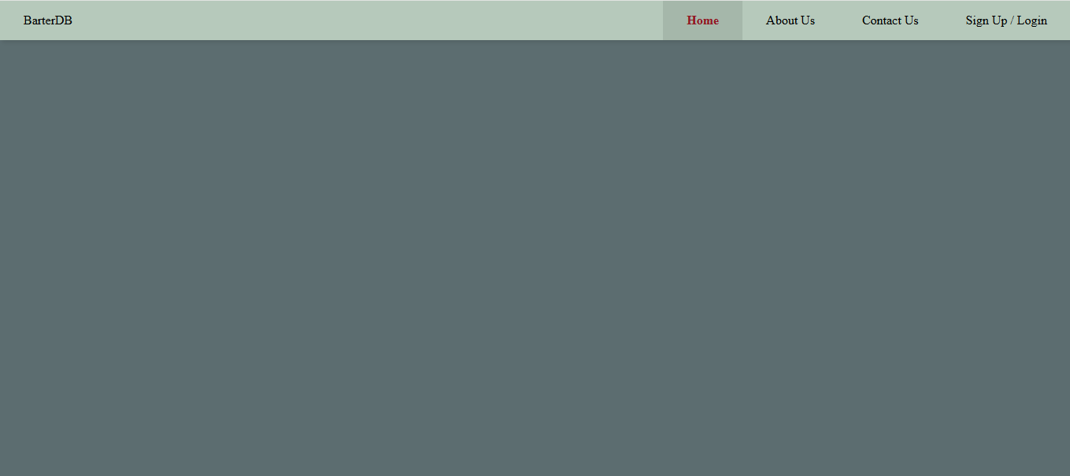

About us

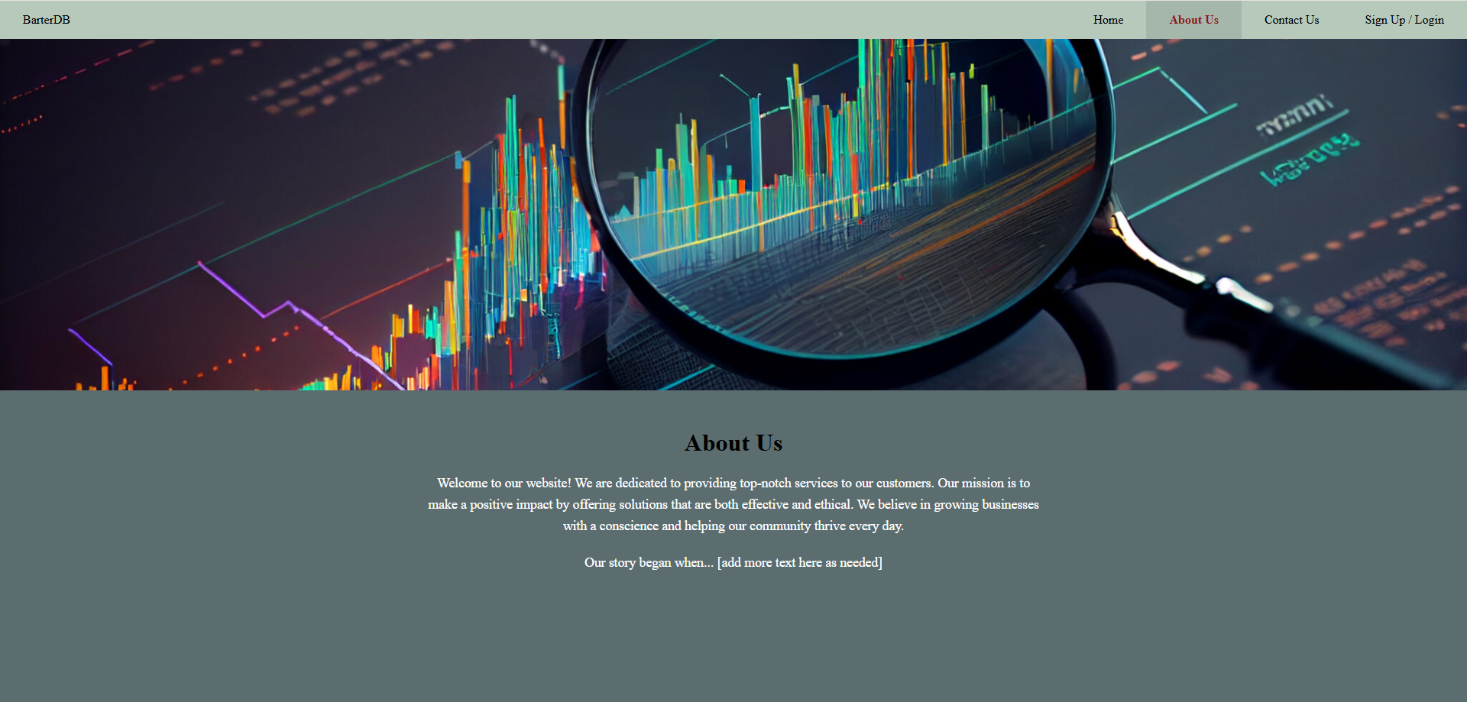

Contact us

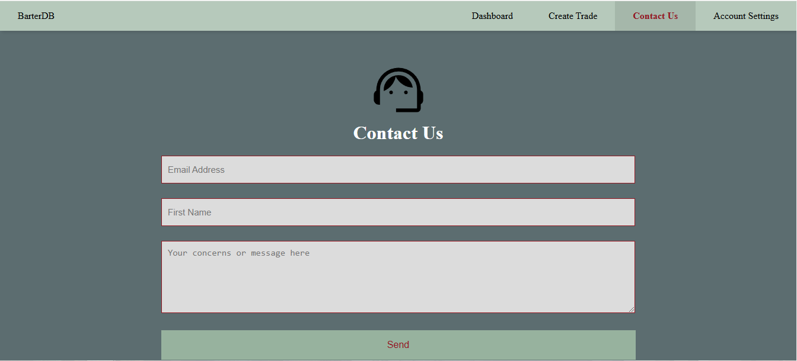

Sign up

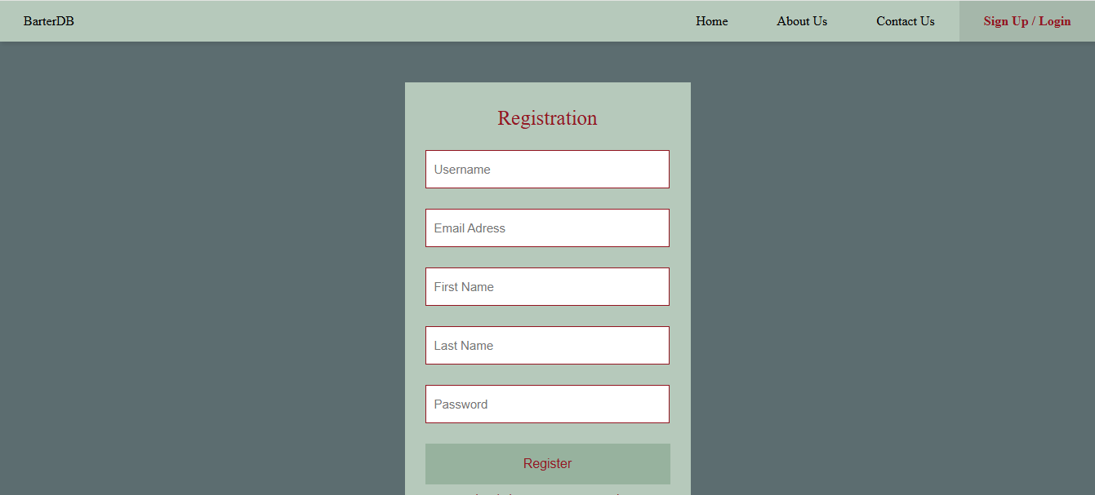

Log in

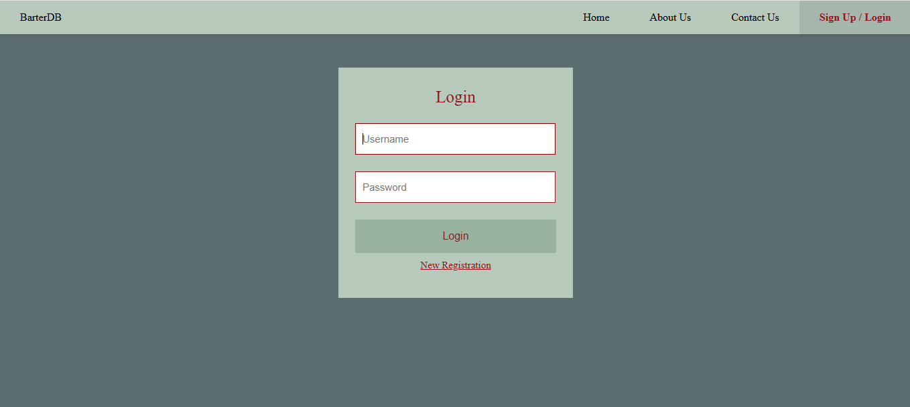

User Dashboard

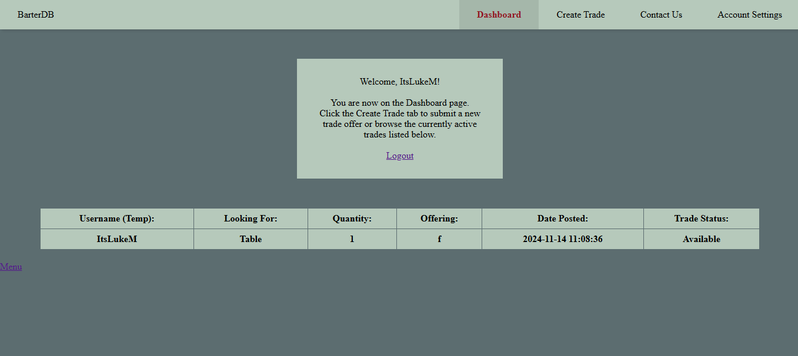

Create Trade

