Lucas Mayo
Evolutionary Robotics
Final Project Written Report
Goals
For my final project I chose “Daddy Long Legs”. This project entailed evolving the length of the legs of the quadruped along with the “brain” and evolve the robot to walk efficiently. The “A” variant of my robot evolved the length of the lower legs. The “B” variant evolved both the upper and lower legs. The question I tried to answer follows: Using evolutionary algorithms, can I evolve the quadruped to find lengths of lower legs that will allow efficient locomotion? Additionally, can I evolve the quadruped to find lengths of both the upper and lower legs to allow locomotion? Finally, which evolved robot performs better?

Implementation
To implement this project, I first had to modify solutions constructor and added arrays to encode the length of the lower and upper legs. These values are set randomly between 1.5 and 2.5 units long. Since the lengths of legs are no longer constant, I had to dynamically adjust the position values dynamically in solution’s generate_body function. This was accomplished by using the random values stored in the arrays to adjust their position values accordingly. The size values of the legs were also modified using the length values in the arrays. Additionally, I had to adjust the initial height of the robot to be the height of the longest generated lower leg, so that the robot would not be forced out of the ground. Next, I modified Solution’s mutate function to mutate the upper and lower legs along with the synapses of the robot, with an equal chance of mutating.
Finally, I had to modify the fitness function in robot. I wanted to evolve, locomotion, so used the same fitness function in the assignments, distance in the negative x direction. The first thing that I noticed is that since the robot’s legs were now different lengths, it was much more prone to falling over. So, I had to modify the fitness function to prevent this from happening. I first added a constant penalty that would be enforced if the torso of the quadruped touched the ground at any moment. Then, I got the orientation of the quadruped using pybullets getBasePositionAndOrientation function and calculated the pitch and roll angles from the final orientation of the robot. If the robot’s orientation reached a certain threshold, a penalty would be enforced. This worked somewhat well, but the robot would still fall over, and try to push itself with its other legs. The next strategy I attempted was punishing the orientation of the robot on an exponential scale, instead of a constant penalty. The greater the orientation, the larger the penalty enforced. This also did not work as well as I would have hoped. The fitness function I settled on enforced a penalty when one of the lower legs laid flat on the ground. I did this by getting the pitch and roll values of all the lower legs and then enforcing a penalty within a certain range. This worked well, as the quadruped would have to learn how to balance on its legs first before starting to move in the correct direction.

Results
As Previously described, the A/B test I performed was comparing the quadruped with just the height of the lower legs evolved vs the height of both the upper and lower legs evolved. Below are 2 fitness curves of my evolutionary algorithm with 100 generations with a population size of 30. Note that I am minimizing the fitness.
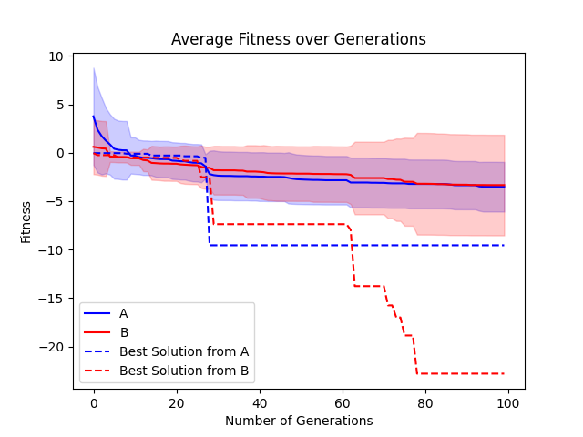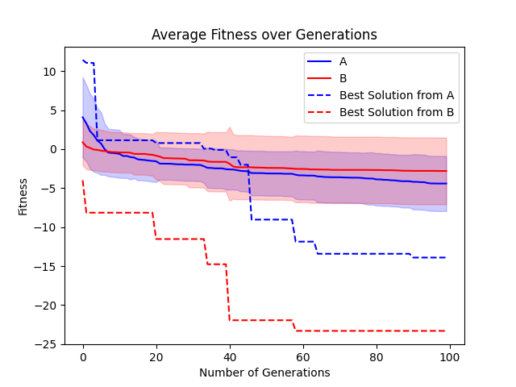
Here we can see that the average fitness, and the standard deviation of A and B are approximately the same, leading me to believe that there is not much difference between them. In addition, we see the best solution from this run of the evolutionary algorithm in the dashed lines. In this case, the best solution from this run is A, but B has a somewhat similar curve; although the B is outperformed. This again leads me to the conclusion that A and B are somewhat similar and do not outperform each other.
Reflection and Future Work

