Luke Newman

ICS 240 Intro to Data Structures

Programming Assignment #3

1. The purpose of these first couple of trial simulations is to check the reasonableness of the results and test for bugs.

|  |  |
| --- | --- |
| Arrival Rate | .45 |
| Departure Rate | 0.0 |
| Time to land | 2 min |
| Time to takeoff | 3 min |
| Minutes of fuel remaining | 10 |
| Number of runways | 1 |
| Simulation time | 100000 min |

a)

Results:

|  |  |
| --- | --- |
| How many planes landed? | 44353 |
| How many planes crashed? | 802 |
| How many planes took off? | 0 |
| How long did a plane wait on average to land? | 3.036 min |
| How long did a plane wait on average to takeoff? | NaN |

These results are reasonable. In 100000 simulation minutes with the probability of an arrival at .45 for every minute, we should expect there to be about 45000 landings. Crashes are certainly possible since a plane does not have to be very far back in the queue to crash. If a plane is ever in the 6th spot in the queue and the 5 planes ahead of it will land, that 6th plane will crash. However, this is not likely, and is why the number of crashes relative to the number of planes landed is small. Also, since the amount of time it takes to land is only two minutes, and the probability of an arrival is close to one in every two minutes, the average wait time is closer to 0 than 9.

b)

|  |  |
| --- | --- |
| Arrival Rate | 0.0 |
| Departure Rate | 0.2 |
| Time to land | 2 |
| Time to takeoff | 3 |
| Minutes of fuel remaining | 10 |
| Number of runways | 1 |
| Simulation time | 100000 |

Results:

|  |  |
| --- | --- |
| How many planes landed? | 0 |
| How many planes crashed? | 0 |
| How many planes took off? | 20106 |
| How long did a plane wait on average to land? | NaN |
| How long did a plane wait on average to takeoff? | 1.497 min |

Again these results are reasonable. There is a one-fifth chance of a plane being scheduled to depart in every minute of the 100000 simulation minutes. We should expect to see about 20000 takeoffs. The queue shouldn’t get very backed up since the time to takeoff (3 minutes) is less than the inverse of the departure rate (inverse of 1/5 = 5). The low average wait time of 1.497 minutes shows this.

2. Arrival Rate Experiment – The purpose of this experiment is to see how the arrival rate effects landings, takeoffs, average wait times and crashes. These results will be used to suggest an optimal arrival rate.

Constants

|  |  |
| --- | --- |
| Departure Rate | .1 |
| Time to Land | 2 |
| Time to takeoff | 2 |
| Fuel remaining | 10 |
| Simulation time | 100000 |

One Runway

|  |  |  |  |  |  |
| --- | --- | --- | --- | --- | --- |
| Arrival Rate | Planes Landed | Planes Departed | Avg. Wait  Arrival | Avg. Wait Departure | Crashes |
| 0.00 | 0 | 9995 | NaN | 0.0 | 0 |
| 0.025 | 2456 | 10153 | 0.1221 | 0.2545 | 0 |
| 0.05 | 5046 | 10999 | 0.1635 | 0.377 | 0 |
| 0.075 | 7421 | 9940 | 0.2085 | 0.5253 | 0 |
| 0.10 | 10064 | 10075 | 0.2519 | 0.7599 | 0 |
| 0.125 | 12623 | 9766 | 0.2873 | 0.9803 | 0 |
| 0.15 | 14840 | 9972 | 0.3556 | 1.384 | 0 |
| 0.175 | 17450 | 9954 | 0.1491 | 1.7346 | 0 |
| 0.20 | 19931 | 10117 | 0.5114 | 2.256 | 0 |
| 0.225 | 22615 | 9956 | 0.5983 | 2.967 | 0 |
| 0.25 | 25099 | 9977 | 0.7005 | 3.827 | 0 |
| 0.275 | 27364 | 10176 | 0.8192 | 5.301 | 1 |
| 0.30 | 30018 | 9999 | 0.9856 | 7.890 | 3 |
| 0.325 | 32545 | 10127 | 1.203 | 12.43 | 8 |
| 0.35 | 34548 | 9982 | 1.405 | 20.07 | 17 |
| 0.375 | 37430 | 10030 | 1.878 | 53.84 | 77 |
| 0.40 | 39617 | 9959 | 2.227 | 238.0 | 134 |
| 0.45 | 44439 | 5558 | 3.368 | 23047 | 759 |
| 0.50 | 47459 | 2540 | 4.726 | 34863 | 2392 |
| 0.55 | 49259 | 740 | 6.174 | 47500 | 5758 |
| 0.60 | 49842 | 158 | 7.268 | 54740 | 10483 |
| 0.65 | 49966 | 34 | 7.841 | 51952 | 14940 |
| 0.70 | 49998 | 2 | 8.258 | 57330 | 20055 |
| 0.75 | 50000 | 0 | 8.496 | NaN | 24938 |
| 0.80 | 50000 | 0 | 8.670 | NaN | 30041 |
| 0.85 | 50000 | 0 | 8.784 | NaN | 35096 |
| 0.90 | 50000 | 0 | 8.870 | NaN | 39953 |
| 0.95 | 50000 | 0 | 8.943 | NaN | 44986 |
| 1.00 | 50000 | 0 | 8.991 | NaN | 49991 |

Two Runways

|  |  |  |  |  |  |
| --- | --- | --- | --- | --- | --- |
| Arrival Rate | Planes Landed | Planes Departed | Avg. Wait Arrival | Avg. Wait Departure | Crashes |
| 0.00 | 0 | 10065 | NaN | 0 | 0 |
| 0.025 | 2438 | 9772 | 0.0029 | 0.0057 | 0 |
| 0.05 | 5043 | 10083 | 0.0038 | 0.0145 | 0 |
| 0.075 | 7422 | 10108 | 0.0055 | 0.0195 | 0 |
| 0.10 | 10104 | 10016 | 0.0089 | 0.0335 | 0 |
| 0.125 | 12507 | 10016 | 0.0107 | 0.0433 | 0 |
| 0.15 | 15036 | 9966 | 0.0121 | 0.0569 | 0 |
| 0.175 | 17723 | 9973 | 0.0133 | 0.0728 | 0 |
| 0.20 | 20074 | 9986 | 0.0162 | 0.1012 | 0 |
| 0.225 | 22448 | 10007 | 0.0166 | 0.1289 | 0 |
| 0.25 | 24681 | 9986 | 0.0191 | 0.1449 | 0 |
| 0.275 | 27628 | 9959 | 0.0198 | 0.1449 | 0 |
| 0.30 | 30038 | 9831 | 0.0232 | 0.2245 | 0 |
| 0.325 | 32630 | 9910 | 0.0230 | 0.2460 | 0 |
| 0.35 | 35175 | 10053 | 0.0256 | 0.3112 | 0 |
| 0.375 | 37633 | 10026 | 0.0278 | 0.3556 | 0 |
| 0.40 | 40330 | 10052 | 0.0270 | 0.4199 | 0 |
| 0.45 | 44776 | 10030 | 0.0292 | 0.5424 | 0 |
| 0.50 | 49618 | 9976 | 0.0320 | 0.7427 | 0 |
| 0.55 | 55262 | 10103 | 0.0359 | 1.035 | 0 |
| 0.60 | 60083 | 9890 | 0.0360 | 1.388 | 0 |
| 0.65 | 65195 | 10168 | 0.0392 | 2.003 | 0 |
| 0.70 | 69994 | 10004 | 0.0419 | 2.765 | 0 |
| 0.75 | 74840 | 9887 | 0.0373 | 4.416 | 0 |
| 0.80 | 80139 | 9915 | 0.0444 | 7.193 | 0 |
| 0.85 | 85077 | 10084 | 0.0394 | 18.22 | 0 |
| 0.90 | 90090 | 9813 | 0.0519 | 702.0 | 0 |
| 0.95 | 94995 | 5005 | 0.0000 | 24524 | 0 |
| 1.00 | 100000 | 0 | 0 | NaN | 0 |

The graph above is a wide range view at what happens to the number of planes landing vs. the number of planes departed when the arrival probability goes from 0.0 to 1.0. This graph is important because it shows that my program is indeed working correctly. With one runway you would expect the number of planes landing to level off and peak at 50000 planes. This is because it takes two minutes to land. One feature of this graph not included in the graph below is the dip in the planes departed with two runways when the arrival rate probability reaches 0.90. This is because both runways are increasingly being used for landings. The maximum number of planes the two runways can handle is 100000, since both the landing time and take off time are two minutes. This maximum number is reached when the arrival rate is 0.90 and the constant departure rate is at 0.10. Arrivals have precedence and so after this point arrivals increase while departures decrease.

The graph above is a blowup version of the number of planes landing vs. planes departing. The color of the lines are different. The planes landed line, for both 1 runway and 2, follows a positive sloped linear path of 5000 planes per 0.05 increase of the arrival rate. This continues until the simulation with one runway reaches its peak of 50000 planes serviced (landed or departed). This starts to happen around 0.4, which is as expected, since the departure rate is held at 0.10. (0.10*100000 + 0.40*100000 = 50000). At this point, the planes landed levels off at 50000 and the departures starts to decline towards 0, since arrivals have precedence over departures. With two runways we see straight lines exhibiting the linearly increased arrival rate and the constant departure rate. The runways are not exhausted yet and we see no dips or maximums.

More arrival rates were trialed for these next two graphs to smoothen out the lines. The rates were increased by 0.025 per trial instead of 0.05. We see that the average wait times slowly increase but the wait times for departures increase faster than wait times for landings. Adding another runway decreases the wait times a lot and it also decreases the rate at which they increase, making the lines flatter.

Crashes start to happen at an arrival rate of 0.275 (1 crash). The maximum arrival rate that an airport with one runway can handle without crashes is 0.25. This airport has a departure rate of 0.10.

3. Departure Rate Experiment – The purpose of this experiment is to see how the departure rate effects landings, takeoffs, average wait times, and crashes. These results will be used to suggest an optimal departure rate.

Constants

|  |  |
| --- | --- |
| Arrival Rate | 0.10 |
| Time to land | 2 minutes |
| Time to takeoff | 2 minutes |
| Fuel Remaining | 10 minutes |
| Simulation Time | 100000 minutes |

One Runway

|  |  |  |  |  |  |
| --- | --- | --- | --- | --- | --- |
| Departure Rate | Planes Landed | Planes Departed | Avg. Wait Arrival | Avg. Wait Departure | Crashes |
| 0.00 | 10110 | 0 | 0.1293 | NaN | 0 |
| 0.025 | 10015 | 2404 | 0.1503 | 0.4243 | 0 |
| 0.05 | 9878 | 4968 | 0.1818 | 0.5171 | 0 |
| 0.075 | 10015 | 7482 | 0.2205 | 0.6329 | 0 |
| 0.10 | 9925 | 9840 | 0.2471 | 0.7073 | 0 |
| 0.125 | 10090 | 12512 | 0.2890 | 0.9030 | 0 |
| 0.15 | 9984 | 15031 | 0.3117 | 1.013 | 0 |
| 0.175 | 9885 | 17697 | 0.3405 | 1.234 | 0 |
| 0.20 | 9967 | 19813 | 0.3703 | 1.419 | 0 |
| 0.225 | 10180 | 22444 | 0.4116 | 1.775 | 0 |
| 0.25 | 10057 | 25009 | 0.4362 | 2.133 | 0 |
| 0.275 | 9825 | 27592 | 0.4636 | 2.647 | 0 |
| 0.30 | 10073 | 30271 | 0.4937 | 3.530 | 0 |
| 0.325 | 10133 | 32554 | 0.5353 | 5.008 | 0 |
| 0.35 | 9990 | 34683 | 0.5639 | 6.989 | 0 |
| 0.375 | 10099 | 37668 | 0.5982 | 20.03 | 0 |
| 0.40 | 10022 | 39969 | 0.6211 | 231.6 | 0 |
| 0.50 | 9969 | 40031 | 0.6254 | 9651 | 0 |
| 0.60 | 10178 | 39822 | 0.6271 | 16673 | 0 |
| 0.70 | 9900 | 40100 | 0.6322 | 21335 | 0 |
| 0.80 | 10116 | 39884 | 0.6189 | 24995 | 0 |
| 0.90 | 9899 | 40100 | 0.6319 | 27700 | 0 |
| 1.00 | 10128 | 39872 | 0.6337 | 30013 | 0 |

Two Runways

|  |  |  |  |  |  |
| --- | --- | --- | --- | --- | --- |
| Departure Rate | Planes Landed | Planes Departed | Avg. Wait Arrival | Avg. Wait Departure | Crashes |
| 0.00 | 9985 | 0 | 0 | NaN | 0 |
| 0.025 | 9970 | 2577 | 0.0012 | 0.0194 | 0 |
| 0.05 | 9988 | 5056 | 0.0046 | 0.0194 | 0 |
| 0.075 | 10063 | 7472 | 0.0076 | 0.0301 | 0 |
| 0.10 | 9851 | 10053 | 0.0087 | 0.0312 | 0 |
| 0.125 | 9932 | 12364 | 0.0108 | 0.0385 | 0 |
| 0.15 | 9852 | 15067 | 0.0123 | 0.0410 | 0 |
| 0.175 | 9909 | 17390 | 0.0141 | 0.0511 | 0 |
| 0.20 | 9892 | 20040 | 0.0169 | 0.0572 | 0 |
| 0.225 | 10004 | 22498 | 0.0184 | 0.0612 | 0 |
| 0.25 | 10007 | 24983 | 0.0176 | 0.0704 | 0 |
| 0.275 | 9875 | 27560 | 0.0220 | 0.0754 | 0 |
| 0.30 | 9962 | 30028 | 0.0201 | 0.0819 | 0 |
| 0.325 | 10128 | 32446 | 0.0217 | 0.0952 | 0 |
| 0.35 | 10063 | 35130 | 0.0261 | 0.1027 | 0 |
| 0.375 | 10177 | 37741 | 0.0284 | 0.1177 | 0 |
| 0.40 | 10206 | 40082 | 0.0273 | 0.1301 | 0 |
| 0.50 | 10021 | 49715 | 0.0346 | 0.1765 | 0 |
| 0.60 | 10021 | 59762 | 0.0392 | 0.2632 | 0 |
| 0.70 | 9955 | 70257 | 0.0411 | 0.4282 | 0 |
| 0.80 | 9977 | 79971 | 0.0452 | 0.9726 | 0 |
| 0.90 | 9959 | 89851 | 0.0100 | 28.78 | 0 |
| 1.00 | 10052 | 89948 | 0.0000 | 5023 | 0 |

The number of planes departed increases linearly with the departure rate probability until it abruptly reaches its maximum level. For an airport with one runway, this is at 40000 planes. This is because the airport can only service 50000 planes, and since arrivals are given precedence, 10000 planes will land no matter what the departure rate is. An airport with two runways can service a maximum of 100000 planes, and so the maximum departures is at 90000.

This graph is very similar to the average wait times for the arrival rate experiment. The shapes of the lines are the same with smaller wait times. This is because the arrival queue does not have to wait for an empty takeoff queue, while the takeoff queue is getting backed up more as the departure rate increases. However, in the arrival rate experiment, the takeoff queue has to wait for an empty arrival queue before removing a plane for takeoff. The arrival queue is getting backed up as the arrival rate increases. Both queues get backed up in the previous experiment, while in the departure rate experiment only the takeoff queue does, if we keep the arrival rate low. Adding a runway dramatically reduces the wait times.

I included extra data in this graph to show that the number of crashes is independent of the departure rate. This is because the arrival queue has precedence over the takeoff queue. The extra data is the blue line which represents the number of crashes when the arrival rate is held at 0.35 at an airport with one runway. The number of crashes stays within the range of 15 – 45. Adding a runway would reduce the number of crashes, but this is not shown in our original data since we chose a low arrival rate of 0.10. Both pools of trials, with one runway and two runways, resulted in 0 crashes independent of the departure rate. In this experiment, as long as you choose a low arrival rate, planes never start to crash. If you choose a high arrival rate, crashes do not continually increase or decrease, but instead fluctuate around an average or a straight line. The average wait time for an arrival does increase as the departure rate increases, so this may increase the likelihood of a crash. The increase is so small though that it really is insignificant. The airport should instead determine to add another runway when the average wait time for departures becomes too high.

4. Summary

a) In the arrival rate experiment we find that the number of planes landing increases linearly with an increasing arrival rate until it approaches its maximum of 50000 planes. As the planes landed approaches 50000, the takeoffs line slowly declines toward 0 from its steady value of 10000. This results in the leveling off or tapering effect in the graph. (With two runways this declining number of takeoffs is a straight line reaching 0 takeoffs much quicker. This is because the arrival queue is that much more backed up. Arrivals are coming at a faster rate giving departures less of a chance to takeoff. In other words, you do not see the planes landed line curve as it reaches its maximum of 100000 landings.) In the departure rate experiment the number of takeoffs line does not level off as it approaches its maximum but hits its maximum with the same positive slope and then turns into a straight line. This phenomenon occurs because as the takeoff line approaches its maximum, it is not accompanied by a declining arrival or “planes landed” line. This observation is not relevant unless we were to increase the time for fuel remaining, so that there wouldn’t be any crashes until this maximum amount of serviced planes is reached.

Departures have to wait longer than landings in both experiments, and adding a runway substantially lowers the average wait time for both. The arrival rate experiment exhibits longer wait times than the departure rate experiment. This is because both queues are getting backed up in the arrival rate experiment, whereas only the takeoff queue is getting long in the departure rate experiment. The arrival queue, which is held at a constant arrival rate in the departure rate experiment, does not have to wait for an empty takeoff queue for a plane to be removed. The takeoff queue does have to wait for an empty arrival queue, but the arrival rate is kept at a low rate of 0.10. Contrast this with the arrival rate experiment, where departures have to wait for a growing arrival queue to become empty. And arrivals also have to wait in the back of the line for a growing arrival queue.

b) Crashes depend on the arrival rate and not on the departure rate. This is because the arrival queue does not wait for the takeoff queue to be empty. Therefore the departure rate does not significantly affect the arrival queue. The average wait time for an arrival does increase as the departure rate increases, so this may increase the likelihood of a crash. The increase is so small though that it really is insignificant.

c) In the arrival rate experiment the optimal value for an arrival rate is 0.25. There were no crashes at this level and departures waited on average under 4 minutes to takeoff. Arrival rates higher than this require the airport to have 2 runways. This is true of course only when we have the constant relative values that we have. Customers will wait too long to takeoff if the departure rate is too high.

In the departure rate experiment the optimal departure rate, on the basis of average wait times, depends how long customers are willing to wait to takeoff and how behind schedule the airport commission decides is acceptable. If the commission decides that five minutes behind schedule is unacceptable, you may want to add another runway after the rate gets above 0.30. This of course is true when the arrival rate is held at 0.10. If the arrival rate were higher, somewhere between 0.10 and 0.25 where there will still be no crashes, then planes in the takeoff queue will be waiting longer on average. Do not assume that the optimal arrival rate in the arrival rate experiment can be used as a standard along with the optimal departure rate from the departure rate experiment at the same airport. For example, an arrival rate of 0.25 and a departure rate of 0.25 is not good for an airport. Crashes will not happen, but planes that were scheduled to leave will be delayed for too long. The landing time, takeoff time and fuel remaining time are all factors at an airport as well. I chose the landing time and takeoff time to be 2 minutes each for both experiments. I chose the fuel remaining time to be 10 minutes.

In the first experiment crashes begin to happen after the airport experiences an arrival rate above 0.25. The airport should then build another runway. There are no crashes after the airport builds another runway regardless of the arrival rate. However, planes in the takeoff queue are waiting too long after the arrival rate goes above 0.75.

In the second experiment crashes never happen, but the wait becomes too burdensome after the departure rate goes above 0.30. I made the arbitrary choice that 5 minute delays on average is unacceptable. At this point another runway should be added. An airport with 2 runways can handle a departure rate of 0.80 and an arrival rate of 0.10. We see that at a departure rate of 0.90, departures are having to wait too long to takeoff.

In reality however, it doesn’t make sense to have a departure rate different than the arrival rate. They should be the same on average so that the number of planes departing equals the number of planes arriving. If the rates are different then the airport will either run out of planes or will have too many. These rates do not always have to be the same, but should be kept close together. We know that this optimal rate is somewhere at 0.25 or below since anything above an arrival rate of 0.25 results in crashes. Adding a runway will increase the number of planes that the airport may service, and will increase the optimal rate. Using the same constants, here are the results for finding the optimal rate of planes coming and going at an airport with one runway:

|  |  |  |
| --- | --- | --- |
| Arrival Rate/Departure Rate | Avg. Wait Time for Departure | Crashes |
| 0.25/0.25 | 317.8 | 0 |
| 0.20/0.20 | 5.269 | 0 |
| .19/.19 | 4.17 | 0 |

The optimal arrival rate and departure rate for an actual airport with one runway, these particular constants, and constraint of not having on average 5 minute delays is 0.19. A second runway must be built if the rate is expected to go above 0.19. Increasing the arrival rate for a period of time requires the departure rate be decreased. For example an arrival rate of 0.25 and a departure rate of 0.12 is acceptable for a while. Changing the constants of landing time, takeoff time, fuel remaining time and total simulation time may change the results. Lowering the total simulation time does not have much of an effect unless you lower it to a point where the results are meaningless. Increasing the landing time will increase the chances of a crash, and it will also increase the waiting times. Increasing the takeoff time will also increase the waiting times, and slightly increase the chances of a crash. Increasing the fuel remaining time will decrease the chances of a crash, but will not do anything to the wait times.

Example of what program interface looked like:

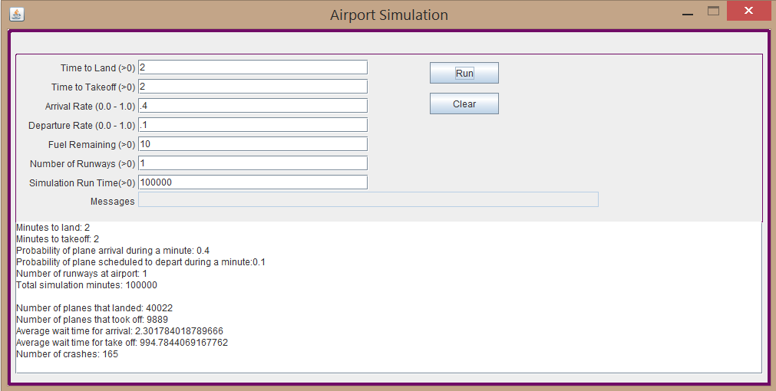

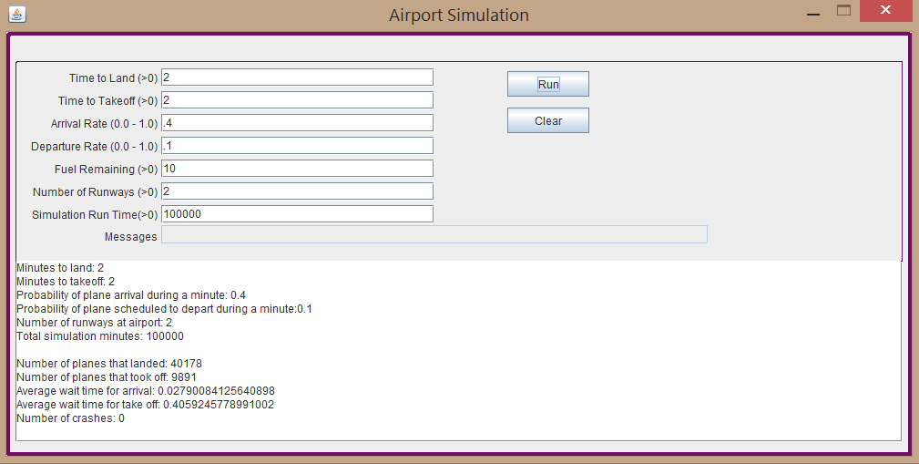

In retrospect, I would have done some things differently. First of all I would have rounded the average wait times or cut off the digits at the end with java’s formatted print function. Also, the second group of outputs is generated all from one function inside a class called Main. Proper design would have called for separate functions for each type of output.