2314348p – Luke Poutney

Assignment 2 innit

**Exercise 1**

**The Integrated Qualitative Model**

After completing the qualitative growth model for Airbnb previously, I realised it could be improved upon. I chose to revise the elements of the model, going through and clearly identifying some elements that were missed using a table similar to the one shown in week 8 Slide 22.

|  |  |  |  |
| --- | --- | --- | --- |
| CGM - Type | Detail | Actor | Action |
| Direct CGM:  Financially Driven | Share site with potential host | Existing User | Successfully referring a new host rewards the existing user with money. |
| Direct CGM:  Personal Utility Driven | Share stay details with friends | Booking User | Shares booking link to log attendees. Users require an account to participate and so sign up. |
| Indirect CGM:  Social Capital Driven | Stay is shared via social media | Sharing user | User shares interesting house with friends/followers as content, some of these users book a stay or sign up. |
| Indirect CGM:  Currency = content | YouTube channel content attracts viewers to the channel | Company media team + Influencer | Viewers subscribe to the channel and build familiarity with Airbnb, so may book with them in the future. |
| Brand Network Effect | Easier to build userbase as brand trust increases | New Users |  |

**Activation:**

The activation sheet begins with all the linear marketing channels that product a monthly traffic of users [1]. Nearly all of these channels are improving over time to due to brand network effect, with the exception of the paid channels. They will remain steady as I have chosen not to increase the spending of such marketing channels due to the increase from brand network effect. Instead, marketing budget is used elsewhere to continue to increase the brand awareness, which will be seen in the cost tab.

The conversion rate of the visits via these linear channels has been given a fluctuating percentage that roughly correlates to an underexaggerated graph of when users book holidays [2]. While Airbnb are not exclusively used for such a purpose, a portion of their users will sign up for such a purpose and so more users may sign up and book around the times of year they book a holiday.

Looking at compounding growth mechanisms that the site makes use of, it acquires more bookers through a stay logging system, which allows users to log stays they attended but did not book, prompting those without an account to sign up. The number of invites of this kind being sent fluctuates in a similar manner to the linear mechanisms. The site also offers financial incentive to invite new hosts to the site as another form of CGM, which remains steady throughout the year.

Note: After receiving feedback on assignment 1 I realise I have mistakenly included some of the CGMs for Airbnb in the linear area and have attempted to show an understanding of this should have instead been done in the table above.

Separate summations for the acquisition of bookers and hosts are then made, combining the number of linear acquisitions with that of the CGMs.

**Retention**

The retention tab churns the total number of monthly bookers and hosts so that there is a loss of users over time. Hosts show an extremely low amount of churn as once most are set up they will be unlikely more unlikely to stop using the site when compared to a booker who can switch easily. This tab also keeps track of monthly active inviters, which is used in the compounding growth calculations for acquisition. This is the number of bookers along with the number of hosts who are not also bookers (as bookers and hosts are not mutually exclusive). All of the moving variables in this tab have remained steady for now, but we will experiment with the effects of churn later.

**Monetization**

Here there were a few things to total to calculate total revenue[2]: the revenue booking from bookings, hosts and experiences. Airbnb charges both the booker and the host a respective service fee [3]. The fee for booking was combined with the average number of bookings per month and average stay price [4]. The host fee was again combined with average stay price, as well as estimations of number of stays per month taken from a host forum[5].

Data on experiences were less accessible, presumably due to it being a relatively new aspect to Airbnb, so appropriates estimates were made here, with the amount of bookings being made per month increasing for the first year to account for people gradually learning of its existence within Airbnb’s site.

**Cost**

Costs accounted for include site running fees [6], employee costs and advertisement costs (brand deals, partnerships such as the one with the Olympics, SEM, social media), as well as other miscellaneous costs such as professional photography costs in selected cities.

**Overview**

Here we can investigate the effects of churn on our model. Currently the model has had a rate of 1% for bookers and a much lower and as such the business is projected to grow rapidly:

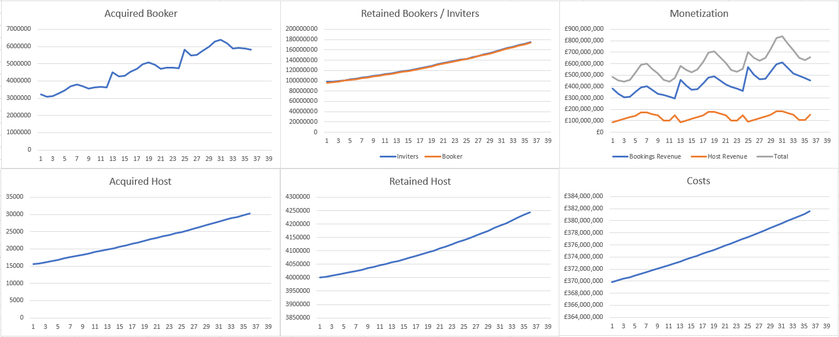

Applying 1% churn and 0.1% churn respectively we can see that the business is able to continue to grow quickly with this level of churn. However, should we apply a 5% and 0.5% churn instead we see different results:

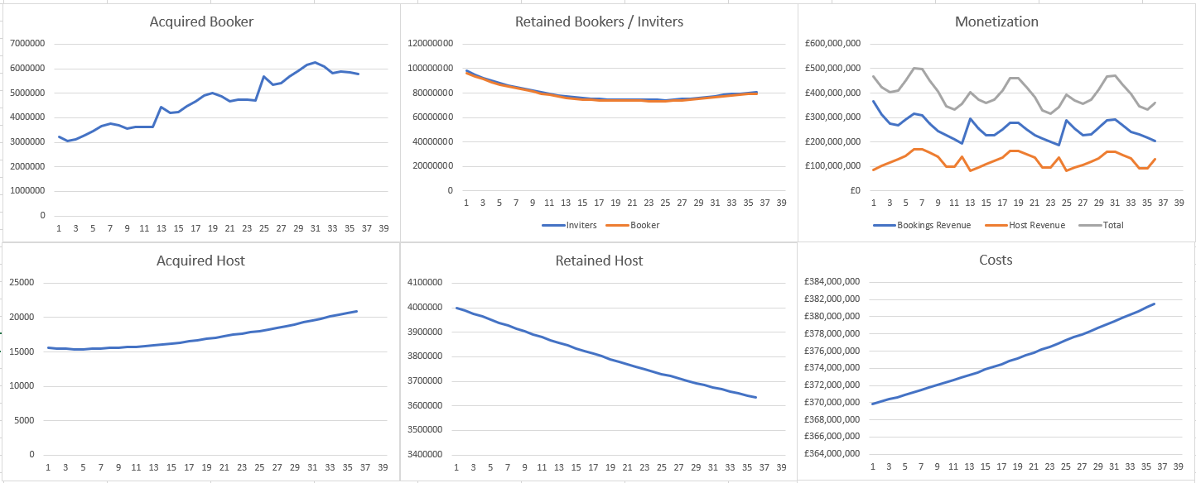

The business appears to stagnate in terms of retention of bookers, but in reality this would be a negative trend if not for the linear marketing which is being affected by the recognition of the brand. Once users begin to stop using the site this brand power would also begin to diminish, resulting in a negative trend. Host retention decreases rapidly due to how infrequently hosts will sign up in comparison to bookers. As a result profits on all fronts begin to go down somewhat slowly, which again would be much faster considering the loss of brand effect.

**Advanced Model**

For the first step of the advanced model, I created an approximation of the 3 cohort retention graphs given in the assignment sheet. Using this I created a formula which takes the sum of each months initial activation numbers multiplied by the percentage from the cohort retention graph which corresponding to its age . Eg. In Month 3, there will be 3 cohorts, so number of users will be the sum of Cohort 1s initial total multiplied by the cohort retention rate after 3 months, Cohort 2s initial total multiplied with retention rate for 2 months, and Cohort 1s total by the retention rate for 1 month. Here are the effects showing the difference between the failing business and one where the churn levels out. As Airbnb are not starting from 0 this model requires for a certain amount of time to pass before we see the long term effects of this retention rate, as we have assumed that there is 100 million users already retained from the beginning.

Retention Falls Off Rapidly:

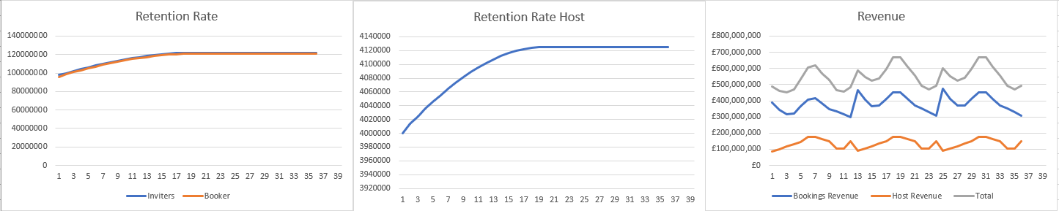

The initial increase in retention in the graphs shown is due to the introduction of new cohorts without any decaying old ones, however after a number of month we can see that the graph flattens out due to the initial 100 million users being topped up by the acquisition of new users, which has continued at a steady rate. Should a similar network effect have been applied to those 90 million we would have seen a significantly steep downward trend which would be more true to a real life scenario.

Retention Levels Out:

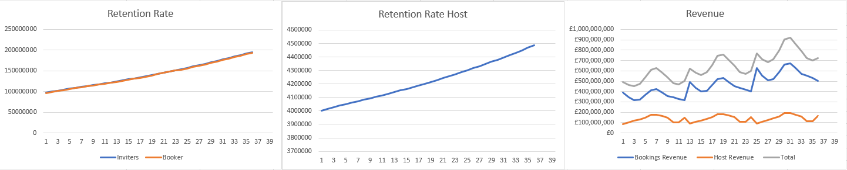

We see when retention levels off that these graphs change dramatically. As users are being retained on a permanent basis they begin to help invite more users, and so as we never lose them beyond this point our total userbase will only increase until we begin to hit saturation.

Part 2: Individual cohorts

To make this section somewhat more accurate, we make use of an initial cohort retention graph that more accurately represents that of a business of this kind [7]. We then multiply this graph by an improvement rate of 10% per month to achieve the following improvements for each cohort:

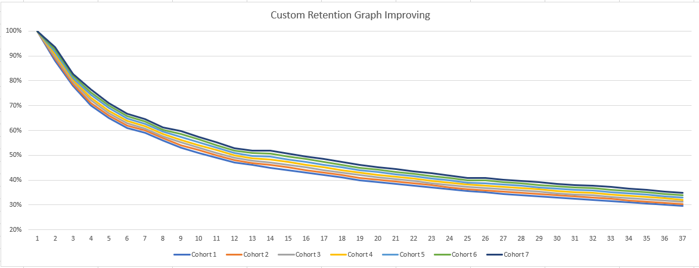

[1] <https://www.similarweb.com/website/airbnb.com/>

[2] <https://supercontrol.co.uk/the-bottom-line-on-bookings>

[3] <https://www.investopedia.com/articles/investing/112414/how-airbnb-makes-money.asp>

[4] <https://www.alltherooms.com/analytics/average-airbnb-prices-by-city/>

[5] <https://community.withairbnb.com/t5/Hosting/What-percentage-of-your-month-is-booked/td-p/128838>

[6] <https://www.quora.com/How-much-does-the-server-structure-of-airbnb-cost-monthly>

[7] <https://www.commonlounge.com/discussion/1f17a4f50b6f427abbf2f088f8323891>

<https://www.businessofapps.com/data/airbnb-statistics/>

<https://www.stratosjets.com/blog/airbnb-statistics/>

<https://ipropertymanagement.com/research/airbnb-statistics>

<https://news.airbnb.com/about-us/#:~:text=Airbnb%20was%20born%20in%202007,every%20country%20across%20the%20globe>.