Group 1 Project Proposal

Due Date: Aug 1, 2018

Group Members:
Sanhita Banerjee
Stan Smith
Yurora Saylor
Luke Williams

Background:

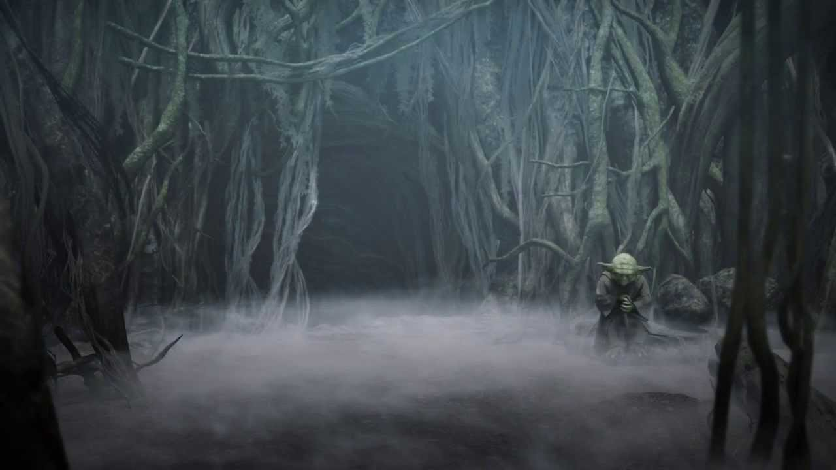

Home to Yoda during his final years, Dagobah was a swamp-covered planet strong with the Force -- a forgotten world where the wizened Jedi Master could escape the notice of Imperial forces. Characterized by its bog-like conditions and fetid wetlands, the murky and humid quagmire was undeveloped, with no signs of technology. Though it lacked civilization, the planet was teeming with life -- from its dense, jungle undergrowth to its diverse animal population. Home to a number of fairly common reptilian and amphibious creatures, Dagobah also boasted an indigenous population of much more massive -- and mysterious -- lifeforms. Surrounded by creatures generating the living Force, Yoda learned to connect with the deeper cosmic Force and waited for one who might bring about the return of the Jedi Order.

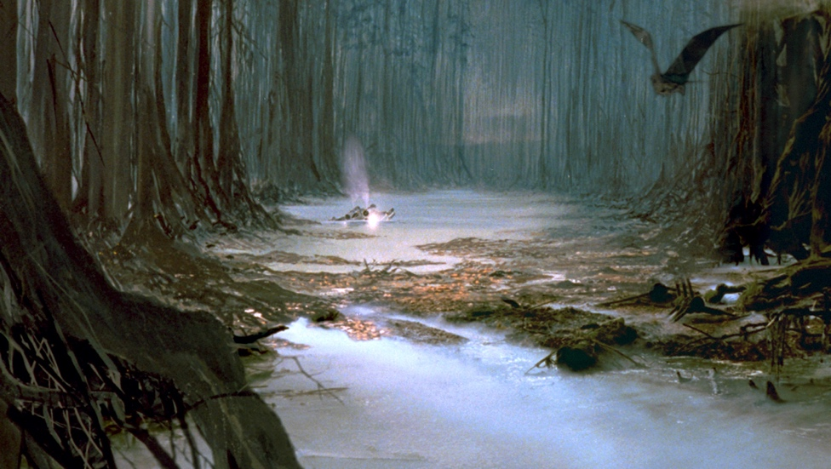

Project Name: "Project Dagobah!"

Project Description:

Conduct data analysis on Star Wars dataset (survey of Star Wars fans) in order to elucidate statistical data, demographic patterns, and generate useful visualizations in understanding the population surveyed.

Dataset/source:
https://github.com/fivethirtyeight/data/tree/master/star-wars-survey

DataFrame.head()

Possible questions for analysis:

