

Luke Lincoln

Hierarchical Techniques in 3D Model Compression

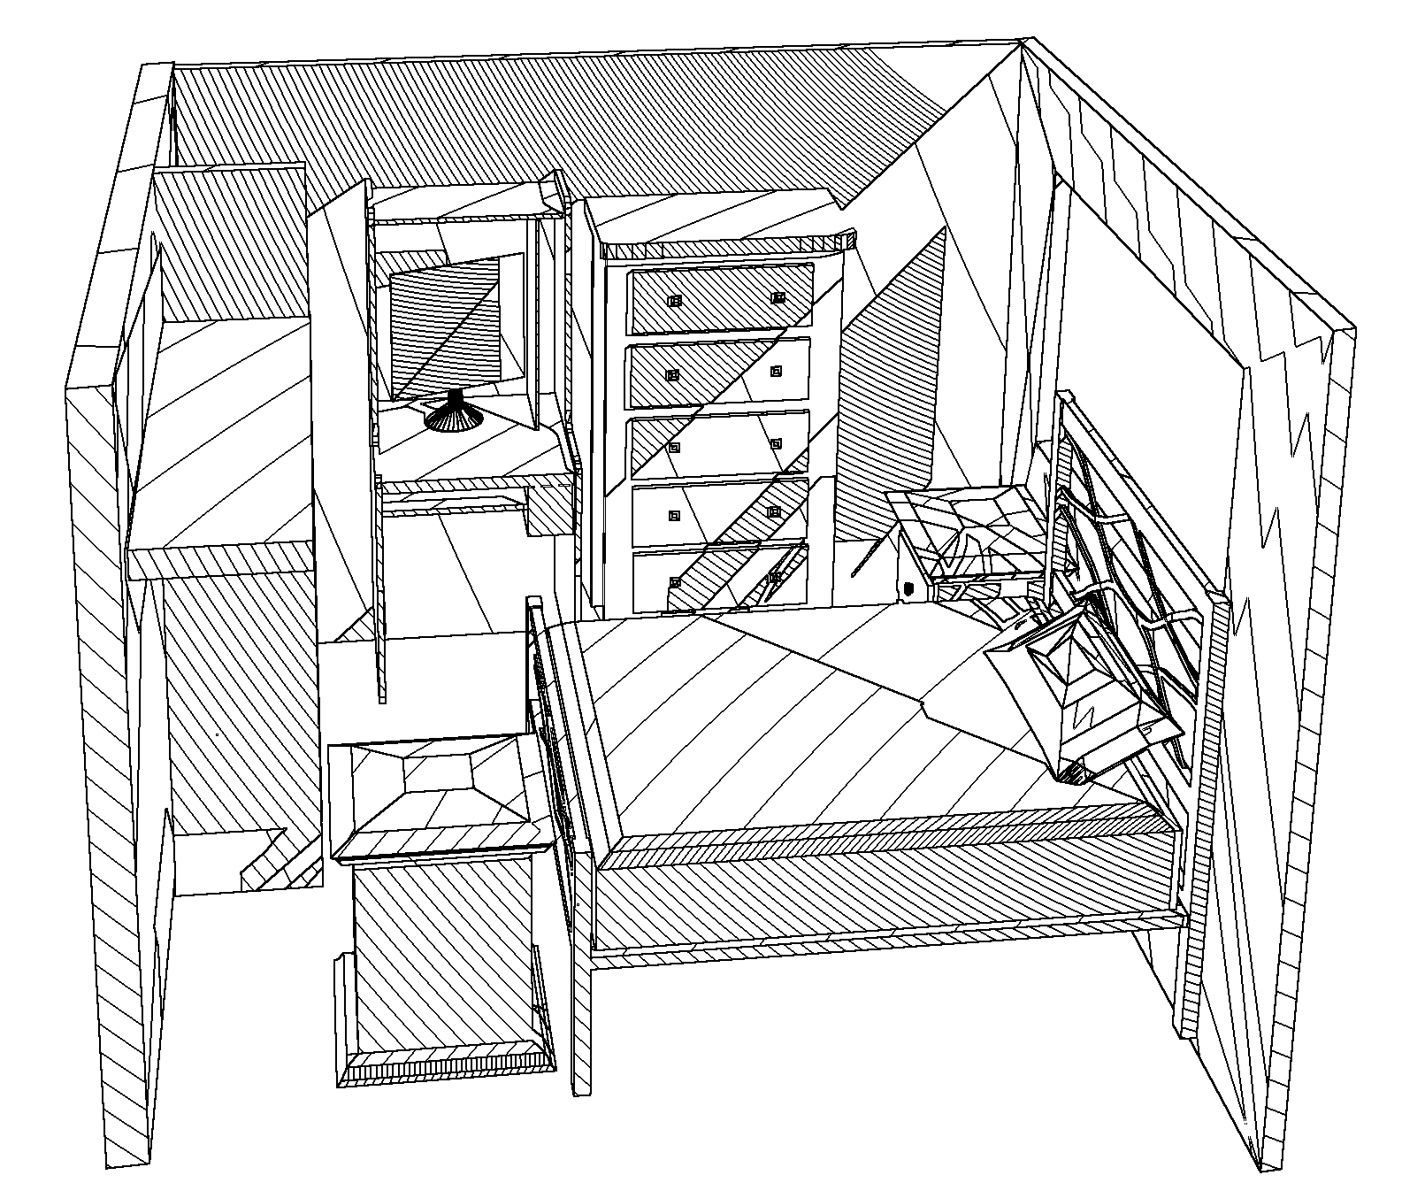

A thesis submitted in partial fulfilment of the requirements of the Degree of Bachelor of Information Technology (Advanced with Honours)

School of Information and Communication Technology

Griffith University, Australia

October, 2013

This work has not previously been submitted for a degree or diploma to any university. To the best of my knowledge and belief, the thesis contains no material previously published or written by another person except where due reference is made in the thesis itself.

Signed: ____________________________

Statement of Originality