 WHICH MOVIE TO WATCH

Which Movie to Watch is a random movie recommendation service with a focus on high quality, critically acclaimed films.

**Available now on the iTunes App Store and Google Play for Android.**

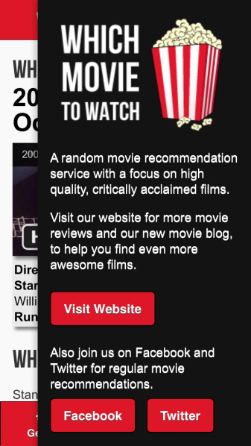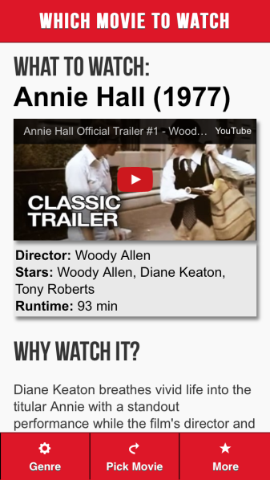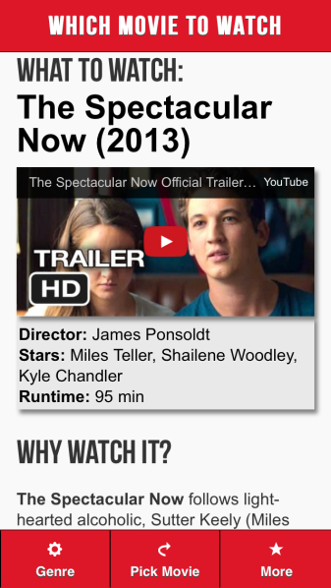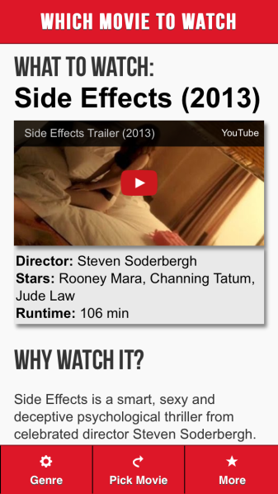Available July 22, 2014 – Which Movie to Watch is a movie recommendation app which provides feature reviews of awesome films to help movie lovers find new films to watch. Now more than ever, with services such as Netflix and Lovefilm, movie addicts have instant access to an inexhaustible quantity of great films, the only problem they face is making the decision of Which Movie to Watch.

Unlike the handful of other mobile apps based on providing movie recommendations, Which Movie to Watch is the first app to feature original reviews of each of the films it recommends, as well as trailers and info about the movie such as director/cast/runtime. Users can pick which genres they want to receive movie recommendations from and the app randomly picks titles with the touch of a button. Which Movie to Watch has already been getting a reasonable number of organic downloads and we feel that this indicates the actual usefulness and potential of this app.

Which Movie to Watch is available on iOS and Android worldwide in English and is absolutely free!

Which Movie to Watch is based on the website of the same name which also features an awesome movie blog, you can find it here: <http://www.whichmovietowatch.com>

---

If you would like more information on Which Movie to Watch please contact:

Luke Smith

Phone: +44 7708514392

Email: [lukesmith@whichmovietowatch.com](mailto:lukesmith@whichmovietowatch.com)

Twitter: <https://twitter.com/whichmov2watch>

Facebook: <https://www.facebook.com/whichmovie2watch>

Download the app for iPhone, iPad and iPod: <http://goo.gl/c1SlwD>

Download the app for Android: <http://goo.gl/QVreCN>