Running head: Simulation-based examination of priors in biogeographic dating

Title: Towards a methodological background for using Biological data to inform Geological models: Interaction of Biological and Paleogeographic priors in Biogeographic Dating

Authors: Luke Sparreo1, Ana Bedoya1*

1*Center for Biodiversity & Evolution, New York Botanical Garden, 2900 Southern Boulevard, Bronx, NY, USA 10458*

*Corresponding author: [abedoya@nybg.org](mailto:abedoya@nybg.org)

# Abstract

Biological and geographic data have long reciprocally informed one another. In this study, we simulate 10 simple molecular phylogenies with known histories and date them with historic geological priors of varying information levels and accuracy in order to test the influence of geological knowledge and molecular data on phylogenetic dating. In our simulations lacking gene flow, models with unknown geological histories performed better than models with informed or incorrect geological histories, but produced much broader posterior age distributions. The result that accurate molecular data may perform accurately in biogeographic dating methods under unknown geographic knowledge shows promise for the utilization of the geogenomic method, which has been used to date geographic events with biological data. However, the broad distributions produced relying solely on biological data may render the median node ages less meaningful. Both the introduction of gene flow in our demographic simulations and the incorporation of incorrect historic geological data shifted the accuracy of our phylogenetic dating. These findings illuminate the influence of various error sources on posterior age distributions that systematists must address when conducting biogeographic dating.

Keywords: biogeography, geogenomics, dating, molecular, simulation

# Introduction

The recognition of the interplay of biological evolution and geological change laid the foundation for historical biogeography (Wallace, 1854). The discipline centers on the study of how the geographic distribution of organisms has changed over evolutionary time and how those changes are shaped by Earth’s geological history. Therefore, biogeographic thinking inherently forces the interpretation of biological data in reference to a specified geological background. However, as organismal evolution often proceeds in parallel with changes in abiotic conditions (e.g., landscape or climate shifts; Dong et al., 2024), biological data has been used to propose and inform geological models. In other words, patterns of geographic co-variation across taxa have been used in concert with genomic data, as proxies to infer the timing of formation of shared abiotic processes that may have driven those patterns (e.g., formation of a mountain as a barrier to gene flow).

Examples of the use of biological data for testing or formulating landscape change evolution scenarios include: 1) the formulation (and later rejection) of the forest refugia hypothesis to explain a mechanism for the high biodiversity observed in regions like the Amazon (Haffer, 1969). 2) The development of a model for the timing and mode of uplift of the Andean cordillera (Sanín et al., 2022). 3) The estimation of the timing of river connectivity in norther South America since the Miocene (Bedoya et al., 2021). This approach was unified in a theoretical framework (i.e., geogenomics; Baker et al., 2014), which involves the reciprocal integration of geological, climatic, ecological, paleontological, and genomic data to test landscape or climate evolution hypotheses (Baker et al., 2014, Dolby et al., 2022; Rahbeck et al., 2019; Badgley et al., 2017). This theoretical framework has also discussed the main characteristics of ideal study systems, as well the geographic and geological scales at which geological models can be developed from biological data (Baker et al., 2014, Dolby et al., 2022; Bedoya, 2024).

Using biological and geological data independently, or interpreting them in reference to each other (e.g., establishing geological hypotheses as ground truth against which biological data are interpreted), may introduce biases inherent to each biology and geology. Standard approaches for the analysis of geological and of biological data inherently carry uncertainty (e.g., the interpretation of zircon data in provenance analyses and the estimation of divergence times across lineages (Weltje & von Eynatten, 2004). Further, as the responses of organisms to a shared paleogeographical event are idiosyncratic, careful attention should be placed to the model system used to infer geological models from biological data. Organisms best serve as appropriate model systems for this purpose when their evolutionary trajectories mirror geological history. In this regard it is worth noting that even if evolutionary patterns of a given set of organisms are shaped by a landscape event, the predictability of landscape hypotheses from evolutionary patterns may be affected by common and stochastic processes (e.g., gene flow).

An example that illustrates the overall biases in the use of biological and geological data to date the timing of geomorphic events, is the study of the timing and pattern of closure of the Isthmus of Panama. The traditional model for the evolution of the Panama Isthmus suggests that its formation took place ~4.2–3.5 Ma (late Pliocene; Keigwin, 1978, 1982; Coates et al., 1992; Jackson & O’Dea, 2013) or earlier at 2.8 Ma (O’Dea et al., 2016). Geochronological data and provenance analyses have challenged this model, pushing back the timing of closure of the Central American Seaway to 13–15 Ma (middle Miocene; Montes et al., 2012a, 2012b, 2015). This more recently published model is based on the interpretation of detrital zircon provenance data (Montes et al., 2015), and has been called into question (O’Dea et al., 2016). However, the evidence used to this end has in turn been challenged (Jaramillo et al., 2017; Molnar, 2017; Jaramillo, 2018). Inferred divergence times of several taxa distributed across the Americas —including freshwater fishes, ground sloths, shrimp, and several plant taxa— are older than 3 Ma, supporting the notion of pre-Pliocene contact (Erkens et al., 2007; Hurt et al., 2009; Weir et al., 2009; Cody et al., 2010; Pinto-Sánchez et al., 2012; Bacon et al., 2013; Leigh et al., 2014; Barker et al., 2015). Multiple pulses of migration across the Isthmus prior to 3.5 Ma were inferred by Bacon et al., 2015, in opposition to the traditional model of formation of the Isthmus. While earlier pulses of organismal migration between the Americas may be evidence for an earlier onset of a land bridge connecting the Americas, earlier divergence times have sometimes been interpreted as episodes of stochastic long-distance dispersal by defendants of the traditional model of closure of the Isthmus of Panama (O’Dea et al., 2016). This underscores the importance of considering species-specific traits when interpreting bio/phylogeographic patterns used for inferring geological models.

Despite the existence of a theoretical background for the integration of biological, paleontological, and geological data to test geomorphic hypotheses, a unified methodological framework is still lacking. Such a framework would allow testing of how geological priors and biological data interact. This would facilitate the exploration of the effect of incorrect, vague, and correct geological models (i.e., those that deviate from reality, incorporate great uncertainty, or accurately describe the timing of a geomorphic event), as well as the impact of using biological study systems that variably mirror geological processes. Here, we address this gap using biogeographic dating, a data-dependent and process-based method that uses biogeographic information alongside molecular data, and time-calibrated paleogeographical priors for divergence dating (Landis, 2017; Landis et al., 2018). In biogeographic dating, the observed biogeographic states of extant taxa induce a posterior distribution of dated speciation times. Specifically, observed distributional data are used to model dispersal rates between areas. The estimation of such dispersal rates results from the interaction of tip data with a specified paleogeographic prior (e.g., for the emergence or disappearance of a barrier), where the latter influences the expected probability that a particular dispersal event between areas takes place (Fig. 1a).

In this study, we aimed to test the reciprocal influence of biological and geological data and priors, leveraging biogeographic dating as a method where both are specified and analyzed simultaneously. We generated a hypothetical scenario where a temporal and spatial correspondence of biological and geological processes was enforced, such that divergence times are a proxy for the timing of a landscape change event (Fig. 1b). We specified geological priors with varying levels of accuracy and simulated the evolution of two model systems whose evolutionary histories do and do not mirror an underlying geological event. In using this simulated dataset with known geological, evolutionary histories, we test the potential for well-calibrated phylogenies to estimate paleogeographic events and the impact of accuracy and uncertainty in geologic models.

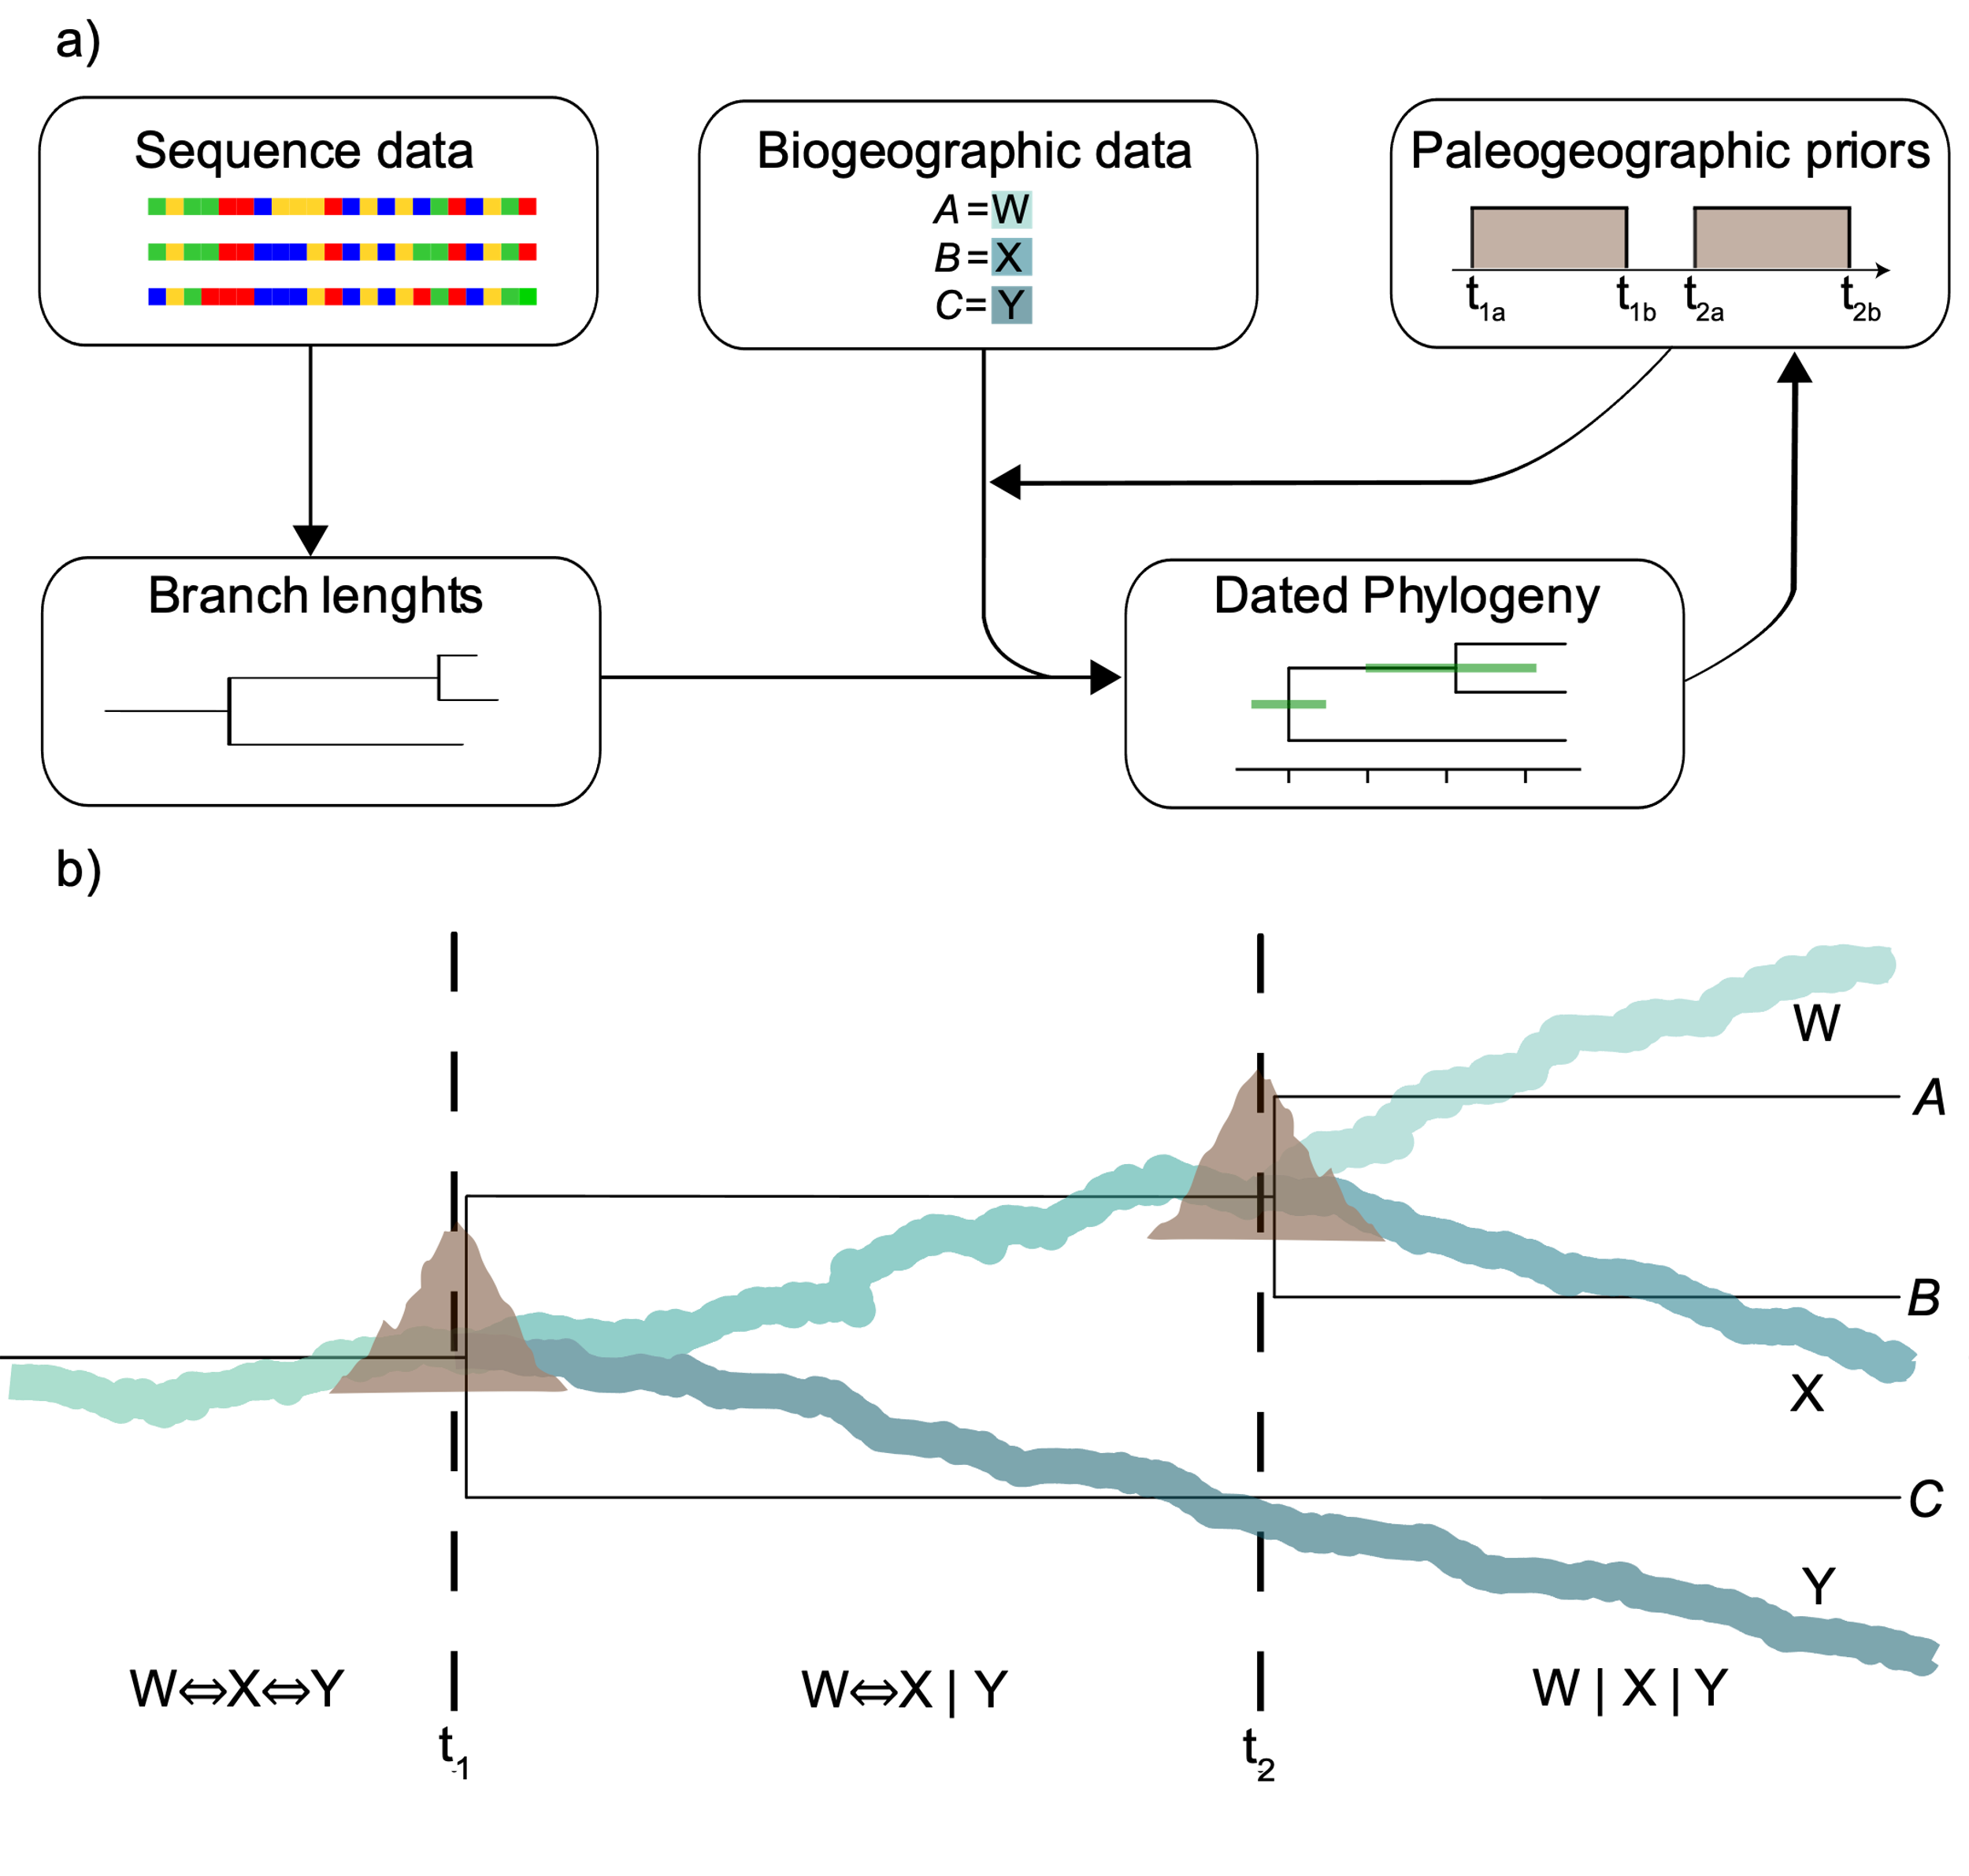

Figure 1: a) Data, priors, and their interaction in biogeographic dating for the estimation of divergence times. The framework facilitates the reciprocal influence of biological and geological data. b) Simulated scenario illustrating the splitting or rivers with surface uplift and the parallel evolution of a river plant lineage. Dotted lines represent known geological dates of uplift and river splits at 6 Ma and 2 Ma. The outgroup is not represented in the figure.

# Materials & Methods

## *Evolutionary and Geological scenarios*

We built a hypothetical scenario where a river-dwelling plant lineage occurs across rivers in a basin that experienced three historical rearrangements; a landscape change event (i.e., surface uplift) triggered the split of rivers at 10, 6, and 2 Ma. River splitting and the formation of isolated river branches (W, X, Y, and Z) result in lineage splits and divergence, and the origin of taxa A, B, C, and D respectively, whose phylogenetic relationships mirror the history of riverine connections (Fig. 1b). Initially, we assume that our study system is bounded to rivers, thus having a limited dispersal.

## *Demographic and Sequence Simulation*

We simulated the evolution of our hypothetical river plant lineage under two scenarios with msprime (Baumdicker et al., 2022). In the first scenario, the demographic model exactly mirrored the known history of river splits (gene flow between taxa was not allowed such that geological events completely isolated taxonomic groups). We modelled the first split at t=10 Ma, leading to outgroup taxon D and stem taxon ABC. A second split was specified at t=6Ma, resulting in taxon C splitting from taxon AB. Finally, a third split was specified at t=2Ma, separating taxon AB into taxa A and B. We specified a generation time of one year (in line with what has been reported in real-world river-dwelling angiosperms; Philbrick & Retana, 1998). We generated a DNA matrix of 10,000 bp under the HKY substitution model, a mutation rate of 1e-8 substitutions per site per generation (Ossowski et al., 2010; as in Exposito-Alonso et al., 2022), and a recombination rate of 4.8 cM/Mb (Rizzon et al., 2006; as in Brown et al., 2016). All invariant sites were filled in with random invariant bases using a custom script (fill_invariant_sites.py from https://github.com/Bedoya-Research-Group/BioGeoDating_Geogenomics/).

The second scenario we modeled the evolution of taxa whose evolutionary history do not perfectly match the evolution of riverine connections due to migration. We allowed for gene flow to take place across taxa A and B located in two adjacent rivers (W and X) at 2–1 Ma. Gene flow was simulated using the migration function in msprime (rate = 0.2). Demographic models were visualized using the package DemesDraw (Gower et al., 2022). When prohibiting gene flow, our demographic model produced divergence patterns and times that mirror the known geological event times from our hypothetical scenario (Figs. 2a and 1b). Contrastingly, the demographic model permitting gene flow produced a tree that is inconsistent with the geological history in our model (Fig. 2b). Inferred trees resulting from our simulations in msprime were used as input in downstream analyses.

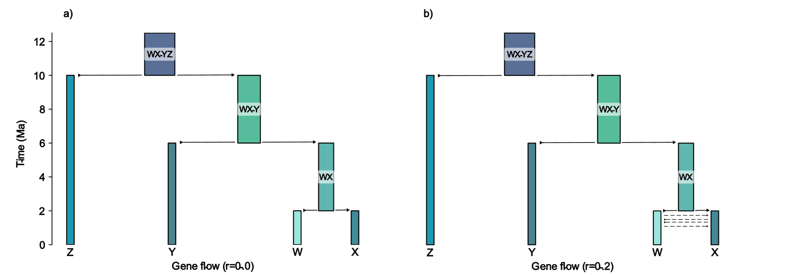

Figure 2: Demographic models used to generate sequence data and trees with msprime. a) Scenario without gene flow, where biological history mirrors geological events. b) Hypothetical scenario where biological and geological events do not match due to migration across landscape units (gene flow is allowed between taxa W and X from 2 to 1 Ma).

## *Biogeographic dating with differing Biological data and Geological Priors*

Under the scenario where biological and geological events coincide (no gene flow; 2a and 1b), we specified five different geological priors in five independent biogeographic-dating analyses (Fig. 3); informed with hard bounds, informed with soft bounds, incorrect with hard bounds, incorrect with soft bounds, and unknown. These five priors represent different degrees of accuracy and certainty in geological models. For instance, informed models with hard bounds illustrate the formation of the Hawaiian archipelago (Clague & Dalrymple, 1994) as used in empirical and simulation studies (Lerner et al., 2011; Clague et al., 2009). Assumptions on the timing of events can be relaxed to accommodate uncertainty (i.e., using soft bounds). In all cases, hard bounds and soft bounds were modelled using uniform and gamma distributions respectively (Fig. 3). The uniform distributions were 1Ma in length, extending 0.5Ma from either end of the time. A gamma distribution centered on the time was used to approximate a normal distribution with a SD of 0.1 due to challenges working with normal distributions (not type RealPos) in ensuing computational analyses (Fig. S1). In informed models, the distribution bounds were centered on 6 and 2 Ma respectively, while incorrect models centered distributions on 8 and 2 Ma. We then used the five geological priors to run another set of five independent biogeographic-dating analyses, but under the second scenario where biological and geological events did not perfectly match (gene flow allowed; Fig. 2b).

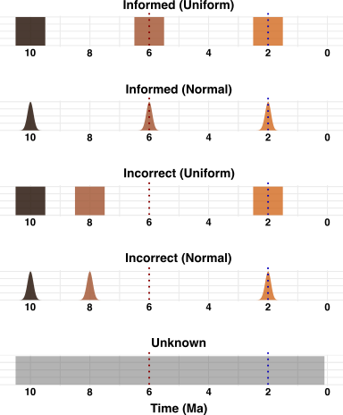

Figure 3: Geological priors specified for the two biological scenarios modeled. Red dotted line represents the true time for the node where taxon C splits from taxa A and B, and blue dotted line represents the true time for the node where taxon A splits from taxon B.

Biogeographic dating analyses for the model data were performed in RevBayes (Höhna et al., 2016) under the Dispersal-Extinction-Cladogenesis (DEC) model (Landis, 2017; Landis et al., 2018). We created new scripts adapted from Landis, 2017 for biogeographic dating in RevBayes available at https://github.com/Bedoya-Research-Group/BioGeoDating_Geogenomics.git. Molecular sequence data, a phylogeny, present ranges, distances between areas, geological event times, and dispersal probabilities across the latter, are defined as inputs to jointly estimate divergence times, and range evolution. Phylogenetic relationships can be specified a priori or estimated in parallel. Two MCMC chains were run with 3 million generations, saving a tree every 100 generations, for each of the ten analyses. In all analyses reported in main figures we assigned a uniform distribution from 0 to 10.5 Ma for the root age of the tree. We also tested an alternative scenario for the same 10 models where the root age was a uniform distribution from 9.5 to 10.5 Ma, reported as supplementary figures. The extirpation rate was set to zero. Chain convergence was assessed with Tracer v1.7.2 (Rambaut et al., 2018) and with the R package Convenience (Fabreti & Höhna, 2021). The two generated tree files for each analysis were then combined after removing 0.25 burn-in fraction on each file. The final generated trees and posterior distributions were visualized in R using RevGadgets (Tribble et al., 2021), with kernel density estimation with a value of adjust=0.5 used to smooth the posterior distributions for visual clarity.

# Results

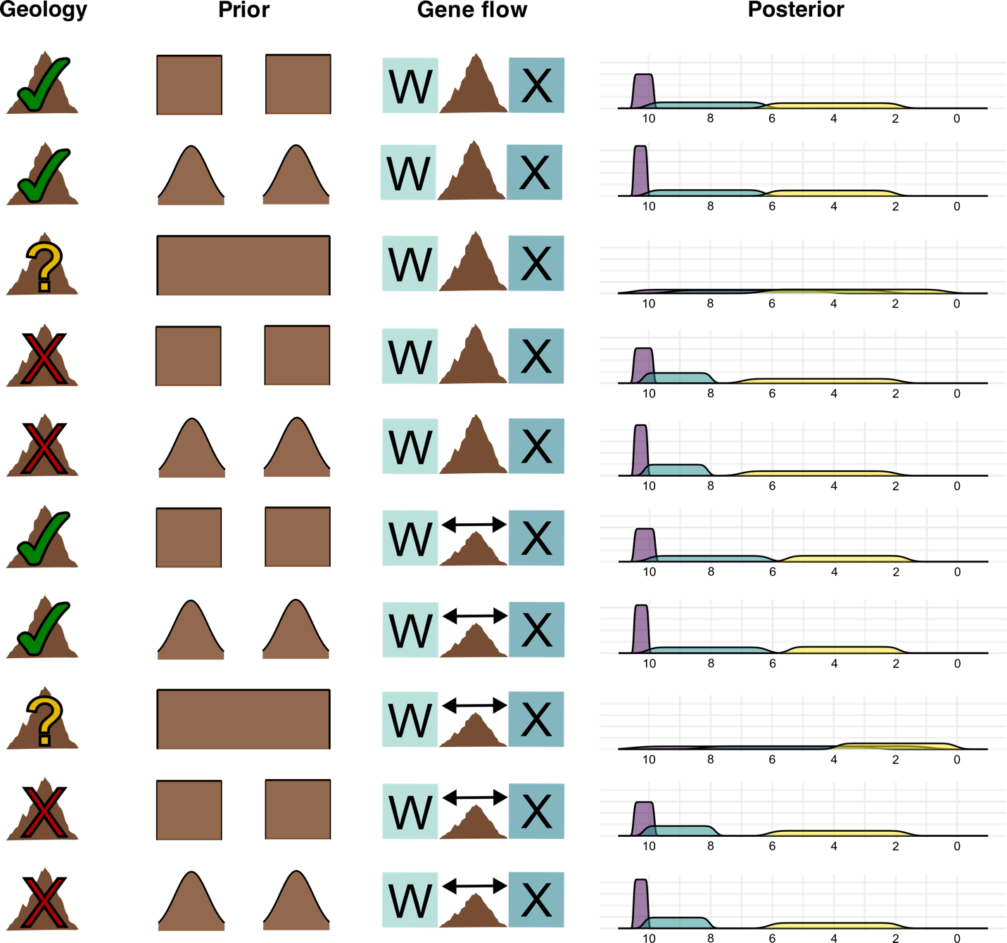

Figure 4:Posterior distributions for the date of cladogenetic events produced from 10 biogeographic-dating analyses conducted using different demographic models and geological priors. Purple: event following river split at 10 Ma, teal: event following river split at 6 Ma, yellow: event following river split at 2 Ma.

|  |  |  |  |
| --- | --- | --- | --- |
| **Model** | **Node 1 age** | **Node 2 age** | **Node 3 age** |
| Demographic (true age) | 10 Ma | 6 Ma | 2 Ma |
| Informed uniform, no gene flow | 10.2295 | 8.1357 | 3.8428 |
| Informed normal, no gene flow | 10.3044 | 8.1792 | 3.8523 |
| Unknown, no gene flow | 7.7607 | 5.6703 | 3.0043 |
| Incorrect uniform, no gene flow | 10.2419 | 9.0672 | 4.1164 |
| Incorrect normal, no gene flow | 10.3115 | 9.1357 | 4.2024 |
| Informed uniform, gene flow | 10.2194 | 8.0802 | 3.2875 |
| Informed normal, gene flow | 10.2925 | 8.1141 | 3.3182 |
| Unknown, gene flow | 6.6197 | 4.4442 | 1.5529 |
| Incorrect uniform, gene flow | 10.2332 | 9.0196 | 3.4854 |
| Incorrect normal, gene flow | 10.2985 | 9.0758 | 3.5376 |

Table 1: The medians of the 95% HPD of estimated divergence times predicted for nodes 1 (taxa D and stem group ABC), node 2 (taxa C and stem group AB), and the demographically manipulated node 3 (taxa A and B).

## *Dating with informed geological priors*

When using geological priors that conform to our hypothetical landscape change scenario and prohibiting gene flow (Fig. 4 and Table 1, rows 1 and 2), the medians of the 95% HPD of the estimated divergence time for nodes 2 and 3 were found to be between 1.8-2.1 Ma older than the true date. Yet, the median of the 95% HPD for the splitting event between taxa AB and C (node 3), was estimated to be within around 0.2-0.3 Ma from the actual cladogenetic event. When gene flow between taxa A and B was permitted in correctly informed models (Fig. 4 and Table S1, rows 6 and 7), the median of the 95% HPD for node 3 was not affected (less than 0.1 Ma change). However, the introduction of gene flow found a median age for node 2 as 3 Ma older than the true date, and the median of the 95% HPD for node 3 as 1.5 Ma older than the true date. In all of these informed models, the selection of a uniform versus normal prior had little impact on the median or spread of the 95% HPD for all nodes.

## *Dating with unknown geological (flat) prior*

In the scenario in which we did not allow geological history to inform the dating process and prohibited gene flow (Fig. 4 and Table 1, row 3), the median of the 95% HPD of node 1 was found to be around 2.2 Ma younger than the true date. The median of the 95% HPD of node 2 was around 0.3 Ma younger than the true date, the most accurate median for this node of all models tested. The median of the 95% HPD for node 3 was 1 Ma older than the true age of the node. However, the spread of the 95% HPD for all 3 nodes was much wider than in the informed and incorrect models. When gene flow between taxa A and B was permitted in the unknown model (Fig. 4 and Table 1, row 8), results changed significantly- predictably, gene flow had a larger impact on the model when there were no geological priors. The median of the 95% HPD for node 3 was about 3.4 Ma younger than the true age. The median age of the 95% HPD for node 2 was about 1.6 Ma younger than the true age of the node. The median age of the 95% HPD for node 1 was around 0.6 Ma older than the true age, the most accurate median for this node of all models. The spread of the 95% HPD for all nodes in the unknown geological model remained wider than informed and incorrect models, but when gene flow was introduced, the posterior spread for node 1 did become slightly narrower.

## *Dating with incorrect geological priors*

When incorrect geological priors were used in the model that prohibited gene flow (Fig. 4 and Table 1, rows 4 and 5), the median of the 95% HPD of node 3 was 0.2 to 0.3 Ma older than the true age. Additionally, the median of the 95% HPD of node 2 (the node with the erroneous geological prior) was around 3.1 Ma older than the true age. The median of the 95% HPD of node 1 was 2.1-2.2 Ma older than the true age. As such, all node ages were dated as older than their true age and the ages produced by informed and unknown models when just one geological prior was incorrectly found to be older. When gene flow was introduced into the model, the age of nodes 3 and 2 changed little from the incorrect model without gene flow (less than 0.1 Ma), but the median of the 95% HPD of node 1 was around 1.5 Ma older than the true age, meaning the introduction of gene flow had an effect on the age of this node as in informed and unknown models. As in the informed prior models, the selection of a normal or uniform prior had little impact on the median or spread of the 95% HPD of either node.

## *Posterior distributions of node 1 most affected by enforcing strict root age*

For all models, we tested an alternate scenario (Figures S4, S5, S6, Table S1) where we enforced a root age as a uniform distribution from 9.5 to 10.5 Ma. In this scenario, we modelled dating techniques that rely on data beyond molecular and biogeographic, such as a fossil dating the crown of the clade. Here, there was a relatively consistent median of the 95% HPD (highest posterior density interval) for the dating of the split between taxa ABC and D, or node 1. However, when we allowed only biology to inform the root age, selecting its age as a uniform distribution from 0 to 10.5 Ma, node 1 is dated similarly to nodes 2 and 3. The posterior distributions of other nodes were affected, but much less dramatically. Additionally, while the median node ages were not affected (less than 0.1 Ma change) for the dating of all nodes in all informed and incorrect models, the strict root age dramatically altered median node ages in the unknown models (Tables 1, S1).

# Discussion

## *Methodological constraints of the biogeographic dating method*

In the framework established by Landis in the biogeographic dating method (Landis, 2017), connections between biogeographic areas over time are defined by split and merge events, where, for example, a pairing of two discrete areas may come in and out of dispersal range from each other. While this framework is intuitive for some geographic areas, such as continental landmasses drifting apart and together, it posed challenges in our river framework. For example, when river W and X originate, resulting in the formation of taxa A and B, they are forced to be represented as splitting from a previously connected area W↔X, despite the fact that W↔X may actually be better represented by an entirely different area that splits into the two newly created rivers. Because of this, our connectivity matrices were forced to acknowledge the existence of all modern-day rivers W, X, Y and Z from the beginning of our analyses, with connectivity between these rivers representing the ancestral river than an actual unique ancestral river area being coded. This is likely why in our ancestral state estimations for all 10 of the analyses, the ancestral state for the node of the tree was found to be river Z, rather than all rivers W, X, Y and Z (Figure S3). Can we talk about this, I’m not sure if this was the idea for reporting on the ASE?

## *Limitations of molecular data with geologically unknown priors*

Our results found that models with a flat, unknown geological prior performed well at estimating median divergence times when compared to models with a uniform or normal geological prior centered around correct times when our models did not permit gene flow. Correct, well-informed simulated data successfully being able to predict the timing of the emergence of biogeographic barriers without prior historic geographic information suggests exciting opportunities to test new biogeographic hypotheses. These results confirm the critical idea in geogenomics that biology and geography may reciprocally inform each other. Yet, when we permitted gene flow between taxa A and B after the known geological event that led to their separation, the unknown model was strongly affected and the dating of the manipulated node less accurate. In the unknown model with gene flow, the improvement of the dating of node 2 is likely the result of the gene flow erroneously pushing all date estimation earlier, as we only allowed gene flow between taxa A and B at node 3 and not taxa AB and C at node 2.

Additionally, the 95% HPD is very broad when using the geologically unknown prior, meaning the overall spread of the data may not be as meaningful. This may present a problem as most authors agree that posterior intervals are more biologically meaningful than posterior medians or means (Warnock et al., 2017; Morrison, 2008). Yet, in our simulated dataset does contain known “true” ages to which our median 95% HPD values can be compared, it does seem that the median values found in the analyses are indeed the most accurate despite the broad distribution they were calculated from. When we did run an alternate scenario with an enforced root age from 9.5 to 10.5 Ma, the 95% HPD spread of node ages, especially node 1, was greatly reduced, showing that the incorporation of even a single prior has a large influence on the posteriors produced for all nodes.

While the potential for molecular data to inform geological dating in systems lacking gene flow is exciting, it should be noted that in our simulations, our molecular data was “perfect”: a model scenario in which genetic sequences had no missing data. Additionally, we assume our taxon sampling was complete; there were no unknown extant taxa nor extinct taxa in our group that lacked molecular data. Yet, has been thought that missing data at the molecular (Roure et al., 2013) and taxonomic levels (Zwickl & Hillis, 2002) may negatively influence the accuracy of phylogenies, which could in turn create issues downstream in dating methods. Additionally, our model dataset lacked common informatic errors like inaccurate molecular alignment (Ogden & Rosenberg, 2006) or erroneous taxonomic identification (de Almeida et al., 2023) both of which may lead to inaccurate phylogenies and biogeographic dating. In realistic datasets, imperfect molecular data may interfere with the ability of molecular data to accurately test geographic hypotheses.

Furthering genomic data acquisition and empirical analyses in model systems such as montane or riparian species has been proposed (Bedoya, 2024) as the next steps in furthering the empirical testing of reciprocal geographic-biological dating methods. Model systems such as these that lack known demographic histories of gene flow, have strongly-supported biogeographic histories, and already have accepted dated phylogenies through adequate fossil calibrations (such as Landis et al., 2021) will be necessary to explore the possibilities of dating geographic events through biological data.

## *Incorrect geographic historical data alters dating accuracy*

With the introduction of incorrect prior information, however, models performed significantly worse in predicting geological history. This supports previous studies that have indicated incorrect assumptions within the DEC (Magalhaes et al., 2021) and fossilized birth-death (Barido-Sottani et al., 2020) models have large impacts on inference in biogeographic estimations. Considering debate continues over the timing of influential geological events (White et al., 2013; Zheng, 2015), the selection of accurately resolved paleogeographic priors is critical. Further work should also explore the impact of these historic geographic assumptions in other biogeographic models like DEC+J (Matzke, 2014), which have been debated regarding ability to accurately parameterize the rates of speciation (Ree & Sanmartin, 2018), as the accuracy of model assumptions likely plays a large role in the accuracy of phylogenetic dating results.

Researchers should be conservative and cautious when creating strict priors in biogeographic dating methods, especially considering the fact that with our accurate simulated molecular data, a flat geological prior performed nearly as well as correctly-informed priors.

## *Demographic models that allow gene flow alter dating accuracy*

When demographic models allowed for gene flow, the predicted cladogenesis times were found to be significantly younger, regardless of the historic geographic prior used. The fact that all models allowing gene flow, regardless of the geological information present, produced similar results suggests that the existence of gene flow in molecular data creates a significant barrier to the accurate implementation in using geological data to date phylogenies. Current work continues to reveal histories of introgression (Stull et al., 2023), including from extinct lineages (Tricou et al., 2022), which did not exist in our model system. Researchers should take caution in using geological priors to date phylogenies with known or suspected gene flow.

While gene flow may interfere with inferring the correct biogeographic history, further research may develop methods that allow systematists to properly date phylogenies of systems that include rampant gene flow. In fact, if properly diagnosed, the detection of gene flow itself may be a tool to understand the history of past biogeographic connections, as gene flow is more likely to occur between species that have geographic overlap (Liu et al., 2025) and in areas with ephemeral geological barriers (Araya-Donoso et al., 2022).

# Funding Acknowledgement

X

# Acknowledgements

Code used to run our model simulations was adapted from existing code produced in Landis, 2017 and Landis et al., 2018.

# Data Availability Statement

All code for the generation data and analyses included here is available at the following GitHub repository https://github.com/Bedoya-Research-Group/River_phylogeography

# References

de Almeida, R. F., Pellegrini, M. O. O., de Morais, I. L., Simão-Bianchini, R., Rattanakrajang, P., Cheek, M., & Simões, A. R. G. (2023). Barking up the wrong tree: the dangers of taxonomic misidentification in molecular phylogenetic studies. *Plant ecology and evolution*, *156*(2), 146–159.

Araya‐Donoso, R., Baty, S. M., Alonso‐Alonso, P., Sanín, M. J., Wilder, B. T., Munguia‐Vega, A., & Dolby, G. A. (2022). Implications of barrier ephemerality in geogenomic research. *Journal of biogeography*.

Bacon, C. D., Mora, A., Wagner, W. L., & Jaramillo, C. A. (2013). Testing geological models of evolution of the Isthmus of Panama in a phylogenetic framework. *Botanical journal of the Linnean Society. Linnean Society of London*, *171*(1), 287–300.

Bacon, C. D., Silvestro, D., Jaramillo, C., Smith, B. T., Chakrabarty, P., & Antonelli, A. (2015). Biological evidence supports an early and complex emergence of the Isthmus of Panama. *Proceedings of the National Academy of Sciences of the United States of America*, *112*(19), 6110–6115.

Badgley, C., Smiley, T. M., Terry, R., Davis, E. B., DeSantis, L. R. G., Fox, D. L., Hopkins, S. S. B., et al. (2017). Biodiversity and topographic complexity: modern and geohistorical perspectives. *Trends in Ecology & Evolution*, *32*(3), 211–226.

Barido-Sottani, J., van Tiel, N. M. A., Hopkins, M. J., Wright, D. F., Stadler, T., & Warnock, R. C. M. (2020). Ignoring fossil age uncertainty leads to inaccurate topology and divergence time estimates in time calibrated tree inference. *Frontiers in ecology and evolution*, *8*.

Barker, F. K., Burns, K. J., Klicka, J., Lanyon, S. M., & Lovette, I. J. (2015). New insights into New World biogeography: An integrated view from the phylogeny of blackbirds, cardinals, sparrows, tanagers, warblers, and allies. *The Auk*, *132*(2), 333–348.

Baumdicker, F., Bisschop, G., Goldstein, D., Gower, G., Ragsdale, A. P., Tsambos, G., Zhu, S., et al. (2022). Efficient ancestry and mutation simulation with msprime 1.0. *Genetics*, *220*(3).

Bedoya, A. M. (2024). Botany and geogenomics: Constraining geological hypotheses in the neotropics with large-scale genetic data derived from plants. *American Journal of Botany*, *111*(4), e16306.

Bedoya, A. M., Leaché, A. D., & Olmstead, R. G. (2021). Andean uplift, drainage basin formation, and the evolution of plants living in fast-flowing aquatic ecosystems in northern South America. *The New Phytologist*, *232*(5), 2175–2190.

Brown, J. L., Weber, J. J., Alvarado-Serrano, D. F., Hickerson, M. J., Franks, S. J., & Carnaval, A. C. (2016). Predicting the genetic consequences of future climate change: The power of coupling spatial demography, the coalescent, and historical landscape changes. *American Journal of Botany*, *103*(1), 153–163.

Clague, D. A., Braga, J. C., Bassi, D., Fullagar, P. D., Renema, W., & Webster, J. M. (2009). The maximum age of Hawaiian terrestrial lineages: geological constraints from Kōko Seamount. *Journal of biogeography*, *37*(6), 1022–1033.

Clague, D. A., & Brent Dalrymple, G. (1994). Tectonics, Geochronology, and Origin of the Hawaiian-Emperor Volcanic Chain. *Walter de Gruyter GmbH*.

Coates, A. G., Jackson, J. B. C., Collins, L. S., Cronin, T. M., Dowsett, H. J., Bybell, L. M., Jung, P., et al. (1992). Closure of the Isthmus of Panama: The near-shore marine record of Costa Rica and western Panama. *GSA Bulletin*.

Cody, S., Richardson, J. E., Rull, V., Ellis, C., & Pennington, R. T. (2010). The Great American Biotic Interchange revisited. *Ecography*, no-no.

Dolby, G. A., Bennett, S. E. K., Dorsey, R. J., Stokes, M. F., Riddle, B. R., Lira-Noriega, A., Munguia-Vega, A., et al. (2022). Integrating Earth-life systems: a geogenomic approach. *Trends in Ecology & Evolution*, *37*(4), 371–384.

Dong, X., Stokes, M. F., Hendry, A. P., Larsen, L. G., & Dolby, G. A. (2024). Geo-evolutionary feedbacks: integrating rapid evolution and landscape change. *Trends in Ecology & Evolution*, *39*(9), 863–876.

Erkens, R. H. J., Chatrou, L. W., Maas, J. W., van der Niet, T., & Savolainen, V. (2007). A rapid diversification of rainforest trees (Guatteria; Annonaceae) following dispersal from Central into South America. *Molecular Phylogenetics and Evolution*, *44*(1), 399–411.

Exposito-Alonso, M., Booker, T. R., Czech, L., Gillespie, L., Hateley, S., Kyriazis, C. C., Lang, P. L. M., et al. (2022). Genetic diversity loss in the Anthropocene. *Science*, *377*(6613), 1431–1435.

Fabreti, L. G., & Höhna, S. (2021). Convergence Assessment for Bayesian Phylogenetic Analysis using MCMC simulation. *Methods in Ecology and Evolution*.

Gower, G., Ragsdale, A. P., Bisschop, G., Gutenkunst, R. N., Hartfield, M., Noskova, E., Schiffels, S., et al. (2022). Demes: a standard format for demographic models. *Genetics*, *222*(3).

Haffer, J. (1969). Speciation in amazonian forest birds. *Science*, *165*(3889), 131–137.

Harris, C. R., Millman, K. J., van der Walt, S. J., Gommers, R., Virtanen, P., Cournapeau, D., Wieser, E., et al. (2020). Array programming with NumPy. *Nature*, *585*(7825), 357– 362.

Höhna, S., Landis, M. J., Heath, T. A., Boussau, B., Lartillot, N., Moore, B. R., Huelsenbeck, J. P., et al. (2016). RevBayes: Bayesian phylogenetic inference using graphical models and an interactive model-specification language. *Systematic Biology*, *65*(4), 726–736.

Hurt, C., Anker, A., & Knowlton, N. (2009). A multilocus test of simultaneous divergence across the Isthmus of Panama using snapping shrimp in the genus Alpheus. *Evolution*, *63*(2), 514–530.

Jackson, J., & O’Dea, A. (2013). Timing of the oceanographic and biological isolation of the Caribbean Sea from the tropical eastern Pacific Ocean. *Bulletin of Marine Science*, *89*(4), 779–800.

Jaramillo, C. A. (2018). *Evolution of the Isthmus of Panama: Biological, Paleoceanographic and Paleoclimatological Implications*. John Wiley & Sons.

Jaramillo, C., Montes, C., Cardona, A., Silvestro, D., Antonelli, A., & Bacon, C. D. (2017). Comment (1) on “formation of the isthmus of panama” by o’dea et al. *Science Advances*, *3*(6), e1602321.

Keigwin, L. (1982). Isotopic paleoceanography of the Caribbean and East pacific: role of panama uplift in late neogene time. *Science*, *217*(4557), 350–353.

Keigwin, L. D. (1978). Pliocene closing of the Isthmus of Panama, based on biostratigraphic evidence from nearby Pacific Ocean and Caribbean Sea cores. *Geology*.

Landis, M. J. (2017). Biogeographic dating of speciation times using paleogeographically informed processes. *Systematic Biology*, *66*(2), 128–144.

Landis, M. J., Eaton, D. A. R., Clement, W. L., Park, B., Spriggs, E. L., Sweeney, P. W., Edwards, E. J., et al. (2021). Joint Phylogenetic Estimation of Geographic Movements and Biome Shifts during the Global Diversification of Viburnum. *Systematic Biology*, *70*(1), 67–85.

Landis, M. J., Freyman, W. A., & Baldwin, B. G. (2018). Retracing the Hawaiian silversword radiation despite phylogenetic, biogeographic, and paleogeographic uncertainty. *Evolution*, *72*(11), 2343–2359.

Leigh, E. G., O’Dea, A., & Vermeij, G. J. (2014). Historical biogeography of the Isthmus of Panama. *Biological Reviews of the Cambridge Philosophical Society*, *89*(1), 148–172.

Lerner, H. R. L., Meyer, M., James, H. F., Hofreiter, M., & Fleischer, R. C. (2011). Multilocus resolution of phylogeny and timescale in the extant adaptive radiation of Hawaiian honeycreepers. *Current Biology*, *21*(21), 1838–1844.

Liu, S.-Y., Yang, Y.-Y., Tian, Q., Yang, Z.-Y., Li, S.-F., Valdes, P. J., Farnsworth, A., et al. (2025). An integrative framework reveals widespread gene flow during the early radiation of oaks and relatives in Quercoideae (Fagaceae). *Journal of Integrative Plant Biology*, *67*(4), 1119–1141.

Magalhaes, I. L. F., Santos, A. J., & Ramírez, M. J. (2021). Incorporating Topological and Age Uncertainty into Event-Based Biogeography of Sand Spiders Supports Paleo-Islands in Galapagos and Ancient Connections among Neotropical Dry Forests. *Diversity*, *13*(9), 418.

Matzke, N. J. (2014). Model selection in historical biogeography reveals that founder-event speciation is a crucial process in island clades. *Systematic Biology*, *63*(6), 951–970.

Molnar, P. (2017). Comment (2) on “formation of the isthmus of panama” by o’dea et al. *Science Advances*, *3*(6), e1602320.

Montes, C, Cardona, A., Jaramillo, C., Pardo, A., Silva, J. C., Valencia, V., Ayala, C., et al. (2015). Middle Miocene closure of the Central American Seaway. *Science*, *348*(6231), 226–229.

Montes, C, Cardona, A., McFadden, R., Moron, S. E., Silva, C. A., Restrepo-Moreno, S., Ramirez, D. A., et al. (2012). Evidence for middle Eocene and younger land emergence in central Panama: Implications for Isthmus closure. *Geological Society of America Bulletin*, *124*(5–6), 780–799.

Montes, Camilo, Bayona, G., Cardona, A., Buchs, D. M., Silva, C. A., Morón, S., Hoyos, N., et al. (2012). Arc-continent collision and orocline formation: Closing of the Central American seaway. *Journal of Geophysical Research*, *117*(B4).

O’Dea, A., Lessios, H. A., Coates, A. G., Eytan, R. I., Restrepo-Moreno, S. A., Cione, A. L., Collins, L. S., et al. (2016). Formation of the Isthmus of Panama. *Science Advances*, *2*(8), e1600883.

Ogden, T. H., & Rosenberg, M. S. (2006). Multiple sequence alignment accuracy and phylogenetic inference. *Systematic Biology*, *55*(2), 314–328.

Ossowski, S., Schneeberger, K., Lucas-Lledó, J. I., Warthmann, N., Clark, R. M., Shaw, R. G., Weigel, D., et al. (2010). The rate and molecular spectrum of spontaneous mutations in Arabidopsis thaliana. *Science*, *327*(5961), 92–94.

Philbrick, C. T., & Novelo Retana, A. (1998). Flowering phenology, pollen flow, and seed production in Marathrum rubrum (Podostemaceae). *Aquatic Botany*, *62*(3), 199–206.

Pinto-Sánchez, N. R., Ibáñez, R., Madriñán, S., Sanjur, O. I., Bermingham, E., & Crawford, A. J. (2012). The Great American Biotic Interchange in frogs: multiple and early colonization of Central America by the South American genus Pristimantis (Anura: Craugastoridae). *Molecular Phylogenetics and Evolution*, *62*(3), 954–972.

Rahbek, C., Borregaard, M. K., Antonelli, A., Colwell, R. K., Holt, B. G., Nogues-Bravo, D., Rasmussen, C. M. Ø., et al. (2019). Building mountain biodiversity: Geological and evolutionary processes. *Science*, *365*(6458), 1114–1119.

Rambaut, A., Drummond, A. J., Xie, D., Baele, G., & Suchard, M. A. (2018). Posterior summarization in Bayesian phylogenetics using Tracer 1.7. *Systematic Biology*, *67*(5), 901–904.

Ree, R. H., & Sanmartín, I. (2018). Conceptual and statistical problems with the DEC+J model of founder-event speciation and its comparison with DEC via model selection. *Journal of biogeography*, *45*(4), 741–749.

dos Reis, M., Inoue, J., Hasegawa, M., Asher, R. J., Donoghue, P. C. J., & Yang, Z. (2012). Phylogenomic datasets provide both precision and accuracy in estimating the timescale of placental mammal phylogeny. *Proceedings. Biological Sciences / the Royal Society*, *279*(1742), 3491–3500.

Rizzon, C., Ponger, L., & Gaut, B. S. (2006). Striking similarities in the genomic distribution of tandemly arrayed genes in Arabidopsis and rice. *PLoS Computational Biology*, *2*(9), e115.

Roure, B., Baurain, D., & Philippe, H. (2013). Impact of missing data on phylogenies inferred from empirical phylogenomic data sets. *Molecular Biology and Evolution*, *30*(1), 197– 214.

Sanín, M. J., Mejía‐Franco, F. G., Paris, M., Valencia‐Montoya, W. A., Salamin, N., Kessler, M., Olivares, I., et al. (2022). Geogenomics of montane palms points toMiocene–Pliocene Andean segmentation related to strike‐slip tectonics. *Journal of biogeography*, *49*(9), 1711–1725.

Stull, G. W., Pham, K. K., Soltis, P. S., & Soltis, D. E. (2023). Deep reticulation: The long legacy of hybridization in vascular plant evolution. *The Plant Journal*, *114*(4), 743–766.

Tribble, C. M., Freyman, W. A., Landis, M. J., Lim, J. Y., Barido‐Sottani, J., Kopperud, B. T., Höhna, S., et al. (2021). RevGadgets: an R Package for visualizing Bayesian phylogenetic analyses from RevBayes. *Methods in Ecology and Evolution*.

Tricou, T., Tannier, E., & de Vienne, D. M. (2022). Ghost lineages highly influence the interpretation of introgression tests. *Systematic Biology*, *71*(5), 1147–1158.

Wallace, A. R. (1854). On the monkeys of the amazon. *Annals and Magazine of Natural History*, *14*(84), 451–454.

Wallace, A. R. (1862). On the physical geography of the malay archipelago. *Proceedings of the Royal Geographical Society of London*, *7*(5), 206.

Weir, J. T., Bermingham, E., & Schluter, D. (2009). The Great American Biotic Interchange in birds. *Proceedings of the National Academy of Sciences of the United States of America*, *106*(51), 21737–21742.

Weltje, G. J., & von Eynatten, H. (2004). Quantitative provenance analysis of sediments: review and outlook. *Sedimentary geology*, *171*(1–4), 1–11.

White, L. T., Gibson, G. M., & Lister, G. S. (2013). A reassessment of paleogeographic reconstructions of eastern Gondwana: Bringing geology back into the equation. *Gondwana Research*, *24*(3–4), 984–998.

Zheng, H. (2015). Birth of the Yangtze River: age and tectonic-geomorphic implications. *National science review*, *2*(4), 438–453.

Zwickl, D. J., & Hillis, D. M. (2002). Increased taxon sampling greatly reduces phylogenetic error. *Systematic Biology*, *51*(4), 588–598.

# Figures

Figure 1: Data, priors, and their interaction in biogeographic dating for the estimation of divergence times. The framework facilitates the reciprocal influence of biological and geological data. b) Simulated scenario illustrating the splitting or rivers with surface uplift and the parallel evolution of a river plant lineage. Dotted lines represent known geological dates of uplift and river splits at 6 Ma and 2 Ma. The outgroup is not represented in the figure.

Figure 2: Demographic models used to generate sequence data and trees with msprime. a) Scenario without gene flow, where biological history mirrors geological events. b) Hypothetical scenario where biological and geological events do not match due to migration across landscape units (gene flow is allowed between taxa W and X from 2 to 1 Ma).

Figure 3: Geological priors specified for the two biological scenarios modeled. Red dotted line represents the true time for the node where taxon C splits from taxa A and B, and blue dotted line represents the true time for the node where taxon A splits from taxon B.

Figure 4:Posterior distributions for the date of cladogenetic events produced from 10 biogeographic-dating analyses conducted using different demographic models and geological priors. Purple: event following river split at 10 Ma, teal: event following river split at 6 Ma, yellow: event following river split at 2 Ma. Shed lines represent mean estimated time.

Table 1: The medians of the 95% HPD of estimated divergence times predicted for nodes 1 (taxa D and stem group ABC), node 2 (taxa C and stem group AB), and the demographically manipulated node 3 (taxa A and B).

# Supplemental Information

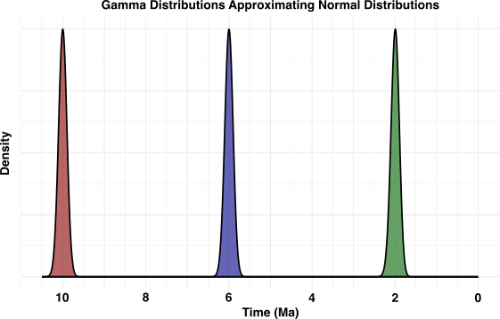

Figure S1: Example of a gamma distributions approximating normal curves used in RevBayes analyses. In these gamma distributions, alpha was set to (10000, 3600, 400) and

rate was set to (1000, 600, 200).

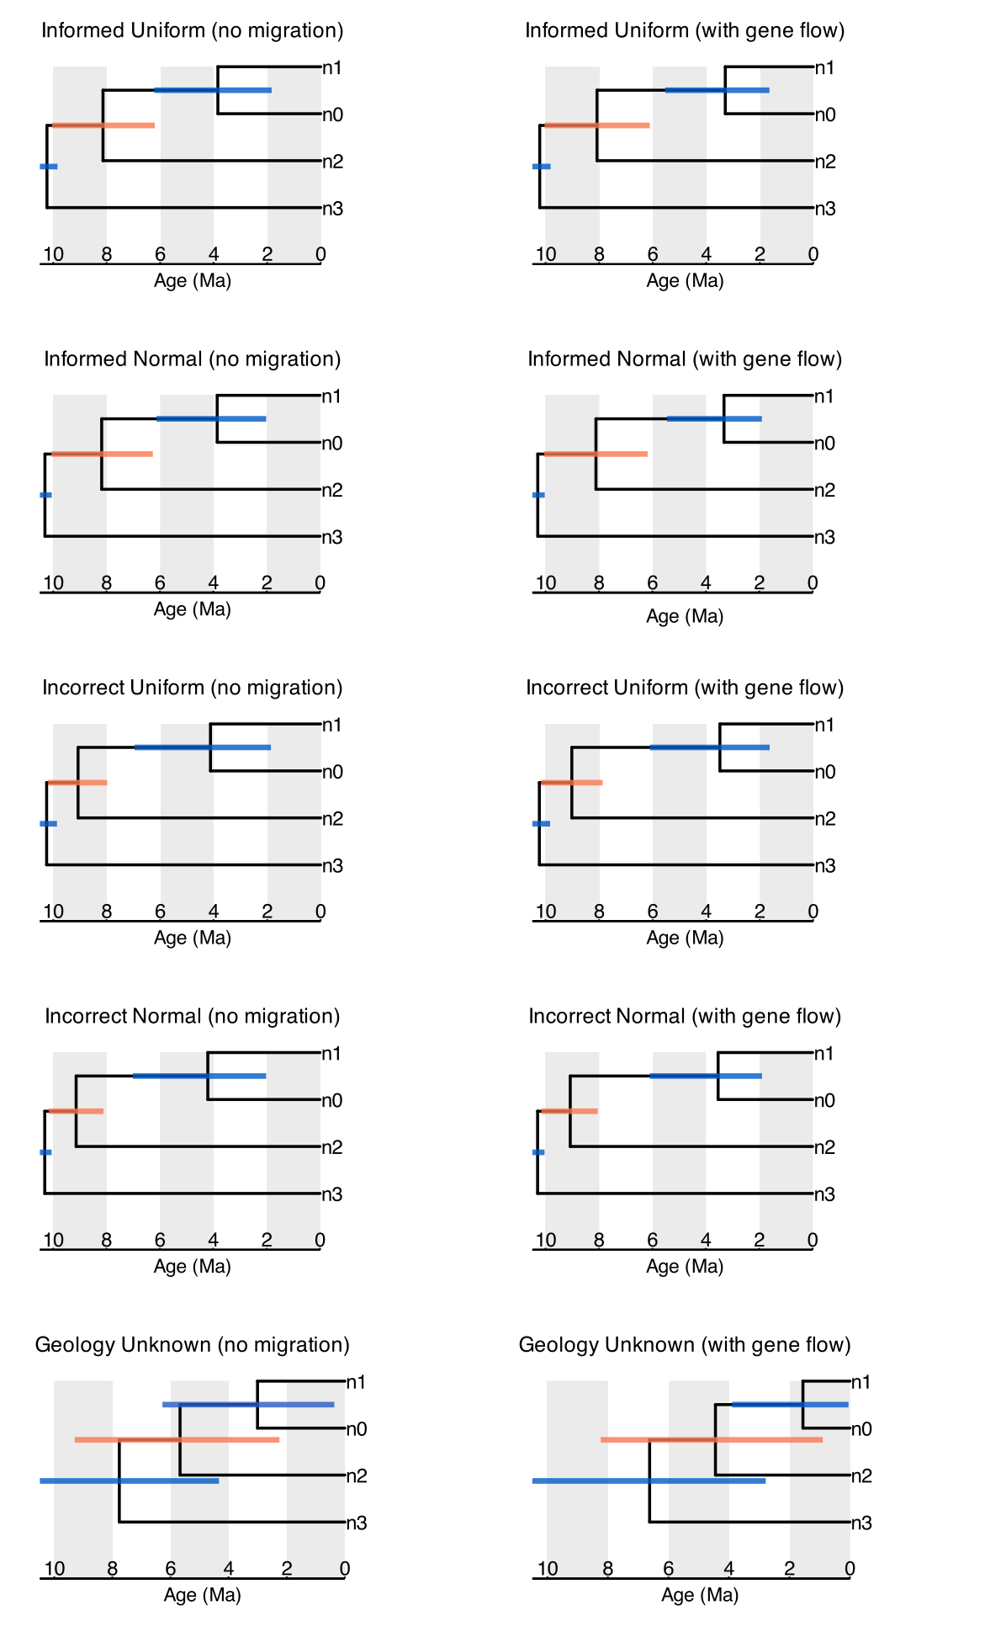

Figure S2: Maximum clade credibility trees constructed from each of the 10 models with a root age from 0 to 10.5 Ma, with 95% HPD bars given for the dating of each node.

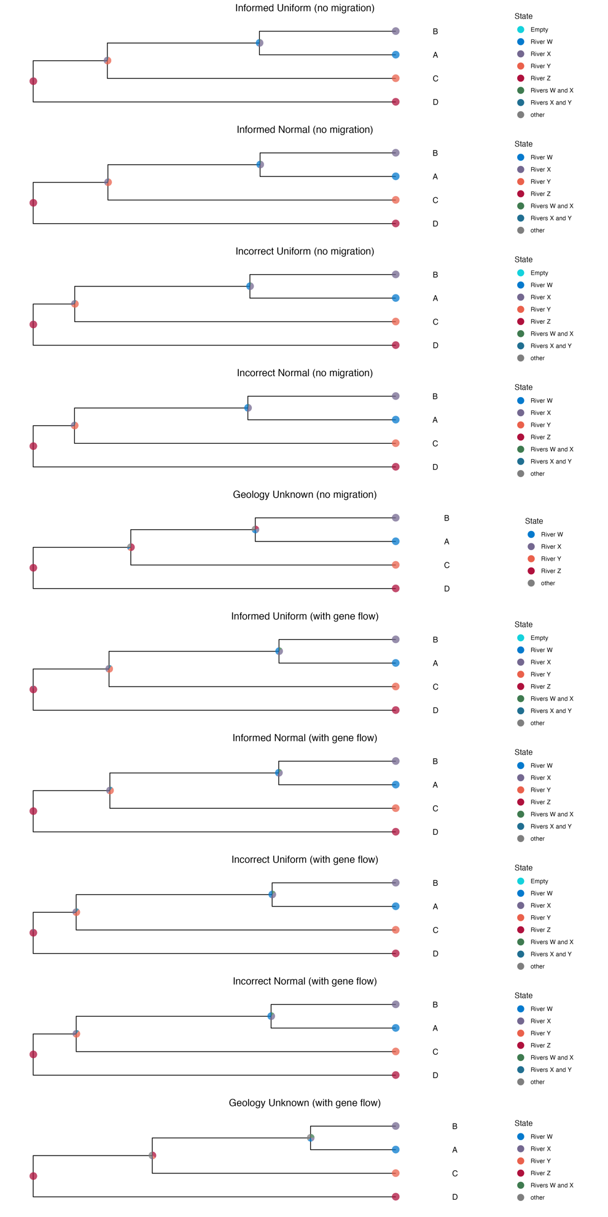

Figure S3: Ancestral state estimation for river geographic ranges produced for each of the 10 models with a root age from 0 to 10.5 Ma.

|  |  |  |  |
| --- | --- | --- | --- |
| **Model** | **Node 1 age** | **Node 2 age** | **Node 3 age** |
| Demographic (true age) | 10 Ma | 6 Ma | 2 Ma |
| Informed uniform, no gene flow – Forced root | 10.2318 | 8.1422 | 3.8288 |
| Informed normal, no gene flow – Forced root | 10.3055 | 8.193 | 3.8398 |
| Unknown, no gene flow – Forced root | 10.0049 | 7.2036 | 3.6905 |
| Incorrect uniform, no gene flow – Forced root | 10.2439 | 9.0774 | 4.164 |
| Incorrect normal, no gene flow – Forced root | 10.3103 | 9.1287 | 4.1516 |
| Informed uniform, gene flow – Forced root | 10.2221 | 8.0879 | 3.2776 |
| Informed normal, gene flow – Forced root | 10.2924 | 8.1372 | 3.3497 |
| Unknown, gene flow – Forced root | 10.0004 | 6.627 | 2.2274 |
| Incorrect uniform, gene flow – Forced root | 10.2346 | 9.0037 | 3.5133 |
| Incorrect normal, gene flow – Forced root | 10.2989 | 9.0791 | 3.525 |

Table S1: The medians of the 95% HPD of estimated divergence times predicted for nodes 1 (taxa D and stem group ABC), node 2 (taxa C and stem group AB), and the demographically manipulated node 3 (taxa A and B) for the models where the root age was forced from 9.5 to 10.5 Ma.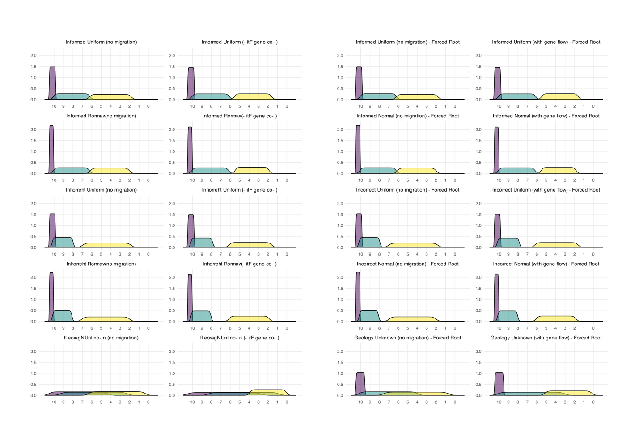

Figure S4: Posterior distributions of the 10 models, comparing those with a root age from 0 to 10.5 Ma and those with an enforced root age from 9.5 to 10.5 Ma.

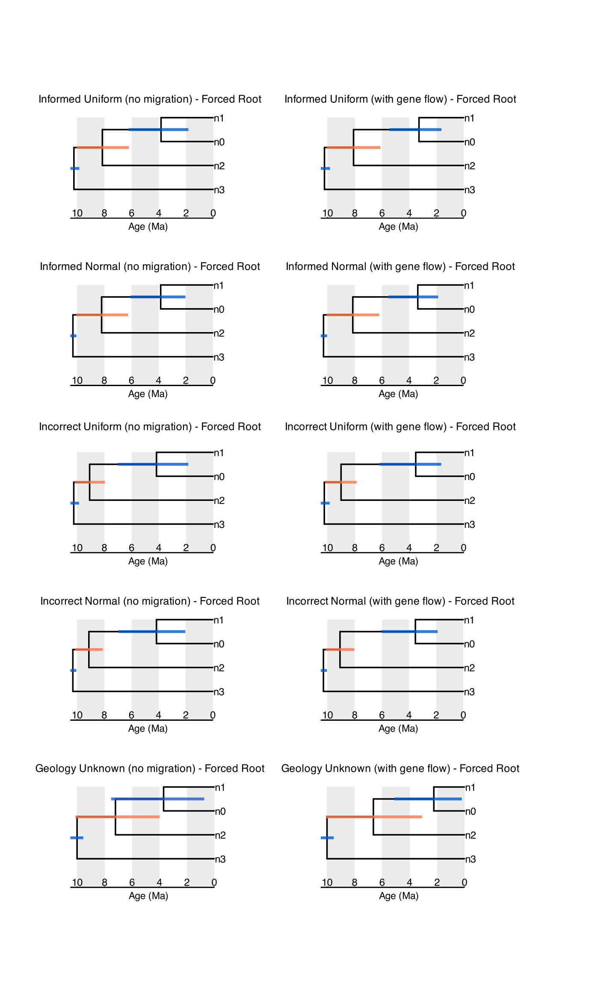

Figure S5: Maximum clade credibility trees constructed from each of the 10 models with a root age from 9.5 to 10.5 Ma, with 95% HPD bars given for the dating of each node.

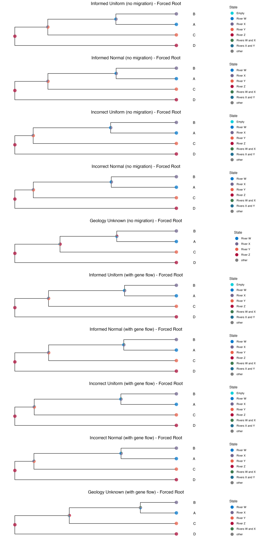

Figure S6: Ancestral state estimation for river geographic ranges produced for each of the 10 models with a root age from 9.5 to 10.5 Ma.