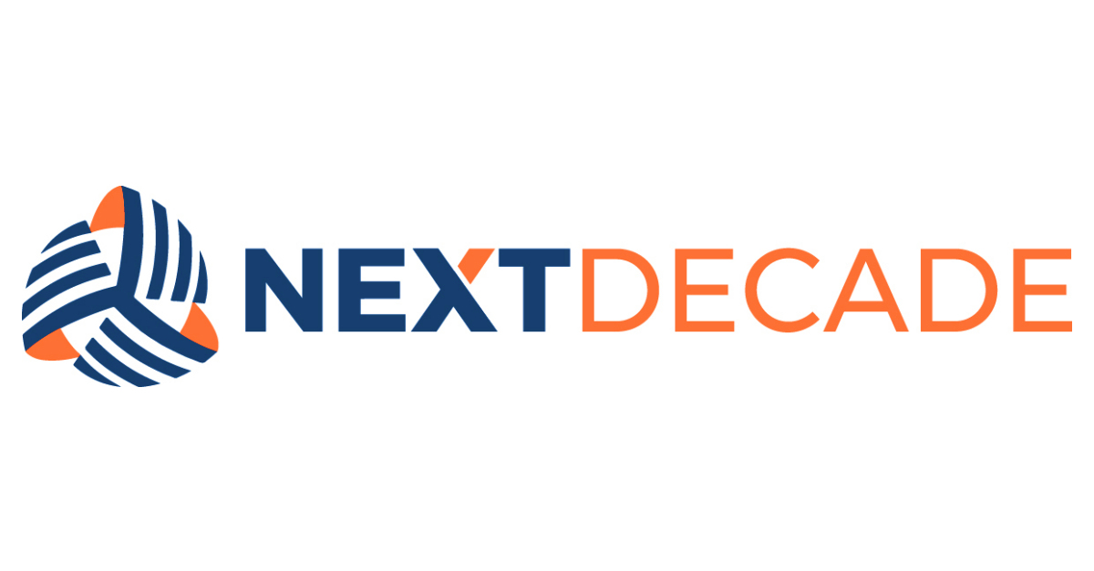

Remote Work Guidance
GUIDANCE DOCUMENT
ORG-NTD-000010-COR-GDN-00008

Table of Contents

1. PURPOSE 3
2. INTEGRATED GOVERNANCE FRAMEWORK 3
3. GUIDELINE 3
4. OWNERSHIP 3
5. APPROVAL 3
REVISION HISTORY 4

PURPOSE
This Guidance describes recommended practices for the Workforce when performing NextDecade work from a location other than a NextDecade-controlled facility. Guidance is advisory: it captures what NextDecade has found to work well and is not mandatory. The mandatory rules are in the Information Classification Standard and the Records Retention Standard.

INTEGRATED GOVERNANCE FRAMEWORK
This Guidance is part of NextDecade's integrated Governance Framework. It supplements — and does not supersede — any applicable Standard or Procedure.

GUIDELINE
The following best-practice recommendations apply when working remotely:
  - Work from a private, controlled environment when handling Confidential information; avoid open cafes, shared workspaces, and public Wi-Fi for material-non-public information.
    - Use the NextDecade VPN when connecting to company systems over any non-NextDecade network.
      - Store company records only in NextDecade-approved repositories (SharePoint, OneDrive). Avoid personal cloud storage, personal email, and USB devices.
      - Lock the workstation when stepping away and ensure the device complies with the current endpoint configuration baseline.
      - For video meetings with external parties, use the NextDecade-approved meeting platform and its waiting-room controls.
      - Confirm your physical location if asked; certain information (for example, Reg FD-sensitive material) has geographic disclosure implications.
      - Report a lost or compromised device to the IT Help Desk at ithelp@next-decade.com immediately.
      - Maintain the same professional standard of written and verbal communication as when working from a NextDecade facility.

OWNERSHIP
Responsible | Accountable | Consulted | Informed
Workforce member working remotely | People Leader (supervisor of record) | Information Technology; Information Security | People & Culture

APPROVAL
Issuer / Title | Adopted By | Effective / Amended Date
R. Chen, Chief Information Officer | NextDecade Corporation | April 15, 2026

REVISION HISTORY

Revision | Description of Changes and Notes
0 | Initial issuance.

The Governance Framework outlines the rules, practices, and processes by which the Company is directed and controlled ensuring accountability, fairness, and transparency in the Company's relationship with its stakeholders, including shareholders, employees, customers, and the community.

