The incidence of near-miss events varies at different times: time effects analysis with panel negative binomial regression

Data

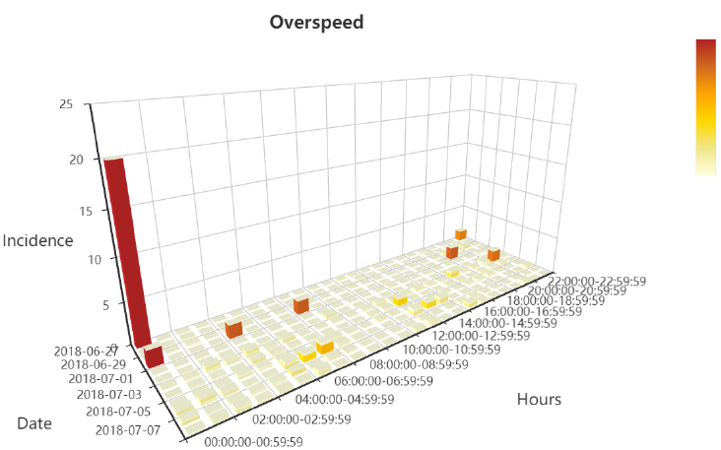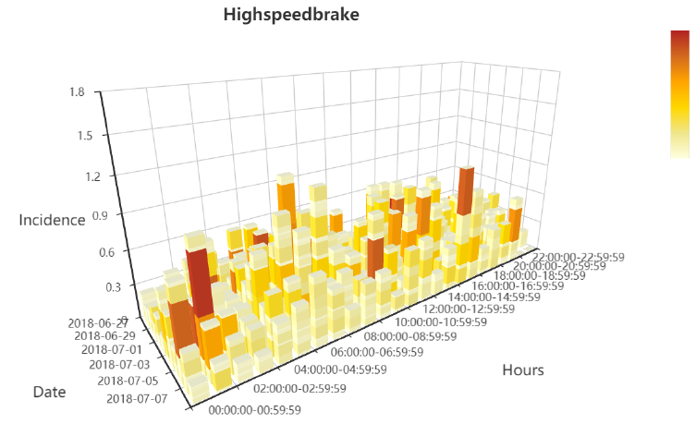

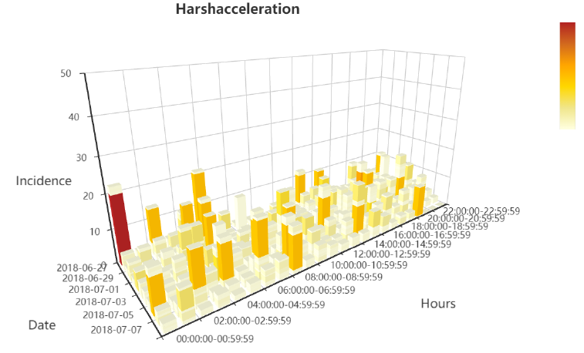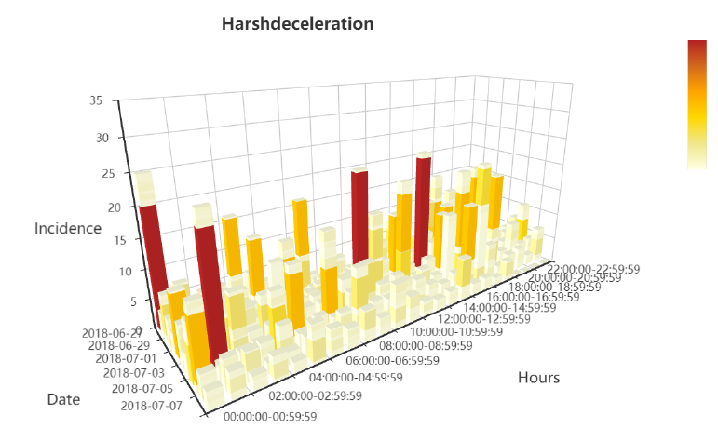

Figure 3D bar chart of absolute incidence of near-miss events, (a)Overspeed, (b)Highspeedbrake, (c)Harshacceleration, (d)Harshdeceleration, per unit driving distance

Result