**BSc Internet Design Final Year Project**

**Luke Taylor**

**BSc Internet Design Final Year Project**

**Luke Taylor**

**Supervisor: Stavros Didakis**

**BSc Internet Design**

**Plymouth University**

**Arts & Humanities**

**May, 2018**

**Words: 1275**

Table of Contents

Introduction 4

Background 5

References 6

# **Introduction**

For my final year project, I wanted to combine my skills from the past 3 years into a project within the realm of the internet of things. I want to merge the use of IOT with topics I found the most interesting throughout my studies in a bid to develop a project that can make a difference in our everyday lives. These include digital art/installations, open data and environmental sensing.

The aim of my project is to look at how the internet of things can be used to aid and show the importance of resource management within the home environment. I would like to build a resource measurement system for water consumption within the household, which will be accompanied by a live data visual art piece representing how much water is consumed on a daily basis by the home occupants. This system would then help to highlight how wasteful we can be with the resources in our own homes and drive home the impact that this has on the rapidly depleting environment, and therefore help people to make the conscious effort to waste less and reduce the consumption of important resources allowing for a healthier environment starting in their homes. This project could also be taken and placed into industrial or emergency settings, I would also like the art piece to be able to stand out on its own regardless of the system for positioning in a gallery or other similar settings. Currently there are very few devices covering this particular task and those which are, do not release that data for people to see nor do they represent the data in an artistic way, I am curious to see if the art could be used to make a change in how people behave. I believe it’s important that people are made more aware of their impact on the future of the world and themselves through the resources which they consume.

# **Background**

The idea for this project came from a compound of different references. To start, at the beginning of the project I was given a presentation by my project supervisor on his PhD research into the internet of things, smart homes and what they are, this gave me a good insight into the topics I had chosen. From the presentation I found interest in two particular references; the psychotropic house and the umwelt. I went on to explore these further and they formed the basis for my idea.

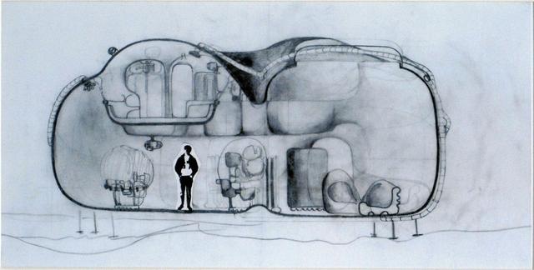

Living Pod (Greene, 1966)

The first reference is a short sci-fi story written by J. G. Ballard called One thousand Dreams of Stellavista. This is a story set in a house he describes as psychotropic. The word psychrotropic is usually used to describe the effects of mental activity, behaviour or perception in conjunction with drugs and medicine. In the case of One thousand Dreams of Stellavista is it describing how the house is designed to sense and mirror the psychological state of their occupants and change aspects such as shape and layout accordingly, and as such are often described as being alive and consious throughout the story. In one part of the story the main character is confronted by his wife and asked to move back into a normal static house to which he objects and responds with a description of normal houses being “it's not just dull, it’s dead” (Ballard, 1992). I found this story interesting and very relevent to today and the increase in the amount of internet of things devices built for the home to make everything in life easier and more adaptable to the user, houses are already monitoring occupants and adapting specifically making them more personalised. From this I started to think about what else the home could autonomously be monitoring or self conscious of and how could that be materialised, which led me to the idea of monitoring resources or a home aware of its own resource consumption/ carbon footprint.

The other reference was the idea of the Umwelt. It is a German word for environment and also a concept introduced by German biologist Jakob von Uexküll in 1909. The Umwelt is a concept used to describe the fact that within the same ecosystem, different species are biologically programmed with sensors to detect a fraction of the possible signals or data that is out there, forming the limit of their entire objective reality of which they cannot see past, potentially missing so much more of the world around them. It is often translated as a self-centred world and Uexküll’s also describes it as “a soap bubble around each creature to represent its own world, filled with the perceptions which it alone knows” (Schiller, Kuenen and Uexküll, 1957). This had me thinking that our self centered nature might mean we are unaware of how wasteful we can be with finite resources as we don’t have that perception, and how our umwelts could be extended to represent this.

This led me to an interesting speech from a neuroscientist called David M. Eagleman whos work is based around the umwelt. In his speech he shows a device that he and his team built to help deaf people to hear again by wearing a vest and using an app that turns sound into vibrations that after training can be percieved by the body as sound, he calls his work “sensory substitution” and “sesory extensions”(Eagleman, 2015). But he also briefly talks about the possibilites of extending our Umwelts by making plug and play sensory periphirals and what kinds of data this would allow us to pick up on and work with. I found that this idea tied in nicely with the theme of home environments and IOT as well as it being really interesting and wanted to find a way of using my project to potentially increase our umwelts or our home umwelts in some way and how this might change our lives.

Through my own research into IOT and smart home technology I found some other interesting resources, one of which is an up and coming google funded project named Synthetic Sensors by Geirad Laput. A project that aims to create a new type of sensor that can work across a broad range of appliances and visualise it, on the project website it is described as “a single, highly capable sensor can indirectly monitor a large context, without direct instrumentation of objects. Further, through what we call Synthetic Sensors, we can virtualize raw sensor data into actionable feeds” (Laput, 2018). This sensor is taking a big step forward in terms of IOT and I found its potential and diversity for envirnmental sensing very inspring for my project. I wanted to try and get hold of one for my project but they are currently only in the prototype stage.

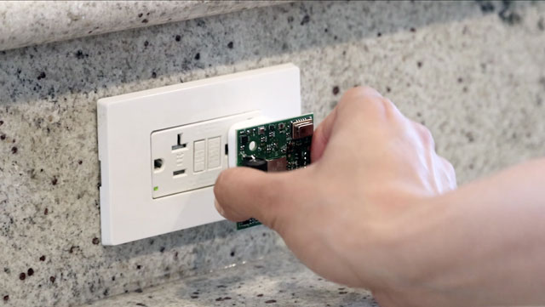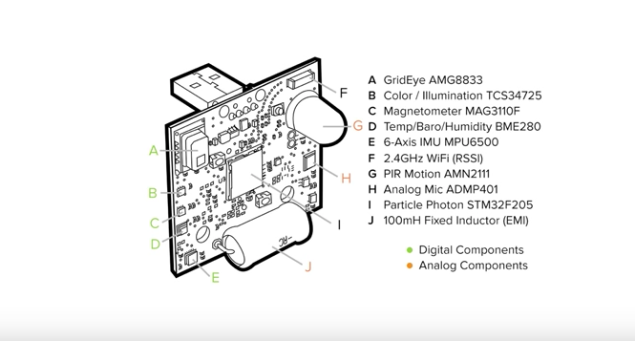

Super Sensor, (Laput, 2017). Super Sensor Schematic (Geirad Laput, 2017).

The idea to use live art in conjunction with home resources and wastage came from an article I read by Lisa Roberts, a visual artist from the University of Technology Sydney and leader of the Living Data Program. In this article Lisa talks about the role of artists in helping to visualise scientific data and part of her work is to use art to change people’s understandings specifically to do with climate changes, she states that to get people to understand the data “we need experiences that stir strong feelings of connection” (Roberts, 2015). Currently their work is based on a global scale and presented online, in conferences, art exhibitions, public spaces and social medias. I am interested on how this idea can be used on a local scale with IOT technology to bring these art pieces and experiences into the home environment.

# **Methodology**

Methodology (the development practice and structure that was followed to make this project. Any specific techniques or technologies used should be mentioned here).

To begin the project, I had to first understand the definition and what would be deemed as a resource within the home environment as a whole, what the different resources are, their importance or weighting in usage, and their environmental effects.

The meaning of resource can vary greatly depending on

What are the home resources

Impact on homes resources on environment

Looking at current resource trends, water is high usage…current draughts etc in news articles, explain choice in water the most usage.

Research into water usage rates

# **References**

1. Greene, D. (1966). *Living Pod*. [image] Available at: http://archigram.westminster.ac.uk/project.php?id=82.
2. Ballard, J. (1992). Vermilion sands. London: Phoenix.
3. Schiller, C., Kuenen, D. and Uexküll, J. (1957). Instinctive Behavior; The Development of a Modern Concept. Introd. by Karl S. Lashley. Contributors. New York: International Universities Press.
4. Eagleman, D. (2015). Can we create new senses for humans?. [Blog] TED. Available at: <https://www.ted.com/talks/david_eagleman_can_we_create_new_senses_for_humans>.
5. Laput, G. (n,d). Gierad Laput | Synthetic Sensors. [online] Gierad.com. Available at: http://www.gierad.com/projects/supersensor/.
6. Laput, G. (2017). *Super Sensor*. [image] Available at: <http://wallstreetpit.com/113460-super-sensor-make-entire-room-super-smart/>.
7. Geirad Laput, G. (2017). *Super Sensor Schematic*. [image] Available at: <https://techcrunch.com/2017/05/11/google-funded-super-sensor-project-brings-iot-powers-to-dumb-appliances/>.
8. Roberts, L. (2015). *Living data: how art helps us all understand climate change*. [online] The Conversation. Available at: http://theconversation.com/living-data-how-art-helps-us-all-understand-climate-change-36890.