Add.html

Index.html

Gallery.html

Pets.html

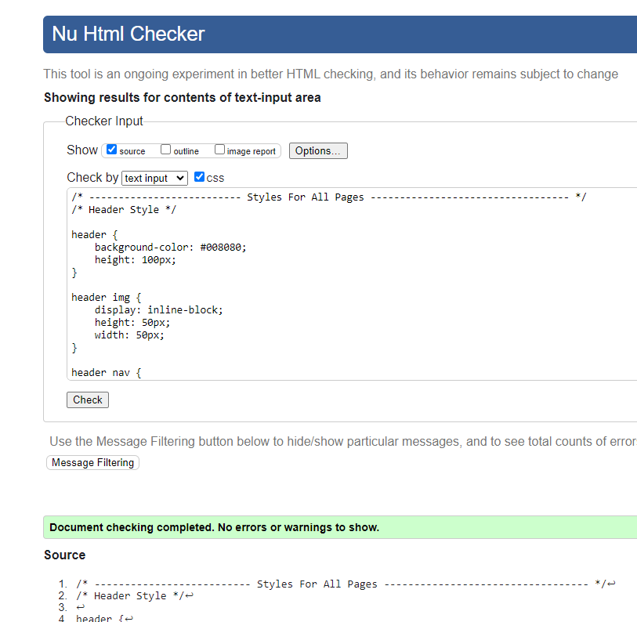

Style.css