**Question 1**

*Using your own words, define Country from an Indigenous and Western perspective and discuss how the two perspectives differ and compare. Carefully explain your answer in 300 words or less.*

The definition of “country” is complex and multilayered because of the diverse perspectives that can be held. One of these perspectives is from the traditional Indigenous Australian worldview, which has a deep connection to the land and an understanding of a country and the land that changes through time and in response to both natural and human actions. Within this traditional Indigenous Australian worldview, a 'country' is seen as much more than simply a physical geographic location. It is viewed as an expansive spiritual and environmental realm where individuals are connected to the land, the plants and animals, the other people, and their own ancestors through a variety of important relationships, cultural obligations, stories and rituals. In contrast, the Western perspective on “country” is more focused on physical geographic locations and legal definitions of political boundaries and nation states. This view of “country” is less concerned with the spiritual, emotional and physical connections to the land, and more focused on human activity within a specific geographic area. The major similarity between the Indigenous Australian and Western perspective on “country” is the importance of having a shared understanding of land and its meaning. While the Indigenous Australian worldview may be more focused on spiritual and emotional connections to the land, the Western perspective centres around legal definitions of nation states and political borders. Thus, both worldviews recognize the importance of understanding the power of land and its influence on people’s lives. The major difference between the two perspectives is in the way they approach the concept of “country”. The Indigenous Australian perspective puts emphasis on a more holistic understanding which considers spiritual, emotional and physical connections to the land. On the other hand, the Western perspective is more focused on political definitions of nation states and geopolitical borders.

**Question 2**

*What is a lunar eclipse? Carefully explain why we do not have a lunar eclipse every month. Provide your own sketch or diagram to help explain. Include all relevant celestial bodies.*

A lunar eclipse is an event that occurs when the Earth's shadow blocks the Moon, resulting in a full or partial blocking of the Moon from the Sun’s light. A lunar eclipse occurs as a result of the Moon's orbit around the Earth. The Moon follows an orbit that passes close enough to the Earth to be obscured by Earth’s shadow. Lunar eclipses don’t occur every month since the Moon has a slightly more angular orbit than the earth. If they had the same orbit, then an eclipse would occur every month. Below is a diagram showing a full lunar eclipse (total blocking of light).

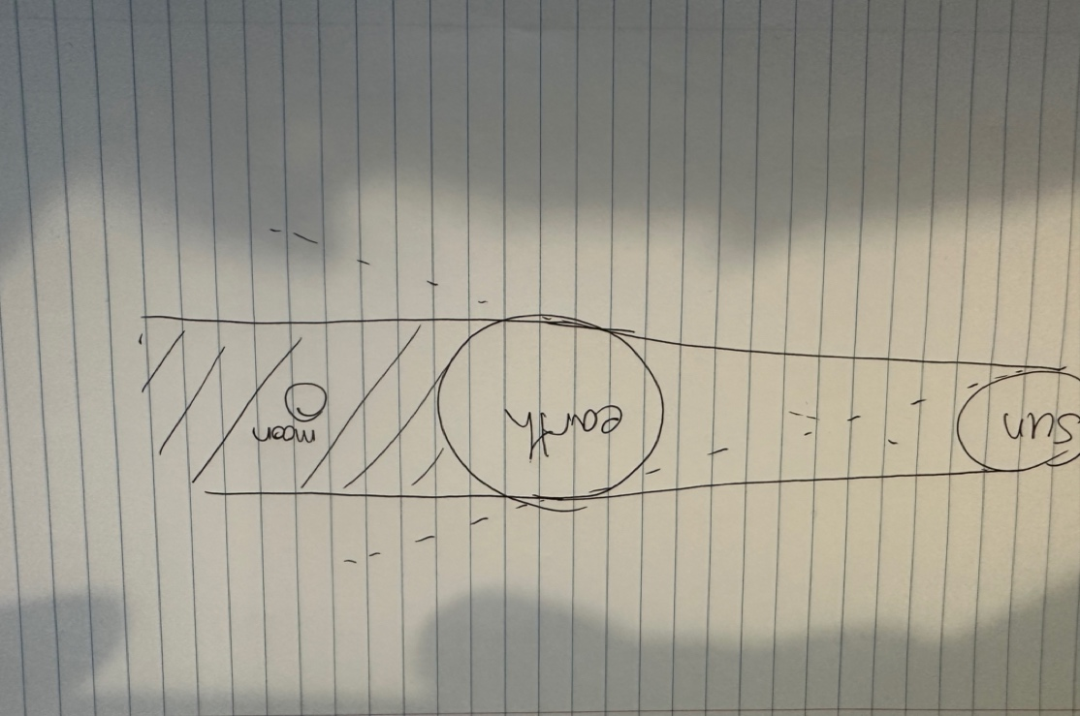

**Question 3**

*Carefully explain what the Moon’s cycle is and its various phases. Include one or more of your own diagrams in your answer.*

The lunar cycle, or the stages of the Moon, is determined by the orbital period of the Moon, which is 29.5 days. This cycle begins at the New Moon phase, which has two subcategories, waxing crescent and waxing gibbous. A waxing crescent is when the Moon is travelling from New Moon to the First Quarter, in which only a thin crescent is visible. A waxing gibbous phase refers to when the Moon has completed the first quarter and is transitioning to the full Moon phase, and a curved piece of the Moon is visible. The full moon phase is when the Earth is directly between the Moon and Sun, and the entire illuminated side of the Moon is facing us on Earth. The scattering of light by the Moon’s surface during this time is what causes the lunar optical phenomena known as “Earthshine”. The full Moon phase is followed by a waning gibbous phase, in which the Moon is transitioning from being full to the third quarter phase. Waning crescent is the last phase of the lunar cycle where the Moon is transitioning from the third quarter phase to the New Moon phase again. These phases are a result of the Moons orbit around the Earth which changes the angle at which the Sun’s light hits the Moon thereby causing it to cast a shadow and appear in various shapes and sizes. The Moon takes approximately 27 days to orbit the Earth, and at the same time, it rotates on its own axis every 27 days (source: https://www.space.com/24871-does-the-moon-rotate.html).

