ChatDot
Design Document
Table of Contents
ChatDot 1
Design Document 1
1 Introduction 2
1.1 Purpose and Scope 2
1.2 Target Audience 2
1.3 Terms and Definitions 2
2 Design Considerations 3
2.1 Constraints and Dependencies 3
2.2 Methodology 3
3 System Overview 5
4 System Architecture 6
4.1 Chat Server 6
4.2 Chat Client 6
4.3 Chat Client Interface 6
5 Detailed System Design 7
5.1 Chat Server 7
5.2 Chat Client 7
5.3 Chat Client Interface 8

Introduction
This document outlines the design considerations, constraints, requirements, and dependencies as well as the system architecture of the ChatDot application.

Purpose and Scope
This document is intended to aid in the implementation, testing, and maintenance of the ChatDot application as well as to ensure that all requirements and functionality of the stakeholders is accounted for in the overall design of the application.

Target Audience
The ideal audience of this document is the programmers, QA, system architects and engineers that will be responsible for both implementing, deploying, and maintaining this application.

Terms and Definitions
Server – The core of the application that links all clients together into a single communication entity.
Client – The end-user program that is responsible for communicating requests from an individual end-user to the Server.

Design Considerations
This section outlines the overall design components that must be taken into account in the final product such as constraint and dependency requirements, tools, and methodologies used to achieve the completion of the project.

Constraints and Dependencies
Java 8 is the primary language of choice for the majority of the project. Some other languages, such as C, may be used to supplement if necessary. Only the Java standard library is allowed to be used and is a core dependency. All other required functionality must be original code specific to this project as a learning exercise.
Linux will be running the server component of the product and for this simple project, a basic file-system based storage medium will be used for data persistence.

Methodology
Five stages of the software engineering lifecycle are being carried out:
- Requirements Gathering
  - This phase is to collect all of the desired functional and non-functional aspects of the desired end-product and to ensure all use cases are properly thought through in order to fuel the analysis and design phases. This phase is primarily written in basic language understandable by clients and stakeholders.
- Object-Oriented Analysis
  - This phase breaks down the requirements into a detailed understanding of the desired results in order to implement in a concise and maintainable way. This step further details the requirements into more technical language suitable for QA and software engineers as well as providing more descriptive documents such as UML and state diagrams.
- Object-Oriented Design
  - This phase turns the analysis or the “what” of the project into the “how” of the project. Specifically, the analysis is turned into an internal structure of what the implemented code should look like by creating a diagram of modules, packages, and methods and how they interact with each other.
- Implementation
  - The aim of this phase is to actually carry out the creation of the classes, packages, modules, and interactions defined in detail in the design document.
- Testing
  - This last phase is usually carried out in parallel to the implementation phase by ensuring that the classes and modules created are thoroughly tested by creating test cases for each of the use cases defined in the requirements document and ensuring they meet the necessary specifications.

System Overview
This section describes the high-level overview of the ChatDot application and the basic flow diagram. There are two event loops, the Chat Server, and the Chat Client. The Chat Server waits for incoming connection requests, Register, Login/Logout, and Send Message requests. The Chat Client waits for these same events from the Chat UI. Each request is sent off to the server before resuming the event loop. For each Login/Logout and Message received by the Chat Server, a state transition is sent off to the Chat Client before resuming the event loop.
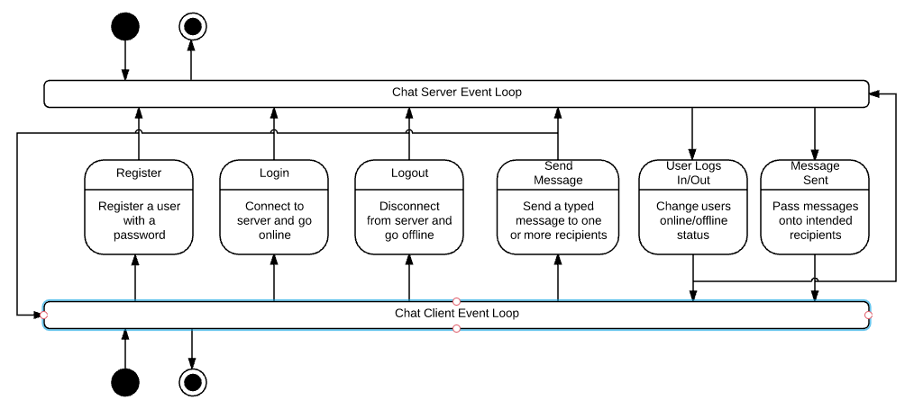

System Architecture
This is a basic Client/Server architecture where the Chat Server is running on a local or remote machine waiting for incoming socket requests from one or more Chat Clients also on a local or remote machine.

Chat Server
The Chat Server will be the core of the application and will monitor and control all user registrations, logins, logouts, and messages sent and received by users. It provides the central linking point between all users of the ChatDot application.

Chat Client
The Chat Client is the intermediary between the end-user and the Chat Server. It connects the users computer system to the Chat Server and provides communication between the end-user interface and other users by way of the Chat Server. All attempts to register, login, logout, or send messages will be sent from the Chat Client to the Chat Server.

Chat Client Interface
This is the boundary between the Chat Client and the end-user. It provides a graphical representation of all interactions possible with the Chat Client and the Chat Server including registration, logging in/out, and sending/receiving messages. It also provides an up-to-date view of the online status of all other users whether they are logged in or out.
Here is a basic data flow diagram of interaction with a user:
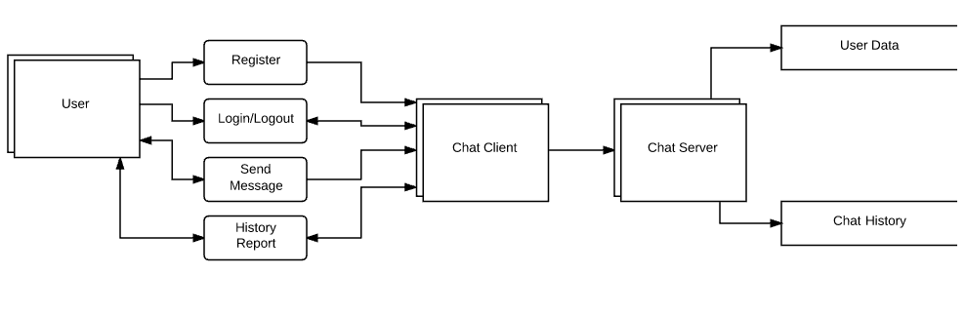

Detailed System Design

Chat Server
The Chat Server is a class that extends the Thread class allowing it to fork multiple threads for each Chat Client that connects to it up to a maximum value defined at runtime. The initialization of the class gets the local host address that the server is running on as well as a runtime defined listening port. Upon initialization, a socket is created which begins listening for clients to connect on the designated hostname and port. An Event Loop is then started which ensures that it accepts any new Client connections as well as disconnects any invalid or disconnected clients. It also listens for any requests to come in for Registration, Logging In/Out, and Sending Messages. There is a default throttle as well of 200ms for the interval in which the event loop sleeps between iterations.
The Chat Server will use an array of logged in Users to keep track of who is online as well as an array of offline Users who have been registered but are currently not connected.

Chat Protocol
The Chat Protocol is responsible for handling the incoming and outgoing data for the Chat Client. It ensures that data is retrieved from or sent into an ObjectOutputStream or ObjectInputStream respectively.

Chat Client
The Chat Client is responsible for initializing the initial client socket connection and reaching out to the Chat Server host on the specific server port that that Chat Server is listening on. It leverages the Chat Protocol to send/receive data and communicates with the Chat Client Interface which is responsible for updating/displaying data to the end-user.

User
This is an entity class responsible for keeping data such as the email, password, name, and online status of the end-user. It also keeps track of the current session of chat history of that user.

Messages
This entity class is responsible for the data pertaining to messages including the sender, receiver(s) and timestamp of the message being sent or received.

History
This is a collection class that aggregates all messages from/to a given user. An array of messages will be used to keep track of message history.

Chat Client Interface
This class is the UI interface for the end-user and provides text, buttons, and input boxes for the user to both see the online/offline status of other users, what messages have been sent/received, as well as buttons to send/receive their own messages or to register, login, or logout. Additional functionality is available to send individual messages to users by double clicking their name in a list.

