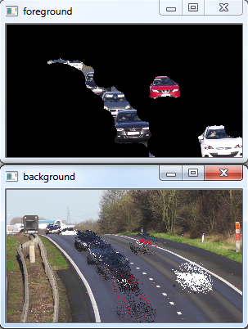Background Subtraction

BG Segmentation

Traffic.mp4 (3:00)

Five segmentation algorithms are explored:

1. KadewTraKuPong and Bowden segmentaion mask

2. Gaussian Mixture segmentation by Zoran Zuvkovic

3. Godbeher, Matsukawa, and Goldberg

4. Counting by Sagi Zeevi

5. KNN Nearest Neighbors (best)

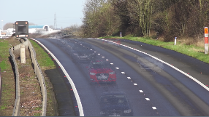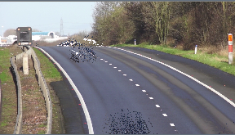

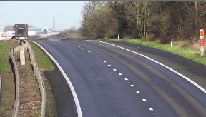

MOG2

KNN

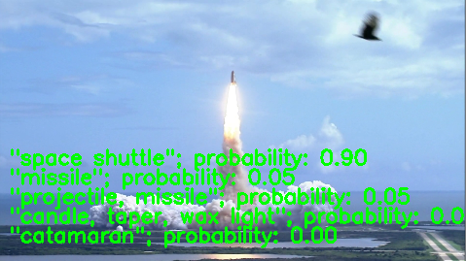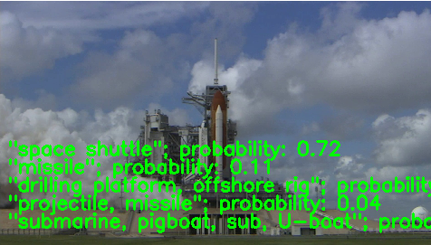

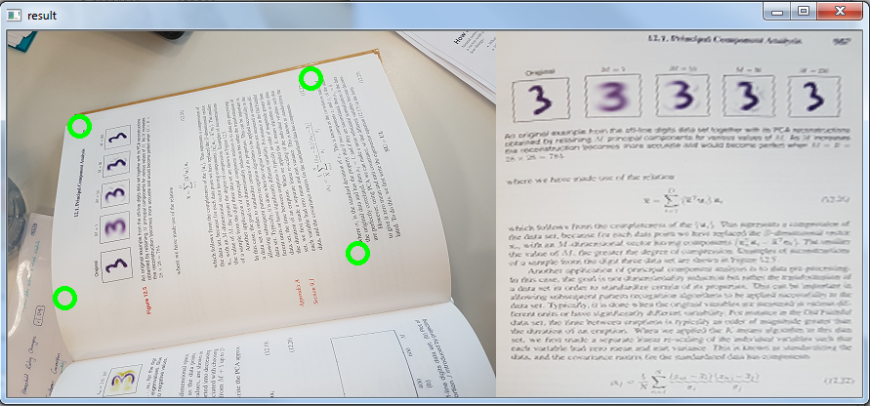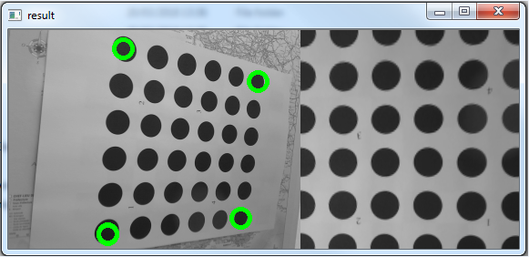fin