Part C: Prediction Model of Company Bankruptcy with Machine Learning Algorithms

Yi Wei Yek
(p2107631)

Abstract—Based on the data set from the Taiwan Economic Journal for the years 1999 to 2009 by Kaggle.com. Company bankruptcy prediction is modelled using regression algorithms. Three machine learning classification namely KNM, SVM and Logistic Regression are used to detect company bankruktcy . The performances of all the tree algorithms are evaluated on various measures like Precision, Accuracy, Fscore, and Recall. Both SVM and Logistic Regression are having similar accuracy of 0.97 and precision 0.74. Both models can be cosidered as supervised machine learning method to predict company bankruptcy. Other classification algorithm such as decision trees can be incorporated to obtain a more accurate results.
Keywords—company bankruptcy, KNM, SVM, Logistic Regression, Machine Learning

Introduction
Businesses that show signs of insolvency are more likely to go bankrupt. The following factors or features can be used to determine if a company will go bankrupt or not: (1) According to the firm’s accounting data, if the amount of debt assets exceeds the overall value of the company’s assets, the company is likely to file for bankruptcy. (2) Based on the existing solvency of the business in relation to due debts, if the firm is unable to meet the solvency of due debts, the enterprise is likely to enter business bankruptcy. In this work, KNM, SVM and Logistic Regression machine learning algorithms are used and evaluated on the data set from the Taiwan Economic Journal for the years 1999 to 2009 by Kaggle.com.

Data Description
In the dataset, the total number of records is 6819 and there are 95 features. The status of bankruptcy is represented by 0 and 1. 0 means not bankrupt and 1 means bankrupt. Figure 1 shows 220 companies have gone bankrupt and 6599 companies haven’t. Part of the features is shown in Figure 2. There has no missing value in the data set. All are numeric features so no conversion is needed.

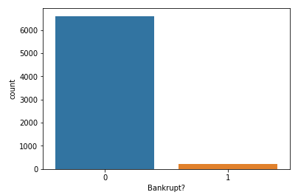
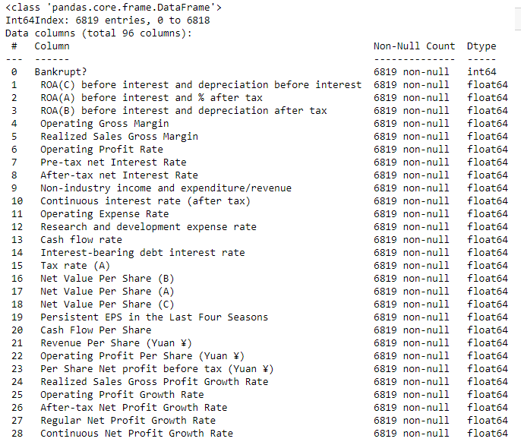

Machine learning
Estimating the bankruptcy based on a given features is a regression problem that involves mainly nimeric features. The task to evaluate the performance of three different machine learning algorithms using the data set from the website. The algorithms used are briefly discussed.

K nearest neighbors (KNM)
The k-nearest neighbors (KNN) algorithm is a simple supervised machine learning algorithm. It can be used to solve classification and regression problems. KNN is based on the assumption that similar things are close to each other. It calculates the similarity between different samples by calculating the distance between them. There are various methods for calculating this distance, but the Euclidean distance is the common one. For an accurate result, the number of neighbors K used in the calculationne must be fine-tuned. The key benefit of this algorithm is its simplicity and the fact that it just has a few parameters to tune.

Support Vector Machine (SVM)
SVMs are based on the principle of locating a hyperplane that best divides a dataset into two classes. In this context, "best" refers to the hyperplane with the greatest margin. In the case of linearly nonseparable classes, SVM uses a technique known as the kernel trick. This approach transforms data into a higher-dimensional space where it is linearly separable[1]. The method has several hyperparameters that must be tuned, including the kernel and regularization

Logistic Regression (LR)
Logistic Regression classifier used to predict the probability of a target variable. Also, it is easier to implement, interpret, and very efficient to train [2]. Moreover, the logistic regression classifier can provide a measure and association direction of the predictor. It is less inclined to over-fitting. It uses a logistic function to model the dichotomous dependent variable. In this case the dependent variable is either bankcrupt or not.

results and Discussion
This section provides the evaluation results of the machine learning models. In the first subsection, the classification metrics for the model evaluation are displayed. Then the training and parameter tuning for these models are discussed. Finally, the comparison of the models performance, and the best model is selected.

Metrics
The evaluation metrics used in clsssification algorithms are Accuracy(A), Precision(P), Recall(C), and Fscore. ROC are used to compare the usefulness of tests. Table 1 shows the definition and formula for the various measures [3].

Model Evaluation
Corresponding classifiers performace over Accuracy, Precision, Fscore, Recall and ROC are listed in Table 2.

TABLE 1 Classifier Evaluation Metrics
Measure | Definitions | Formula
Accuracy (A) | Accuracy determines the accuracy of the algorithm in predicting instances. | A=(TP+TN) / (Total no of samples)
Precision (P) | Classifier¢¢s correctness/accuracy is measured by Precision. | P = TP / (TP+ FP)
Recall (R) | To measure the classifier¢¢s completeness or sensitivity, Recall is used. | R =TP / (TP+FN)
FScore | FScore is the weighted average of precision and recall. | F=2*(P*R) / (P+R)
ROC | ROC(Receiver Operating Curve) curves are used to compare the usefulness of tests.

TABLE 2 Comparative Performance
Model | Precision | Recall | F-Score | Accuracy | ROC
KNN | 0.677 | 0.573 | 0.601 | 0.967 | 0.712
LR | 0.738 | 0.593 | 0.631 | 0.970 | 0.855
SVM | 0.736 | 0.519 | 0.528 | 0.970 | 0.882

SVM and LR showing the maximum accuracy which 76% of the data can be predicted correctly. Both models also having the similar precision of 74%. In can be concluded that both SVM & LR machine learning classifier have better prediction on company bankruptcy. The work can be extended and improved for the prediction of company bankruptcy using some other machine learning algorithms.

References
- R. A. Nugrahaeni and K. Mutijarsa, "Comparative analysis of machine learning KNN, SVM, and random forests algorithm for facial expression classification," 2016 International Seminar on Application for Technology of Information and Communication (ISemantic), 2016, pp. 163-168, doi: 10.1109/ISEMANTIC.2016.7873831.
- Huda Kutrani, Saria Eltalhi, and Naeima Ashleik. Predicting factors influencing survival of breast cancer patients using logistic regression of machine learning. University of Benghazi, ICEMIS’21, October 11–13, 2021, Almaty, Kazakhstan 2019.
- Deepti Sisodia and Dilip Singh, “Prediction of Diabetes using Classification Algorithms,” International Conference on Computational Intelligence and Data Science (ICCIDS 2018).

