Cougs in Space

Design Document

10/16/2017

Version <1.0>



SSS Jared Strand Luke Seo Rahul Singal

Course: CptS 322 - Software Engineering Principles I Instructor: Sakire Arslan Ay

TABLE OF CONTENTS

**I. INTRODUCTION** 2

**II. ARCHITECTURE DESIGN** 2-3

II.1. OVERVIEW 2-3

**III. DESIGN DETAILS** 3-5

III.1. SUBSYSTEM DESIGN 3-4

|  |  |
| --- | --- |
| *III.1.1.* HTML User Interface | 4 |
| *III.1.2. JavaScript Interface* | 4 |
| *III.1.3. Python Database Server* | 4 |
| III.2. DATA DESIGN | 5 |
| III.3. USER INTERFACE DESIGN | 5 |

**IV. TESTING PLAN** 5-6

**V. REFERENCES** 6

I. Introduction

The purpose of providing this design document is to illustrate and outline the main component and subsystem diagrams that will be used as a guide to serve as a visual aid for our web development project. The goal of this project is to build a website for the WSU Cougs In Space Club. We want to build this website so that the site administrator will be able to post updates about events and happenings from within the club. The website will mainly serve to keep current and potential members informed with the current projects of the club and progress within each team. It will also serve as a platform to attract donors and keep past donors informed with where and how their money is being utilized.

*Section II includes Architecture Design*

*Section II.1 includes the overview of the software system*

*Section III includes Design Details*

*Section III.1.1 includes HTML User Interface Section III.1.2 includes JavaScript Interface Section III.1.3 includes Python Database Server Section III.1 includes Subsystem Design*

Document Revision History

Rev 1.0 10-16-2017 Initial version

II. Architecture Design

II.1. Overview

Our software system will be a website designed to handle basic navigation and content post updates per team page that is implemented. We have decided that the best way to serve up a solid website to our end user is to build three main components, or subsystems that will work cohesively within the entire website system structure. The first of these subsystems is going to be our user interface. This user interface is going to written in HTML with the help of the Bootstrap libraries and grid layout CSS styling. Our user interface will be designed in such a way that will allow it to have many interactive buttons and action events that users may trigger with mouse clicks and keyboard input. Our second sub-system will be the JavaScript database interface and event handling software. This JavaScript sub-system will allow the user to modify certain input data fields and handle many mouse button clicks on certain pages. In this sub-system we will also make extensive use of the jQuery libraries to dynamically update our HTML front end content. Our third and final sub-system interface is the python database server interface. This API will be designed to work with the JavaScript and jQuery commands from the second interface to store and withdraw data from an SQL database. For our software system we have decided to implement a Model View Controller architectural pattern. The rationale behind choosing this pattern was the fact that our website will need to run interactive commands on the client side and be able to make requests to a database structure on the server side. With the Model View Controller architectural pattern, we are able to process and handle many user interactions and interfaces on the client side and minimize the amount of server-side computation that must be handled.

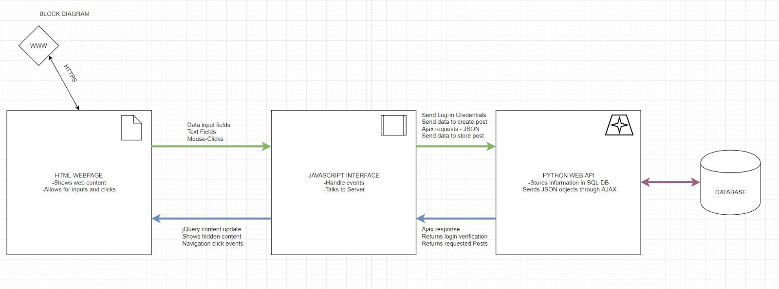

III. Design Details

III.1 Subsystem Design

There are three subsystems within our architecture which includes the front-end UI with

HTML/CSS/BootStrap, the JavaScript database interface and the Python flask backend server.

The front-end UI is implemented using HTML and BootStrap. We utilize the BootStrap grid system to implement the navigation bar and the side bar so the user can easily switch between various pages through the website. In the Requirements Document we explain that the users the website will target are admins/team leaders, potential donors, WSU student and K-12 students. In the navigation bar we have links that are aimed the respective users such as a Get Involved page for WSU students which informs them on how to become a part of the club.

The second subsystem in our architecture is the JavaScript database interface which handles various calls between the client and server. Administrators and team leaders will have special privileges which results in more client/server interactions. Team leaders are able to create/delete/update posts within their respective teams, while the website administrator will be allowed to do the same throughout all team pages along with modifying additional content throughout the website and linking their Google calendar to the sidebar to insert upcoming events/meetings for the club. We describe these privileges briefly in section 2.1 of the Requirements Document and in use cases 4/5. Most these create/delete/update requests to the server will be initiated by a button, administrators/team leaders will have a special view of the web pages since they’ll be allowed to edit. The common user will also make requests to the server when they load a team page, the javascript will call to the server for posts from the team page and sort them by a specified parameter, the server will return a JSON object with posts that contain an id, team, title, update (body text), like count and a created date.

The final subsystem in our architecture is the Python flask backend server which handles all the calls from the front-end UI which is handled by the JavaScript code. The main responsibility for the backend server is to store the data the website will use to display on various pages. There are two database

tables that the server will contain which includes the Posts and User table. The Posts table will contain posts created by either the Team Leader or Administrator since they’ll be the only users allowed to create/edit/delete content. As mentioned before the posts contain several attributes and each post may contain up to 2048 words. The other datatable table that the backend will handle is the User database which keeps track of all users that will be able to login and create/edit/delete content. When deleting a team’s post history the server will return a 200 status along with a JSON object that should contain a

field with “status: 1”, otherwise it will return a 500 error. Creating a post will also return a similar JSON object, except with all the current posts for that team along with a 200 status, it will also return 500 if there’s an error.

III.1.1 [HTML User Interface]

We have the HTML pages set up. The HTML pages will show the content of the pages (right now it is blank, until we get more information from the club). The only input we have set up at this point is the redirect to another HTML page via the navigation bar. Right now there is a separate HTML file for each page, there is a lot of redundant content and we will try to minimize the unnecessary extra HTML files in future iterations. Eventually we will make use of show and hide for webpages. This will show content specific to certain pages and hide content that is not relevant to that page.

III.1.2 [JavaScript Interface]

We have the file structure to use the javaScript interface setup. We have not implemented any requests or server interactions yet. Basically the javaScript interface connects a request from the HTML to the Server. In future iterations, when a user wants to log in, the javaScript will allow the data to be sent to the server and will receive the server's response. The response will be sent back to the HTML side where it will perform its specified task. The javaScript will also handle showing and hiding posts for a specific team since it’ll all be handled on a single HTML page, similar to how the Smile project hides/shows content. More interactions will occur in iteration 2 when we implement the donation option and more.

III.1.3 [Python Database Server]

Currently the Python database server we’ll be using isn’t running, but we have a general outline for how the Flask database will be implemented and how it should operate. The backend database server will consist of two main database tables, a post and user table. The post table will be similar to the Smile projects table since it will contain a unique id for each post, team name, title of the post, update which

is the body of the post, like count and a created at attribute. Then the user table will be used to handle various users that will be logging into the site to create/update/delete content. The backend also handles various routes for the site, one feature of the website is that there’ll be a team page that will handle displaying posts for all the various teams in Cougs in Space. When a user clicks on a specific team the JS will make a call to the backend depending on the team they choose and the backend will respond

by sending back a JSON object with the posts for that team in order by the specified order by parameter. An alternative to grabbing posts for a team is requesting it from the backend with a specified ID which corresponds to a team’s ID. The backend will also handle other requests such as creating a post for a specific team so that it’s displayed when browsing that teams page.

III.2 Data design

For our project we are basing the database tables similar to the Smile project by allowing administrators to post on various pages. This requires a Post database tables that has attributes such as id, team, title, update, like count and created at. This will allow us to utilize the various attributes when it comes to adding, deleting or updating posts by a certain trait. We also include a User database table that will be used to manage users for the website that will be allowed to update/post/delete content from the website. The User database table has only username/password attributes and they’ll be used to handle the login of users.

III.3 User Interface Design

So far for iteration 1 our user interface consists of the following: The home html page has the name of the club alongside the logo. It has a horizontal navigation bar spanning the entire width of the page (even when resized). It has a vertical navigation bar to the teams within the club. By hovering and clicking on each navigation bar option the home page is redirected to the page specified by the click. Those pages: about, k-12, donate, donors, teams, get involved. Each of those pages have the same navigation bar setup for now. Eventually there will be more content specific to each page once we get the information from the club. New features will be added as planned out in the use cases. Here is a screenshot of the main page.

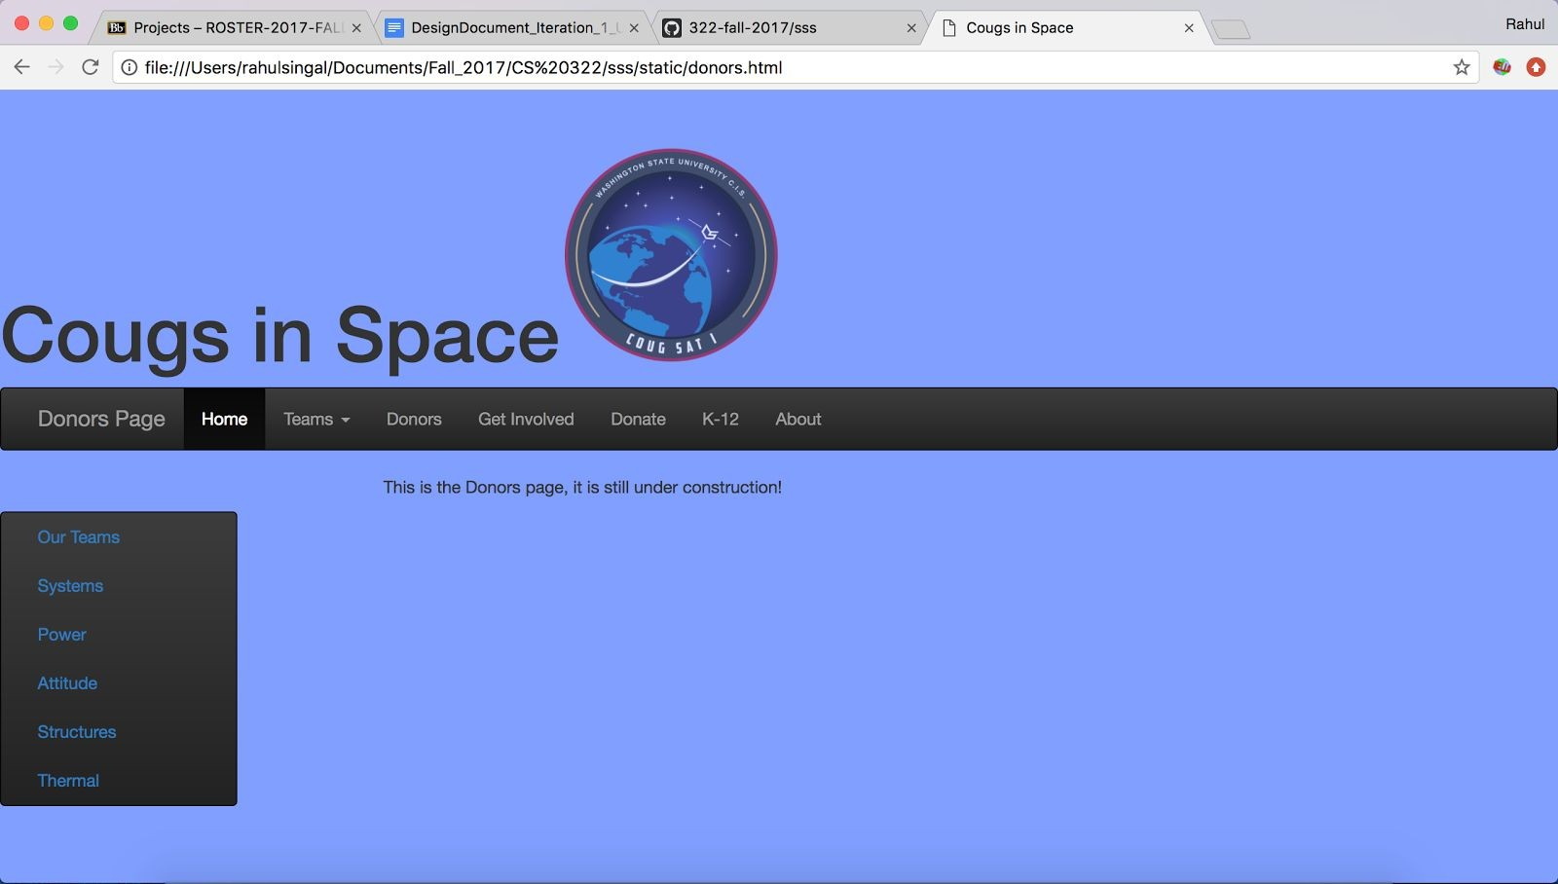

IV. Testing Plan

(starting iteration 2)

In this section goes a brief description of how you plan to test the system. Thought should be given to how mostly automatic testing can be carried out, so as to maximize the limited number of human hours

you will have for testing your system. The effort you put early on automated testing will pay off when you have to ensure that you are not breaking existing functionality in future iterations.

Consider the following kinds of testing:

- Unit Testing: Explain for what modules you plan to write unit tests, and what framework you plan to use.

- Functional Testing: What routes and APIs does your server support that you plan to test? How will you test them? What tools you will use? Will you write mocks?

- UI Testing: How do you plan to test the user interface?

V. References

https://getbootstrap.com/docs/4.0/getting-started/introduction/