EEE088F 2022

Concept Proposal

**Group 33**

**BINA MUKUYAMBA: MKYBIN001**

**LUKHANYO VENA: VNXLUK001**

**MATSOSO LESELI: LSSMAT001**

# Q1 Enviro sensing HAT Concept [5]

The HAT in the our design project is a CO2 detector and Temperature sesnor with an onboard FTDI ic chip. Some scenarios in which the HAT will be mostly used include; Fire Detection where CO2 levels and temperature levels will we monitor and alarm system will be triggered if the levels rise to the extreme. It can also be used in weather station for weather forecasting purposes. It can also be used in a Greenhouse as part of control system to control fans and irrigation according to environmental conditions detected by sensor.

# Q2 Requirements [10]

# Scenario1 (Fire Detection)

* Detect CO2 levels and increase in temperature in the environment
* Trigger alarm/buzzer using 3.3V output
* Run of Rechargeable Lion Battery

## Scenario2 (Greenhouse/ Agricultural)

* Data needs to be stored and compared with some set temperature and CO2 concentration
* Needs to be connected to corresponding control system e.g., turns on sprinklers, fans, alarm
* Needs to measure appropriate range of temperatures and CO2 depending on location and needs to be waterproof.

## Scenario3 (Weather Forecast)

* Measure temperature changes in the environment.
* Detect changes in CO2 levels of the surounding air over time.
* Record of daily range of temperatures.
* Date and time display

# Q3 Project Subsystems Block Diagram [5]

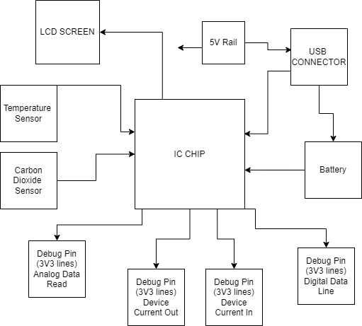

# Q4: Link to Team Git Repo [5]

Repository link: <https://github.com/lukhanyoVena808/EEE3088F_PROJECT>