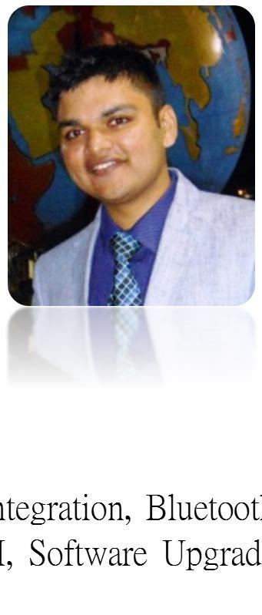**LUKISH YADAV**

Current: Accenture Solutions Pvt Ltd.

E-mail: yadavlukish@gmail.com

Mobile: +91-7083114502

**SKILL SET**



1. Programming Languages: **Python** (OOP and Script), **R** (Programming & Statistical Analysis)
2. ETL Tools: **Ab initio,** Datastage
3. BI & Reporting: Cognos, Qliksense, Framework manager
4. Knowledge of: **Git**, **Machine Learning**, SQL, Shell Scripting, Django, Javascript, JSON, Qlikview, Digital Image Processing, C (Pure & Embedded), Deep learning.

**ABOUT ME**



I have a total experience of 2.5 years in Data Analytics (Code Computations, BI, Reporting & ETL). I am a quick learner, so I am flexible enough to learn new technologies. I have had experiences in Embedded, Data Analytics, Visualization, BI & Reporting etc. during my Graduation & Corporate tenure. Below is my tech-specs reflecting my exposure to different domains till date.

**TECH-SPECS**



1. Cloud Platforms: IBM Bluemix : Watson, NodeRED etc.
2. MDM tools: IBM Cognos Transformer, IBM Cognos Powerplay
3. Built analytical structure for Siebel, BRM & UIM data using Ab initio.
4. Application Systems data: SAP & TES fusion (IDOC, bulk load), Rylson8, MinVu (Open Cut), Minesuite (Underground), SORD.
5. Python Packages (AIML, sklearn, numpy, matplotlib, Pandas, requests, xlrd, xlwt etc), R (Rminer, e1071, ggplot2)
6. Forecasting Systems: PFS (Planning & Forecasting System) => HFM, Ramesys & Flat file
7. Processors & Micro controllers: TMS320F28335, Arduinho, ATxmega 128A1, 8051, PIC16F887
8. Communication Protocols: UART, USART, SPI, I2C
9. Software Packages: MATLAB, Xilinx, Code Composer Studio
10. Emulators & debuggers: JTAG emulator, AVR Dragon kit
11. Digital Audio Workstation: LMMS, Audacity.
12. OS: Windows 7, Windows 10, Unix, Linux
13. Video Editors: Cyber link Power Director 11 & 12.
14. Additional Trainings attended: Talend, Tableau
15. Management experience: Mentoring new hires, Co-ordinating across teams for solutions.

|  |  |
| --- | --- |
| **WORK EXPERIENCE (Accenture Solutions Pvt Ltd.)** | **JUL 2015 TO PRESENT** |
|  |  |

1. **Project Name: Vodafone Newco**  (**JAN-2017 TO PRESENT)**
   1. Developed a Chat-Bot who will be able to give data insights by communicating on functional terms with team members and development planning of chat bot brain to be able to communicate with users not familiar with functional aspect of the project.
   2. Top Product Correction Failures vs correction Success insights using Python Script. (Packages: Pretty Tables, Xlrd, Xlwt)
   3. Vodafone UIM revision impact detection (w.r.t functional flow) using Unix scripting.
   4. Machine Learning Practice: Naïve Bayes Classifier, Anomalous Classifier & Theorizing of Random forest/decision tree based on metrics available.
   5. Retailed Price Indexing and HBB scope creation using Ab Initio. (Siebel & BRM data).
   6. Dashboard development using Qliksense & script modifying the same.
   7. Bill Shock Detection(BSIP) using K-means Clustering and NB/SVM score calculations. (Model In progress)

**2. Project Name: SAFARI (CoalMIS)** (**JUL-2015 TO DEC 2016)**

1. Creation of Datastage jobs for insights & analysis.
2. Multidimensional cube development using IBM Cognos Transformer & Analysis on the same using IBM Cognos Powerplay.
3. System Failure Alert using Datastage (mail & Text) & Automatic Query run automations using Cognos & Python.

Access tracker automation & Parallel Cube builds.

1. Rylson8 duplicate detection using Python Script & data modelling using Cognos Framework manager.
2. SAP Bulk Load detection using Datastage facilitating smooth processing of data (IDOC files) which is to be fed into COALMIS.
3. Coals Sales Forecasting Practice (Machine Learning) using Python (csv, random & math) and R programming (Rminer, e1071). (Naïve Bayes Theorem)

**ACHIEVEMENTS**



1. Accenture Talent Turf winner. (Beatboxing)
2. Dance Competition and skit winner (Best Actor Award) in few competitions
3. Carom Competition winner at Corporate level.
4. Prizes for subject topper and college topper in school as well as junior college.
5. Audition experience of reality shows like BIGBOSS & Dance+

**EDUCATION**



|  |  |  |  |  |
| --- | --- | --- | --- | --- |
| **Year** | **Course** | **Institution** | **Board/University** | **Percentage** |
| 2015 | BE | MIT, Pune | Pune University | 67.79% |
| 2011 | HSC | Amrita Jr. College, Pune | Maharashtra State Board | 87.87% |
| 2009 | SSC | Amrita Vidyalayam, Pune | Maharashtra State Board | 89.38 % |

**PERSONAL DETAILS**



DOB: August 9th 1993

|  |  |  |
| --- | --- | --- |
| Languages Known: English, Hindi and Marathi | | |
|  |  |  |
| Address: Sambhaji Nagar (Thermax Chowk), Chinchwad, Pune | | |