Third_2022

1. Which statements about Unsupervised Machine Learning are true?
Multiple answers are possible!
a. Underfitting means that a model is adapted to special training characteristics such as noisy measurements or outliers.
b. Projection methods project data into a higher-dimensional space while keeping their neighborhoods.
c. The model selection procedure is called "training" or "learning".
d. Examples of unsupervised methods are: PCA, ICA, Factor Analysis, k-means clustering, and mixture models.
e. In parametric models, every parameter (vector) realization represents a model.
f. k-nearest neighbors is a nonparametric model.
g. Generative models do not aim at modeling the data creation process.
h. Unsupervised Machine Learning algorithms learn patterns from unlabeled data

2. EM/Max. entropy
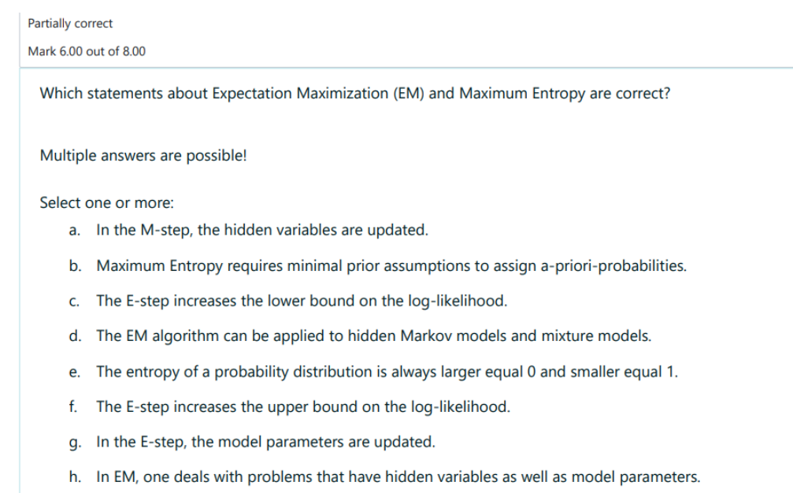

3. PCA
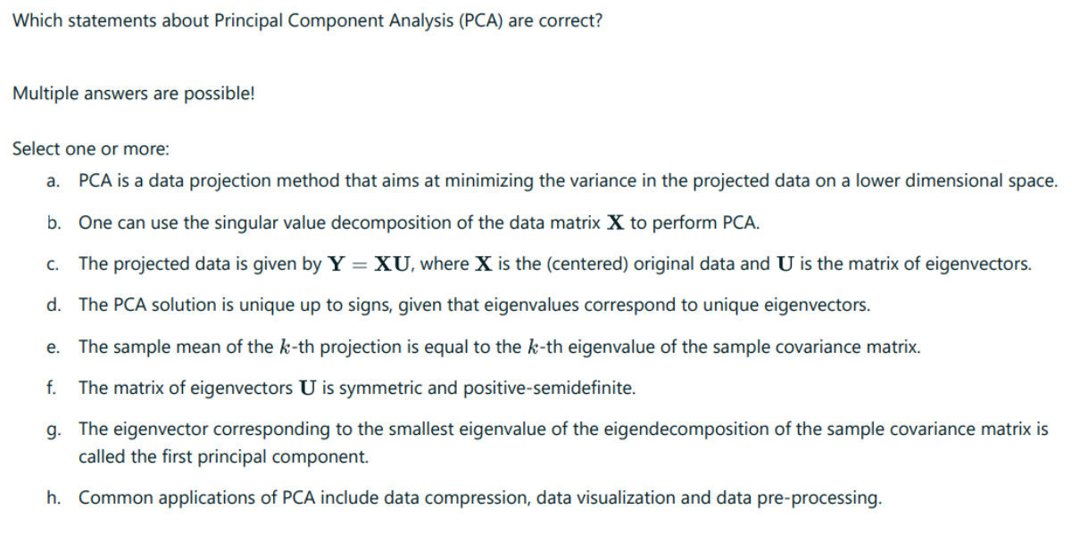

4. calc somethign
(hint: kinda related to kernel PCA)
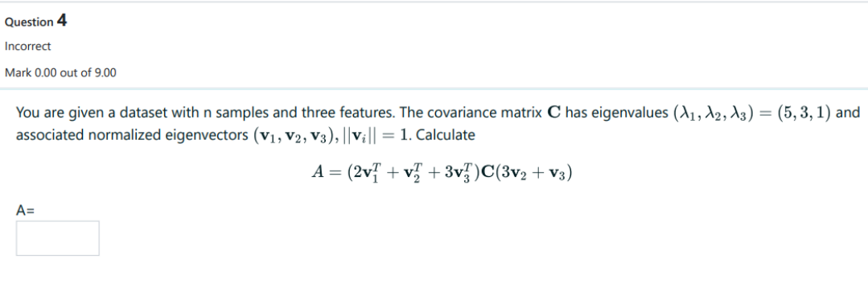
5. Kernel PCA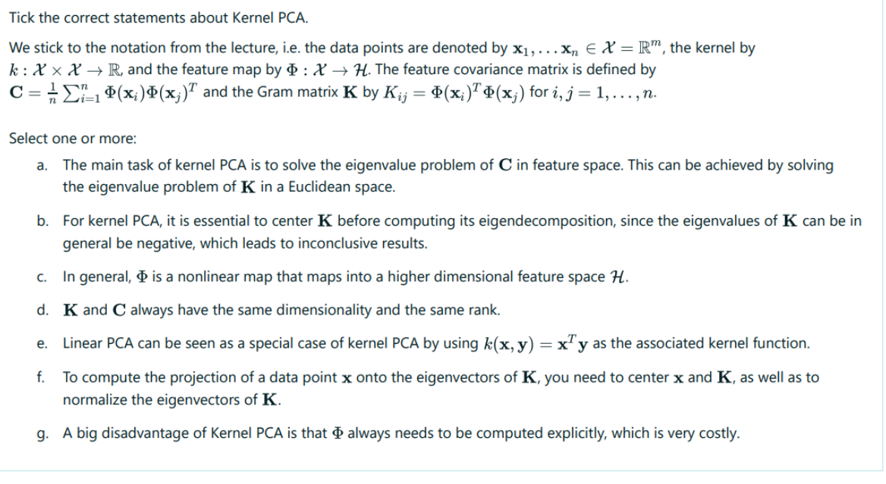

6. ICA
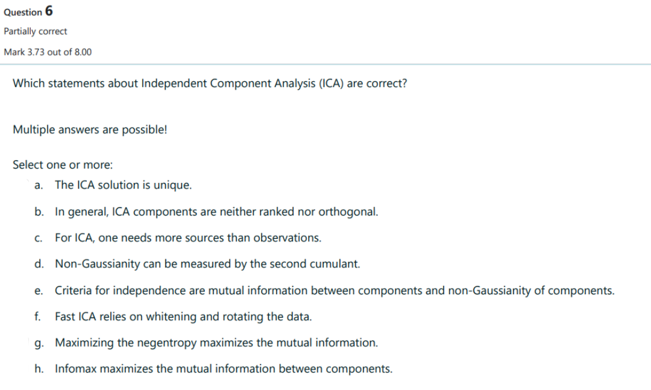

7. Factor analysis
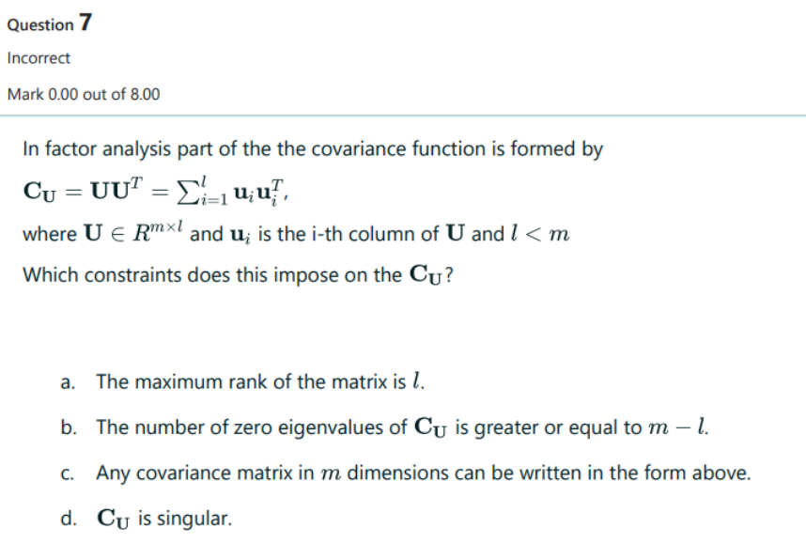

8. Calculate KL divergence
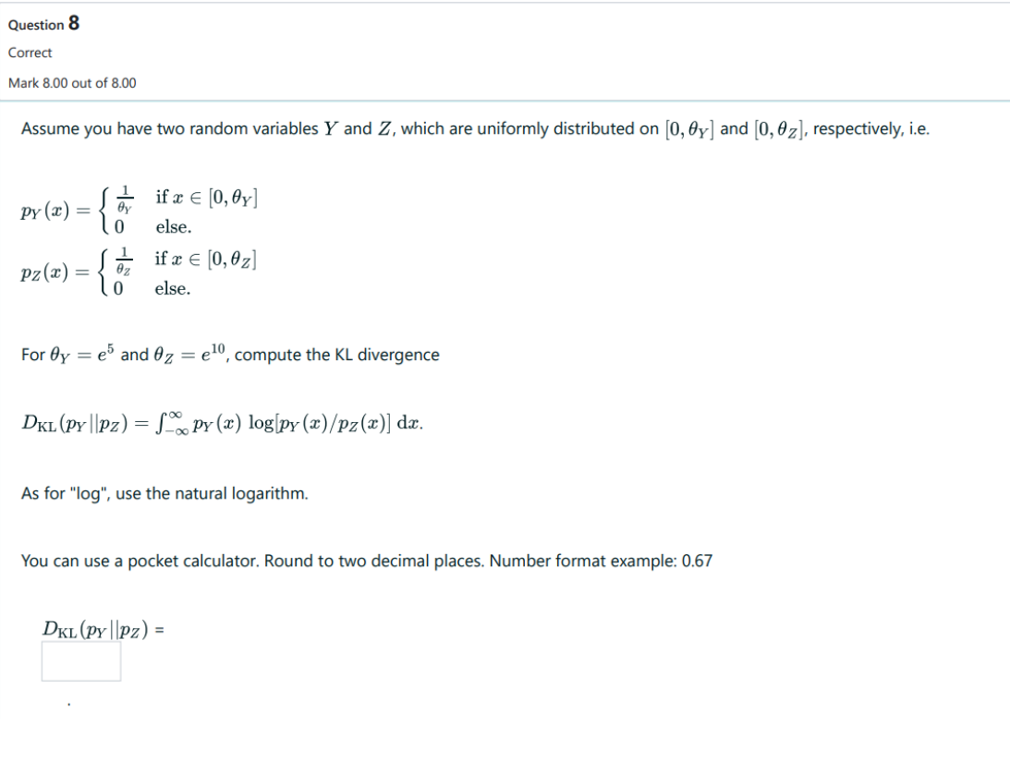

9. t-SNE
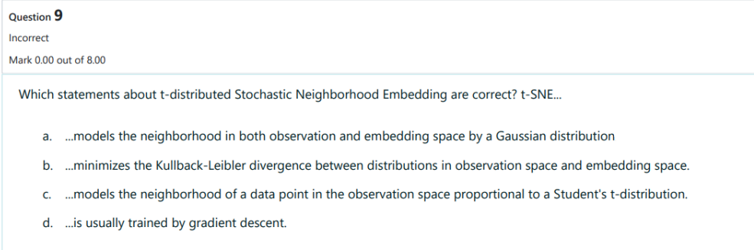

10. k-means
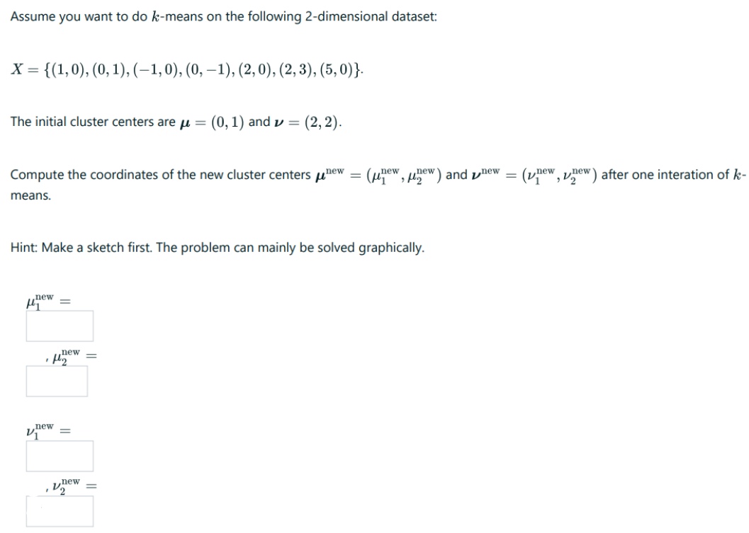

Exam_Part_1_052022

3. Which statements about Parameter Estimation and Maximum Likelihood are true?
Multiple answers are possible!

a. If the data are distributed i.i.d., the likelihood can be written as a product of individual probabilities over the data samples.
b. The likelihood and the log-likelihood are maximized for the same parameter value, and at that parameter value $\hat{w}$, their values coincide: 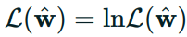.
c. Parameter estimation and the maximum likelihood approach rest on the assumption that the model class is not known and estimated from the data.
d. The maximum likelihood estimator is asymptotically unbiased and efficient, but not asymptotically consistent.
e. The mean squared error can be written as the sum of the variance of the estimator and the squared bias of the estimator.
f. An estimator $\hat{w}$ is unbiased if its expected value (over the training set distribution) equals the true parameter: $E\left(\hat{w}\right)=w$
g. The likelihood 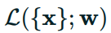 is the probability that the model with parameter $w$ produces the data $\{x\}$
h. The mean squared error is defined as follows: $mse\left(\hat{w}\right)={(\hat{w}-w)}^{T}(\hat{w}-w)$

4. Which statements about Expectation Maximization (EM) and Maximum Entropy are correct?
Multiple answers are possible!:
a. The EM algorithm can be applied to hidden Markov models and mixture models.
b. In the M-step, the model parameters are updated.
c. The E-step increases the upper bound on the log-likelihood.
d. In EM, one deals with problems that have hidden variables as well as model parameters.
e. The entropy of a probability distribution is always larger equal 0 and smaller equal 1.
f. Hidden state models in general have analytical solutions for the likelihood.
g. In the E-step, the hidden variables parameters are updated.
h. The Maximum Entropy approach requires minimal prior assumptions to assign a-priori-probabilities

5. Calculate marginal probabilities, entropies, and mutual information for a joint distribution of 2 variables.
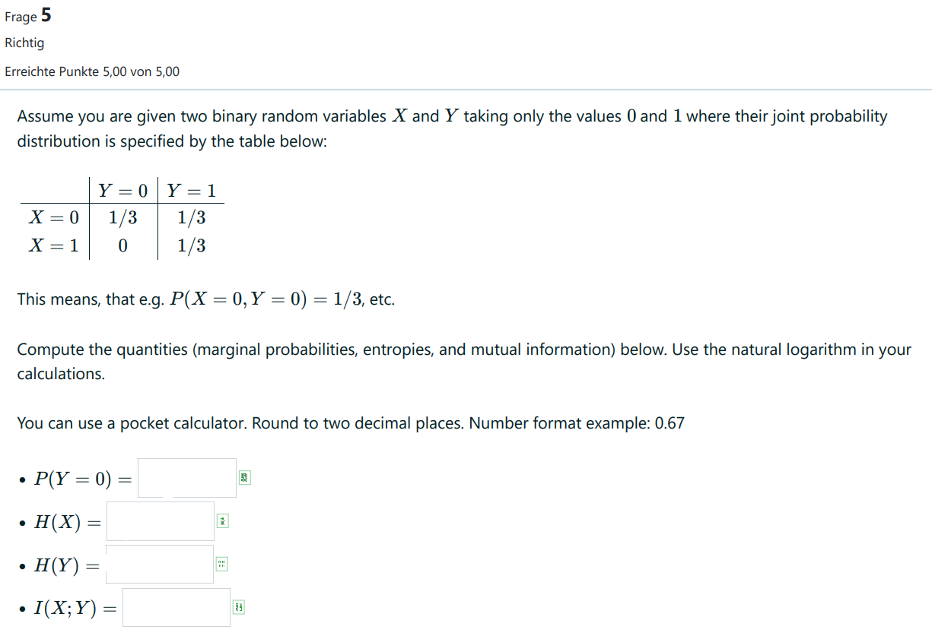

6. PCA
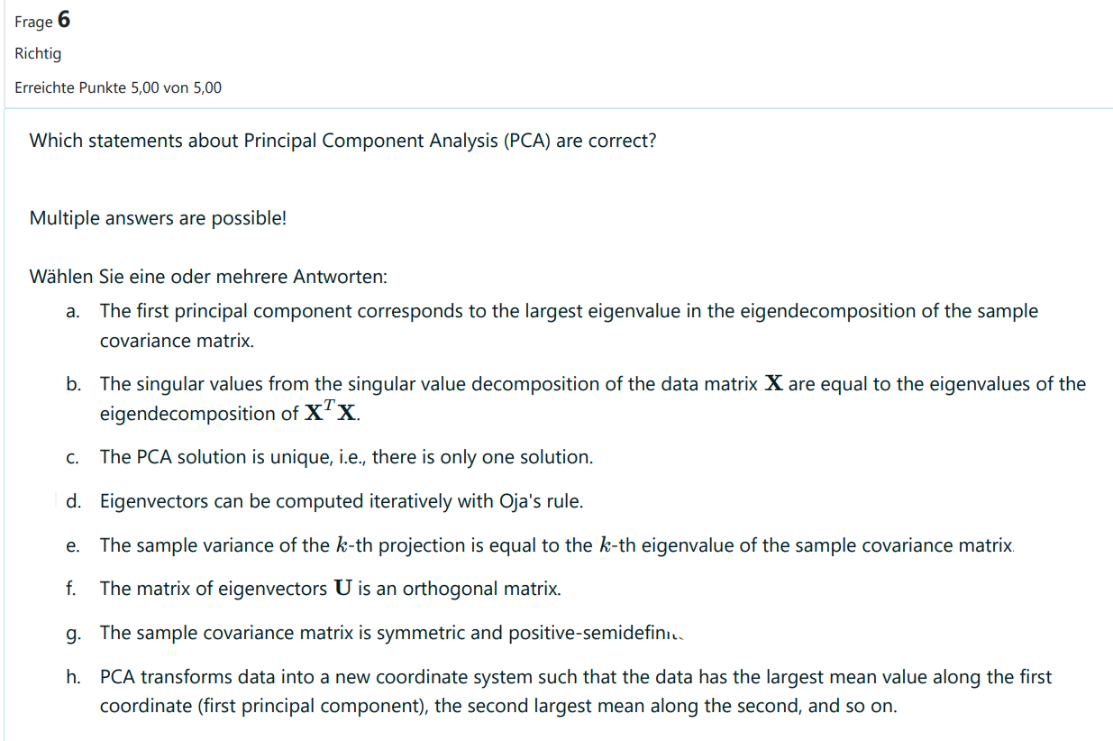

7. PCA calculation
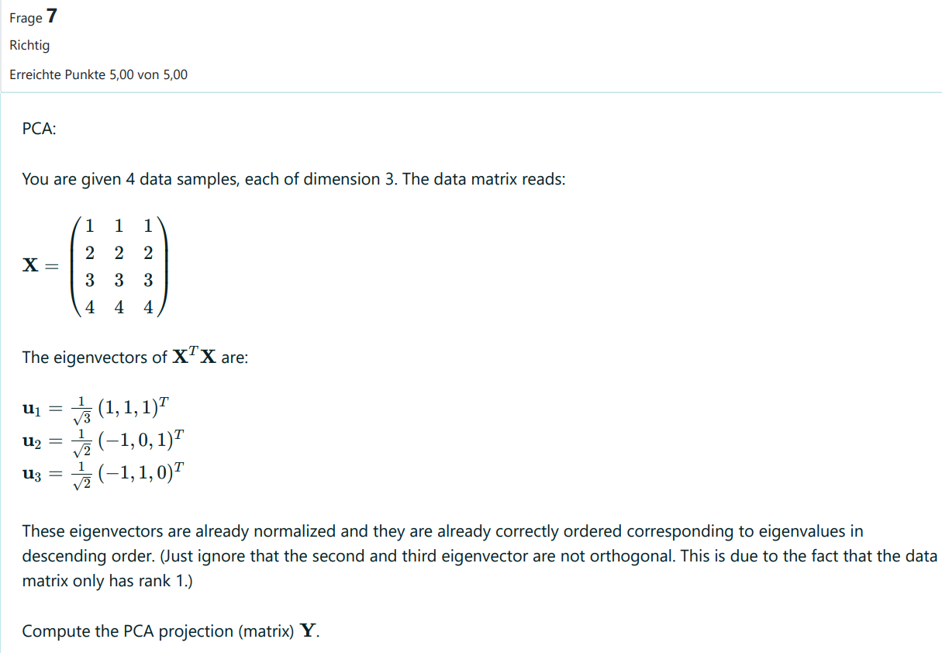
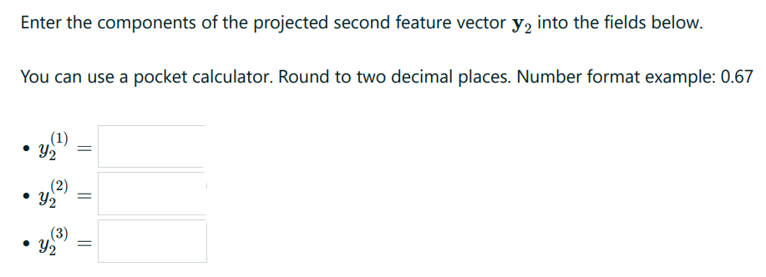

8. Kernel PCA
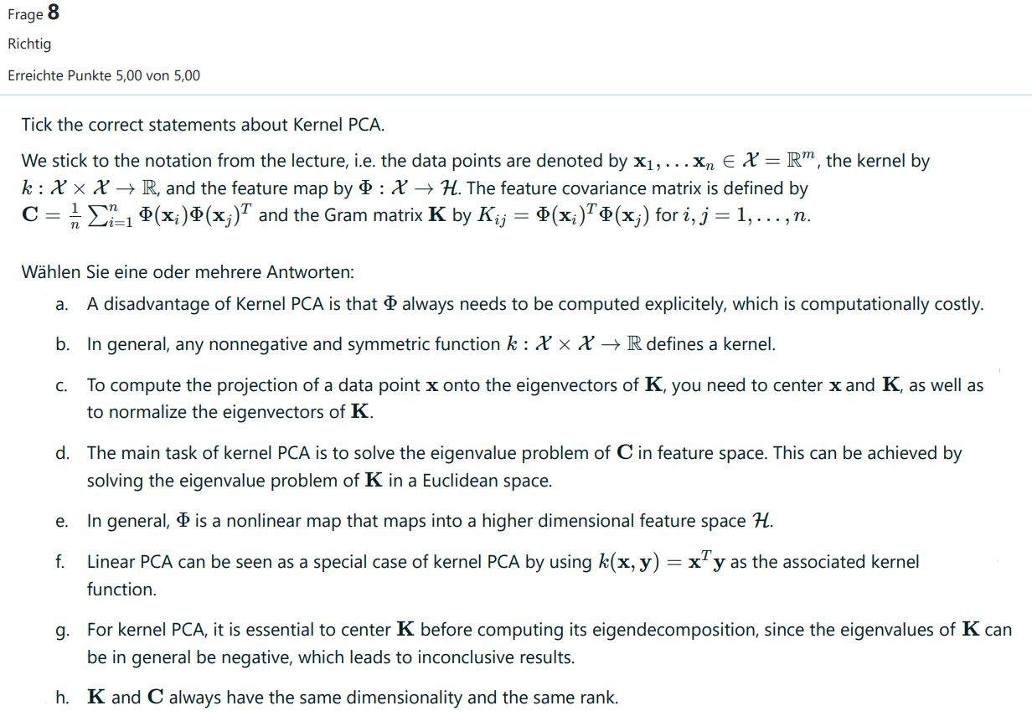

9. ICA
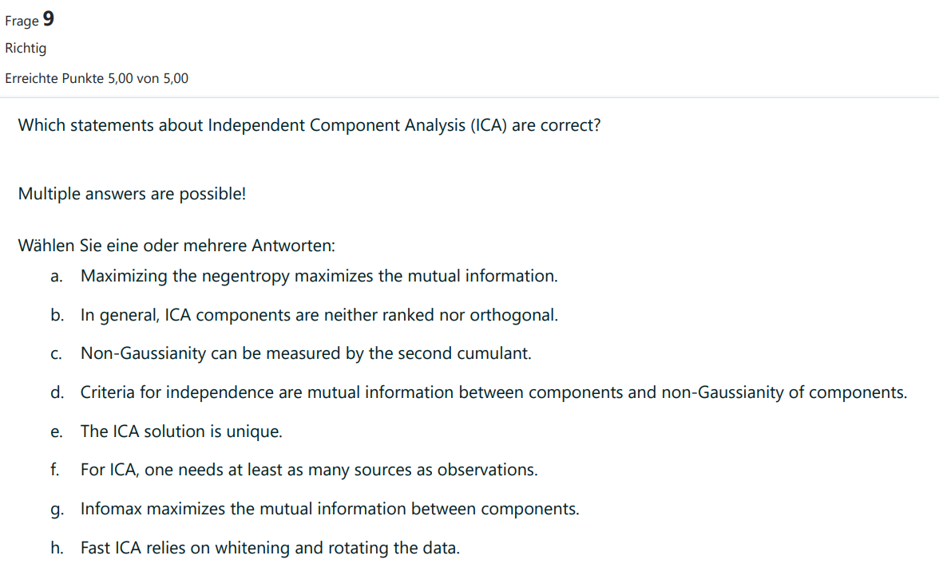

10. ICA/PCA
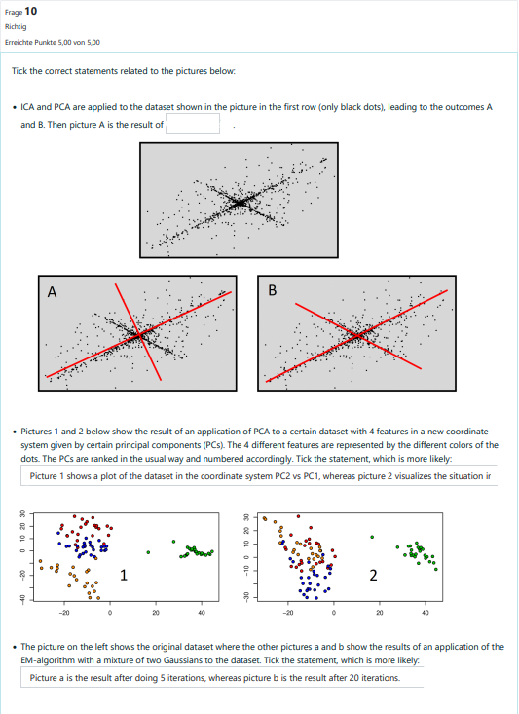
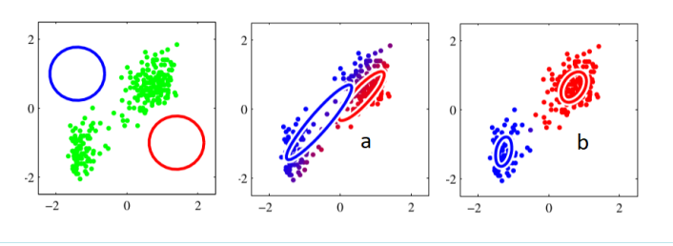

11. Cumulants
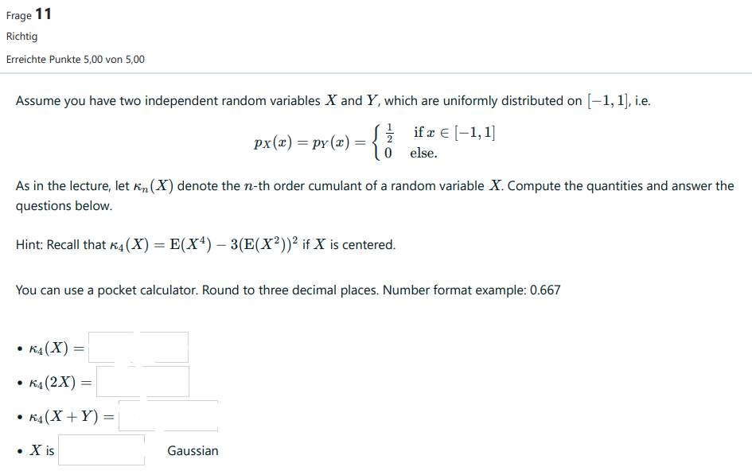

Exam_02_PARTB_2022

Factor analysis
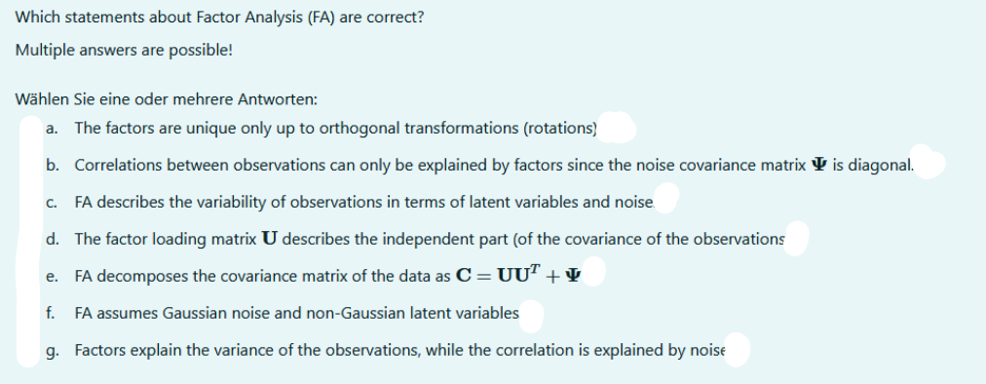

Strange FA
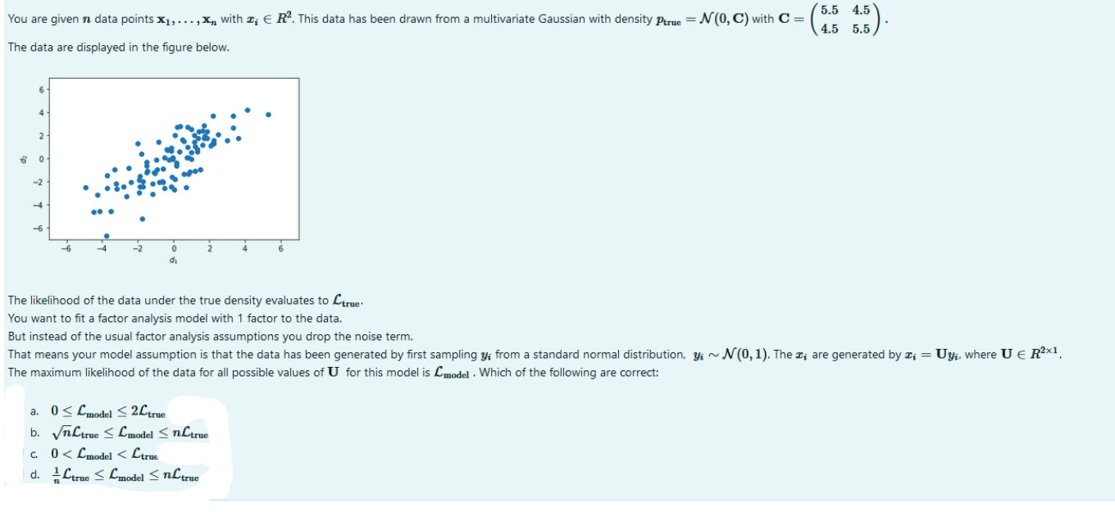

3. projection and scaling methods
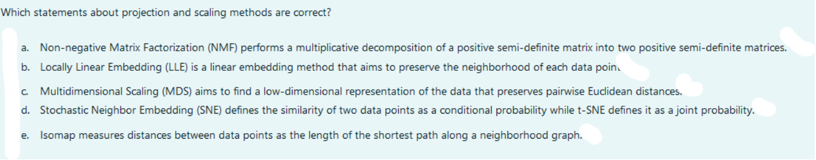

4. t-SNE
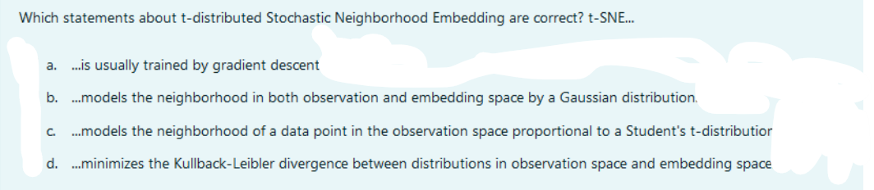

5. Clustering
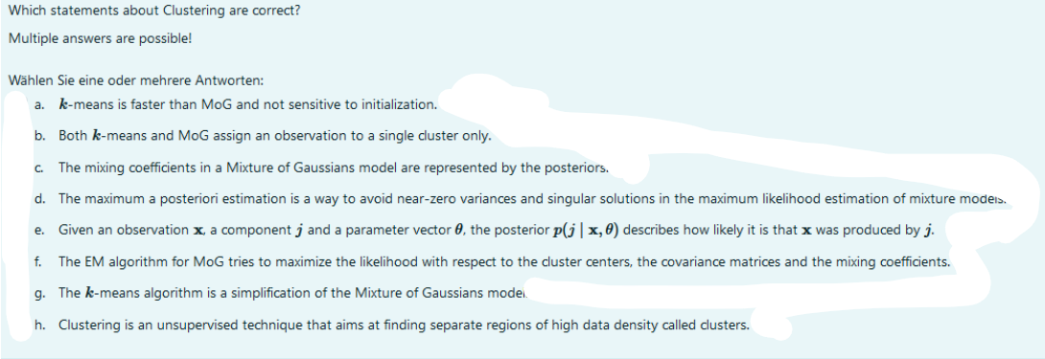

6. Clustering
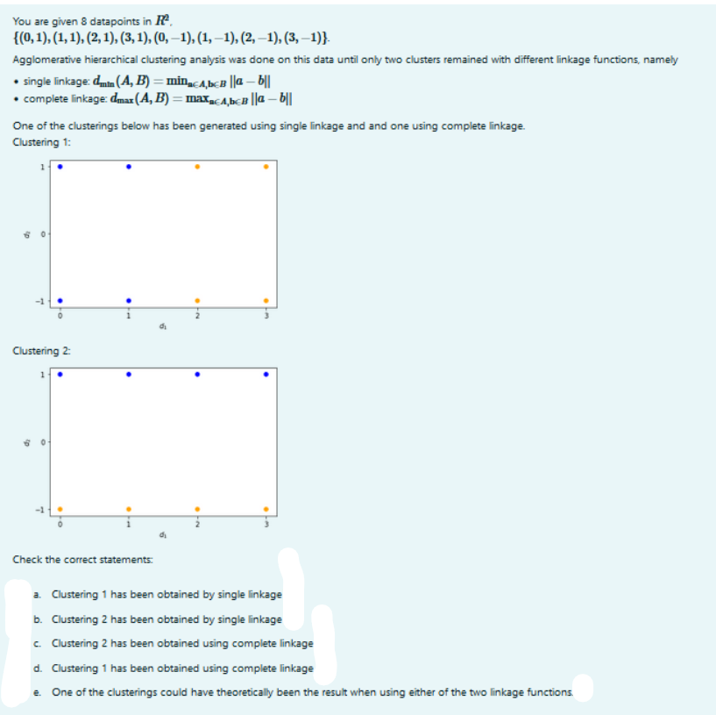

7. GMM (or like they call it, MoG, i.e. Mixture of Gaussians)S
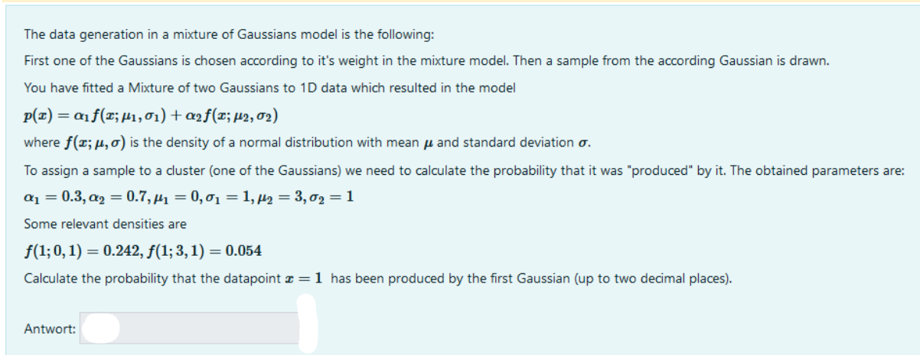

8.Biclustering
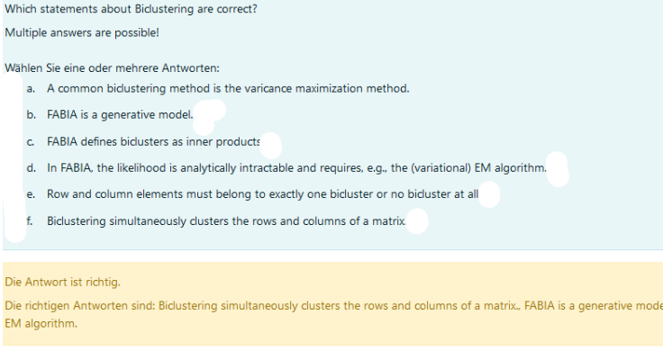

1st_part_27062022
This one was already uploaded unmarked: (see here)

2nd_exam (2021)

Factor analysis
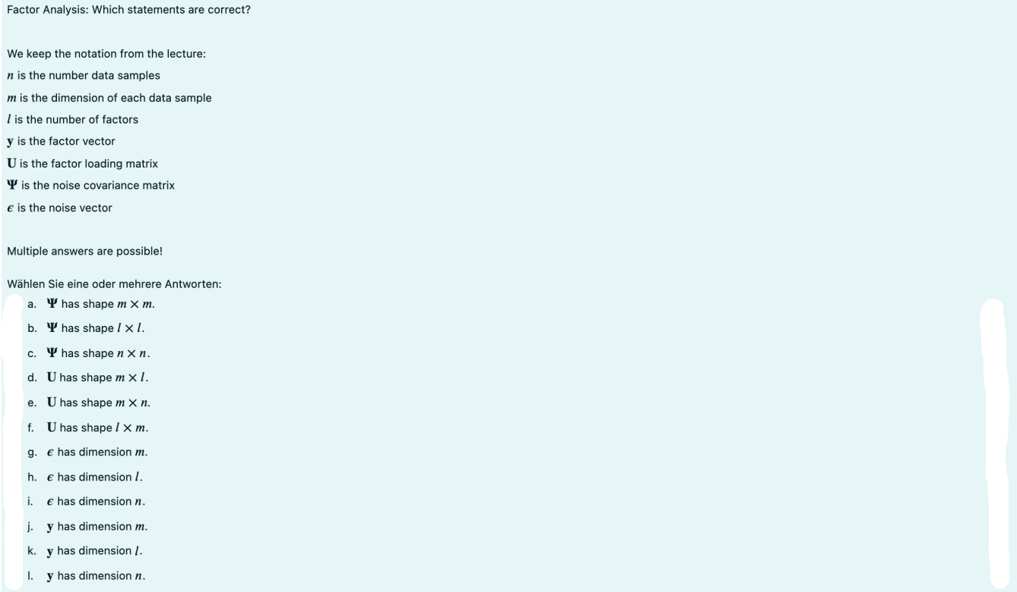

Factor analysis calculation
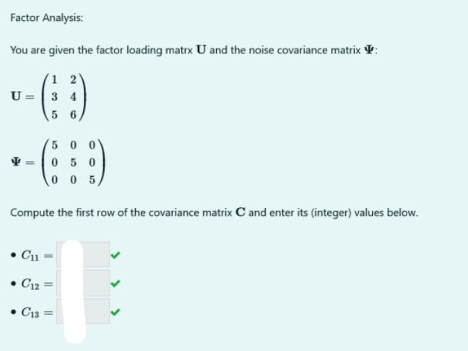

LLE
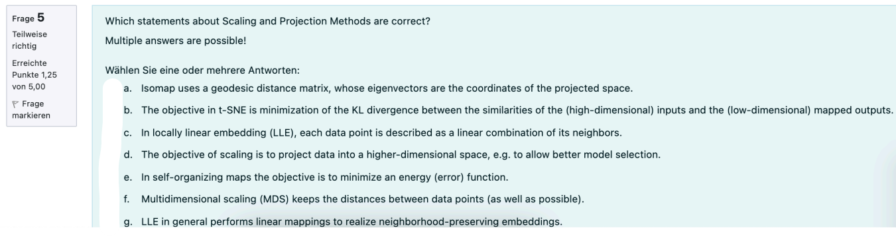

Scaling & projection methods
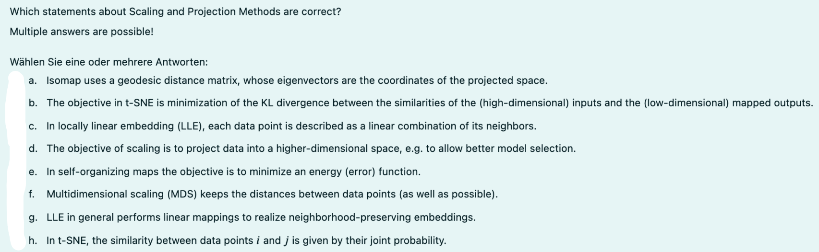

KL divergence
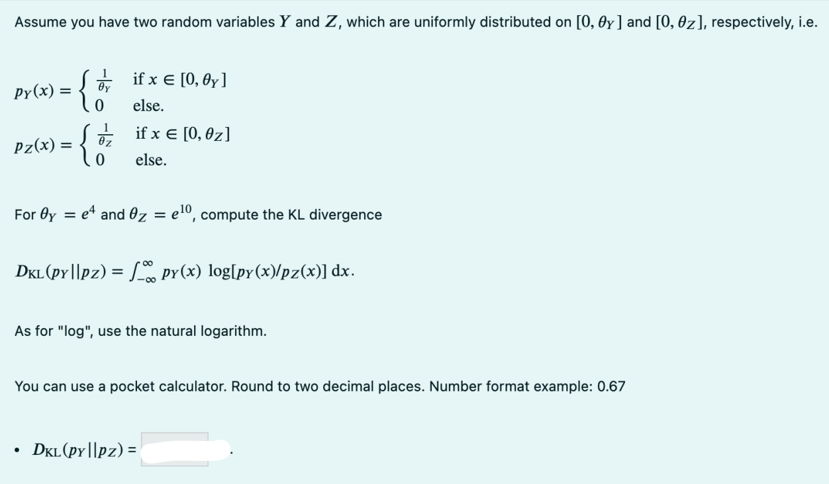

NMF
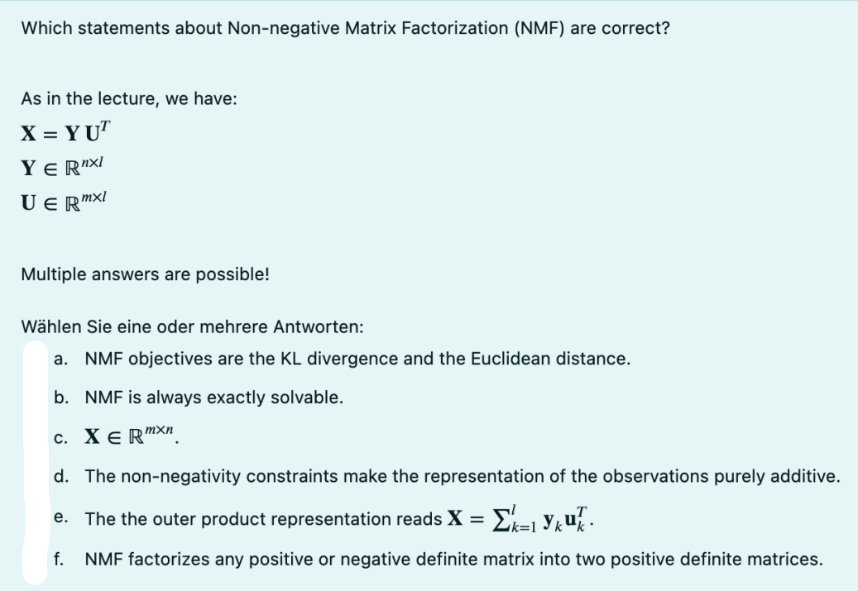

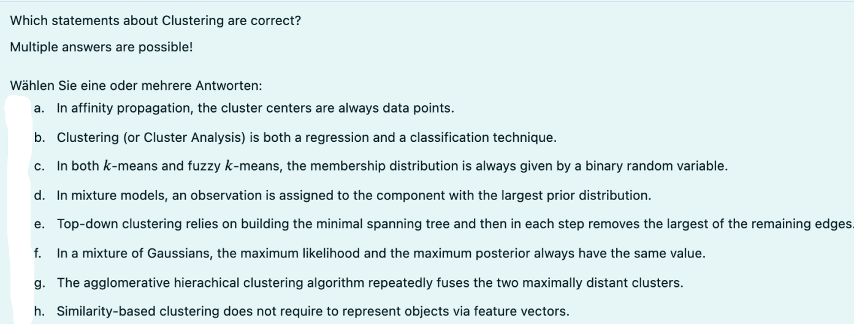
Clustering

Mixture model
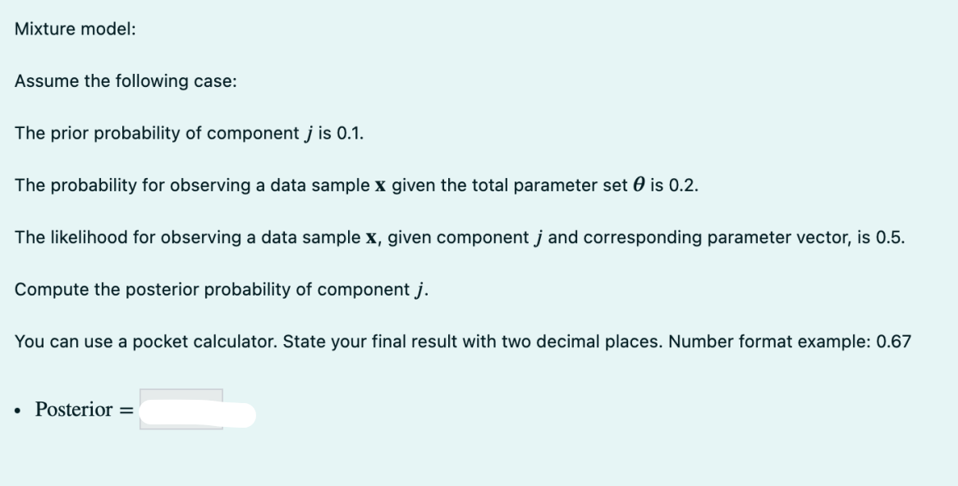

K-means
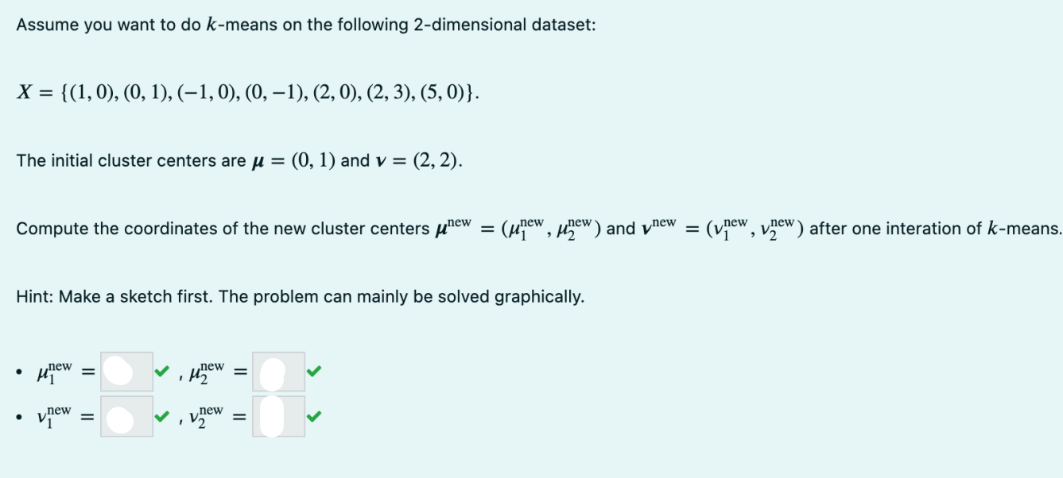

Biclustering
