**Analog oscilloscope.**

Definition:

An oscilloscope is a type of electronic instrument that displays varying electrical voltages as a two-dimensional plot of one or more signals as a function of time. It is widely used in various experiments in order to register change in any physical value that can be viewed as an electric signal. There are two types of oscilloscopes: analog and digital. Analog oscilloscope uses a set of capacitors and a cathode-ray tube (CRT) to display a varying voltage by spraying a stream of electrons on the CRT. In the digital oscilloscope, the signal is digitalized by the analog-to-digital converter (ADC) first, and then stored and displayed via the computer. An analog oscilloscope will be described in this text.

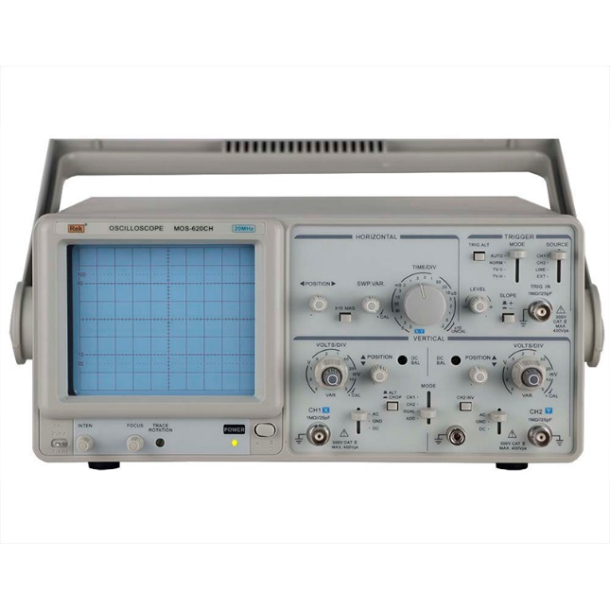

Structural parts:

There are four parts to an analog oscilloscope i.e. the display, vertical controls, horizontal controls and trigger controls.

* The **display** of the oscilloscope is the fluorescent-coated part of the tube, on which the electronic beam is applied.
* The **vertical section** controls the amplitude of the applied signal. This section has a Volts/Div. selector knob, an AC/DC/Ground selector switch, and the input for the instrument. It’s also often equipped with the vertical beam position knob.
* The **horizontal section** controls the time base of the oscilloscope. It is done via the Sec/Div. selector switch. The switch also includes X-Y mode for plotting dual signals if needed.
* The **trigger section** is mainly used to control the beginning phase of the displayed signal. It also may be used to switch between different sweep modes for the oscilloscope.

Parts of the CRT:

1. Heater (1), cathode (2) and two anodes (4 and 5) all create a stream of electrons that will be further displayed on the screen. The heater and the cathode allow electrons to escape the wire, while anodes 4 and 5 focus electrons in a beam and accelerate it.
2. Horizontal (7) and vertical (6) capacitors create an alternating EMF that makes the passing electrons change direction, which creates some kind of an image on the screen (9). Another capacitor (8) accelerates the electrons to help them get to the screen. The image usually resembles a sine wave, although it depends on the source of the signal.

