# Homework M1: Infrastructure as Code

Main goal is to build further on what was demonstrated during the practice

## Tasks

We have a project used to build a set of two container images:

* Project: <https://github.com/shekeriev/bgapp>
* Image 1: <https://github.docker.com/repository/docker/shekeriev/bgapp-web>
* Image 2: <https://github.docker.com/repository/docker/shekeriev/bgapp-db>

Utilizing what was discussed and shown during the lecture, try to do the following:

1. Create a **Terraform** configuration to build a small containerized application in **Docker** by using the two images. You must provide the containers with connectivity and depending on the approach to mount the **web** folder. For details, check the information in the repository
2. Using the files (**SQL** and **PHP**) from the project, create a **Terraform** configuration for building a small infrastructure with two VMs (one for the DB part, and another for the WEB part) either in a cloud platform (for example, **AWS**, **Azure**, **GCP**, etc.) or in on-premises hypervisor (for example, **Hyper-V**, **KVM**, etc.)

*(1) Please note that you can do either one of the tasks or all of them. Whichever you choose, your submission will be accepted, and you will be eligible to receive the corresponding amount of homework points*

*(2) The “official” solution will contain solutions to both tasks. For task 2, the solution will contain information for AWS and KVM*

## Proof

Prepare a document that show what you accomplished and how you did it. It can include (not limited to):

1. The commands you used to achieve the above tasks
2. Any configuration files produced while solving the tasks
3. A few pictures showing intermediary steps or results

## Solution

## Task 1

1. Navigate to folder Task 1 and exec “**vagrant up**”
2. Create file **main.tf**

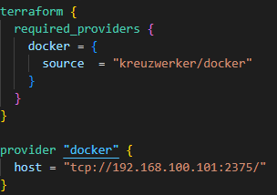

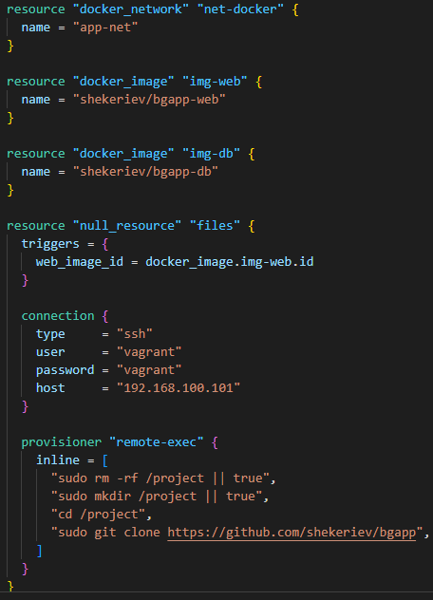

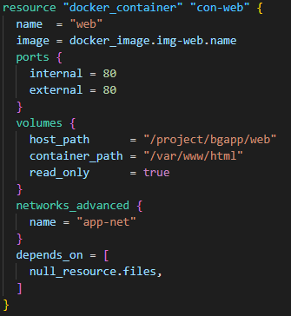

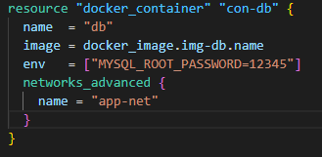

1. **terraform init**
2. **terraform validate**
3. **terraform plan**
4. **terraform apply**

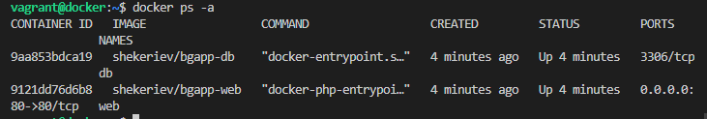

1. Open your browser and navigate to [**http://192.168.100.101**](http://192.168.100.101)

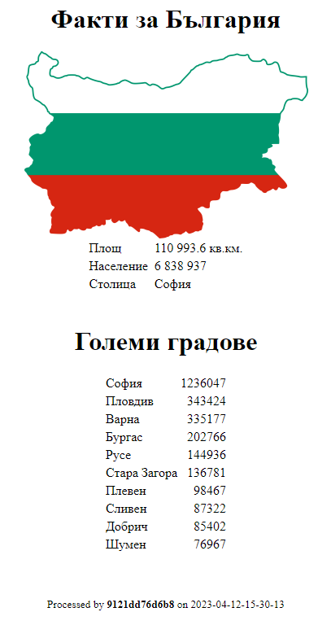

## Task 2

1. Navigate to folder Task 2 and exec “**vagrant up**”
2. Create files **web.sh** and **db.sh**

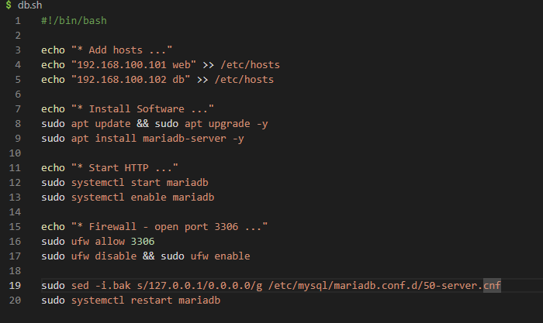

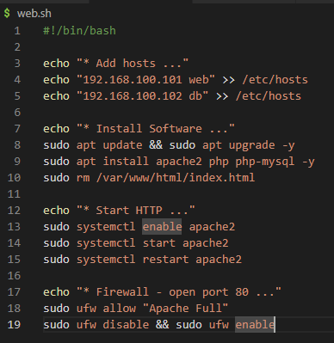

1. Go in folder “**./web”**
2. Create file **main.tf**

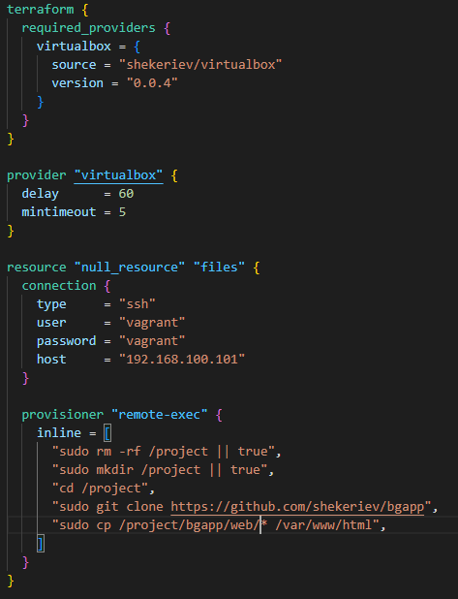

1. **terraform init**
2. **terraform validate**
3. **terraform plan**
4. **terraform apply**
5. Go in folder “**./db”**
6. Create file **main.tf**

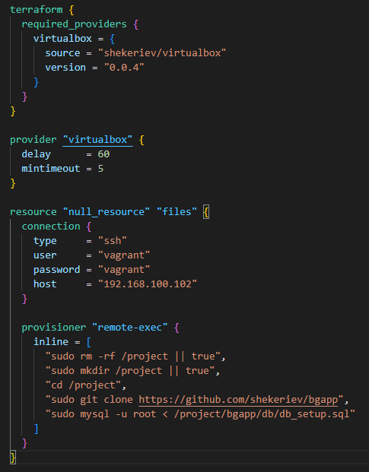

1. **terraform init**
2. **terraform validate**
3. **terraform plan**
4. **terraform apply**
5. Open your browser and navigate to [**http://192.168.100.101**](http://192.168.100.101)

