# Homework M2: Ansible

## Assignment

You must execute the following set of tasks:

1. With the help of **Ansible** and **Vagrant** create **Docker** host and run a **nginx** container in it

You can use a role downloaded from **Ansible Galaxy**, or create the playbook all by yourself

1. With the help of **Ansible** and **Vagrant** create a two-host setup:
   * One of the hosts should be based on **Debian**/**Ubuntu** and the other one – on **CentOS**
   * Both hosts should see each other in terms of network communication. Their names should be **web** and **db**
   * One of the hosts should play the role of **WEB** server with web solution of your choice and **PHP** installed and the other one – **DB** server with **MySQL**/**MariaDB** installed
   * On the **WEB** host deploy the content of the **web** folder in **M2-Homework-Challenge-Ansible (files).zip** archive and on the other – the content of the **db** folder from the same archive

Please note that the two tasks are two separate environments

Even though we should try to automate repetitive tasks as much as possible, the emphasis here is to have a working solution and not a fully automated one. Functionality over automation 😉

## Solution

**Task 1**

1. Vagrantfile
2. playbook.yml
3. requirements.yml
4. Navigate to folder and exec **vagrant up**
5. Open in your browser <http://192.168.100.101>

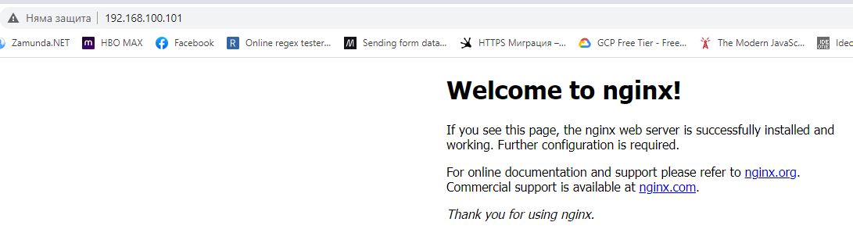

**Task 2**

1. Vagrantfile
2. db/playbook.yml
3. db/requirements.yml
4. db/db_setup.sql
5. web/playbook.yml
6. web/requirements.yml
7. web/bulgaria-map.png
8. web/index.php
9. Navigate to folder where is Vagrantfile and exec **vagrant up**
10. Open in your browser <http://192.168.100.101>

