# Homework M4: Chef

## Assignment

You must execute **either** of the following set of tasks or both:

1. With the help of **Chef** and **Vagrant** create **Docker** host and run a **nginx** container in it
2. With the help of **Chef** and **Vagrant** create a two-host setup *(Chef could be installed on one of the machines)*:
   * One of the hosts should be based on **Debian**/**Ubuntu** and the other one – on **CentOS**
   * Both hosts should see each other in terms of network communication. Their names should be **web** and **db**
   * One of the hosts should play the role of **WEB** server with web solution of your choice and **PHP** installed and the other one – **DB** server with **MySQL**/**MariaDB** installed
   * On the **WEB** host deploy the content of the **web** folder in **M4-Homework-Challenge-Chef (files).zip** archive and on the other – the content of the **db** folder from the same archive

Please note that the two tasks are two separate environments

Even though we should try to automate repetitive tasks as much as possible, the emphasis here is to have a working solution and not a fully automated one. Functionality over automation 😉

## Solution

### Task 1

1. **Vagrantfile (it’s work with 2048 MB RAM)**
2. If you use **Vagrantfile1 (you will need 3072 MB free RAM)** you need to create **install.sh**, if not skip this step.
3. **solo.json** – only for Vagrantfile1
4. **solo.rb** – only for Vagrantfile1
5. **./cookbooks/docker/\*** (this is docker cookbooks and you need him if you use Vagrantfile, if not skip this step)
   1. **knife supermarket download docker**
   2. **tar xzvf docker-10.4.8.tar.gz**
6. **./cookbooks/test/metadata.rb**
7. **./cookbooks/test/recipes/default.rb**
8. **vagrant up**
9. Open your browser and go to [**http://192.168.100.201:8080**](http://192.168.100.201:8080)

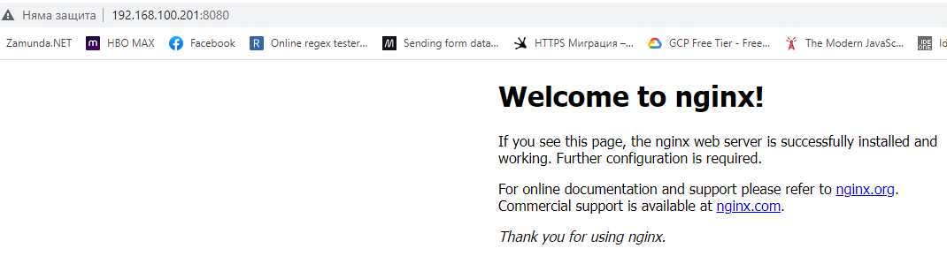

### Task 2

1. **Vagrantfile**
2. **./cookbooks/firewalld/\***
   1. **knife supermarket download firewalld**
   2. **tar xzvf firewalld*.gz**
3. **./cookbooks/selinux/\***
   1. **knife supermarket download selinux**
   2. **tar xzvf selinux*.gz**
4. **./cookbooks/web/metadata.rb**
5. **./cookbooks/web/recipes/default.rb**
6. **./cookbooks/web/files/\***
7. **./cookbooks/db/metadata.rb**
8. **./cookbooks/db/recipes/default.rb**
9. **./cookbooks/db/files/\***
10. **vagrant up**
11. Open your browser and go to [**http://192.168.100.201**](http://192.168.100.201)

