# Homework M7: RabbitMQ

## Assignment

You are expected to execute the following:

1. Create a **single machine** with **Docker** installed
   * Create a **three node** **RabbitMQ** cluster
   * Add a policy to distribute/replicate queues to all nodes
   * Run the last example (Topics) either on the command line on the Docker host or as containers
     1. One producer
     2. One consumer subscribed to all warn and crit messages
     3. One consumer subscribed to all ram related messages
   * Deploy **Prometheus** as container and make it collect metrics for all three nodes of the cluster
   * Deploy **Grafana** as container and add Prometheus as a data source
   * Prepare at least one visualization to display any of the metrics exposed by the nodes

Even though we should try to automate repetitive tasks as much as possible, the emphasis here is to have a working solution and not a fully automated one. Functionality over automation 😉

## Solution

1. Vagrantfile
2. datasource.yml
3. prometheus.yml
4. ./apps/emit_log_topic.py
5. ./apps/recv_log_topic.py
6. vagrant up
7. Open in your browser <http://192.168.100.201:9090> for Prometheus or <http://192.168.100.201:3000> for Grafana

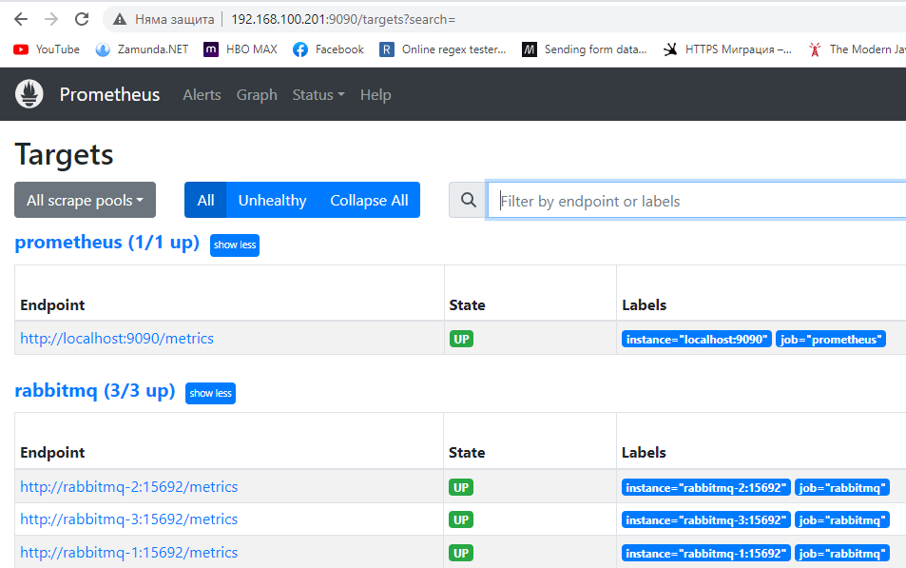

For Grafana you need to create dashboard

