# Exam: DevOps #1 2023.01 (2023.03.26)

### Main goal

You are expected to utilize all or most of the studied products and technologies and create an infrastructure with **three** hosts. Their parameters are up to you to decide *(considering your free resources and the actual distribution of components)*

The goal is to have the whole **infrastructure** as a **file** or **set** of **files**. Then on top of it to create an **automated** **build** **process** which will wait for a hook call by the **source control system** and if there is a change in the project then all related images should be **re-build** and **re-run**

Your solution should look like and follow this structure:

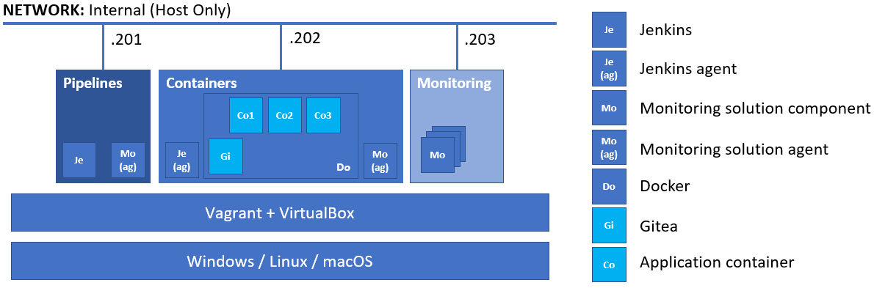

**All** **hosts** should be **provisioned** and **configured** in an automated fashion by utilizing **both** **Vagrant** and **bash** scripts

The **emphasis** should be on **features** usage **demonstration** versus optimal solution

### Rules

Be sure to **follow** the **naming** **conventions** specified in the checklist and in project source files

The tasks execution order should not be derived from the order in which they are listed below. Please note that there are tasks that depend on the successful completion of one or more other tasks

### Proof

You are expected to prepare a short document that outlines the steps you did. It should include all major milestones

If there are any manual steps, you **must** describe them in a free form *(including commands if any)* in the document

Don’t forget to include **some pictures** of the important *(according to you)* steps and of the **result** *(at least the* ***visualizations****, the* ***working application*** *in* ***test*** *and* ***production*** *mode, and pictures of the* ***pipeline****)* as well

There **should be pictures** (one or more) for **all tasks** that are shown like this **(T202, 3 pts)** at least. The **current date and time** **should be visible** on all the pictures

The document, together with all supporting files *(outputs, pictures, configuration files and scripts)*, should be stored in a compressed archive *(32 MB max)* and uploaded not later than **13:30** to:

<https://softuni.bg/trainings/4036/devops-containerization-ci-cd-monitoring-january-2023#lesson-51091>

### Tasks

#### Infrastructure (9 pts)

*You are expected to demonstrate knowledge working with* ***Vagrant*** *and* ***VirtualBox***

* (T101, 2 pts) Infrastructure with **three** machines each with a dedicated role
* (T102, 1 pts) All virtual machines named according to the following convention – ***role*.do1.exam**. Where ***role*** is one of ***pipelines***, ***containers***, and ***monitoring***. For example, the machine on which **Jenkins** will run, should be named ***pipelines.do1.exam***
* (T103, 1 pts) All hosts in a dedicated network of your choice. For example, this could be ***192.168.111.0/24***
* (T104, 1 pts) All hosts should have **the last octet** in their address set according **to the picture above**
* (T105, 4 pts) At least one host provisioned with the help of **Vagrant** and **shell** *(inline or external)* **script**

#### Source Control (8 pts)

*You are expected to demonstrate knowledge working with* ***Gitea****. On the picture it is displayed as* ***Gi****. It is expected that* ***Gitea*** *is run as a container*

* (T201, 2 pts) Installed and working **Gitea**
* **(T202, 3 pts)** Local project named **exam**, copied from [**https://github.com/shekeriev/fun-facts**](https://github.com/shekeriev/fun-facts)
* **(T203, 3 pts)** Configured and tested web hook to **Jenkins**

#### Pipelines (19 pts)

*You are expected to demonstrate knowledge working with* ***Jenkins****. On the picture it is displayed as* ***Je***

* (T301, 3 pts) Working base installation of **Jenkins** with configured administrator user
* **(T302, 1 pts)** Additional (at least one) plugin(s) installed and enabled
* **(T303, 1 pts)** Added credentials for the **vagrant** user
* **(T304, 1 pts)** Added credentials for **Docker Hub**
* **(T305, 2 pts)** Added slave (agent) node (the **Docker** host). *On the picture it is displayed as* ***Je (ag)***
* (T306, 10 pts) А pipeline that has the following stages:
  + (T306.1, 1 pts) gets the project code from **Gitea**
  + (T306.2, 2 pts) **builds** the images
  + (T306.3, 2 pts) **runs** the application in **test mode** *(the* ***front-end component*** *published on* ***port 8080****)*
  + (T306.4, 2 pts) **tests** if the front-end is **reachable** *(execute a simple check)*
  + (T306.5, 1 pts) **publishes** the images to **Docker Hub** *(in your own account)*
  + (T306.6, 2 pts) **deploys** the application in **production mode** *(the* ***front-end component*** *published on* ***port 80****)* out of the published images *(the ones that are in your Docker Hub)*
* **(T307, 1 pts)** The pipeline should be triggered via a webhook

*Once done, you should commit a few changes (change the contents of the* ***client/code/app.dat*** *file) to prove the whole pipeline + source control setup is working*

#### Monitoring (16 pts)

*You are expected to demonstrate knowledge working with either* ***Prometheus*** *+* ***Grafana*** *or* ***Elastic Stack*** *(****Elasticsearch****,* ***Logstash****, and* ***Kibana****) On the picture it is displayed as* ***Mo***

* (T401, 5 pts) Working base installation of all components of the chosen monitoring solution
* (T402, 3 pts) Deployed monitoring agent *(extractor or beat)* on the **Jenkins** and **Docker** nodes that will load data to the monitoring solution. It should produce data for CPU, RAM, Disk, etc.
* (T403, 3 pts) Capture the containers metric of Docker *(either via agent or by configuring the daemon)*
* **(T404, 1 pts)** One **visualization** that shows the **CPU load** of the monitored hosts, based on the collected information
* **(T405, 1 pts)** One **visualization** that shows the **RAM utilization** of the monitored hosts, based on the collected information
* **(T406, 1 pts)** One **visualization** that shows the **number of containers** *(any state – running, paused, etc.)* on the Docker host, based on the collected information
* **(T407, 2 pts)** A **dashboard** that includes **all three visualizations**

#### Containers (8 pts)

*You are expected to demonstrate knowledge working with* ***Docker****. On the picture it is displayed as* ***Do***

* (T501, 1 pts) Create a dedicated network (**exam-net**) for the containers *(either as part of the pipeline or not)*
* (T502, 1 pts) Attach the containers (**Co1**, **Co2**, and **Co3**) to the dedicated network (**exam-net**)
* **(T503, 3 pts)** Working containerized application in **test mode** as expected *(for a valid and expected output, check the repository you cloned earlier)*
* **(T504, 3 pts)** Working containerized application in **production mode** as expected *(for a valid and expected output, check the repository you cloned earlier)*

#### Solution

1. Vagrantfile
2. add_hosts.sh
3. node_exporter.sh
4. install_jenkins.sh
5. install_docker_debian.sh
6. gitea.sh
7. jenkins/credentials.xml
8. nodes/docker/config.xml
9. grafana/provisioning/datasources/datasource.yml
10. docker-compose-monitoring.yml
11. docker-compose.yml
12. docker.json
13. plugins.txt
14. pipeline.txt
15. Navigate to project folder and execute **vagrant up**
16. Open in your browser <http://192.168.100.201:8080/> and log in using username **jenkins** with password **jenkins**
17. Navigate to “[Управление на Jenkins](http://192.168.100.201:8080/manage/)” -> “[Управление на приставки](http://192.168.100.201:8080/manage/pluginManager/)” -> “Installed plugins”

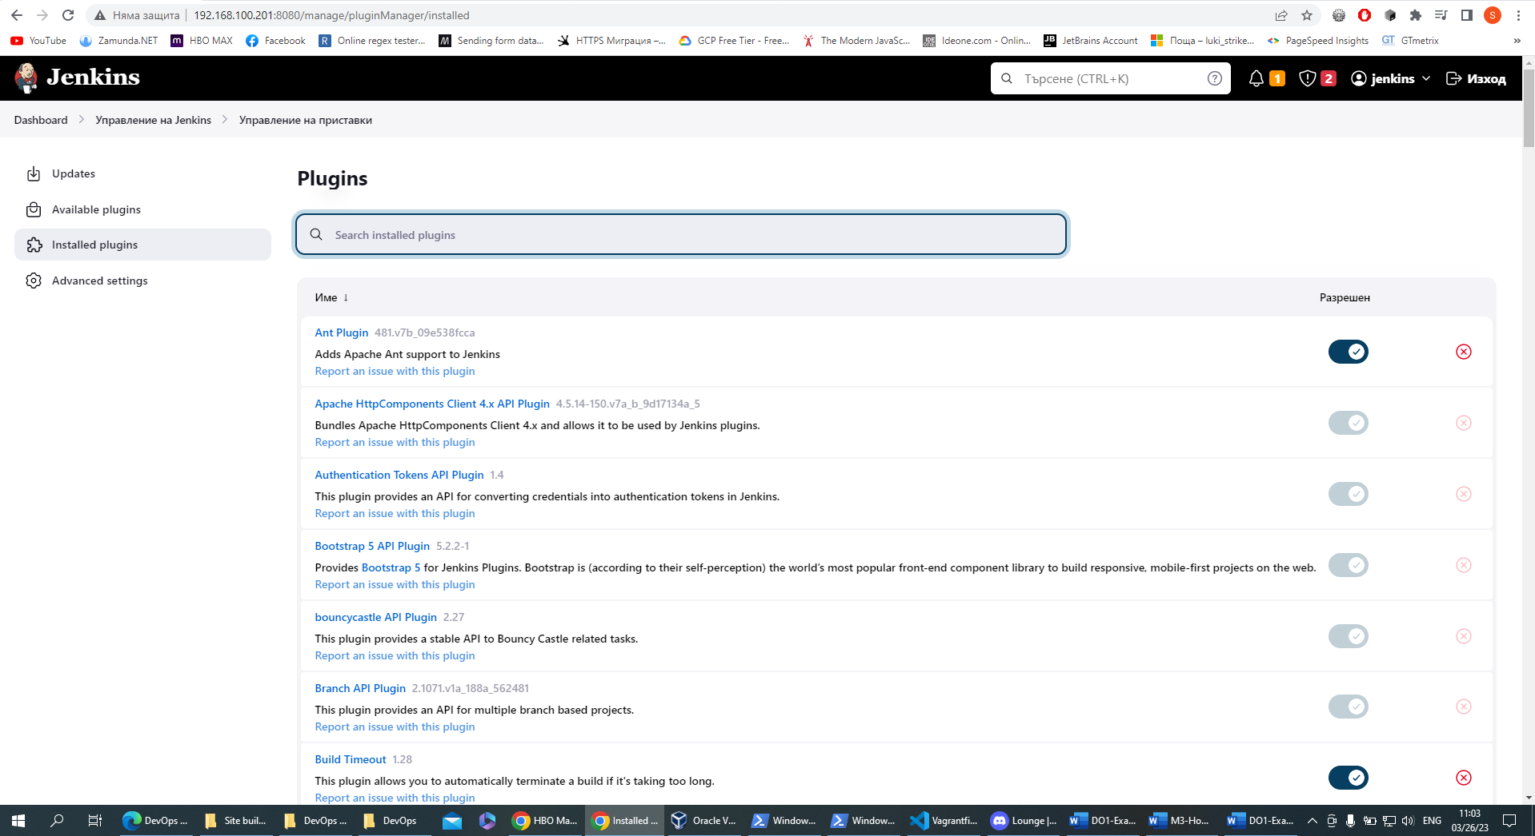

1. Credentials we can see in “[Управление на Jenkins](http://192.168.100.201:8080/manage/)” -> “Manage Credentials”

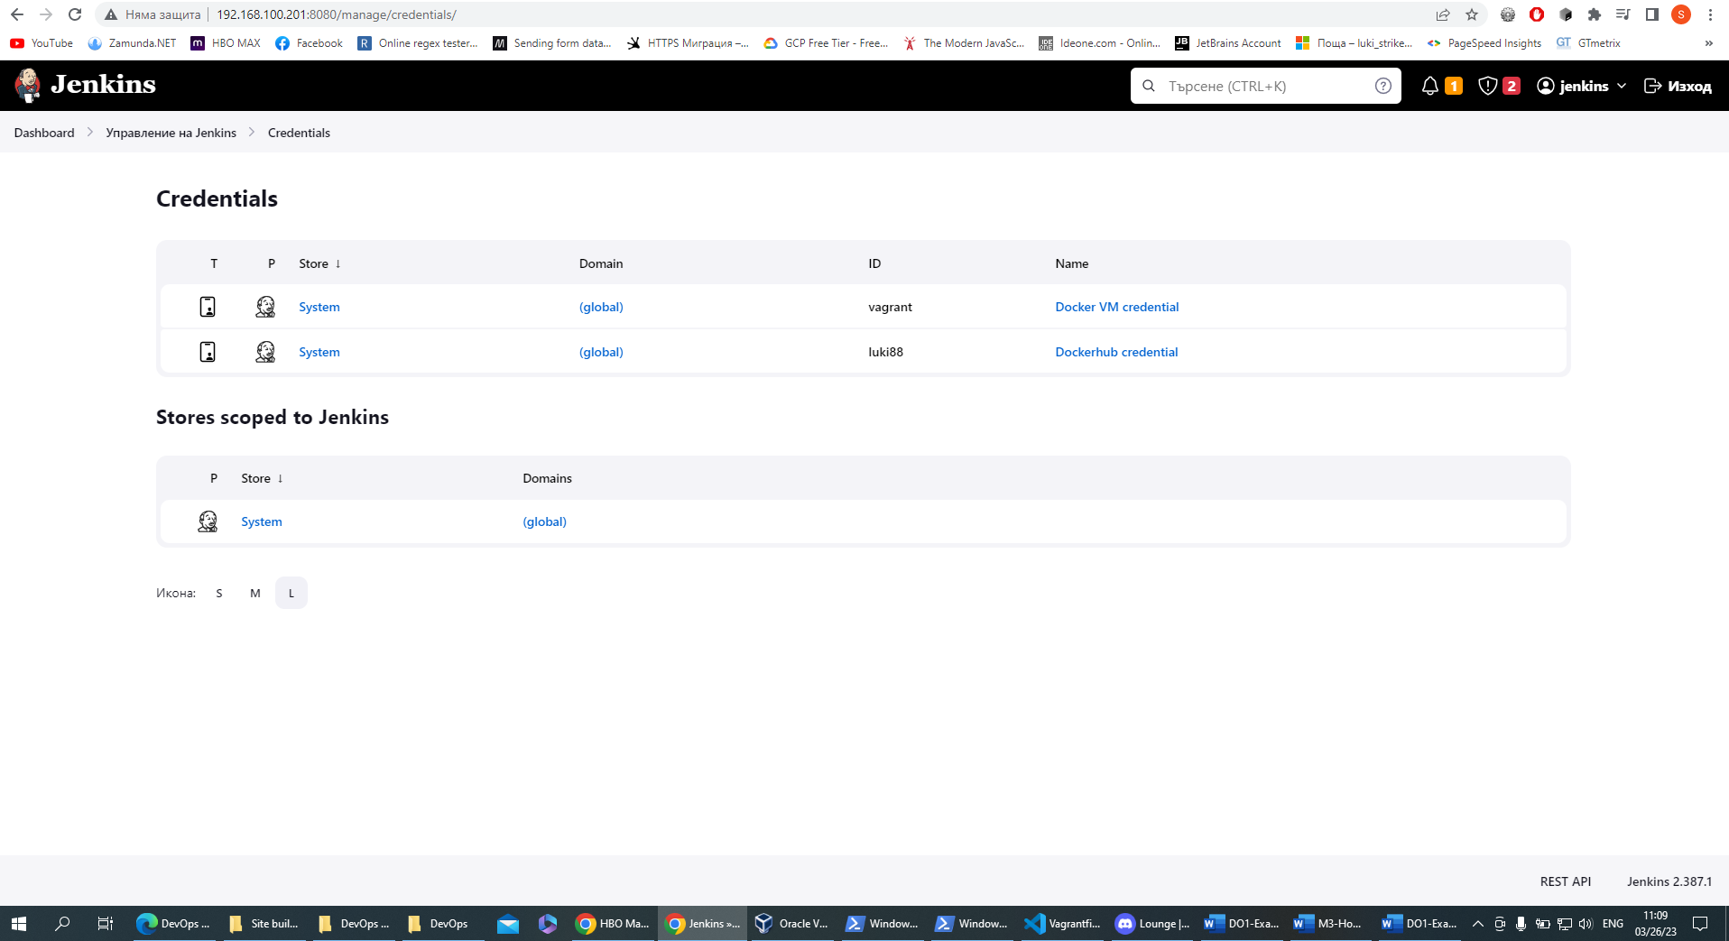

1. We need to create Docker hub token before that and input that info into jenkins/credentials.xml

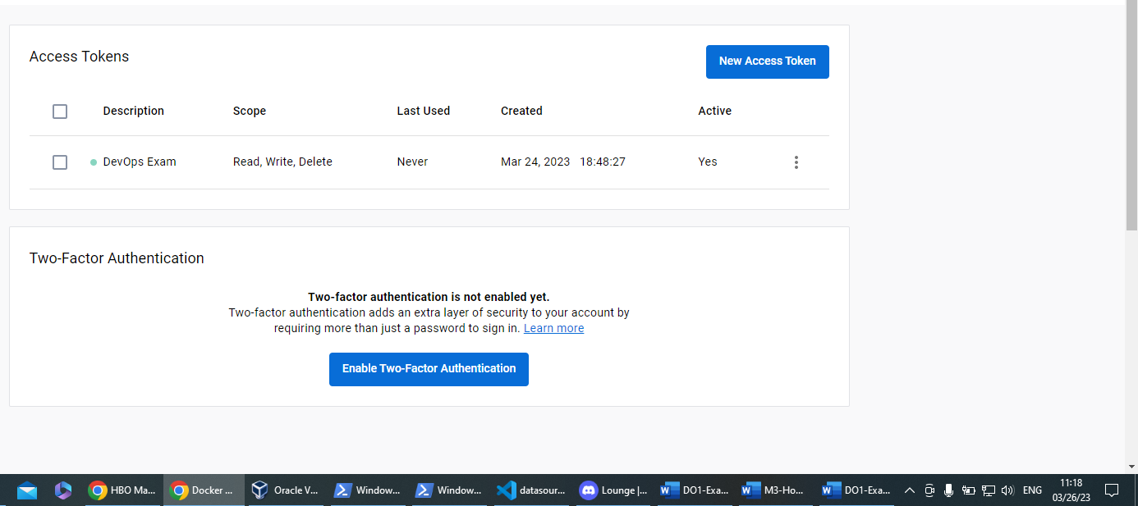

1. “[Управление на Jenkins](http://192.168.100.201:8080/manage/)” -> “[Управление на машини](http://192.168.100.201:8080/manage/pluginManager/)”

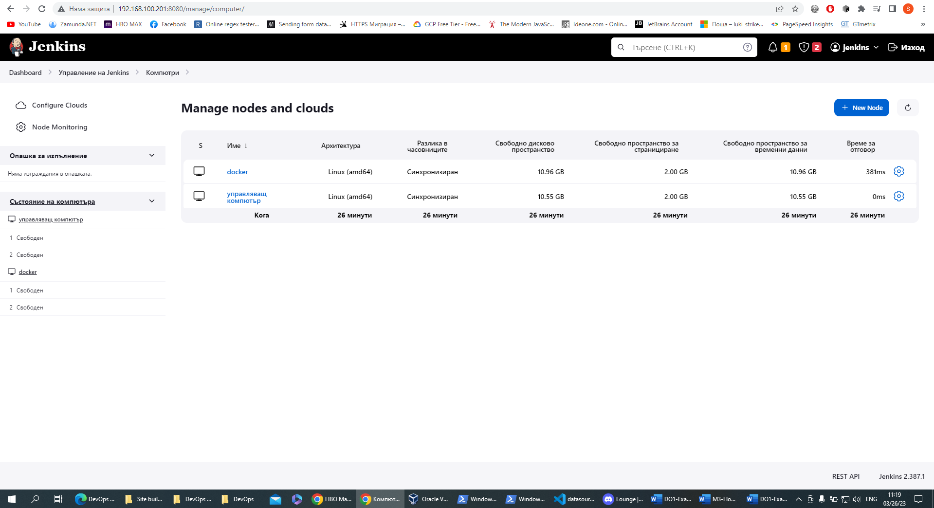

1. “Create a job” -> “Pipeline” (for name **cont** and press Ok) ->
2. Open in your browser <http://192.168.100.202:3000/> and log in using username **vagrant** with password **docker** and navigate to the repository **exam**

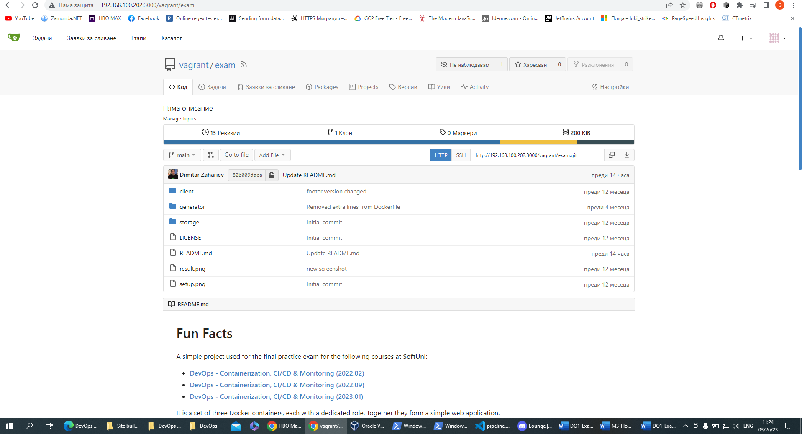

1. From here press “Настройки” -> “Уеб-куки” -> “Добави уеб-кука” -> “Gitea”
   1. Target URL: <http://192.168.100.201:8080/gitea-webhook/post> and press “Добави уеб-кука”

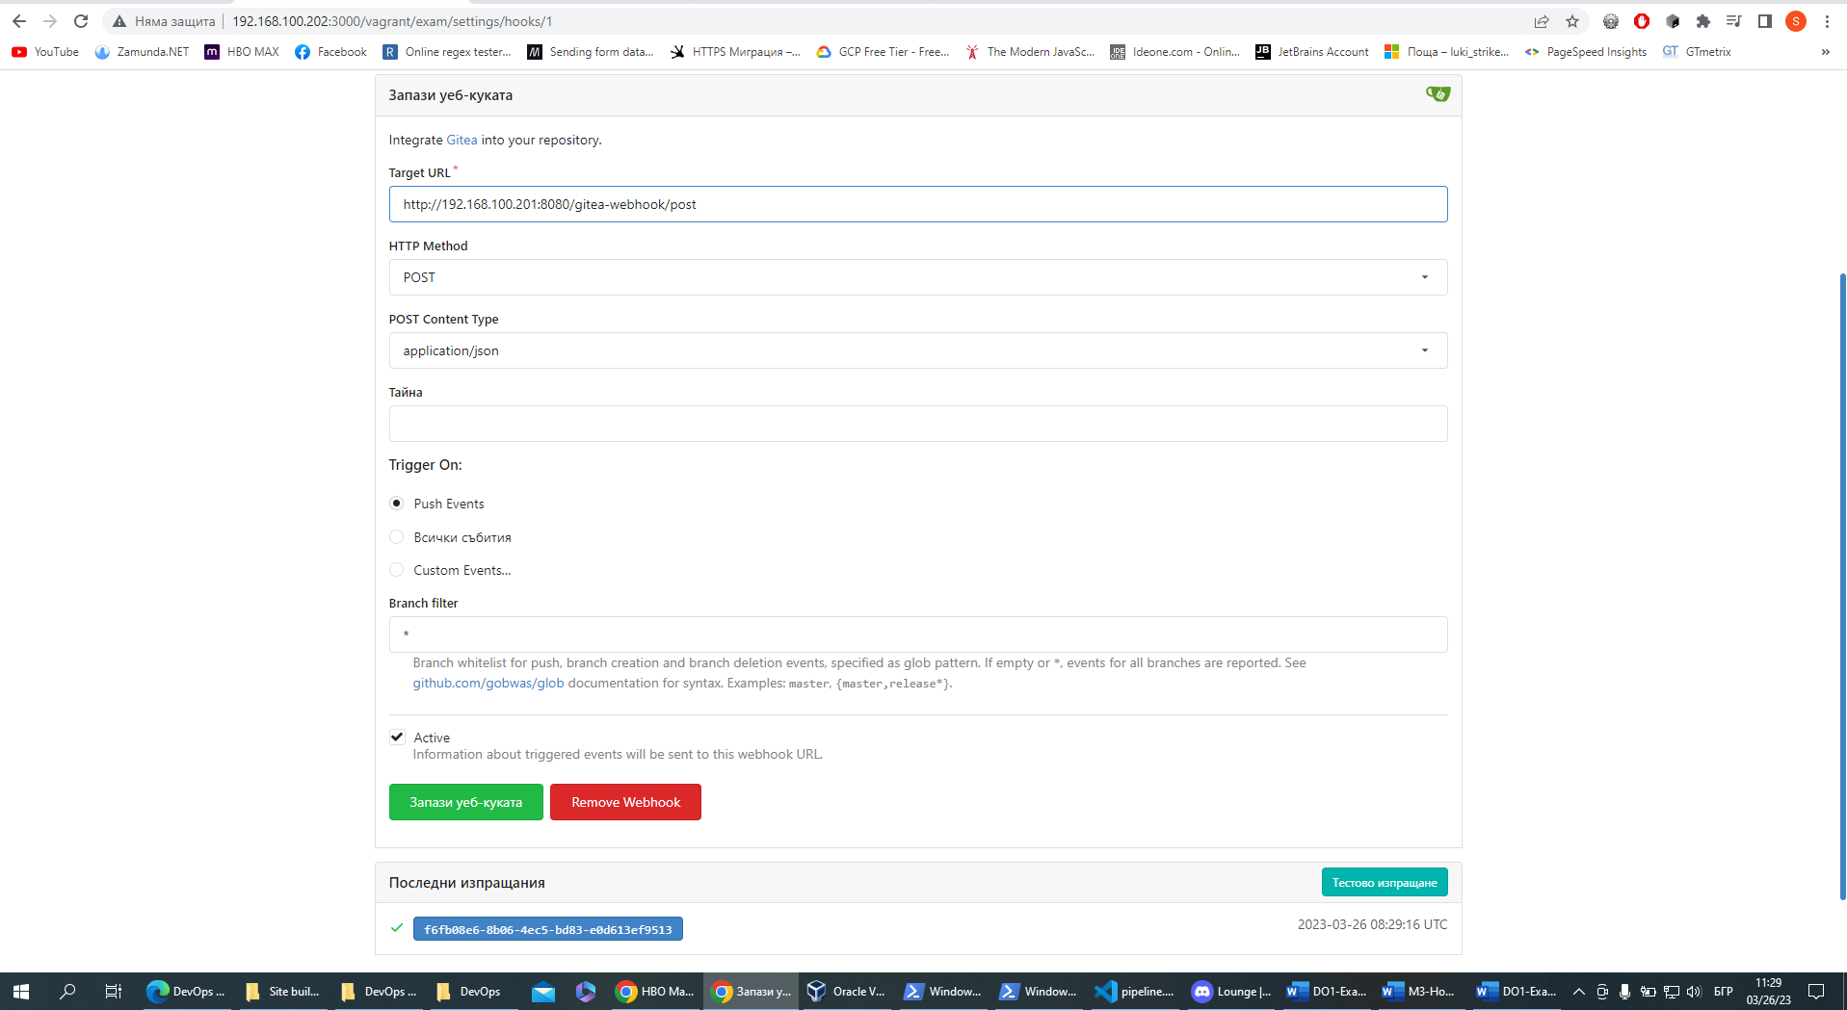

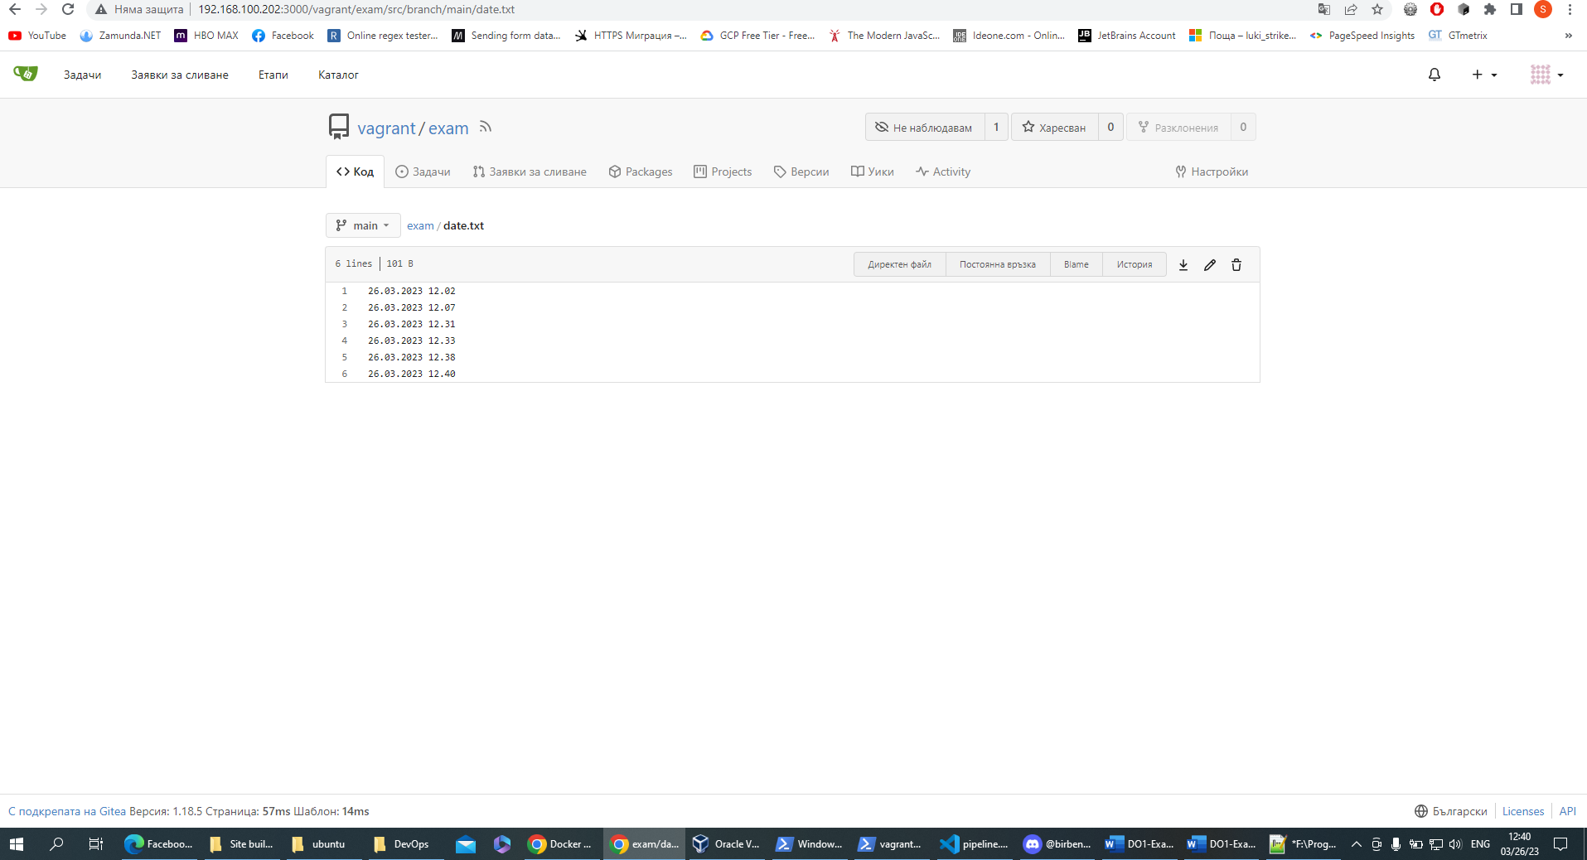

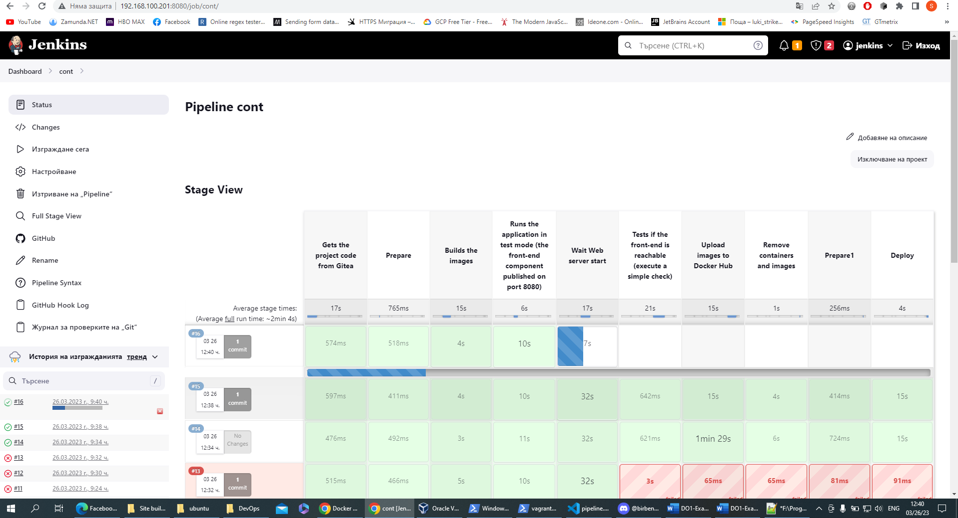

1. Open in your browser <http://192.168.100.203:9090/targets>

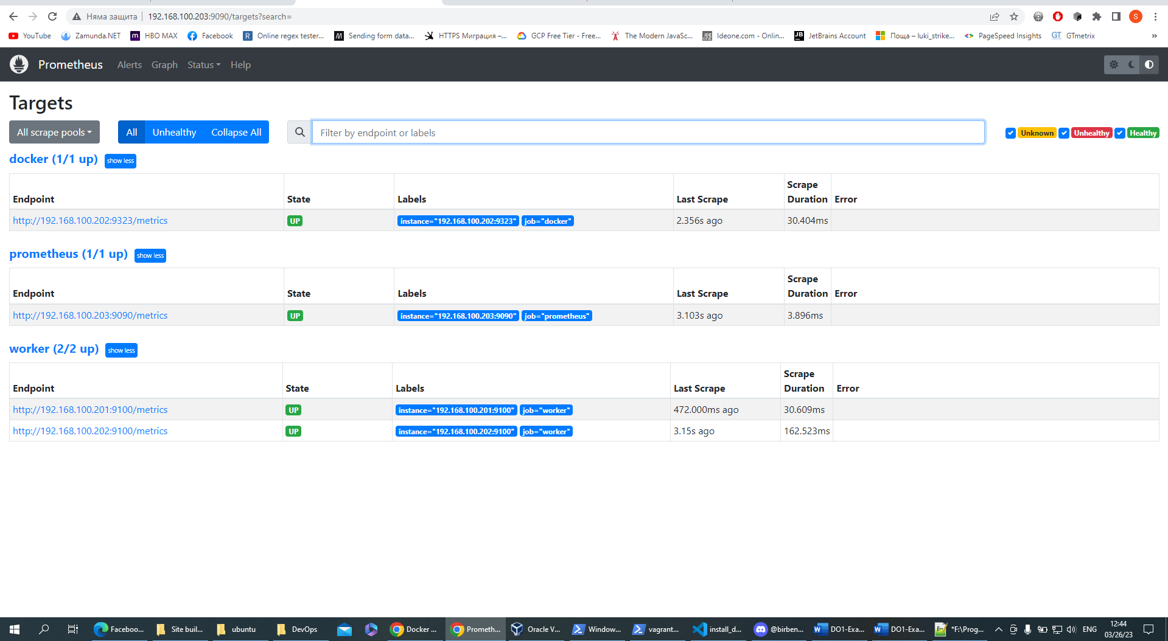

1. Open in your browser <http://192.168.100.203:3000/> and use username **admin** with password **admin**
2. Change password or you can skip that step

