**SimpleMerge program of screenshots**

1. **Start execution on the program**
   1. **Run SimpleMergeMVC**

* The program displays View from SimpleMergeView
* Show the small window.

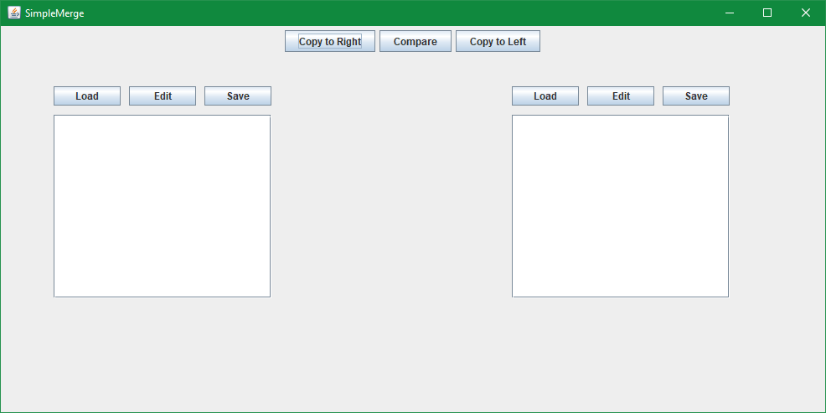

1. **LOAD**
   1. **Press Load button from the button of the left.**

* Press “Load” button.

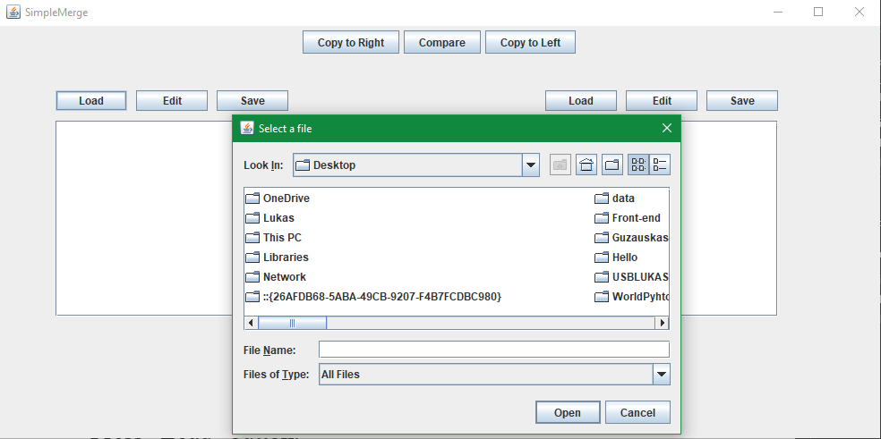

* 1. **Select file and press open button**
* Select file from Filechooser frame window.
* Click open button.

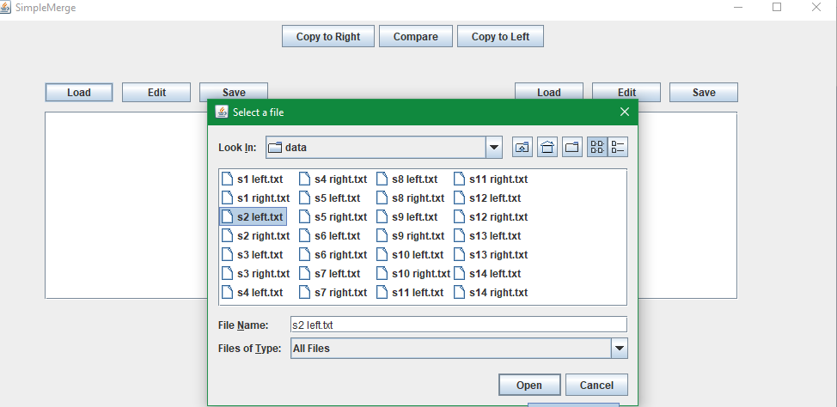

* 1. **Loaded to the left panel**
* The selected file’s contents exist in the left or the right panel

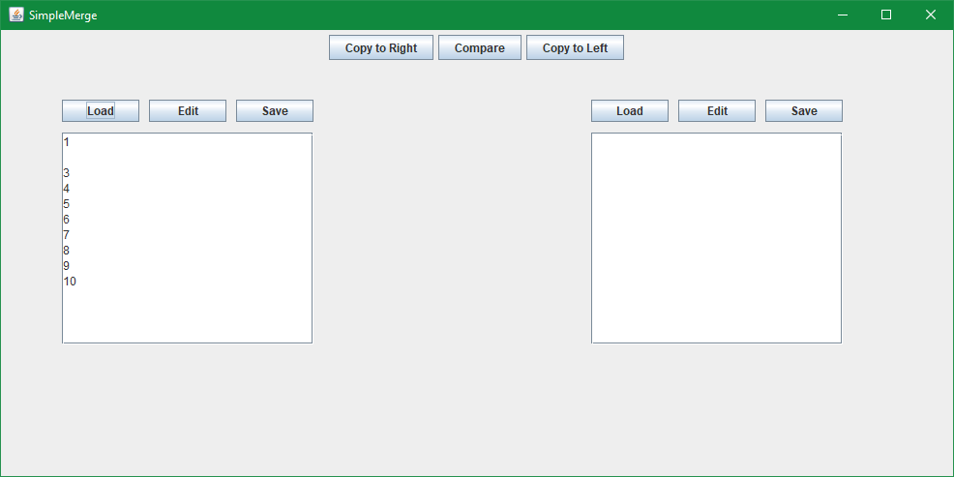

* 1. **Press Load button from the button of the right and open button**
* Press “Load” button.
* Select file from Filechooser frame window.
* Click open button.

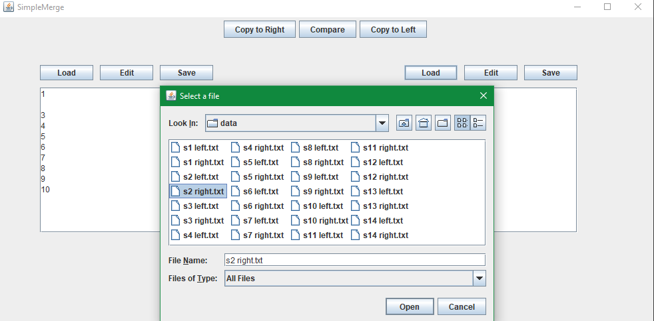

* 1. **Loaded to the right panel**
* The selected file’s contents exist in the left or the right panel.

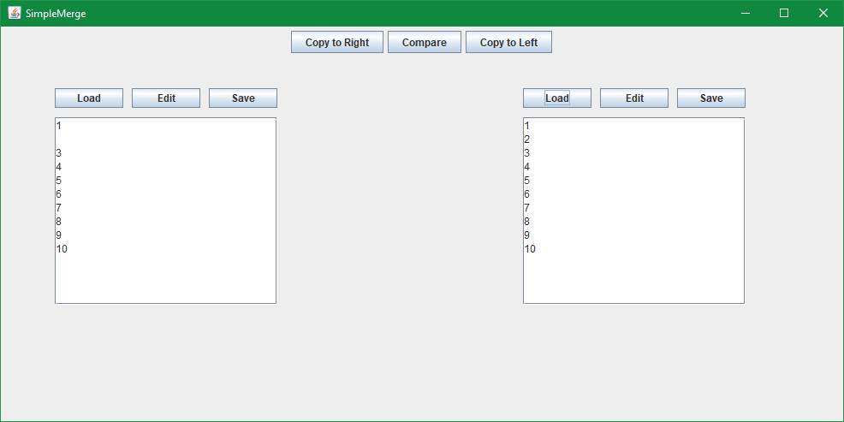

1. **EDIT**
   1. **Default panels – unedited**

* Panels still unlock.

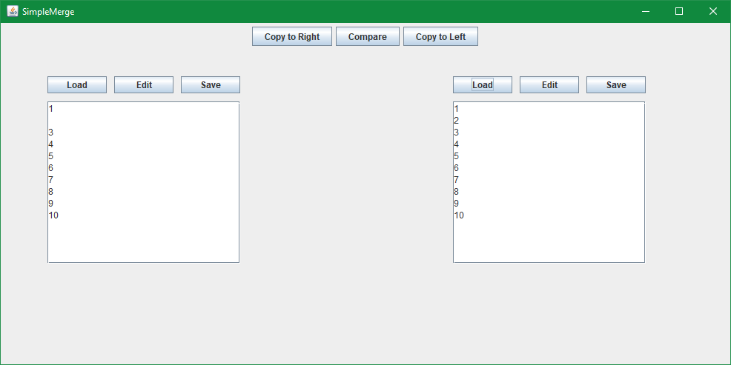

* 1. **Click Edit button (set editable)**
* Click edit button
* the user could access to text area.
* The panel is editable

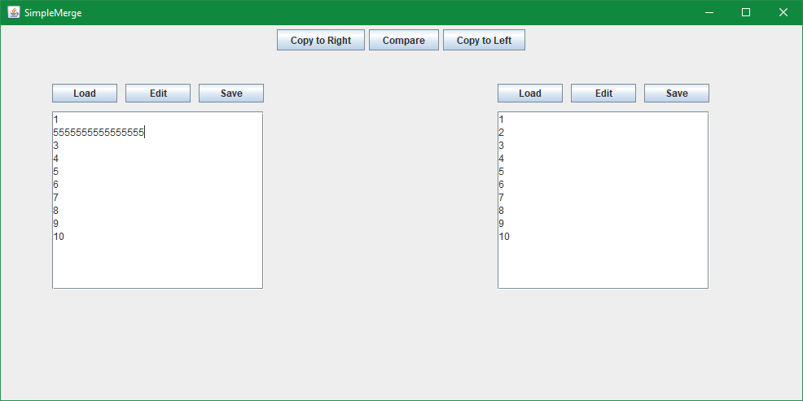

* 1. **Click Edit button (set unedited)**
* Click edit button
* the user couldn’t access to text area.
* The panel isn’t editable

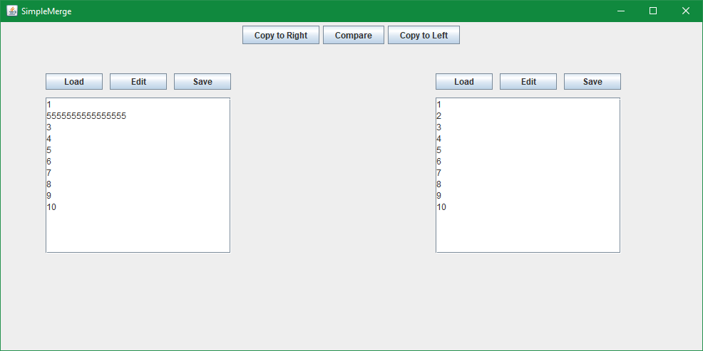

1. **SAVE**
   1. **Press Save button from the left**

* Press Save button.
* Saved to the file and the program will report successfully.

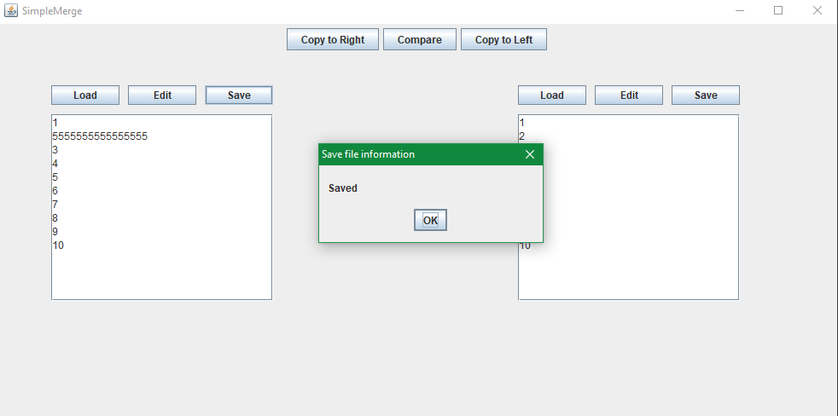

* 1. **Press Save button from the right**
* Press Save button
* Saved to the file and the program will report successfully.



1. **Compare**